****PYMACEUTICALS  
 Data Analysis****

****KAVYA SHABNAVEEs****

****HOME ASSIGNMENT – 5****

**INTRODUCTION:**

Pymaceuticals, a drug-based anti-cancer pharmaceutical has been screening treatments to skin cancer by treating 250 mice with variety of drugs for a period of 45 days. A dataset regarding physiological responses of these mice during this period has been analyzed and observations have been presented further in this document.

**CONTENTS:**

* Github/iPython Notebook file link
* Observations/Conclusions
* **GitHub/I Python Notebook file link:**

Ipython Notebook:

https://github.com/skavya90/MATPLOTLIB_Week5/blob/master/PYMAPYMACEUTI/pymaceuticals_starter.ipynb

GitHub:

https://github.com/skavya90/MATPLOTLIB_Week5.git

* **Observations**

1. The graph below shows Tumor volume for 4 different drugs over a period of 45 days.

* Capomulin drug has seen a consistent decrease in Tumor volume whereas the other 3 drugs have marked a consistent increase.

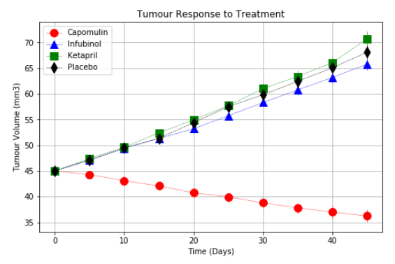

2. The graph below shows mice survival rate by the end of treatment.

* Capomulin drug has recorded highest rate of mice survival compared to other drugs shown in graph.

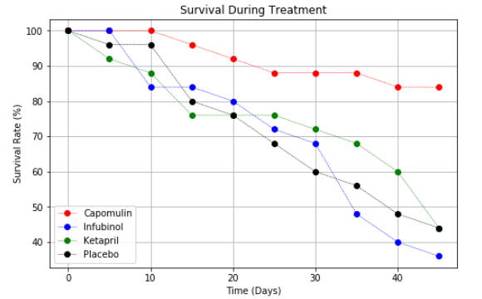

3. The graph below shows change rate of tumor volume for 4 drugs.

* Capomulin drug alone has come up with negative change rate of tumor volume which indicates that it had good impact on reducing tumor cells.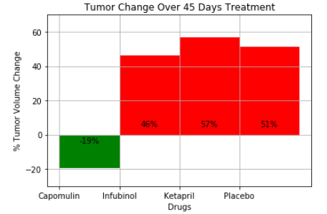

**Conclusion:**

Capomulin drug outperformed in considerably decreasing tumor volume, mice survival count.