****Multiple Year Stock Data Analysis****

****KAVYA SHABNAVEEs****

****HOME ASSIGNMENT (VBA)– 2****

**INTRODUCTION:**

A data set consisting of multiple (3) years stock data for various stocks is provided. To analyze the data with provided information, a VBA script has been developed and this document further discusses the following concepts:

* + - * Code Implementation Logic (Refer Page 3)
      * Screenshots of different years (Refer to Pages 4-6)
* Year 2014
* Year 2015
* Year 2016
  + - * Conclusions from output (Refer Pages 7- 10)
* Observations from 2014
* Observations from 2015
* Observations from 2016
  + - * Predictions (Refer to Pages 11 & 12)

**1. CODE IMPLEMENTATION LOGIC:**

A VBA script has been built to in a way to consolidate ticker specific (Stock) data like total volume of a stock over a year, yearly Change and its percentage.

With a “FOR” loop we fetched data as explained below:

* We calculated Total volume of different tickers by adding up the date specific stock volume value related to one particular stock by looping through every row of the sheet (used range only).
* Next, we calculated yearly change by subtracting stock’s open value at the start of year from stock’s closing value at the end of the year.
* Later, we derived yearly change percentage by dividing yearly change value with year open value and then multiplying the result with 100.
* With this data available, then pulled stocks with greatest percent increase/decrease and greatest volume for a year.
* Finally, handled exceptions for stocks opening with a value of “0” and applied conditional formatting accordingly.

**2. SCREENSHOTS:**

This section includes screenshots for sheets of excel workbook with above specified VBA script executed on it.

* screenshot provides the Ticker specific consolidated data (yearly Change along with its percent and Total volume of a stock) recorded for the year of 2014/2015/2016.
* Also provides the stock that recorded greatest % Increase, greatest % Decrease and greatest total volume for each year
* **For year 2014:**

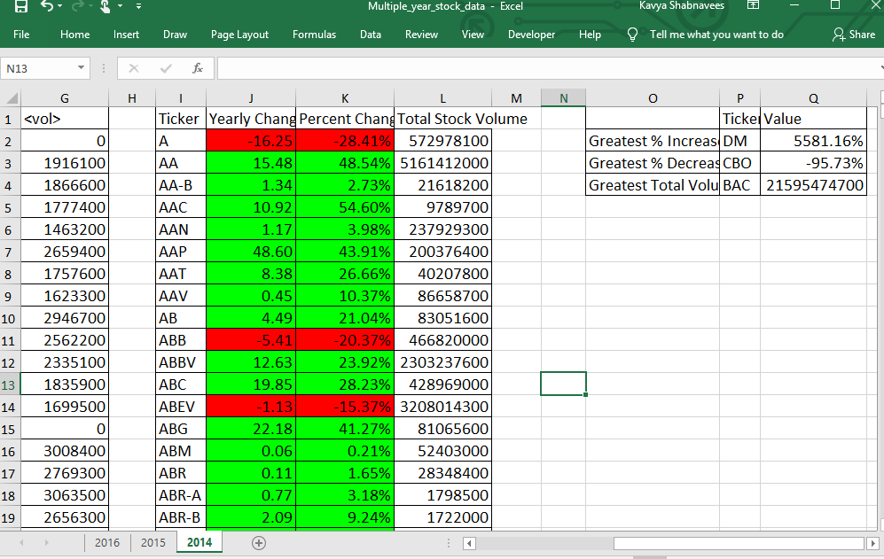

* **For year 2015:**

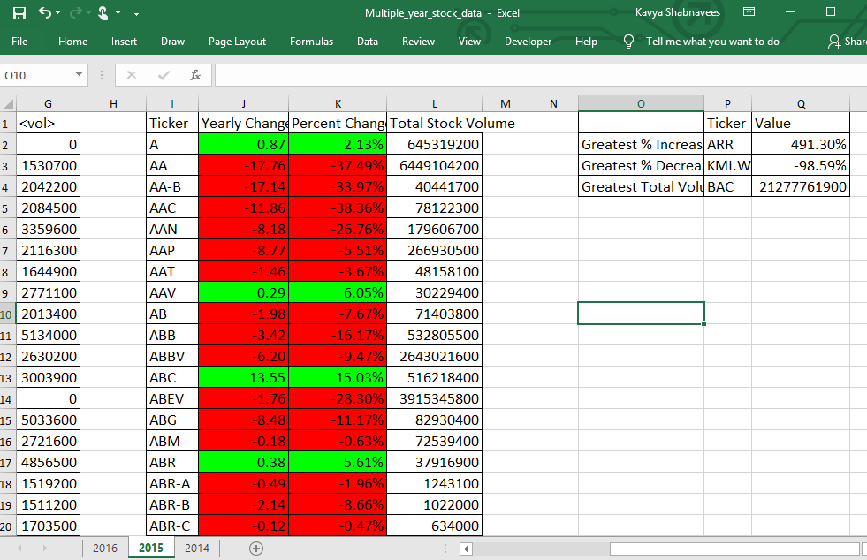

* **For year 2016:**

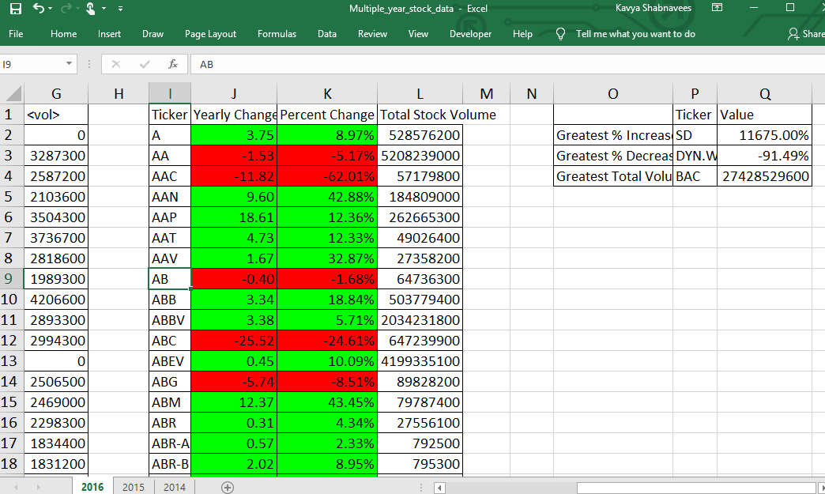

**3. CONCLUSIONS FROM OUTPUT:**

considering the output of the script that is run on dataset, observations are specified below:

* **Observations from year 2014**
* Stock “DM” stood top in highest percent increase of ~5500%.

When this stock is closely analyzed, it is noticed that it had no participation or data limited to only 2 quarters and in specific to 4 months and traded a high in the month of October and there is a smaller number of trade volume compared to other stocks.

**Fig - DM STOCK DATA VOLUME BY QUARTER FOR YEAR 2014**

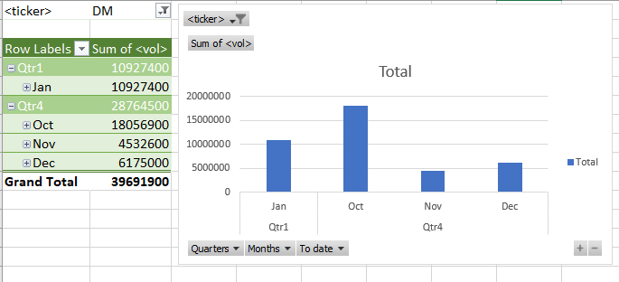

* Stock “BAC” is found to have traded highest number of shares. But, if we take a close look, it is observed that the stock was active and traded high in first quarter, following a downward trend in next quarters of the year.

**Fig - BAC STOCK DATA VOLUME BY QUARTER FOR YEAR 2015**

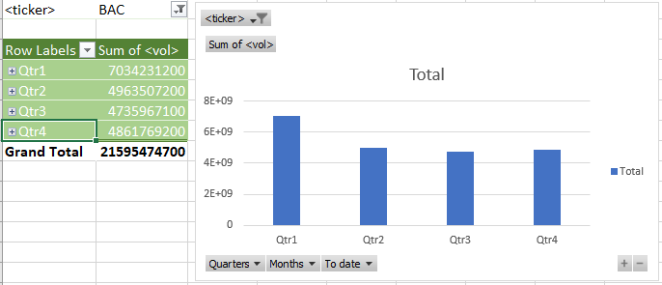

* **Observations from year 2015:**
* Though stock “ARR” has recorded highest percent increase for the year, its trading history shows that trade volume steadily declined in next quarters of the year.

**Fig - ARR STOCK DATA VOLUME BY QUARTER FOR YEAR 2015**

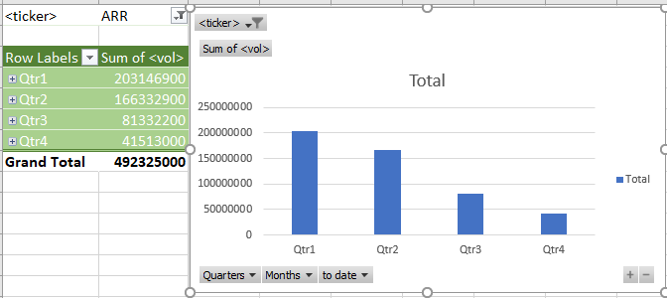

* **Observations from year 2016:**
* Stock “SD” with highest percent increase was active only for 4 months and traded high only in the month of Jan and coming to last quarter, traded a smaller volume of shares.

**Fig - SD STOCK DATA VOLUME BY QUARTER FOR Year 2016**

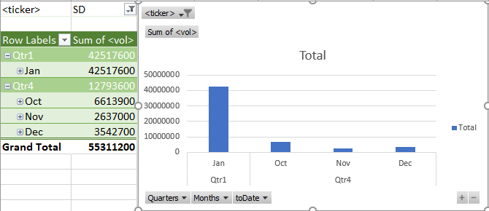

**4. PREDICTIONS:**

* BAC stock is observed to be trading highest number of shares for three consecutive years. Buying BAC shares could land us good returns with low risk considered.

**4.1 Table– BAC Stock data for 3 years**

|  |  |  |  |  |
| --- | --- | --- | --- | --- |
| Year | Ticker | Yearly Change | Percent Change | Total volume |
| 2014 | BAC | 2.32 | 14.90% | 21595474700 |
| 2015 | BAC | -1.06 | -5.93% | 21277761900 |
| 2016 | BAC | 5.27 | 31.31% | 27428529600 |

* Next to BAC, GE stock traded a considerably good volume of shares. Getting hold of GE stocks could give good returns. Also, the stock had seen an increase in yearly change for 2 consecutive years which minimizes.

**4.2 Table– GE Stock data for 3 years**

|  |  |  |  |  |
| --- | --- | --- | --- | --- |
| Year | Ticker | Yearly Change | Percent Change | Total Stock Volume |
| 2014 | GE | -2.76 | -9.85% | 7969813100 |
| 2015 | GE | 5.88 | 23.27% | 13240844800 |
| 2016 | GE | 0.45 | 1.44% | 9012420700 |

* DM stock had good results in the year 2014. However, it could not continue to keep up the same in following years. Considering the risk factor, it may not be good choice of stock to invest. Refer to figure below.

**4.3 Table– DM Stock data for 3 years**

|  |  |  |  |  |  |
| --- | --- | --- | --- | --- | --- |
| Year | Ticker | Yearly Change |  | Percent Change | Total Stock Volume |
| 2014 | DM | 38.51 |  | 5581.16% | 39691900 |
| 2015 | DM | -8.54 |  | -21.79% | 38334600 |
| 2016 | DM | -1.11 |  | -3.62% | 50995500 |

**Fig-DM STOCK DATA OF 3 YEARS BY QUARTER**

