****DATA ANALYSIS   
Heroes of Pymoli****

****KAVYA SHABNAVEEs****

****HOME ASSIGNMENT (PANDAS)– 4****

**INTRODUCTION:**

Heroes of Pymoli is a free-to-play fantasy game which included optional items for purchase that enhance their playing experience.

As part of analyzing different 576 unique players’ purchase data of optional items, certain trends have been observed and explained further in this document

**CONTENTS:**

* Observations/Conclusions
* Limitations
* iPython Notebook file links

**Observations:**

* Pie chart below shows the percentage of revenue contribution by

Male /Female and other/Non-Disclosed categories.

* It is obvious that male category has generated majority of contribution towards revenue.
* Also, below chart shows that males category showed great interest in enhancing their game than other categories.

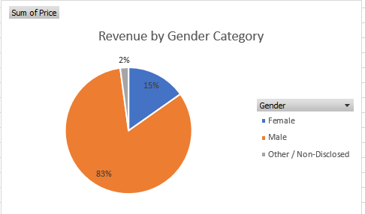

* The chart below shows total purchase value contributed by players with different ages (ranging between 7 - 45 years)

### Players falling into age-group 20-25 have actively purchased more than 360 items worth $1295.96 which is greater than other age groups.

* + - We could also conclude that our top spenders also fall into the same age-group. So, it is better to focus on interests of these players for more profits.

### The below chart also shows a spike for players with age 20 as they made 99 number of purchases worth $314.32.

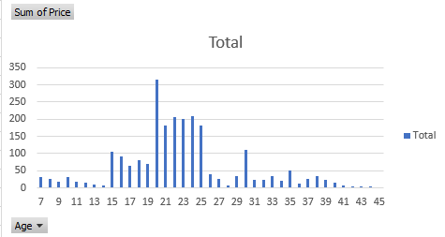

* + - * Below table shows the popular items sorted by purchase count .
* Item “Oathbreaker , Last Hope of Breaking Storm” has recorded highest number of purchases(12) and generated a revenue of $50(~).

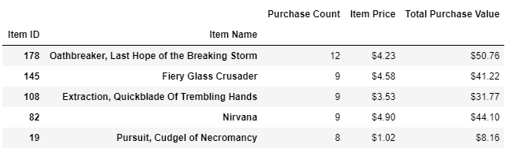

* Limitations
* Though we are notified that the game Heroes of Pymoli is a most recent game, the data set is limited to providing the details on how many months/weeks of dataset we are analyzing. If the dates of purchase were included, it could have been helpful to analyze effectively.
* And in case, we are analyzing data of very short span, our analysis could go wrong with the addition of more data. So, it is important to know if we are doing an early analysis on the limited set of data.
* iPython Notebook file uploaded links: