****DATA ANALYSIS   
PyCity Schools****

****KAVYA SHABNAVEEs****

****HOME ASSIGNMENT (PANDAS)– 4****

**INTRODUCTION:**

As part of analyzing City’s school district dataset for helping school board and mayor to make strategic decisions regarding future school budgets and priorities, certain trends have been observed and explained further in this document.

**CONTENTS:**

* Github/iPython Notebook file link
* Observations/Conclusions
* Limitations
* **Github/iPython Notebook file uploaded link:**
* Github Link:

<https://github.com/skavya90/Pandas.git>

* Ipython Link: https://github.com/skavya90/Pandas/blob/master/HeroesOfPymoli/PyMoli.ipynb

**Observations:**

1. For the all schools in the dataset, average reading score is much higher for every grade(9th,10th,11th,12th) compared to average math score. So schools could allocate more resources to improve students’ math scores.

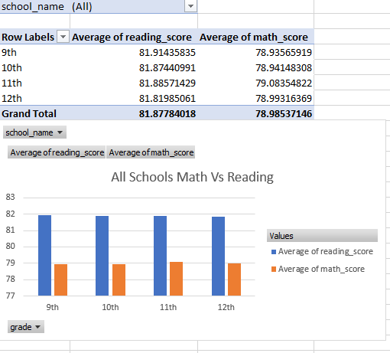

2. Though we have more charter schools than district schools, district schools maintained 26,976 students (69% of the Total students) which is double the strength of charter schools (31%- 12,194 Students).

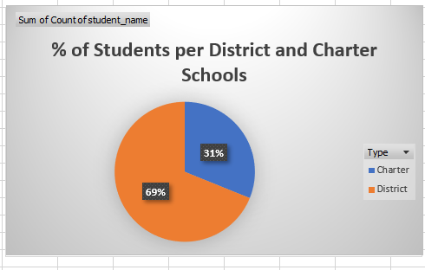

3. The table below shows the data of top 5 positioned schools which are all found to be “Charter Schools” with less than 2500 students’.

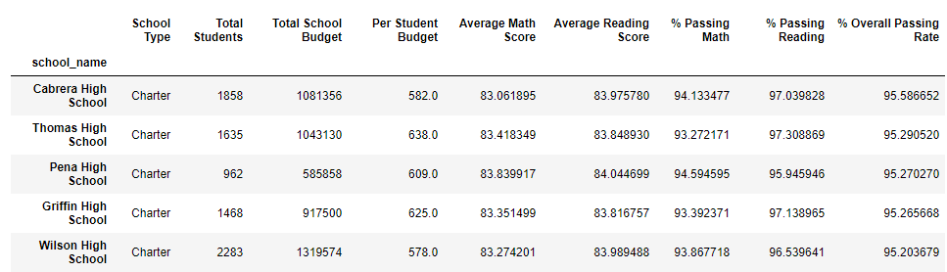

4. By considering the below chart, we could conclude that all charter schools are ranging from small to medium sized, whereas all the district schools are large sized.

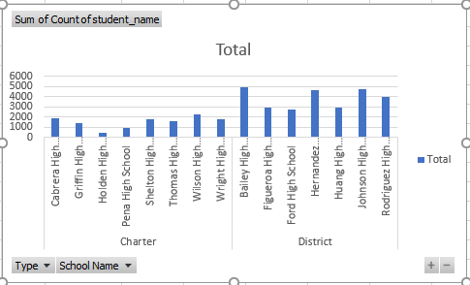

**LIMITATIONS:**

1. The data set specifically relies on math and reading scores but completely ignored or limited to science/other scores. If most of the students from district schools are science champions, overall performance rates could change to prove our current analysis wrong.

2. Also, we know that all District schools are large sized, it could be highly possible that these schools provide a wide range of many other courses in Arts (which holds many sub category courses), Technology etc. In this case district schools could be performing well with all scores included.