Segmented bar plot

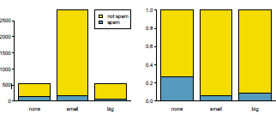

Mosaic plot

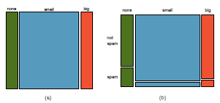

hollow histograms

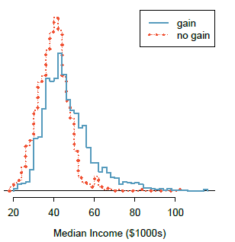

Probability

The probability of an outcome is the proportion of times the outcome would

occur if we observed the random process an in_nite number of times.

Law of Large Numbers

As more observations are collected, the proportion ^pn of occurrences with a par-

ticular outcome converges to the probability p of that outcome.

Disjoint or mutually exclusive outcomes

Two outcomes are called disjoint or mutually exclusive if they cannot both happen.

For instance, if we roll a die, the outcomes 1 and 2 are disjoint since they cannot both

occur. On the other hand, the outcomes 1 and \rolling an odd number" are not disjoint

since both occur if the outcome of the roll is a 1.

Addition Rule of disjoint outcomes

If A1 and A2 represent two disjoint outcomes, then the probability that one of

them occurs is given by

P(A1 or A2) = P(A1) + P(A2)

If there are many disjoint outcomes A1, ..., Ak, then the probability that one of

these outcomes will occur is

P(A1) + P(A2) + _ _ _ + P(Ak)

General Addition Rule

If A and B are any two events, disjoint or not, then the probability that at least

one of them will occur is

P(A or B) = P(A) + P(B) 􀀀 P(A and B)

where P(A and B) is the probability that both events occur.

Probability distributions

A probability distribution is a table of all disjoint outcomes and their associated prob-

abilities. Table 2.5 shows the probability distribution for the sum of two dice.

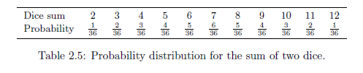

Rules for probability distributions

A probability distribution is a list of the possible outcomes with corresponding

probabilities that satisfies three rules:

1. The outcomes listed must be disjoint.

2. Each probability must be between 0 and 1.

3. The probabilities must total 1.

Complement of an event

Rolling a die produces a value in the set {1, 2, 3, 4, 5, 6}. This set of all possible outcomes

is called the **sample space (S)** for rolling a die. We often use the sample space to examine

the scenario where an event does not occur.

Let D = {2, 3} represent the event that the outcome of a die roll is 2 or 3. Then the

complement of D represents all outcomes in our sample space that are not in D, which

is denoted by Dc = {1, 4, 5, 6}. That is, Dc is the set of all possible outcomes not already

included in D. Figure 2.9 shows the relationship between D, Dc, and the sample space S.

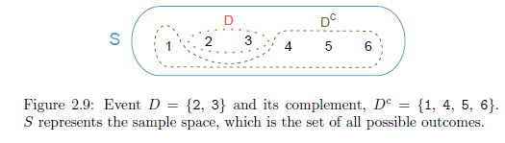

Complement

The complement of event A is denoted Ac, and Ac represents all outcomes not

in A. A and Ac are mathematically related:

P(A) + P(Ac) = 1; i.e. P(A) = 1 - P(Ac)

Independence

Two processes are independent if knowing the outcome of one provides no

useful information about the outcome of the other. For instance, flipping a coin and rolling

a die are two independent processes { knowing the coin was heads does not help deter-

mine the outcome of a die roll. On the other hand, stock prices usually move up or down

together, so they are not independent.

Multiplication Rule for independent processes

If A and B represent events from two different and independent processes, then

the probability that both A and B occur can be calculated as the product of their

separate probabilities:

P(A and B) = P(A) * P(B)

Similarly, if there are k events A1, ..., Ak from k independent processes, then the

probability they all occur is

P(A1) * P(A2) * ……* P(Ak)

Marginal and joint probabilities

If a probability is based on a single variable, it is a **marginal probability**. The

probability of outcomes for two or more variables or processes is called a **joint**

**probability.**

Conditional probability

The conditional probability of the outcome of interest A given condition B is

computed as the following:

P(A | B) = $\frac{P(A and B)}{P(B)}$

General Multiplication Rule

If A and B represent two outcomes or events, then

P(A and B) = P(A | B) * P(B)

It is useful to think of A as the outcome of interest and B as the condition.

Sum of conditional probabilities

Let A1, ..., Ak represent all the disjoint outcomes for a variable or process. Then

if B is an event, possibly for another variable or process, we have:

P(A1 | B) + …… + P(Ak | B) = 1

The rule for complements also holds when an event and its complement are con-

ditioned on the same information:

P(A | B) = 1 - P(Ac | B)

Independence considerations in conditional probability

If two events are independent, then knowing the outcome of one should provide no in-

formation about the other.