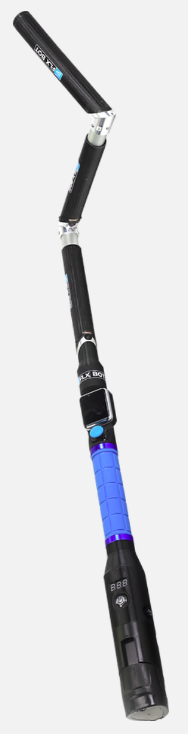
PlatformIO
Arduino
SDK
&

3rd Party
Libraries
ROS
Base Station Controller
Handler Controller
Segment Controller
Drive Controller

VSCode

Espressif ESP32
← FTDI →
Teensy® 3.2

Espressif ESP32

T-Watch-2020-V2

