A PROJECT REPORT ON

APPLICATION RECOMMENDATION SYSTEM

SUBMITTED TO THE SAVITRIBAI PHULE PUNE UNIVERSITY, PUNE IN THE PARTIAL FULFILLMENT OF THE REQUIREMENTS FOR THE AWARD OF THE DEGREE

BACHELOR OF ENGINEERING
(Computer Engineering)

BY

Shweta Upadhyay Exam No: 14121015
Chinmay Patil Exam No: 14121033
Shubham Badhe Exam No: 14121035

Nikhil Shinde Exam No: 14121066

Under The Guidance of

Prof. Danny Periera

DEPARTMENT OF COMPUTER ENGINEERING

GOVERNMENT COLLEGE OF ENGINEERING AND RESEARCH AVASARI
AVASARI (Kh), PUNE 412405

SAVITRIBAI PHULE PUNE UNIVERSITY, PUNE 2017 - 18

CERTIFICATE

This is to certify that the Project Entitled

APPLICATION RECOMMENDATION SYSTEM

Submitted by

Shweta Upadhyay Exam No: 14121015
Chinmay Patil Exam No: 14121033
Shubham Badhe Exam No: 14121035

Nikhil Shinde Exam No: 14121066

Is a bonafide work carried out by them under the supervision of Prof. Danny Pereira and it is approved for the partial fulfillment of the requirement of Savitribai Phule Pune University, Pune for the award of the degree of Bachelor of Engineering (Computer Engineering).

Prof. Danny Pereira | Dr. S.V.Ghumre
Guide | H.O.D
Dept. of Computer Engg. | Dept. of Computer Engg.

Dr. A. S. Pant

Principal

Government College of Engineering and research Avasari

Signature of Internal Examiner Signature of External Examiner

PROJECT APPROVAL SHEET

A Project Report Titled as

APPLICATION RECOMMENDATION SYSTEM

Is varied for its originality in documentation, problem statement, proposed work and implementation successfully completed by

Shweta Upadhyay Exam No: 14121015
Chinmay Patil Exam No: 14121033
Shubham Badhe Exam No: 14121035

Nikhil Shinde Exam No: 14121066

at

DEPARTMENT OF COMPUTER ENGINEERING

GOVERNMENT COLLEGE OF ENGINEERING and RESEARCH AVASARI

SAVITRIBAI PHULE PUNE UNIVERSITY,PUNE

ACADEMIC YEAR 2017-2018

Prof. Danny Pereira | Dr. S.V. Ghumre
Guide | H.O.D
Dept. of Computer Engg. | Dept. of Computer Engg.

Acknowledgments

It gives us great pleasure in presenting the preliminary project report on ‘APPLICATION RECOMMENDATION SYSTEM using Sentimental Analysis’.

I would like to take this opportunity to thank my internal guide Prof. Danny Jaron Pereira for giving us all the help and guidance I needed. I am really grateful to them for their kind support. Their valuable suggestions were very helpful.
I am also grateful to Dr. S. U. Ghumbre, Head of Computer Engineering Department, Government College of Engineering, Avasari Khurd for his indispensable support, suggestion.

Shweta Upadhyay
Chinmay Patil
Shubham Badhe
Nikhil Shinde

(B.E. Computer Engg.)

GCOERA, Department of Computer Engineering 2017-18 II

Contents

1 | Synopsis |  |  | 1
 | 1.1 | Project Title . . . . . . . . . . . . . . . . . . . . . . . . . . . . |  | 2
 | 1.2 | Project Option . . . . . . . . . . . . . . . . . . . . . . . . . |  | 2
 | 1.3 | Internal Guide . . . . . . . . . . . . . . . . . . . . . . . . . . . |  | 2
 | 1.4 | Technical Keywords (As per ACM Keywords) . . . . . . . . . |  | 2
 | 1.5 | Problem Statement . . . . . . . . . . . . . . . . . . . . . . . . |  | 2
 | 1.6 | Abstract . . . . . . . . . . . . . . . . . . . . . . . . . . . . . . |  | 3
 | 1.7 | Goals and Objectives . . . . . . . . . . . . . . . . . . . . . . . |  | 3
 | 1.8 | Relevant mathematics associated with the Project . . . . . . . |  | 3
 | 1.9 | Names of Conferences / Journals where papers can be published |  | 3
 | 1.10 | Plan of Project Execution . . . . . . . . . . . . . . . . . . . . |  | 4
2 | Technical Keywords |  |  | 5
 | 2.1 | Area of Project . . . . . . . . . . . . . . . . . . . . . . . . . . |  | 6
 | 2.2 | Technical Keywords . . . . . . . . . . . . . . . . . . . . . . . . |  | 6
3 | Introduction |  |  | 7
 | 3.1 | Project Idea . . . . . . . . . . . . . . . . . . . . . . . . . . . . |  | 8
 | 3.2 | Motivation of the Project . . . . . . . . . . . . . . . . . . . . |  | 8
4 Problem De nition and scope |  |  |  | 9
 | 4.1 | Problem Statement . . . . . . . . . . . . . . . . . . . . . . . . |  | 10
 |  | 4.1.1 | Goals and objectives . . . . . . . . . . . . . . . . . . . | 10
 |  | 4.1.2 | Statement of scope . . . . . . . . . . . . . . . . . . . . | 10
 | 4.2 | Major Constraints . . . . . . . . . . . . . . . . . . . . . . . . |  | 10
 | 4.3 | Methodologies of Problem solving and e ciency issues . . . . |  | 10
 | 4.4 | Outcome . . . . . . . . . . . . . . . . . . . . . . . . . . . . . . |  | 10
 | 4.5 | Applications . . . . . . . . . . . . . . . . . . . . . . . . . . . . |  | 10
 | 4.6 | Hardware Resources Required . . . . . . . . . . . . . . . . . . |  | 11

GCOERA, Department of Computer Engineering 2017-18 III

 | 4.7 | Software Resources Required . . . . . . . . . . . . . . . . . . . |  | 11
5 | Project Plan |  |  | 12
 | 5.1 | Project Estimates . . . . . . . . . . . . . . . . . . . . . . . . . |  | 13
 |  | 5.1.1 | Reconciled Estimates . . . . . . . . . . . . . . . . . . . | 13
 |  | 5.1.2 | Project Resources . . . . . . . . . . . . . . . . . . . . . | 13
 | 5.2 | Risk Management w.r.t. NP Hard analysis . . . . . . . . . . . |  | 13
 |  | 5.2.1 | Risk Identi cation . . . . . . . . . . . . . . . . . . . . | 13
 |  | 5.2.2 | Risk Analysis . . . . . . . . . . . . . . . . . . . . . . . | 14
 |  | 5.2.3 | Overview of Risk Mitigation, Monitoring, Management | 14
 | 5.3 | Project Schedule . . . . . . . . . . . . . . . . . . . . . . . . . |  | 17
 |  | 5.3.1 | Project task set . . . . . . . . . . . . . . . . . . . . . . | 17
 |  | 5.3.2 | Task network . . . . . . . . . . . . . . . . . . . . . . . | 17
 |  | 5.3.3 | Timeline Chart . . . . . . . . . . . . . . . . . . . . . . | 17
 | 5.4 | Team Organization . . . . . . . . . . . . . . . . . . . . . . . . |  | 17
 |  | 5.4.1 | Team structure . . . . . . . . . . . . . . . . . . . . . . | 17
 |  | 5.4.2 | Management reporting and communication . . . . . . . | 17
6 | Software requirement speci cation |  |  | 18
 | 6.1 | Introduction . . . . . . . . . . . . . . . . . . . . . . . . . . . . |  | 19
 |  | 6.1.1 | Purpose and Scope of Document . . . . . . . . . . . . | 19
 |  | 6.1.2 | Overview of responsibilities of Developer . . . . . . . . | 19
 | 6.2 | Usage Scenario . . . . . . . . . . . . . . . . . . . . . . . . . . |  | 19
 |  | 6.2.1 | User pro les . . . . . . . . . . . . . . . . . . . . . . . . | 19
 |  | 6.2.2 | Use-cases . . . . . . . . . . . . . . . . . . . . . . . . . | 19
 |  | 6.2.3 | Use Case View . . . . . . . . . . . . . . . . . . . . . . | 19
 | 6.3 | Data Model and Description . . . . . . . . . . . . . . . . . . . |  | 21
 |  | 6.3.1 | Data Description . . . . . . . . . . . . . . . . . . . . . | 21
 |  | 6.3.2 | Data objects and Relationships . . . . . . . . . . . . . | 21
 | 6.4 | Functional Model and Description . . . . . . . . . . . . . . . . |  | 21
 |  | 6.4.1 | Data Flow Diagram . . . . . . . . . . . . . . . . . . . . | 21
 |  | 6.4.2 | Activity Diagram: . . . . . . . . . . . . . . . . . . . . . | 21
 |  | 6.4.3 | Non Functional Requirements: . . . . . . . . . . . . . . | 21
 |  | 6.4.4 | State Diagram: . . . . . . . . . . . . . . . . . . . . . . | 22
 |  | 6.4.5 | Design Constraints . . . . . . . . . . . . . . . . . . . . | 22
 |  | 6.4.6 | Software Interface Description . . . . . . . . . . . . . . | 22
7 Detailed Design Document using Annexure A and B |  |  |  | 23
 | 7.1 | Introduction . . . . . . . . . . . . . . . . . . . . . . . . . . . . |  | 24
 | 7.2 | Architectural Design . . . . . . . . . . . . . . . . . . . . . . . |  | 24
 | 7.3 | Data design (using Annexures A and B) . . . . . . . . . . . . |  | 25

GCOERA, Department of Computer Engineering 2017-18 IV

 |  | 7.3.1 | Internal software data structure . . . . . . . . . . . . . | 25
 |  | 7.3.2 | Global data structure . . . . . . . . . . . . . . . . . . . | 25
 |  | 7.3.3 | Temporary data structure . . . . . . . . . . . . . . . . | 25
 |  | 7.3.4 | Database description . . . . . . . . . . . . . . . . . . . | 25
 | 7.4 | Compoent Design . . . . . . . . . . . . . . . . . . . . . . . . . |  | 25
 |  | 7.4.1 | Class Diagram . . . . . . . . . . . . . . . . . . . . . . . | 25
8 | Project Implementation |  |  | 27
 | 8.1 | Introduction . . . . . . . . . . . . . . . . . . . . . . . . . . . . |  | 28
 | 8.2 | Tools and Technologies Used . . . . . . . . . . . . . . . . . . . |  | 28
 | 8.3 | Methodologies/Algorithm Details . . . . . . . . . . . . . . . . |  | 28
 |  | 8.3.1 | Algorithm 1/Pseudo Code . . . . . . . . . . . . . . . . | 28
 |  | 8.3.2 | Algorithm 2/Pseudo Code . . . . . . . . . . . . . . . . | 28
 | 8.4 | Veri cation and Validation for Acceptance . . . . . . . . . . . |  | 28
9 | Software Testing |  |  | 29
 | 9.1 | Type of Testing Used . . . . . . . . . . . . . . . . . . . . . . . |  | 30
 | 9.2 | Test Cases and Test Results . . . . . . . . . . . . . . . . . . . |  | 30
10 | Results |  |  | 31
 | 10.1 Screen shots . . . . . . . . . . . . . . . . . . . . . . . . . . . . |  |  | 32
 | 10.2 | Outputs . . . . . . . . . . . . . . . . . . . . . . . . . . . . . . |  | 32
11 | Deployment and Maintenance |  |  | 33
 | 11.1 | Installation and un-installation . . . . . . . . . . . . . . . . . |  | 34
 | 11.2 | User help . . . . . . . . . . . . . . . . . . . . . . . . . . . . . |  | 34
12 | Conclusion and Future Scope |  |  | 35
References |  |  |  | 36
Annexure A |  |  | Laboratory assignments on Project Analysis of Al-
 | gorithmic Design |  |  | 39
Annexure B Laboratory assignments on Project Quality and
 | Reliability Testing of Project Design |  |  | 41
Annexure C |  |  | Project Planner | 43
Annexure D Reviewers Comments of Paper Submitted |  |  |  | 45
Annexure E |  |  | Plagiarism Report | 47

GCOERA, Department of Computer Engineering 2017-18

List of Figures

6.1 | Use case diagram . . . . . . . . . . . . . . . . . . . . . . . . . | 20
6.2 | State transition diagram . . . . . . . . . . . . . . . . . . . . . | 22
7.1 | Architecture diagram . . . . . . . . . . . . . . . . . . . . . . . | 24
7.2 | Class Diagram . . . . . . . . . . . . . . . . . . . . . . . . . . . | 26

GCOERA, Department of Computer Engineering 2017-18 VII

List of Tables

4.1 | Hardware Requirements . . . . . . . . . . . . . . . . . . . . . | 11
5.1 | Risk Table . . . . . . . . . . . . . . . . . . . . . . . . . . . . . | 14
5.2 | Risk Probability de nitions [?] . . . . . . . . . . . . . . . . . . | 14
5.3 | Risk Impact de nitions [?] . . . . . . . . . . . . . . . . . . . . | 15
6.1 | Use Cases . . . . . . . . . . . . . . . . . . . . . . . . . . . . . | 19
A.1 | IDEA Matrix . . . . . . . . . . . . . . . . . . . . . . . . . . . | 40

GCOERA, Department of Computer Engineering 2017-18 VIII
CHAPTER 1

SYNOPSIS

1.1 Project Title

Application Recommendation System by using Sentimental Analysis.

1.2 Project Option

Internal Project.

1.3 Internal Guide

Mr. Danny Pereira
Assistant Professor, Computer Department
Government College of Engineering, Avasari khurd.

1.4 Technical Keywords (As per ACM Key-words)

SVM, NLTK, Scientific python, MySQL, Selenium, Pandas

1.5 Problem Statement

Developing an Assistance for Application Recommendation System.

1.6 Abstract

Sentiment Analysis mainly focuses on subjectivity and polarity detection. Today consumers make the buying decisions based on the customer’s review that is available in some of the online shopping sites like shopclues etc. There are also some of the specific websites which discuss about positive and negative facts of those product that comes to market like amazon. Hence this type of analysis are socially much needed for sellers to undergo market analysis, branding, product penetration and so on.
Sentiment Analysis aims at determining the overall polarity of a document, for instance, identifying whether a movie review appreciates or criticizes a movie. We present a machine learning based approach to this problem similar to text categorization. The technique is made more effective by incorporating linguistic knowledge gathered through Wordnet1 synonymy graphs. A method to improve the accuracy of classiﬁcation over a set of test documents is ﬁnally given.

GCOERA, Department of Computer Engineering 2017-18

1.7 Goals and Objectives

To develop an application which will recommend application in your mobile is good to use or a better choice is available.

1.8 Relevant mathematics associated with the Project

System Description:
• Input: User query
• Output: Whether an app is fraud or not.
• Functions: Process Query.
• Success Conditions: Reply for an application provided by user.
• Failure Conditions: Invalid query.

1.9 Names of Conferences / Journals where papers can be published

• IEEE/ACM Conference/Journal 1
• Conferences/workshops in Engg colleges
•Online Journals

1.10 Plan of Project Execution

1. Learn technologies required –
a. SVM
b. NLTK
c. Machine Learning

2. Start building Android Application.
3. Connect frontend to the backend.
CHAPTER 2

TECHNICAL KEYWORDS

2.1 Area of Project

Sentiment Analysis:
Sentiment Analysis is the use of natural language processing, statistics, and text analysis to extract, and identify the sentiment of text into positive, negative, or neutral categories. We often see sentiment analysis used to arrive at a binary decision: somebody is either for or against something, users like or dislike something, or the product is good or bad.
Sentiment analysis is also called opinion mining since it includes identifying consumer attitudes, emotions, and opinions of a company’s product, brand, or service.

Machine Learning:
Machine learning is the science of getting computers to act without being explicitly programmed. In the past decade, machine learning has given us self-driving cars, practical speech recognition, effective web search, and a vastly improved understanding of the human genome. Machine learning is so pervasive today that you probably use it dozens of times a day without knowing it.

Natural Language Processing:
The field of study that focuses on the interactions between human language and computers is called Natural Language Processing, or NLP for short. It sits at the intersection of computer science, artificial intelligence, and computational linguistics

2.2 Technical Keywords

- NLTK
- SVM
- Selenium
- Pandas
- Python
- Scipy
- CSV
CHAPTER 3

INTRODUCTION

3.1 Project Idea

We are trying to develop an android application which will be helpful to detect whether an application you use is good or a better Application is present and it will be:
- Time Saving
- Secure
- No Delivery Waiting Time
- Accurate

3.2 Motivation of the Project

- To reduce the efforts needed to detect whether an application you use is good or a better Application is present.
- To save the time.
- To minimize the efforts of reading the comments and reviews regarding an application before using it.
CHAPTER 4

PROBLEM DEFINITION AND

SCOPE

4.1 Problem Statement

To detect whether an application you use is good or a better Application is present, using Sentiment Analysis and Supervised Learning Algorithm.

4.1.1 Goals and objectives

To develop an application which will detect whether an application you use is good or a better Application is present.

4.1.2 Statement of scope

The Application Recommendation Android Application is going to be an Automated Answering Machine with
- Input: Application Name
- Output: The Status of the Application

4.2 Major Constraints

- Language accepted : English

4.3 Methodologies of Problem solving and efficiency issues

- A through study of existing approaches and techniques in field of the sentimental analysis
- Collection of related data from playstore
- Preprocessing of data collected from playstore so that it can be fit for mining.
- To build a classifier based on SVM machine learning technique.
- Training and testing of classifier using large data set.
- Computing the result of SVM classifier using data set collected from playstore.
- Display whether an application you use is good or a better Application is present.

4.4 Outcome

The Automated system which will give us the Status of the Application, whether an application you use is good or a better Application is present.

4.5 Applications

Can be used in many fields, mainly will help the user to detect whether an application you use is good or a better Application is present.

4.6 Hardware Resources Required

Sr. No. | Parameter | Minimum Requirement
1 | CPU Speed | 2 GHz
2 | RAM | 2 GB

4.7 Software Resources Required

Platform :

- Operating System : Linux Windows Ubuntu

- Programming Language : Python, Java

- NLTK toolkit

- Selenium

- Pandas
CHAPTER 5

PROJECT PLAN

5.1 Project Estimates

Project phases for software development using the Waterfall Model

Analysis
The product development team analyses the requirements, and fully understands the problems. This is a research phase that includes no building. The team attempts to ask all the questions and secure all the answers they need to build the product requirement.

Design
The software developers design a technical solution to the problems set out by the product requirements, including scenarios, layouts and data models. This phase is usually accompanied by documentation for each requirement, which enables other members of the team to review it for validation.

Implementation
Once the design is approved, technical implementation begins. This is often the shortest phase because research and design have been done in advance.

Testing
Upon completion of full implementation, testing needs to occur before the product can be released to customers. The software testing team will use the design documents, personas and user case scenarios delivered by the product manager in order to create their test cases.

Product development—Waterfall methodology
We intend to develop Cognitive Assistant API using the Waterfall methodology, the order of work would be as follows:

Product Requirements
Product manager creates requirements documents that include the following requirements (in order of priority):

- User should be able to ask whether an application is fraud or not.
- User should be able to handle the website.
- User should be satisfied with the Service.
Timeframe: 3 weeks

Analysis
Engineering team takes these requirements and analyses them, asking questions as needed.
Timeframe: 2 weeks

Design
Engineering team creates a design for functionality, including database design, mock-ups and workflows.
Timeframe: 5 weeks

Implementation
Engineering team develops functionality and prepares it for testing.
Timeframe: 3 weeks

Software product testing
Product team tests entire functionality.
Timeframe: 2 weeks

Release
The product functionality is released.
TOTAL elapsed time: 15 weeks

5.2 Risk Management w.r.t. NP Hard analysis

Risk is an expectation of loss, a potential problem that may or may not occur in the future. It is generally caused due to lack of information, control or time. A possibility of suffering from loss in software development process is called a software risk. Loss can be anything, increase in production cost, development of poor quality software, not being able to complete the project on time. Software risk exists because the future is uncertain and there are many known and unknown things that cannot be incorporated in the project plan. A software risk can be of two types
(a) Internal risks that are within the control of the project manager and
(b) External risks that are beyond the control of project manager.

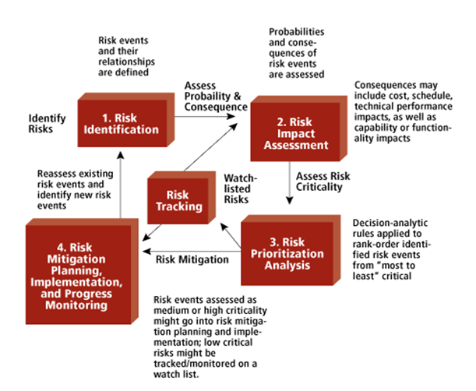

5.2.1 Risk Identification

Risk identification is the process of determining risks that could potentially prevent the program, enterprise, or investment from achieving its objectives. It includes documenting and communicating the concern.
The objective of risk identification is the early and continuous identification of events that, if they occur, will have negative impacts on the project's ability to achieve performance or capability outcome goals. They may come from within the project or from external sources. There are multiple types of risk assessments, including program risk assessments, risk assessments to support an investment decision, analysis of alternatives, and assessments of operational or cost uncertainty. Risk identification needs to match the type of assessment required to support risk-informed decision making. For an acquisition program, the first step is to identify the program goals and objectives, thus fostering a common understanding across the team of what are needed for program success. This gives context and bounds the scope by which risks are identified and assessed.

Risks Identified:
- Language Constraint
- Invalid Query

- Language Constraint:
- Languages: Supports English and US English.
- Invalid Query:
If user enters any unrelated query.

5.2.2 Risk Analysis

The risks for the Project can be analyzed within the constraints of time and quality

ID | Risk Description | Probability | Overall  Impact
1 | Language Constraint | Low | High
2 | Invalid Query | High | Low

Table 5.1: Risk Table

Probability | Value | Description
High | Probability of occurrence is | > 75%
Medium | Probability of occurrence is | 26 75%
Low | Probability of occurrence is | < 25%

Table 5.2: Risk Probability de nitions [?]

5.2.3 Overview of Risk Mitigation, Monitoring, Man-agement

Following are the details for each risk.
Impact | Value | Description
Very high | > 10% | Schedule impact or Unacceptable quality
High | 5 10% | Schedule impact or Some parts of the project have
 |  | low quality
Medium | < 5% | Schedule impact or Barely noticeable degradation
 |  | in quality Low Impact on schedule or Quality can
 |  | be incorporated

Table 5.3: Risk Impact definitions

Risk ID | 1
Risk Description | Language Constraint
Category | Requirement
Source | Software requirement Specification document.
Probability | Low
Impact | High
Response | Mitigate
Strategy | Running the service using specified languages
Risk Status | Identified

Risk ID | 2
Risk Description | Invalid Query
Category | Development Environment
Source | User Input
Probability | High
Impact | Low
Response | Mitigate
Strategy | Better testing will resolve this issue.
Risk Status | Identified

5.3 Project Schedule

5.3.1 Project task set

Major Tasks in the Project stages are:

Task 1: Gather the data
Task 2: Clean the data
Task 3: perform the sentiment analysis
Task 4: training data set
Task 5: testing
Task 6: Display result

5.3.2 Task network

Project tasks and their dependencies are noted in this diagrammatic form.

5.3.3 Timeline Chart

A project timeline chart is presented. This may include a time line for the entire project. Above points should be covered in Project Planner as Annex C and you can mention here Please refer Annex C for the planner

5.4 Team Organization

The manner in which sta is organized and the mechanisms for reporting are noted.

5.4.1 Team structure
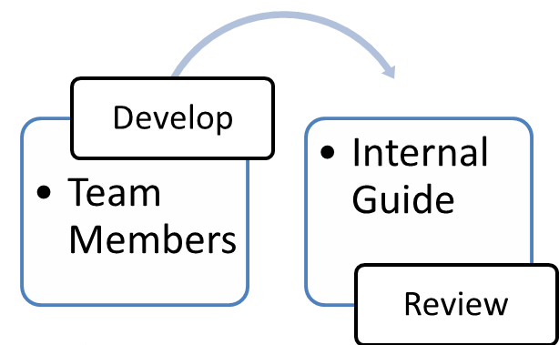

5.4.1 Team structure

- Internal Guide: Mr. Danny Jeron Pereira
Assistant Professor, Computer Department, GCOEARA
- Team Members:
- Shweta Upadhyay
- Chinmay Patil
- Shubham Badhe
- Nikhil Shinde

5.4.2 Management reporting and communication:

Regular Reporting and Presentation is given to Project Internal Guide Mr. D.J.Pereira.

Chapter 6
SOFTWARE REQUIREMENT
SPECIFICATION
6.1 INTRODUCTION
This section enlists some of the key software requirements. These requirements are classified into Functional/Technical categories Explicit / Implicit nature.

6.1.1 Purpose and Scope of Document
A software requirements specification (SRS) is a comprehensive description of the intended purpose and environment for software under development. The SRS fully describes what the software will do and how it will be expected to perform. This document will give the detailed information about the proposed system. It gives the detailed information about system requirements, hardware and software requirement, detailed designed of the proposed system .

6.1.2 Overview of responsibilities of Developer
Learn technologies required –
a)Python
i)NLTK
ii)Selenium
iii)Pandas
iv)Scikit
b)Web development
i)Wordpress
ii)MySQL

6.2 USAGE SCENARIO
It provides various usage scenarios for the system to be developed.

6.2.1 User profiles
A use case diagram can represent pictorially the different users of a system. Various ways that user interacts with the system. In our project customer & System are actors. System detect whether an application is fraud or not.
6.2.2 Use-cases
Use-cases are used for representing how system actually works. System accepts query from customer in voice format then Speech to Text use-case convert that speech into text format. NLC classify that text and passed it to text to Speech use-case which convert text into audio format.
Sr No. | Use Case | Description | Actors | Assumptions
1 | Registration | It register the user. | User | User enter a input
2 | Login | User can login on website | System | System responds quickly and correctly.
3. | Application Name | It enter an application name
4 | Detect if app is fraud | It detect the application is fraud or not
5 | Display result | It display the result
Table 6.1: Use Cases

6.2.3 Use Case View
Use Case Diagram. Example is given below

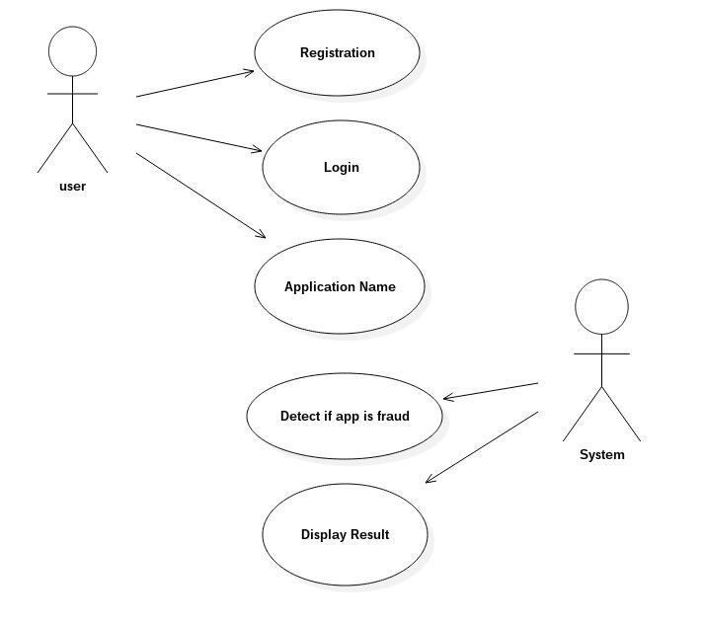
s

6.3 DATA MODEL AND DESCRIPTION

6.3.1 Data Description
We are using Playstore reviews as database. It is Unstructured database. With the help of Selenium and Pandas it change into CSV format.
6.3.2 Data objects and Relationships
Data objects and their major attributes and relationships among data objects are described using an ERD- like form.

6.4 FUNCTIONAL MODEL AND DESCRIPTION
6.4.1 Data Flow Diagram
This highlights the main functions carried out by the system.
- Level-0 describes input and output of system
- Level-1 describes actual functions of system and how it going to process input.

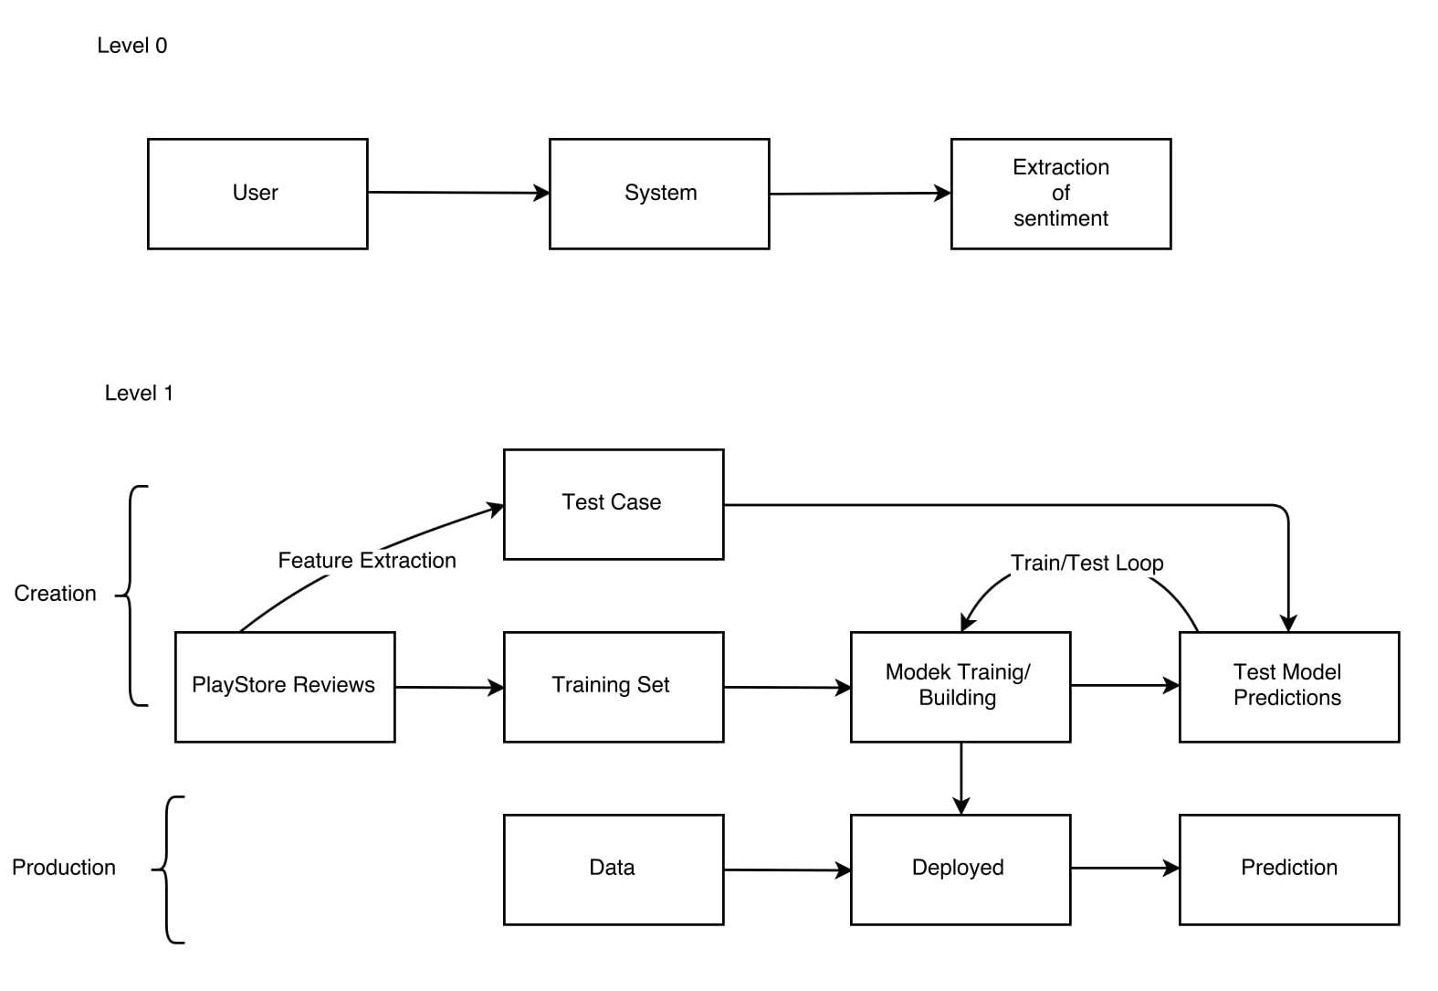

6.4.2 Description of functions
Activity diagrams are nothing but step by step description. Activity diagrams, which are related to program flow plans (flowcharts), are used to illustrate activities.

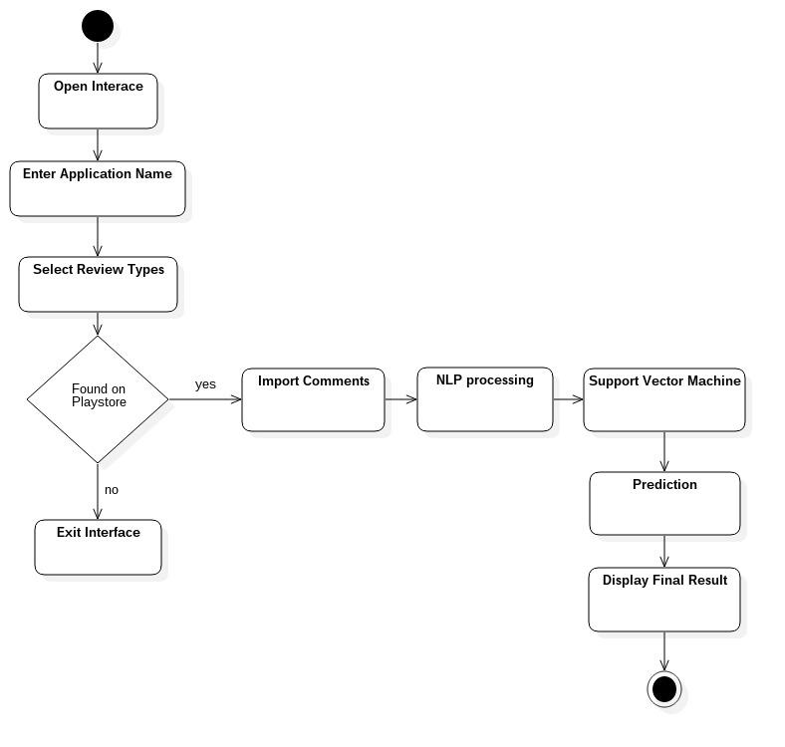

6.4.3 Activity Diagram:
The above activity diagram tell us how user ask for book that is to be recommended by system. The system check for user similarity or interest with active user or other user in database. Based on that it suggest the book to user. Also system ask the user to rate the books and based on the rating categorized the book.

6.4.4 Non Functional Requirements:
- External Interface Requirements
- User Interface
User interface should user friendly and should provide easy access to data. System should be easy to use
- Software Interfaces
Recommender system should compatible to all types of browser. This system is going to use for sales, Social media and other websites.

- Performance Requirements
Response of the system should be real time. Speed of the system should compatible with the other modules of website and search module. Confidentiality of the user personal data should be maintained. Product data and vendor data should be protected. System contains personal information of user, vendor this data should be protect. Passwords of the users and vendors should be stored in encrypted format. Sensitive information of the Product information should be confidential. System should be easy to use and efficient.

    - Software quality attributes :
- Reliability:
The system will be designed with reliability as key feature:
The system is guaranteed of providing the service to user according to his query.
- Availability: The interface is freely available to all users. Any unknown user can use this application. Thus it requires username and password.
- Portability: The interface is portable and can be deploy in any system.
- Security: Confidentiality of the user personal data should be maintained. Product data and vendor data should be protected.

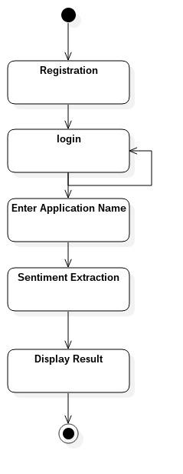
6.4.5 State Diagram:

Figure 6.3: State transition diagram

State Transition Diagram:
State transition diagrams have been used right from the beginning in object-oriented modeling. The basic idea is to define a machine that has a number of states (hence the term finite state machine). The machine receives events from the outside world, and each event can cause the machine to transition from one state to another.

6.4.6 Design Constraints
- Trust is a complex concept used in the system.
- It is very difficult to find the trust between two users.
- Very slow internet connection can affect the fraud application detection system.

6.4.7 Software Interface Description

System module 1 (User Registration and Login)
User registration should include email and mobile number verification.
User registration should include user list for adding in the trust list.
All the required information should be stored in appropriate database.
Registration should create one profile of user on the website.
When user log in using his/her email id and password, user should provide access to the products and users available in the system.
Adding user to own trust list should be provided at the time of registration and after log in also.
User can give ratings to trust users.

System Feature 2 (Admin Login)
Admin registration should take all necessary information and should provide some privileges to control users and product
Admin should give permission to particular vendor to add products on the site.
Admin can add products in the system.
Admin can remove or block the user which is reported by many users as a fake user.

System Feature 2 (Display Result)
Detection of fraud application should based on the past review of the application, contents of the selected application and trust users of the intended user. Detection of fraud application should depend on all the factors. It should be more accurate than other system.

CHAPTER 7

DETAILED DESIGN DOCUMENT USING ANNEXURE A AND B

7.1 Introduction

This document species the design that is used to solve the problem of Prod-uct.

7.2 Architectural Design

A description of the program architecture is presented. Subsystem design or Block diagram, Package Diagram, Deployment diagram with description is to be presented.

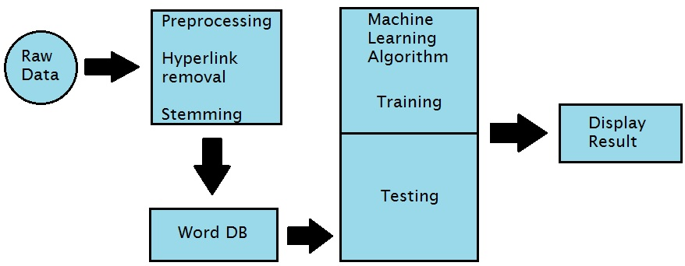

Figure 7.1: Architecture diagram

7.3 Data design (using Annexures A and B)

A description of all data structures including internal, global, and temporary data structures, database design (tables), le formats.

7.3.1 Internal software data structure

Data structures that are passed among components the software are de-scribed.

7.3.2 Global data structure

Data structured that are available to major portions of the architecture are described.

7.3.3 Temporary data structure

Files created for interim use are described.

7.3.4 Database description

Database(s) / Files created/used as part of the application is(are) described.

7.4 Compoent Design

Class diagrams, Interaction Diagrams, Algorithms. Description of each com-ponent description required.

7.4.1 Class Diagram

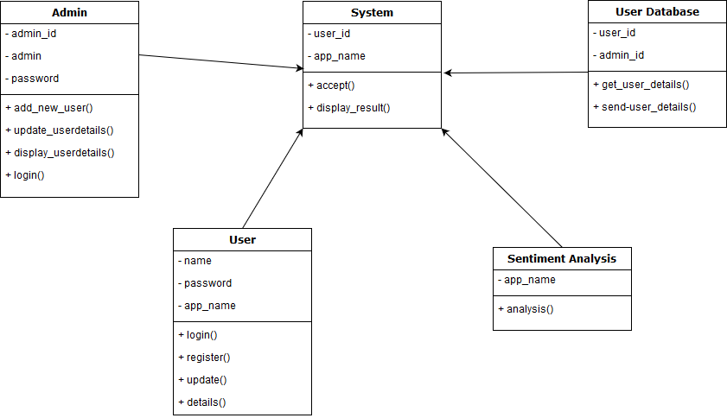

Figure 7.2: Class Diagram

REFERENCE
1. Abbasi, Ahmed, Hsinchun Chen, and Arab Salem.
Sentiment analysis in
multiple languages: Feature selection for opinion classification in web
forums.
ACM Transactions on Information Systems (TOIS), 2008.
26
(3).
2. Abdul-Mageed, Muhammad, Mona T. Diab, and Mohammed Korayem.
Subjectivity and sentiment analysis of modern standard Arabic
. in
Proceedings of the 49th Annual Meeting of the Association for
Computational Linguistics:shortpapers
. 2011.
3. Akkaya, Cem, Janyce Wiebe, and Rada Mihalcea.
Subjectivity word sense
disambiguation
. in
Proceedings of the 2009 Conference on Empirical
Methods in Natural Language Processing (EMNLP-2009)
. 2009.
4. Alm, Ebba Cecilia Ovesdotter.
Affect in text and speech,
2008: ProQuest.
5. Andreevskaia, Alina and Sabine Bergler.
Mining WordNet for fuzzy
sentiment: Sentiment tag extra
ction from WordNet glosses
. in
Proceedings
of Conference of the European Chapter of the Association for
Computational Linguistics (EACL-06)
. 2006.
6. Andreevskaia, Alina and Sabine Bergler.
When specialists and generalists
work together: Overcoming domain dependence in sentiment tagging
. in
Proceedings of the Annual Meeting of the Association for Computational
Linguistics (ACL-2008)
. 2008.
7. Andrzejewski, David and Xiaojin Zhu.
Latent Dirichlet Allocation with
topic-in-set knowledge
. in
Proceedings of NAACL HLT
. 2009.
8. Andrzejewski, David, Xiaojin Zhu, and Mark Craven.
Incorporating
domain knowledge into topic modeling via Dirichlet forest priors
. in
Proceedings of ICML
. 2009.
9. Archak, Nikolay, Anindya Ghose, and Panagiotis G. Ipeirotis.
Show me the
money!: deriving the pricing power of product features by mining
consumer reviews
. in
Proceedings of the ACM SIGKDD Conference on
Knowledge Discovery and
Data Mining (KDD-2007)
. 2007.
10. Asher, Nicholas, Farah Benamara, and Yvette Yannick Mathieu.
Distilling
opinion in discourse: A preliminary study
. in
Proceedings of the
International Conference on Comput
ational Linguistics (COLING-2008):
Companion volume: Posters and Demonstrations
. 2008.
11. Asur, Sitaram and Bernardo A. Huberman.
Predicting the future with
social media.
Arxiv preprint arXiv:1003.5699, 2010.
12. Aue, Anthony and Michael Gamon.
Customizing sentiment classifiers to
new domains: a case study
. in
Proceedings of Recent Advances in Natural
Language Processing (RANLP-2005)
. 2005.
13. Banea, Carmen, Rada Mihalcea, and Janyce Wiebe.
Multilingual
subjectivity: are more languages better?
in
Proceedings of the
International Conference on Computational Linguistics (COLING-2010)
.
2010.
14. Banea, Carmen, Rada Mihalcea, Janyce Wiebe, and Samer Hassan.
Multilingual subjectivity analysis using machine translation
. in
Proceedings of the Conference on Empirical Methods in Natural Language
Processing (EMNLP-2008)
. 2008.
15. Bar-Haim, Roy, Elad Dinur, Ronen Feldman, Moshe Fresko, and Guy
Goldstein.
Identifying and Following Expert Investors in Stock Microblogs
.
in
Proceedings of the Conference on Empirical Methods in Natural
Language Processing (EMNLP-2011)
. 2011

ANNEXURE A

LABORATORY ASSIGNMENTS ON PROJECT ANALYSIS OF ALGORITHMIC DESIGN

To develop the problem under consideration and justify feasibilty using concepts of knowledge canvas and IDEA Matrix.

IDEA Matrix is represented in the following form. Feasibility is represented w.r.t. business perspective.

I | D | E | A
Increase  Increase the speed for detecting whether an app is real or Fraud. |  | Educate  Educate of system by using Machine Learning for detecting Fraud App. | Accelerate  The fraud app are detected faster.
Improve  Improves the percentage of getting the real app. | Deliver  The fraud Application. | Eliminate  Eliminate the time required for the finding the app is real or fraud. | Associate  The record to the user who want to know whether an app is real or fraud.
Ignore  Reading of reviews and comments. | Decrease  The time required to find out whether an app is fraud or real. | Evaluate  Time required is less. | Avoid  Avoid Fraud App.

Table A.1: IDEA Matrix

ANNEXURE B

LABORATORY ASSIGNMENTS ON PROJECT QUALITY AND RELIABILITY TESTING OF PROJECT DESIGN

It should include assignments such as

Use of divide and conquer strategies to exploit distributed/parallel/concurrent processing of the above to identify object, morphisms, overloading in functions (if any), and functional relations and any other dependencies

(as per requirements). It can include Venn diagram, state diagram, function relations, i/o relations; use this to derive objects, morphism, overloading

Use of above to draw functional dependency graphs and relevant Soft-ware modeling methods, techniques including UML diagrams or other necessities using appropriate tools.

Testing of project problem statement using generated test data (using mathematical models, GUI, Function testing principles, if any) selec-tion and appropriate use of testing tools, testing of UML diagram's reliability. Write also test cases [Black box testing] for each identi ed functions. You can use Mathematica or equivalent open source tool for generating test data.

Additional assignments by the guide. If project type as Entreprenaur, Refer [?],[?],[?], [?]

ANNEXURE C

PROJECT PLANNER

Using planner or alike project management tool.

ANNEXURE D

REVIEWERS COMMENTS OF

PAPER SUBMITTED

(At-least one technical paper must be submitted in Term-I on the project de-sign in the conferences/workshops in IITs, Central Universities or UoP Con-ferences or equivalent International Conferences Sponsored by IEEE/ACM)

- Paper Title:

- Name of the Conference/Journal where paper submitted :

- Paper accepted/rejected :

- Review comments by reviewer :

- Corrective actions if any :
ANNEXURE E

PLAGIARISM REPORT

