Lab 3.1: Install and Configure Jenkins

This section will guide you to:

Install and run Jenkins

This lab has 4 subsections:

* + 1. Add a key to use Debian repository.
    2. Make changes to /etc/opt/sources.list.
    3. Update local package index.
    4. Run Jenkins in browser.

Go to <https://pkg.jenkins.io/debian-stable/> to understand how to install Jenkins on a Ubuntu/Debian machine.

**Step 3.2.1 :** To use the Debian repository of Jenkins to automate installation and upgrade, first add the key to your system using the following command:

wget -q -O – <https://pkg.jenkins.io/debian-stable/jenkins.io.key> | sudo apt-key add –

**Step 3.2.2 :** Then, add the following entry in your **/etc/apt/sources.list**:

sudo vi /etc/apt/sources.list

Now add the following command:

deb <https://pkg.jenkins.io/debian-stable binary/>

Save and exit using :wq!

**Step 3.2.3 :** Update your local package index.

sudo apt-get update

Make sure you have jdk installed. If not, install it using the following command:

sudo apt-get install openjdk-8-jdk

**Please Note:** If you get dpkg frontend lock error, please follow the below set of commands to free the process and install JDK again.

**lsof /var/lib/dpkg/lock-frontend****sudo kill -9**

**sudo rm /var/lib/dpkg/lock-frontend**

**sudo dpkg --configure -a**

Then install Jenkins.

sudo apt-get install jenkins

**Step 3.2.4 :**Once Jenkins is installed, open a browser in the lab and enter the URL given below:

URL: localhost:8080

You will need to enter the admin password.

To find the password, type the following command:

sudo cat /var/lib/jenkins/secrets/initialAdminPassword

Use the string of numbers as password. Once you are logged in, you will be redirected to the page below:

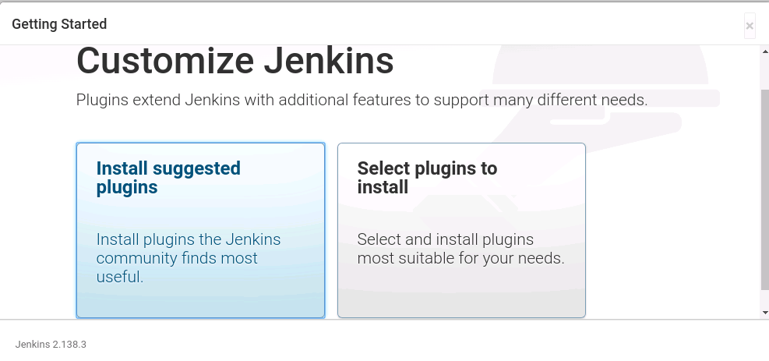

Select **Install suggested plugins**.You will be redirected to the page below:

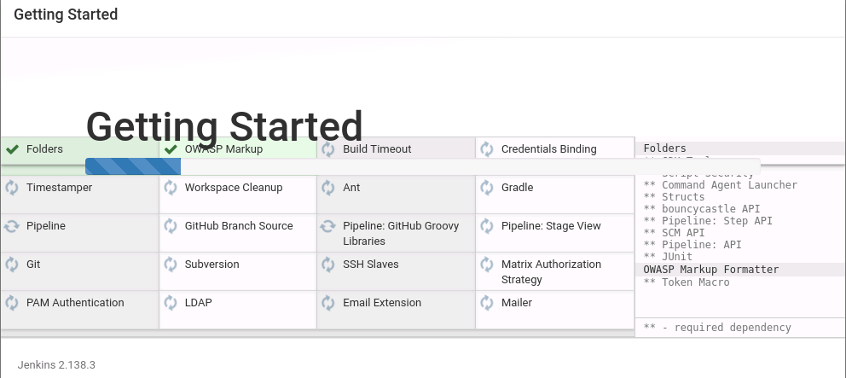

After installing recommended plugins, you can create “First Admin User” or continue as Admin by filling the required details as shown in the screenshot.

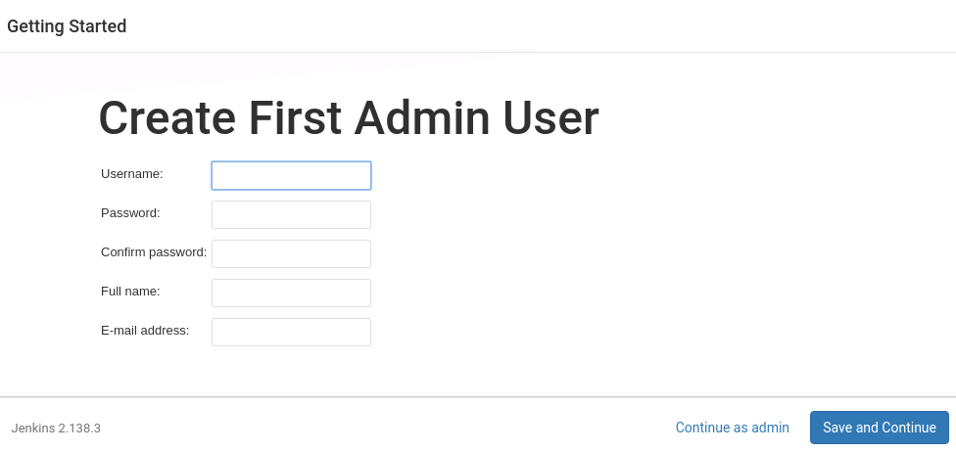

Once that is done, start using Jenkins.