**Introduction** The goal of my FURI undergraduate research project was to determine if programming gestures into a humanoid robot could improve people’s perceptions of the robot’s humanlike and social qualities. To accomplish this goal, I identified two sets of gestures, ‘animated’ and ‘realistic’ and explored how individuals perceive a robot performing these gestures differently. Both the ‘realistic’ and ‘animated’ gestures are emblematic which means they have been documented in nonverbal communication between humans and are commonly understood. The ‘realistic’ gestures mirror human movement and the ‘animated’ gestures are exaggerated and cartoonish. I compared realistic and animated gestures to a control with no gestures by incorporating generic dialog that stays consistent for all conditions.

**Approach** Designing NAO gestures is challenging given the available technologies. The NAO can be programmed via Python, but the . I designed a Python applet to make it easier to create and test the gestures that I used in the study. I started by designing the realistic gestures, then I designed the cartoon gestures by exaggerating the individual movements that comprise the realistic ones. There are 12 gestures of each type, for a total of 24 gestures. I paired each gesture with a generic piece of dialog that stays consistent for both sets of gestures.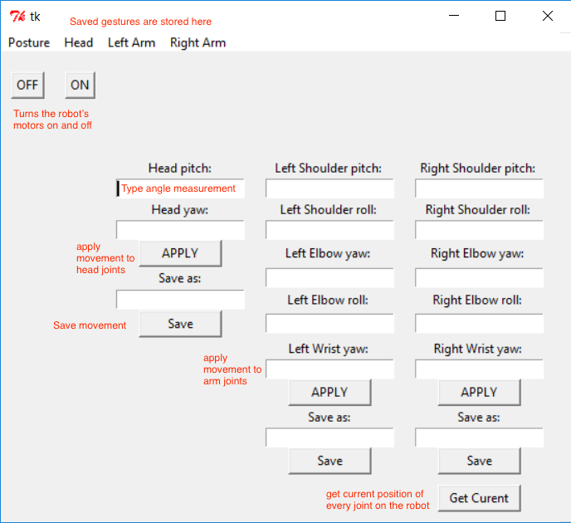

**Study** There are three sets of videos being tested (Realistic gestures, Cartoonish gestures, No gestures) and three videos per set. These three sets became my three conditions in the study. Every video was tested twice, once with a female name assigned to the robot and once with a male name assigned to the robot. I chose to run my study using the Amazon Mechanical Turk platform. The AMT platform gave me access to a diverse pool of participants. The only constraint I added was to exclusively accept participants from the United States. I did so because the gestures I chose were only proven to be emblematic in North America, and showing the gestures to participants who may not understand them may have impacted the results. In total, 367 people completed my Human Intelligence Tasks (HITs).

**Hypotheses**

H1: Participants who reported feeling comfortable interacting with humanoid robots will like the robot more than those who didn’t.

H2: Participants who reported finding humanoid robots creepy will like the robot less than those who didn’t.

H3: There will be no significant difference between male and female participants’ perceptions of the robot.

H4: Participants who saw the cartoonish gestures will find the robot friendlier than participants who saw the realistic gestures or null case.

H5: Participants who saw the null case will find the robot more elegant than participants who saw the realistic gestures or cartoonish gestures.

H6: Participants who saw the realistic gestures will find the robot more humanlike than participants who saw the null case or cartoonish gestures.

**Results** The results of my study showed that people’s perceptions of a humanoid robot can be improved by adding gestures. The two conditions that saw significant change with the presence of gestures were “Friendly” and “Like”. The type of gesture made no difference, and both the Realistic and Cartoonish gestures were significantly better received than the Null condition. The average Friendliness rating given to the robot in the Null condition was 4.109 out of a possible 5. The average Friendliness rating given to the robot in the Realistic condition was 4.422, and the Cartoonish condition was not far behind with 4.400.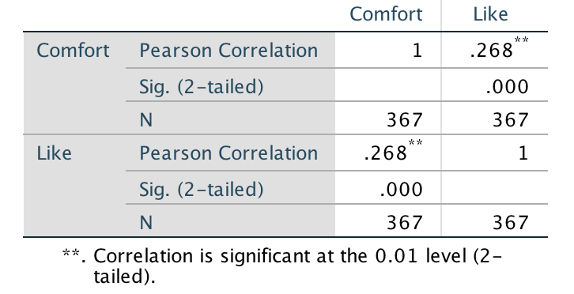

**Discussion** Male participants were more likely to agree with the statement “I feel comfortable interacting with humanlike robots.” Female participants were more likely to agree with the statement “Humanlike robots are kind of creepy.” Overall, participants who reported feeling more comfortable interacting with humanoid robots rated the robot’s likability higher. At first, I thought this meant that male participants preferred the NAO robot, but the mean scores for likability and friendliness were almost identical for males and females when I accounted for those initial questions. Both men and women who rated their opinion of humanoid robots positively tended to rate the NAO positively.

Unfortunately, the presence of gestures did not cause participants to feel that the robot is more human, elegant, or lifelike. There were no significant differences between the control condition and the Realistic or Cartoonish conditions for those three categories. The mean scores for those categories is also surprisingly low considering how highly participants rated the robot’s friendliness and likability. The mean score for “Human” across all conditions was 2.185 out of a possible 5. “Lifelike” and “Elegant” were even worse at 2.171 and 2.681, respectively. In the future, I hope to determine if the other metrics can be improved through some other means like changing the dialog to something more personable.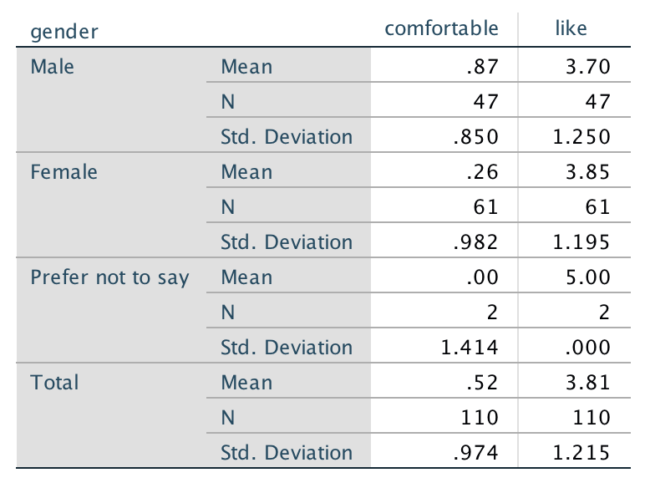

**Conclusions** The NAO robot is an impressive and versatile tool, and it is used frequently in research. But the built-in autonomous life function on the robot is not enough to make the robot appear likable to most participants. My findings can help others who are designing unrelated NAO robot experiments to make their robots appear friendlier and more likable. It would be interesting to see if a more likable robot is a better teacher or learning companion. My study featured participants who were all over the age of 18, and in the future I’d like to find out if these results are generalizable to children.