Ecommerce_Sales_Analysis
Database Design & SQL Query Project
Prepared by Basheerunnisa

Theme
An online store wants to maintain customer details, product catalogue, orders and the items sold in each order, so that sales can be analysed by product, customer, city and order status.

Modules
- Customers – customer name and city
- Products – product name, category and price
- Orders – order date and delivery status for each customer
- Order Items – products, quantity and unit price in each order

ER Diagram
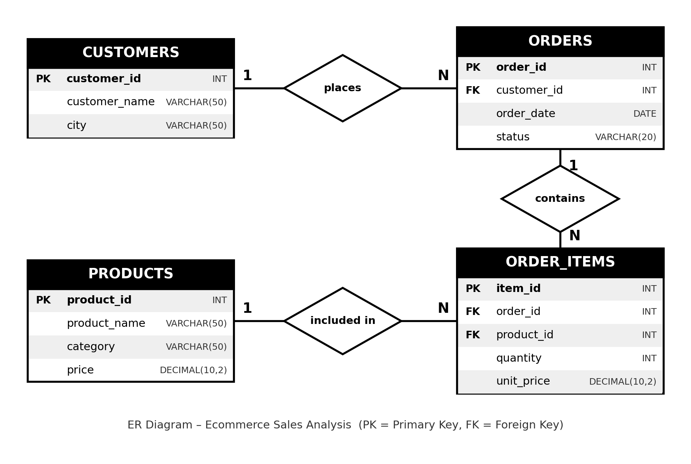

Relationships
- Customers → Orders: One customer can place many orders (1 : N).
- Orders → Order Items: One order can contain many order items (1 : N).
- Products → Order Items: One product can appear in many order items (1 : N).
Order Items is the bridge table that makes Orders and Products a many-to-many relationship.

Table Structure

CUSTOMERS
Column | Data Type | Key
customer_id | INT | Primary Key
customer_name | VARCHAR(50)
city | VARCHAR(50)

PRODUCTS
Column | Data Type | Key
product_id | INT | Primary Key
product_name | VARCHAR(50)
category | VARCHAR(50)
price | DECIMAL(10,2)

ORDERS
Column | Data Type | Key
order_id | INT | Primary Key
customer_id | INT | Foreign Key → customers
order_date | DATE
status | VARCHAR(20)

ORDER_ITEMS
Column | Data Type | Key
item_id | INT | Primary Key
order_id | INT | Foreign Key → orders
product_id | INT | Foreign Key → products
quantity | INT
unit_price | DECIMAL(10,2)

Sample Data

CUSTOMERS
customer_id | customer_name | city
1 | Rahul | Hyderabad
2 | Priya | Vijayawada
3 | Asha | Guntur
4 | Kiran | Hyderabad
5 | Ravi | Guntur

PRODUCTS
product_id | product_name | category | price
101 | Laptop | Electronics | 50000
102 | Mobile | Electronics | 20000
103 | Headphones | Accessories | 2000
104 | Keyboard | Accessories | 1500
105 | Mouse | Accessories | 800

ORDERS
order_id | customer_id | order_date | status
1001 | 1 | 2026-01-10 | Delivered
1002 | 2 | 2026-01-12 | Delivered
1003 | 3 | 2026-02-05 | Pending
1004 | 1 | 2026-02-15 | Delivered
1005 | 4 | 2026-03-01 | Cancelled

ORDER ITEMS
item_id | order_id | product_id | quantity | unit_price
1 | 1001 | 101 | 1 | 50000
2 | 1001 | 103 | 2 | 2000
3 | 1002 | 102 | 1 | 20000
4 | 1003 | 104 | 2 | 1500
5 | 1004 | 103 | 1 | 2000
6 | 1004 | 105 | 2 | 800
7 | 1005 | 102 | 1 | 20000

Queries
1. Display All Customers
SELECT * FROM customers;
Output
customer_id | customer_name | city
1 | Rahul | Hyderabad
2 | Priya | Vijayawada
3 | Asha | Guntur
4 | Kiran | Hyderabad
5 | Ravi | Guntur
2. Display All Products
SELECT * FROM products;
Output
product_id | product_name | category | price
101 | Laptop | Electronics | 50000
102 | Mobile | Electronics | 20000
103 | Headphones | Accessories | 2000
104 | Keyboard | Accessories | 1500
105 | Mouse | Accessories | 800
3. Find Total Number of Orders
SELECT COUNT(*) AS total_orders
FROM orders;
Output
total_orders
5
4. Calculate Total Sales
SELECT SUM(quantity * unit_price) AS total_sales
FROM order_items;
Output
total_sales
100600
5. Find Total Sales from Delivered Orders
SELECT SUM(oi.quantity * oi.unit_price) AS delivered_sales
FROM order_items oi
JOIN orders o ON oi.order_id = o.order_id
WHERE o.status = 'Delivered';
Output
delivered_sales
77600
6. Find the Most Expensive Product
SELECT *
FROM products
ORDER BY price DESC
LIMIT 1;
Output
product_id | product_name | category | price
101 | Laptop | Electronics | 50000
7. Find Customer Order Details
SELECT c.customer_name,
o.order_id,
o.order_date,
o.status
FROM customers c
JOIN orders o ON c.customer_id = o.customer_id;
Output
customer_name | order_id | order_date | status
Rahul | 1001 | 2026-01-10 | Delivered
Priya | 1002 | 2026-01-12 | Delivered
Asha | 1003 | 2026-02-05 | Pending
Rahul | 1004 | 2026-02-15 | Delivered
Kiran | 1005 | 2026-03-01 | Cancelled
8. Find Number of Orders by Status
SELECT status,
COUNT(*) AS total_orders
FROM orders
GROUP BY status;
Output
status | total_orders
Cancelled | 1
Delivered | 3
Pending | 1
9. Find Customers from Hyderabad
SELECT *
FROM customers
WHERE city = 'Hyderabad';
Output
customer_id | customer_name | city
1 | Rahul | Hyderabad
4 | Kiran | Hyderabad
10. Find Products Costing More Than 5000
SELECT *
FROM products
WHERE price > 5000;
Output
product_id | product_name | category | price
101 | Laptop | Electronics | 50000
102 | Mobile | Electronics | 20000
11. Find the Cheapest Product
SELECT *
FROM products
ORDER BY price ASC
LIMIT 1;
Output
product_id | product_name | category | price
105 | Mouse | Accessories | 800
12. Find Delivered Orders
SELECT *
FROM orders
WHERE status = 'Delivered';
Output
order_id | customer_id | order_date | status
1001 | 1 | 2026-01-10 | Delivered
1002 | 2 | 2026-01-12 | Delivered
1004 | 1 | 2026-02-15 | Delivered
13. Find Products Priced Between 1000 and 25000
SELECT *
FROM products
WHERE price BETWEEN 1000 AND 25000;
Output
product_id | product_name | category | price
102 | Mobile | Electronics | 20000
103 | Headphones | Accessories | 2000
104 | Keyboard | Accessories | 1500
14. Find Customers Who Have Not Placed Orders
SELECT c.customer_id,
c.customer_name
FROM customers c
LEFT JOIN orders o ON c.customer_id = o.customer_id
WHERE o.order_id IS NULL;
Output
customer_id | customer_name
5 | Ravi
15. Calculate Total Quantity Sold
SELECT SUM(quantity) AS total_quantity_sold
FROM order_items;
Output
total_quantity_sold
10
16. Display All Customers and Their Orders (Including Customers Without Orders)
SELECT c.customer_name,
o.order_id,
o.status
FROM customers c
LEFT JOIN orders o ON c.customer_id = o.customer_id;
Output
customer_name | order_id | status
Rahul | 1001 | Delivered
Rahul | 1004 | Delivered
Priya | 1002 | Delivered
Asha | 1003 | Pending
Kiran | 1005 | Cancelled
Ravi | NULL | NULL
17. Find the Number of Products in Each Order
SELECT order_id,
COUNT(DISTINCT product_id) AS total_products
FROM order_items
GROUP BY order_id;
Output
order_id | total_products
1001 | 2
1002 | 1
1003 | 1
1004 | 2
1005 | 1
18. Count Customers in Each City
SELECT city,
COUNT(*) AS total_customers
FROM customers
GROUP BY city;
Output
city | total_customers
Guntur | 2
Hyderabad | 2
Vijayawada | 1
19. Find the Average Price of Products
SELECT AVG(price) AS average_price
FROM products;
Output
average_price
14860
20. Display Complete Order Details
SELECT o.order_id,
c.customer_name,
p.product_name,
oi.quantity,
oi.unit_price,
oi.quantity * oi.unit_price AS total_amount,
o.status
FROM orders o
JOIN customers c ON o.customer_id = c.customer_id
JOIN order_items oi ON o.order_id = oi.order_id
JOIN products p ON oi.product_id = p.product_id;
Output
order_id | customer_name | product_name | quantity | unit_price | total_amount | status
1001 | Rahul | Laptop | 1 | 50000 | 50000 | Delivered
1001 | Rahul | Headphones | 2 | 2000 | 4000 | Delivered
1002 | Priya | Mobile | 1 | 20000 | 20000 | Delivered
1003 | Asha | Keyboard | 2 | 1500 | 3000 | Pending
1004 | Rahul | Headphones | 1 | 2000 | 2000 | Delivered
1004 | Rahul | Mouse | 2 | 800 | 1600 | Delivered
1005 | Kiran | Mobile | 1 | 20000 | 20000 | Cancelled
Prepared by Basheerunnisa

