GitHub Hands-on Practice
Day 1
======
Git Conflict:
A Git conflict occurs when multiple developers modify the same line of a file, and Git cannot automatically merge the changes. The conflict must be resolved manually.

Example Situation
You create a branch and edit a file.
Someone else edits the same line in the main branch.
When you try to merge the branches, Git shows a merge conflict.
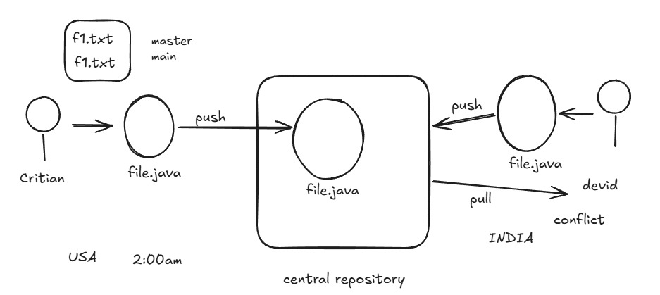

,c

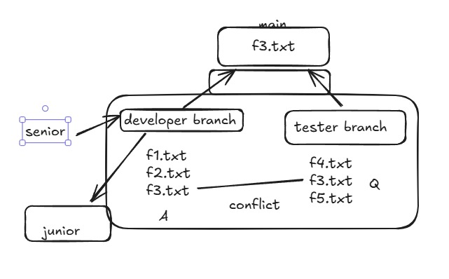

Step 1 — Developer-1 Creates Repository

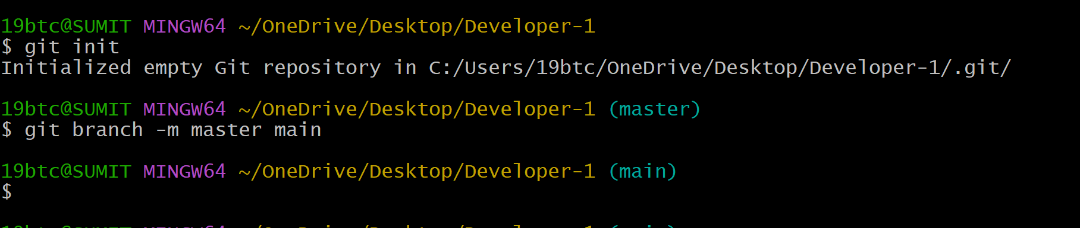

Create a file & Add content:

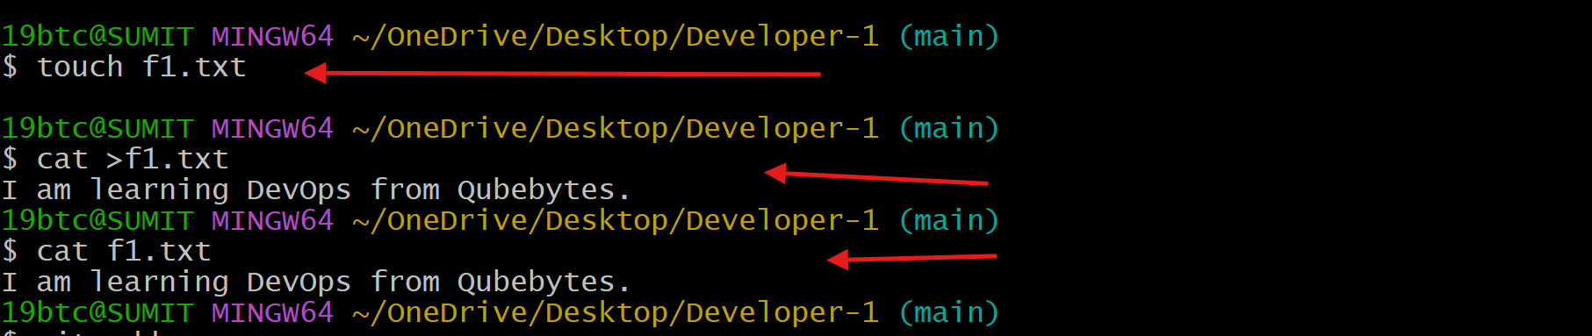

Commit and push

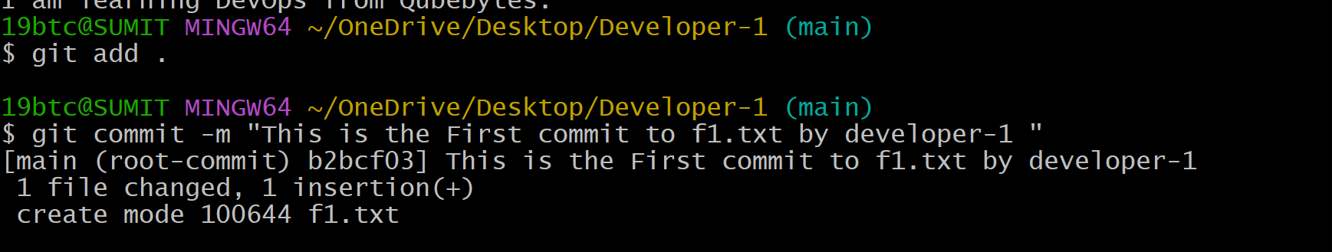

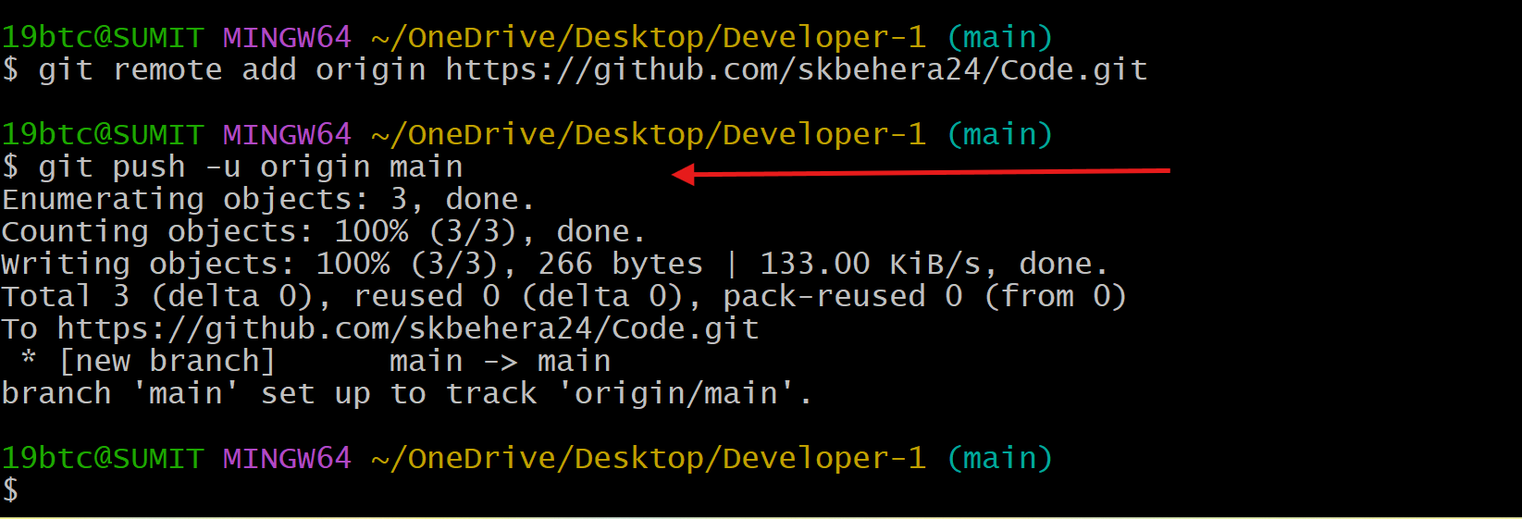

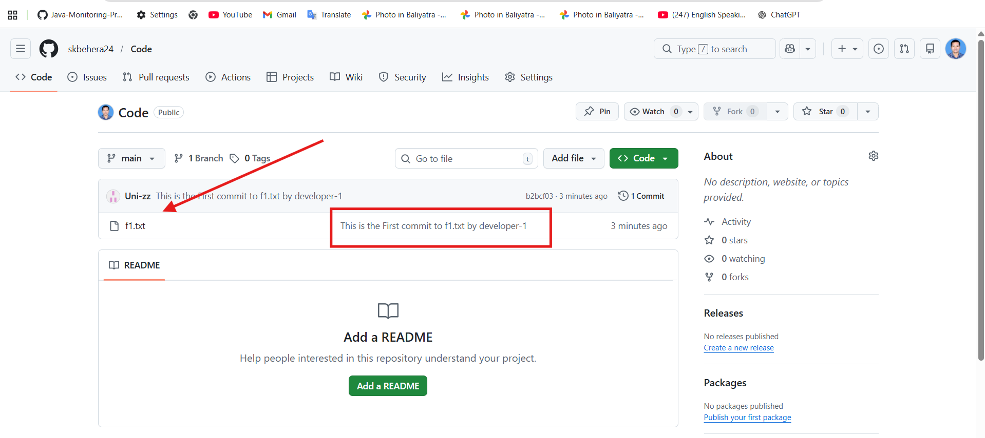

Step 2 — Developer-2 Clones the Repository

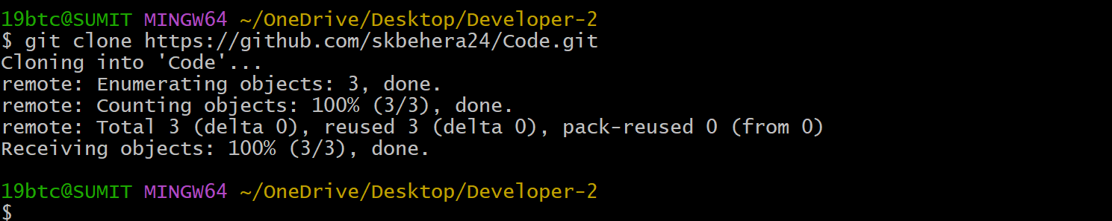

Open f1.txt and modify the line:

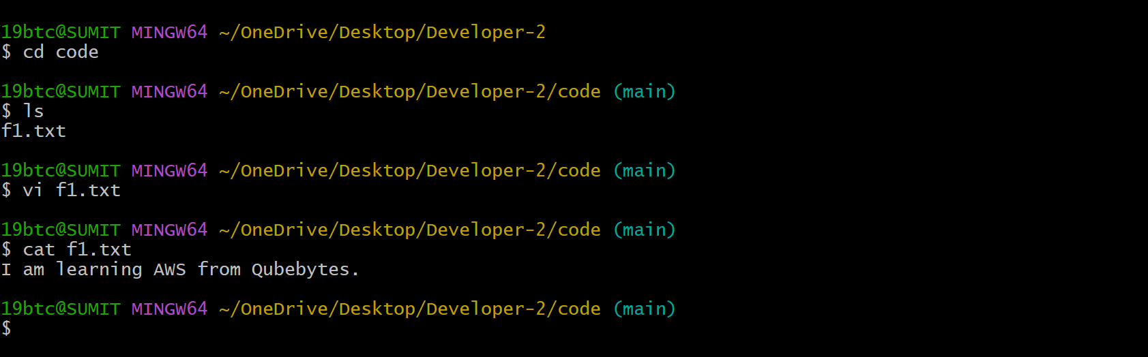

Commit and push

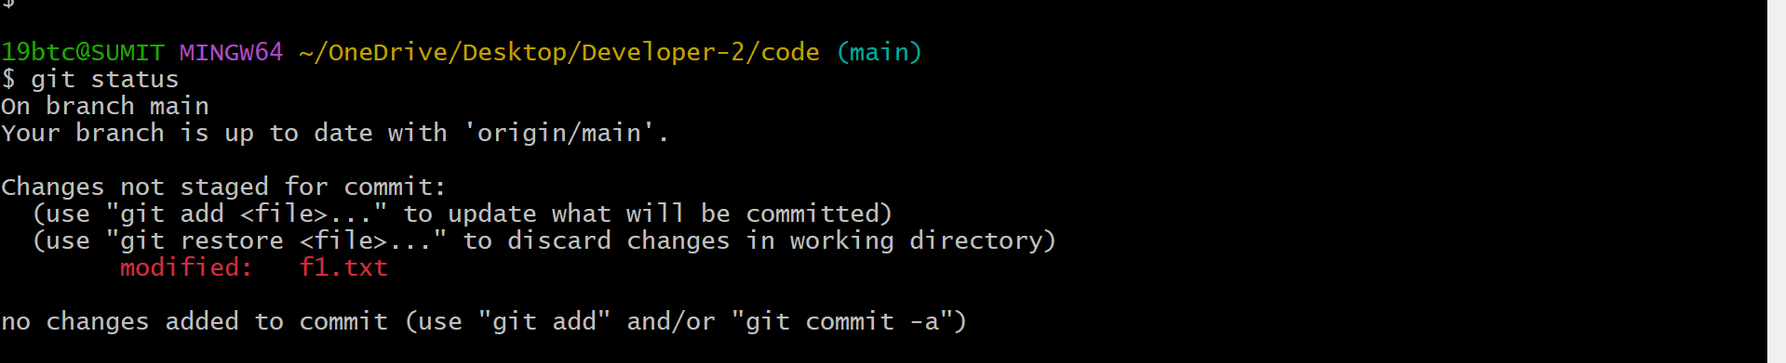

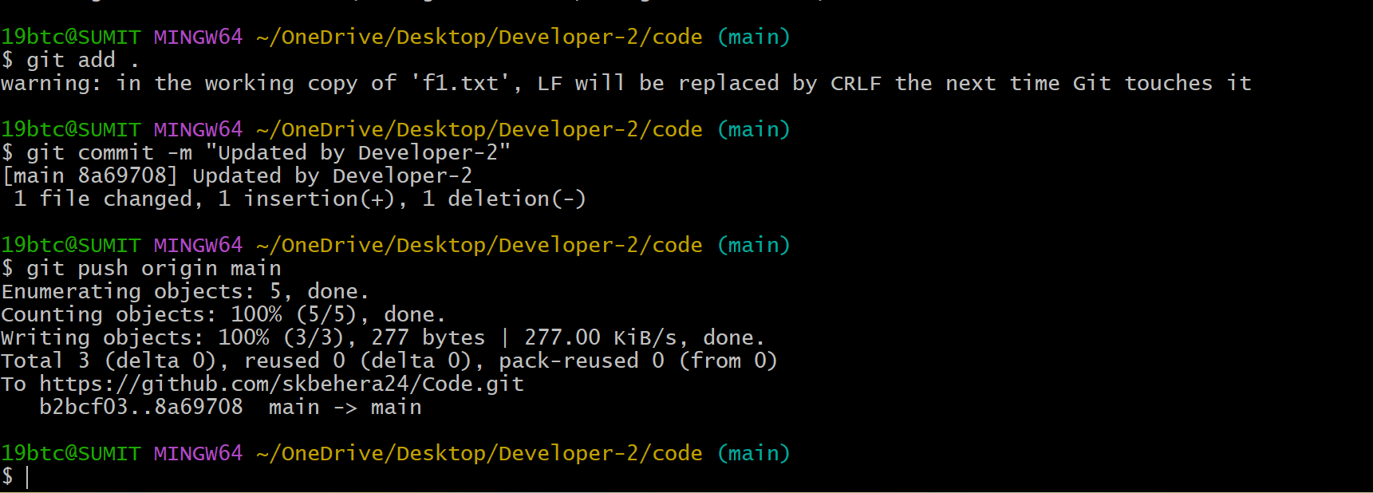
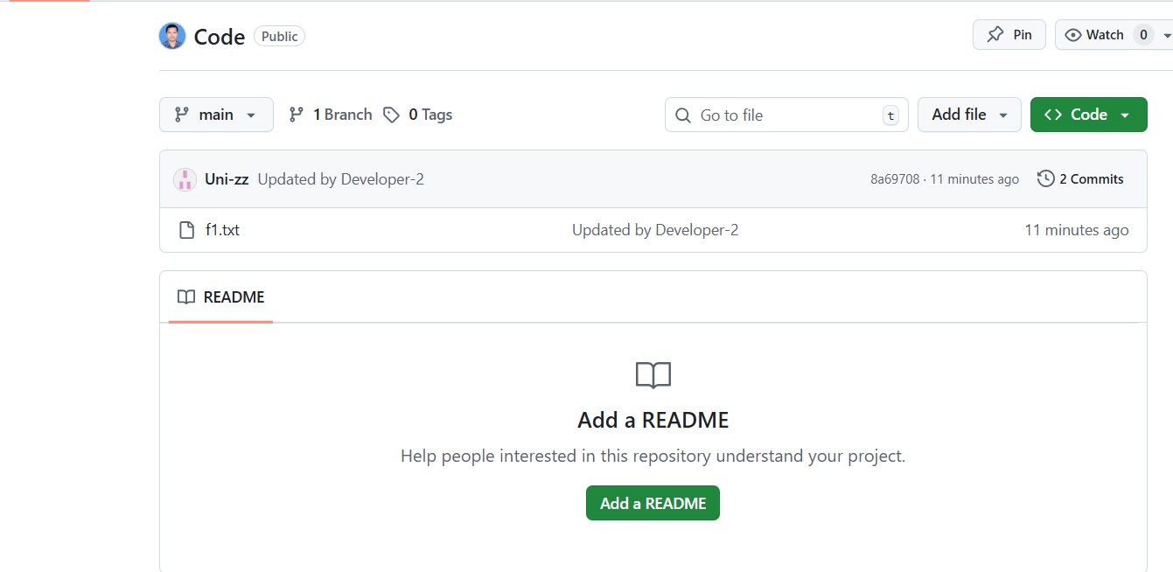

Step 3 — Developer-1 Makes Another Change

Developer-1 still has the old file and edits it:

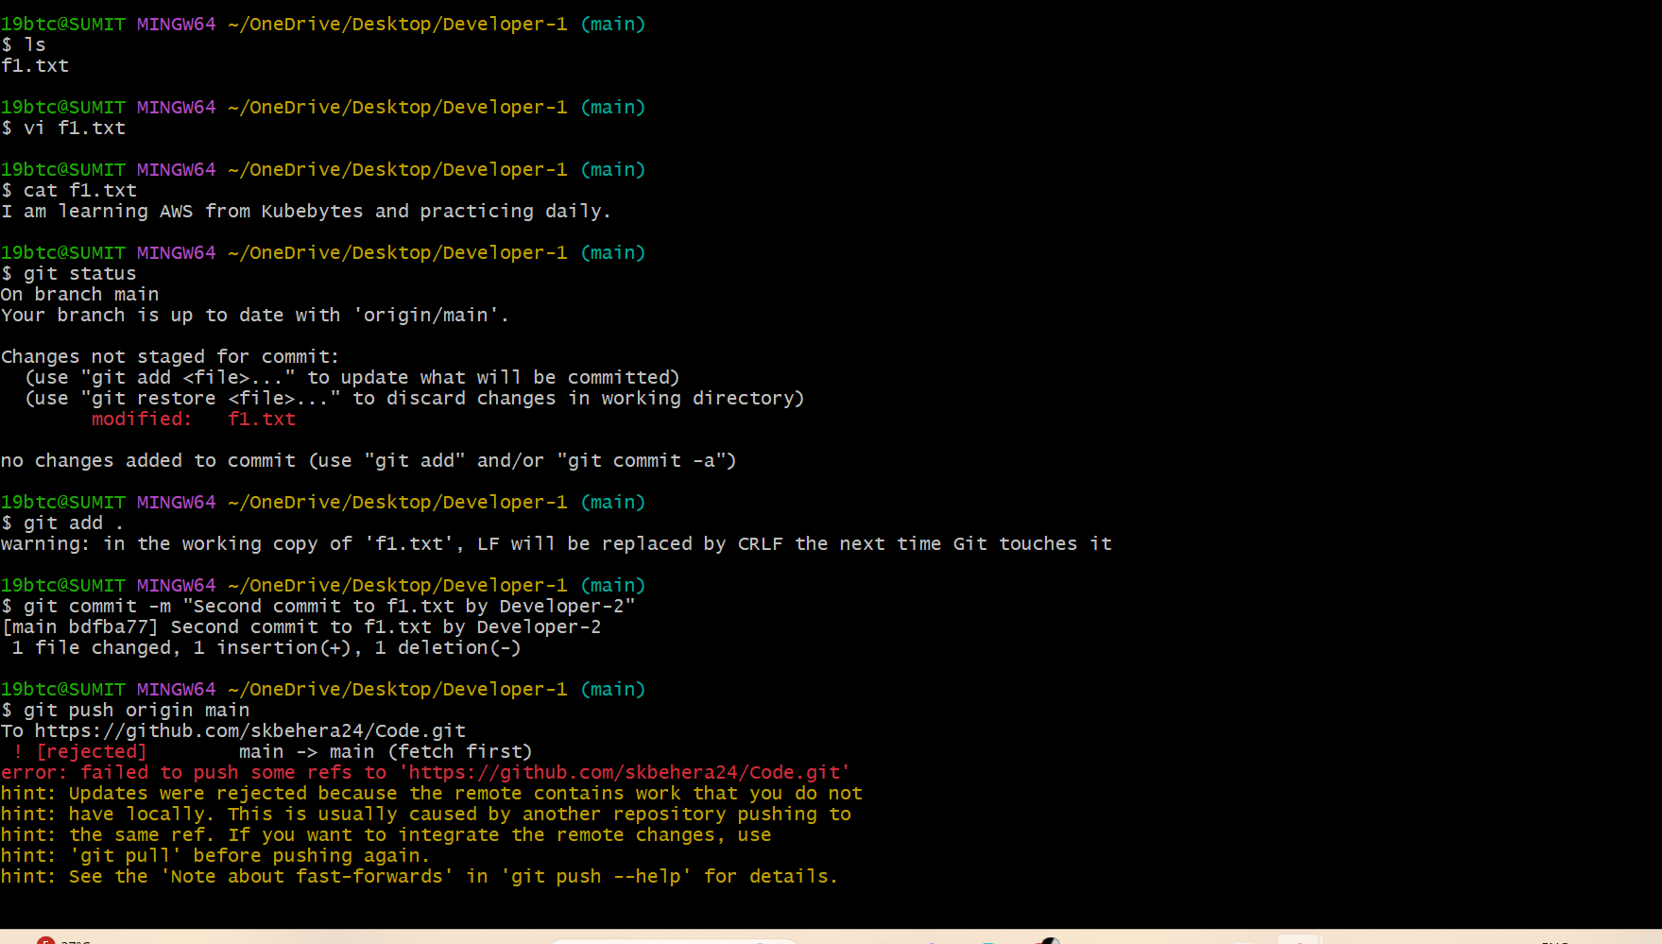

Step 4 — Pull Changes (Conflict Happens)

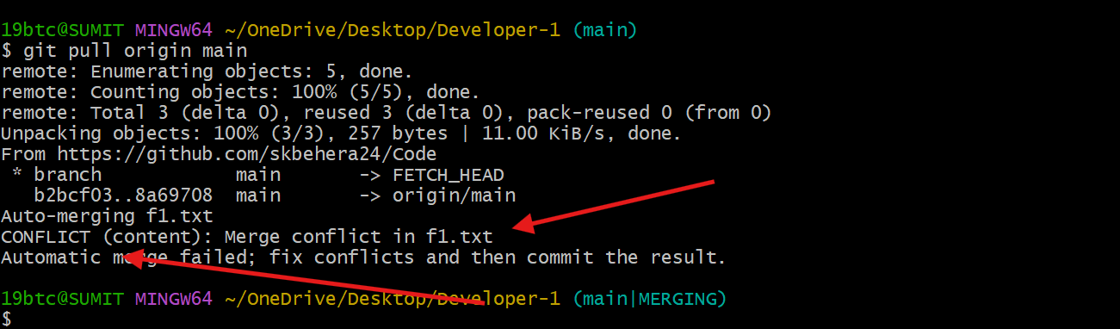

Now Git shows merge conflict.

Step 5 — Resolve Conflict

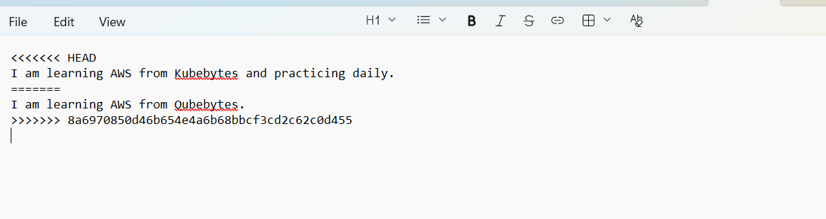

Remove the conflict markers:
<<<<<<<
=======
>>>>>>>

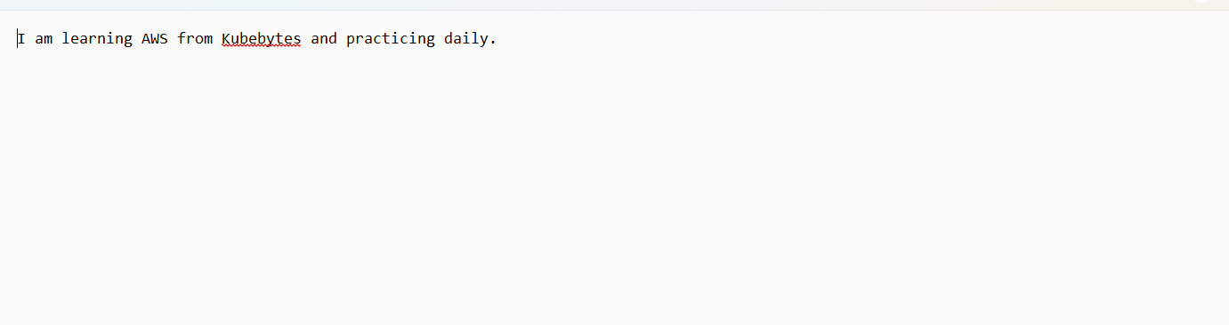

Step 6 — Commit the Fix & Push the Code
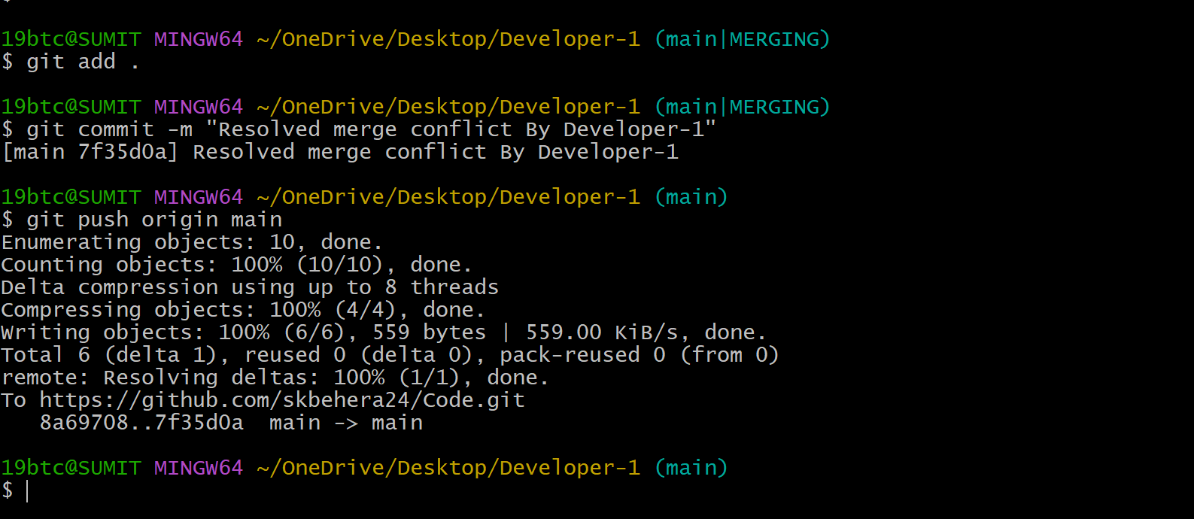

Now the repository is updated successfully.
