GitHub-Hands-on-Practice

Day-2
git ls-files
==============
List of the files which all are tracked by git will display
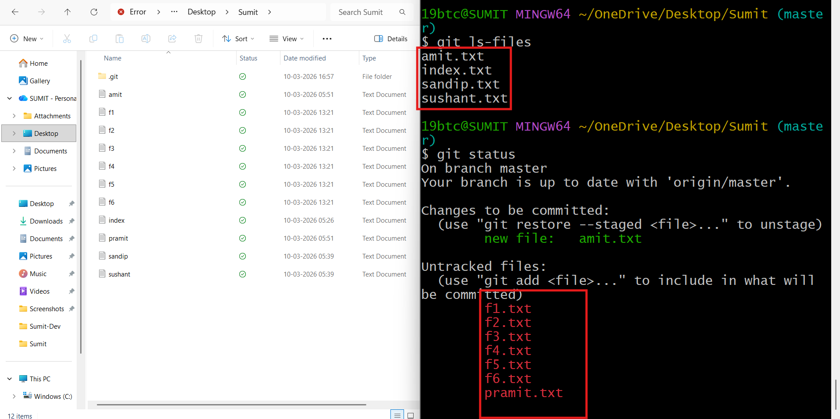

What is Stash ?
============

1. git stash is used for store our incomplete task to a location called " temporary shelves".

2. git stash is a powerful git command that allows you to temporarily save your uncommitted changes without committing them to the repository.

3. what all changes are their in staging area and unstaged area including untracked files those are applied for stash.

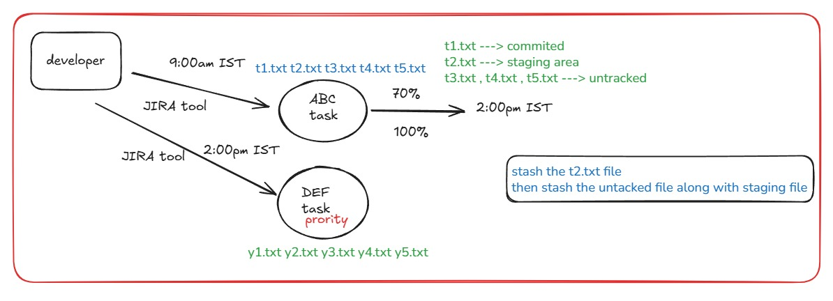

t1.txt is in commited
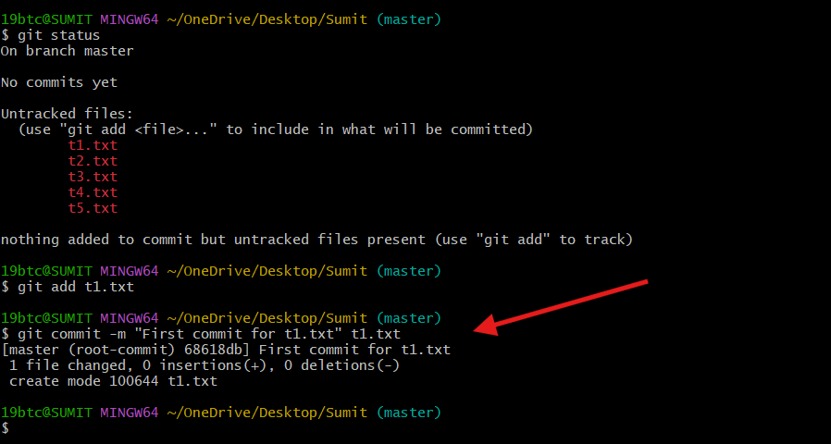

After using git add on t2.txt, the file moved to the staging area
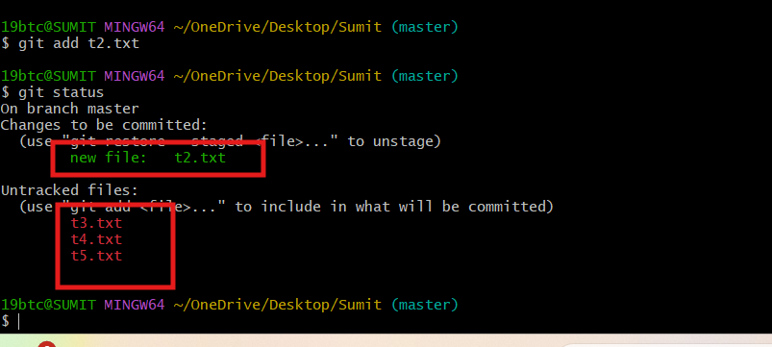

i)git stash is used to temporarily store unfinished changes so you can work on something else and restore them later.

ii) git stash temporarily saves uncommitted changes so you can switch tasks without losing your work.
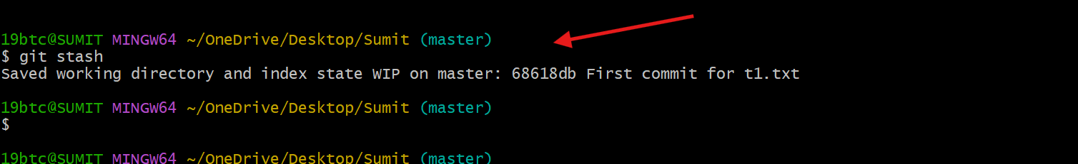

display all the stashes that are currently saved in the repository
command:git stash list
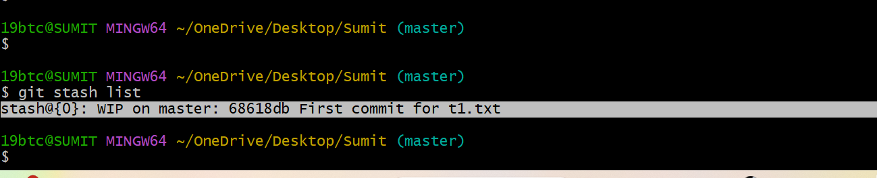

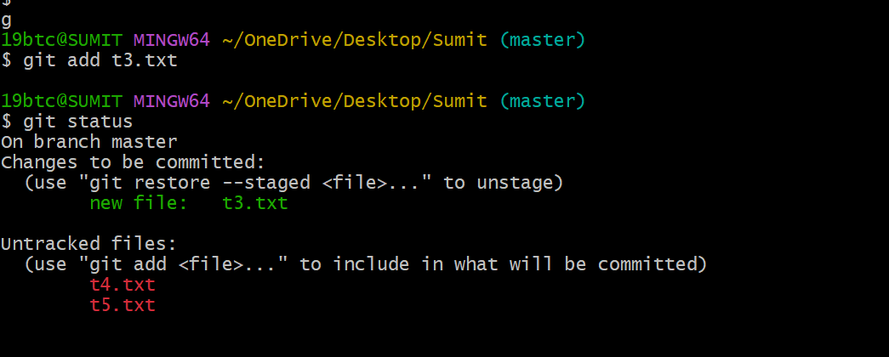

Here, t3.txt is in the unstaged area. If a file was previously added to the staging area and later modified again in the working directory, it becomes an unstaged file
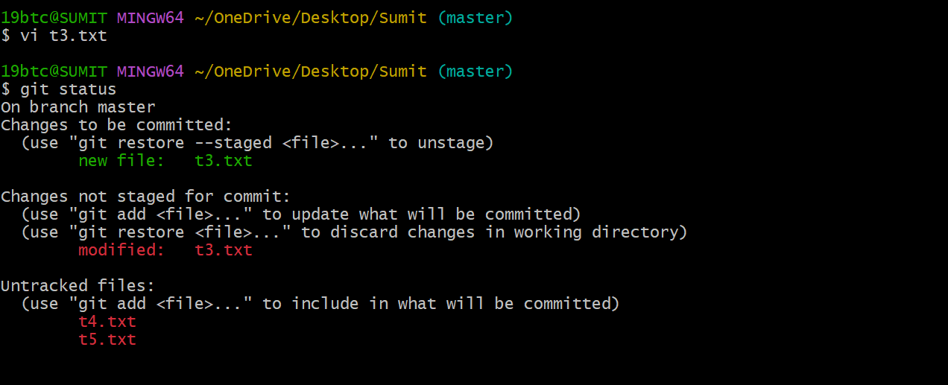

The files which are in staging area that files are stashed

Command:git stash list

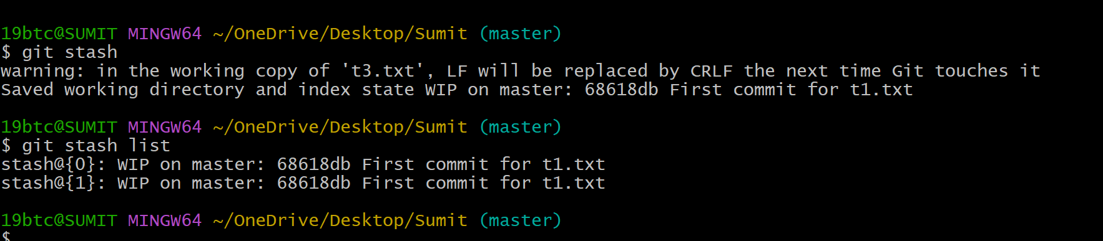

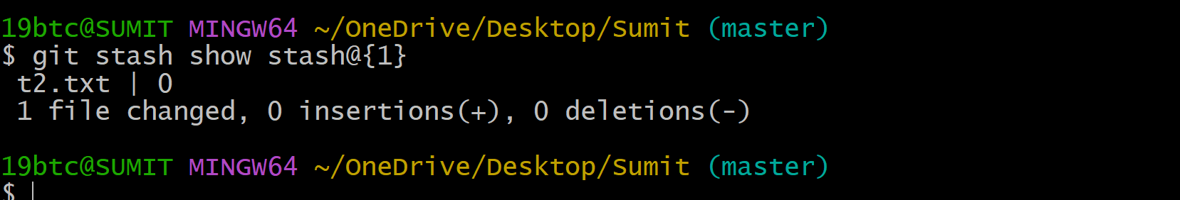
t3.txt | 1 +
- The file t3.txt was modified in this stash.
- 1 + means one line was added to the file.
2️⃣ 1 file changed
- Only one file was modified in this stash.
3️⃣ 1 insertion(+)
- One new line was inserted into the file.
Simple Meaning
This stash (stash@{0}) contains:
- Changes in t3.txt
- 1 line added to that file.

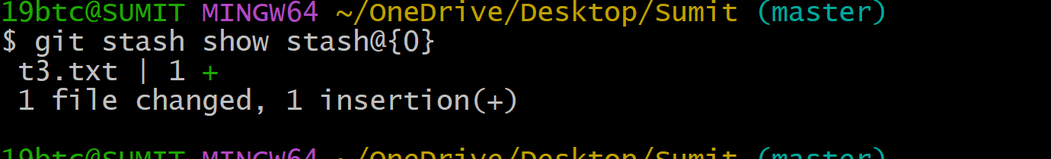

1️⃣ t2.txt | 0
- The file t2.txt is included in this stash.
- 0 means no lines were added or removed.
2️⃣ 1 file changed
- Only one file was affected in this stash.
3️⃣ 0 insertions(+), 0 deletions(-)
- No new lines were added and no lines were deleted.
- This usually means:
  - whitespace change
  - file metadata change
  - or staged state change without content change.

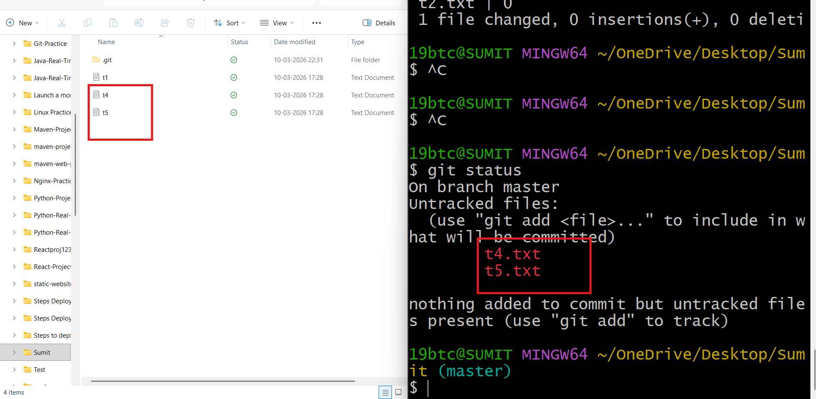
to restore the changes stored in a specific stash back to your working directory.

Command: git stash apply stash@{0}
git stash apply stash@{1}
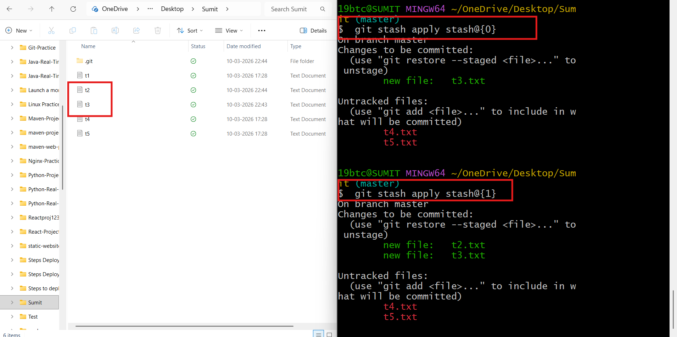

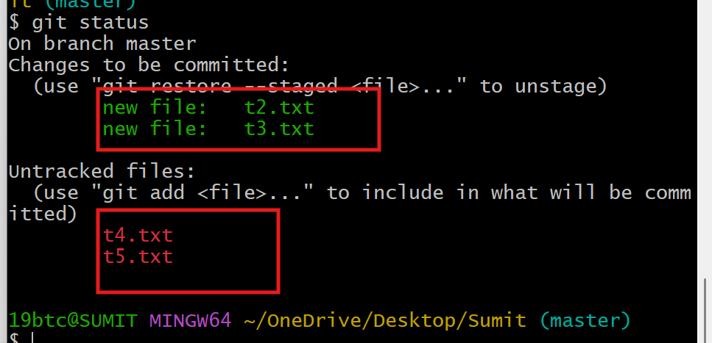

How to delete the stash
removes the latest stash (stash@{0}) permanently from the stash list.

Command:git stash drop stash@{0}
Meaning of the Command
- git stash → Manages saved changes (stashes).
- drop → Deletes a stash entry.
- stash@{0} → Refers to the most recent stash.

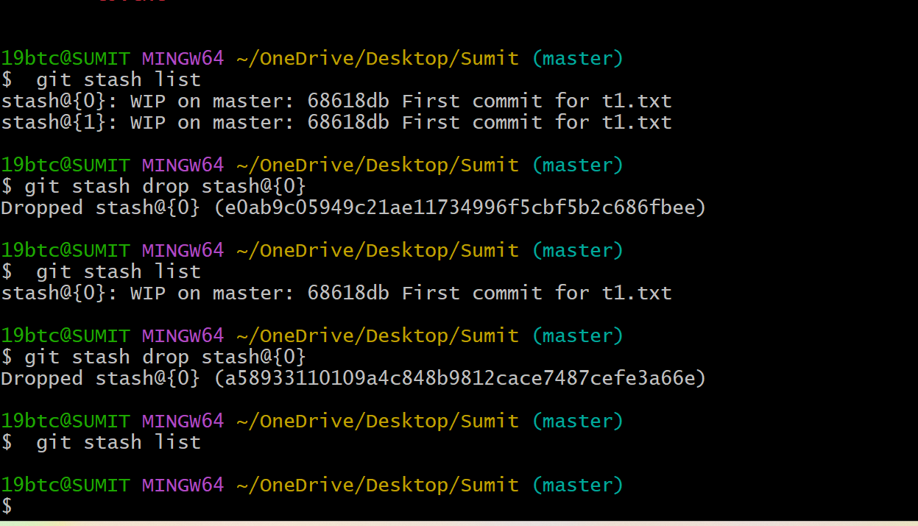

How to stash untracked files
----------------------------------------
Command:git stash -u

git stash -u is used to temporarily save tracked changes and untracked files so that the working directory becomes clean.
