GitHub Hands-on Practice
Day 1
======

Github
-----------
1. It is a version control system.
2. Git Hub is a platform which is used to store project related files / codes.
3.In GitHub , we can create source code repository
to store project code.
4. All developers can connect to the project repository to store all the source code using repository url.

GitHub repo Advantage
===================
we can track
--who modified
--what modified
--when modified
--why modified

Repository types
==================
There are two types of repository in GitHub
Private repo (Owner need to choose who can see and commit)
Public repo (Anybody can see and commit)

git config
==========
This command is used for configure the name and email using git client software.
--> git config --global user.name "kubebytes"
--> git config --global user.email "kubebytes@gmail.in"

Git Architecture
================
working directory
staging area
local repo
central repo
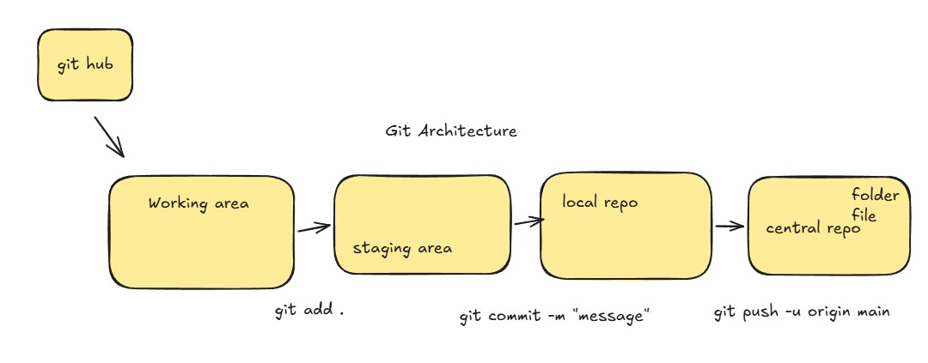

Git init
========
This command is used for initialize the working directory.
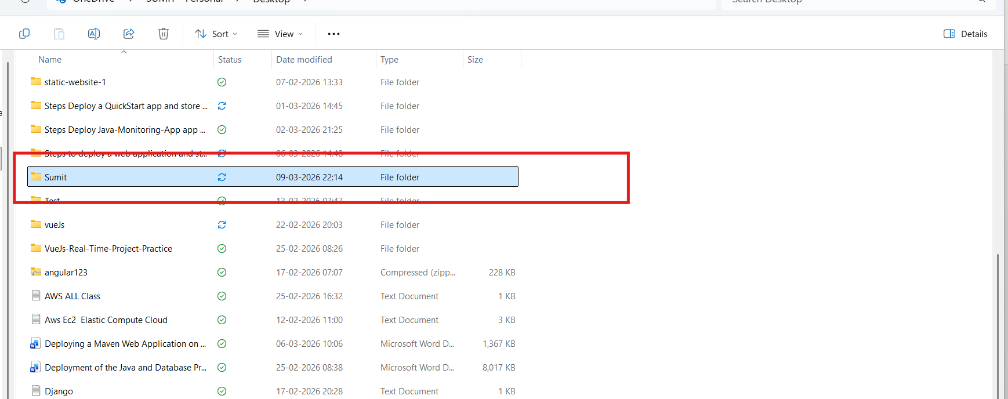

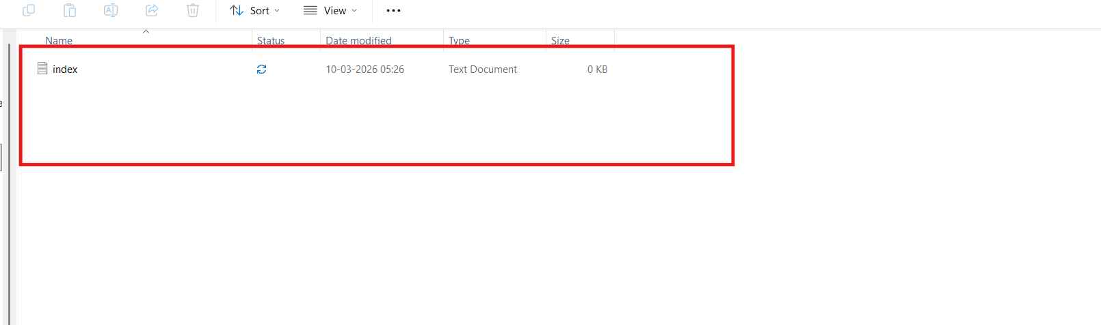

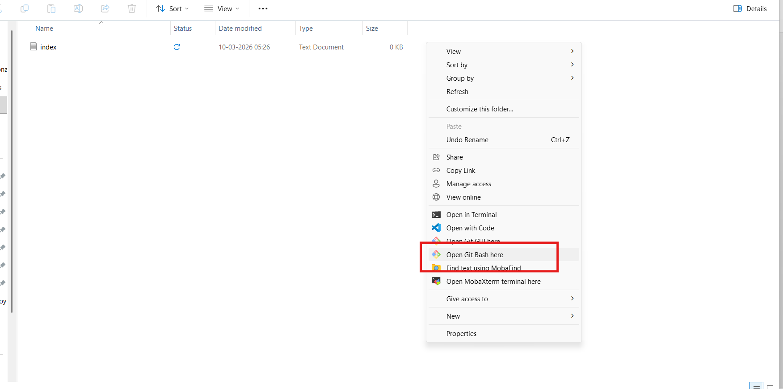
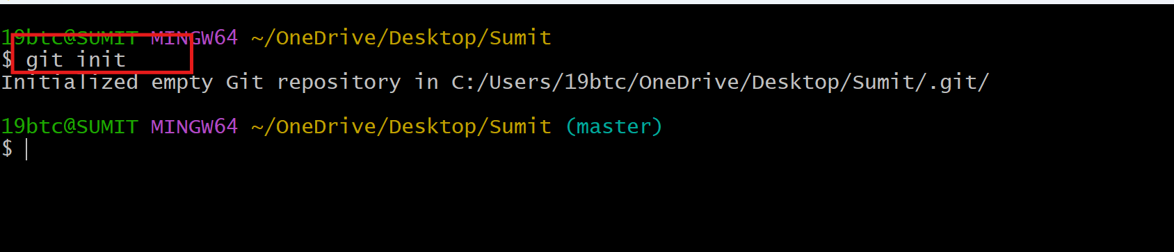

Difference
===========
Untracked files vs Tracked files
Untracked files vs Unstaged files
Staged files vs Unstaged files

1.Untracked Files
Area: Working Directory
- Files exist in your project folder but Git is not tracking them.
- They have never been added using git add.
2.Tracked Files
Area: Staging Area and Repository
Tracked files are files that Git already knows about.
They can exist in:
- Working Directory (modified)
- Staging Area
- Local Repository (committed)
3. Unstaged Files
Area: Working Directory
- Files that are modified but not yet added to the staging area.
- Git knows the file (tracked), but the changes are not prepared for commit.
4. Staged Files
Area: Staging Area (Index)
- Files that are added using git add.
- They are ready to be committed to the repository.

git status
==========
To check the file status .
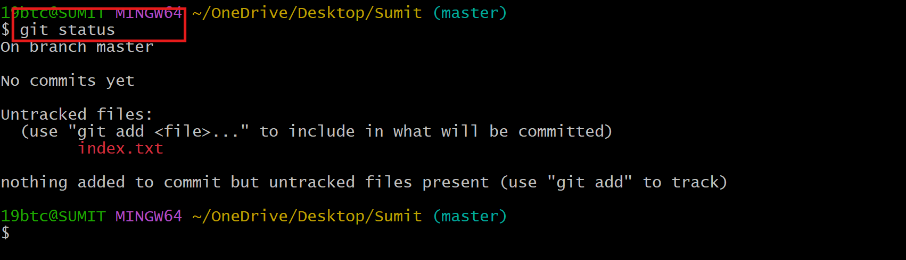

git add
======
To add files from Working directory to staging area
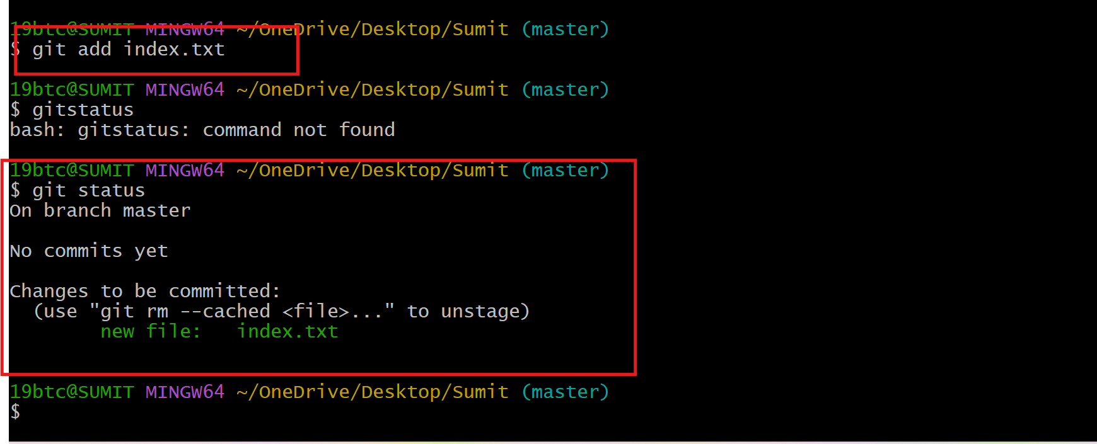

git commit -m "message"
=====================
To add files from staging area to local repo
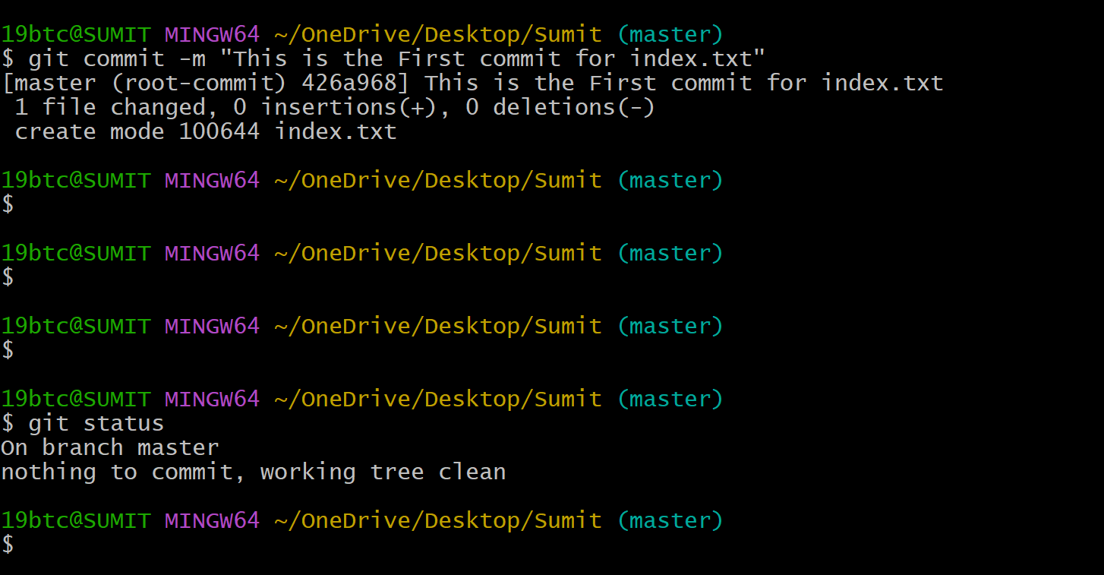

git remote add origin git remote add origin https://github.com/skbehera24/GitHub-Practice-.git

git push -u origin master
====================
for first time we need to use this command for connecting our local repo with central repo
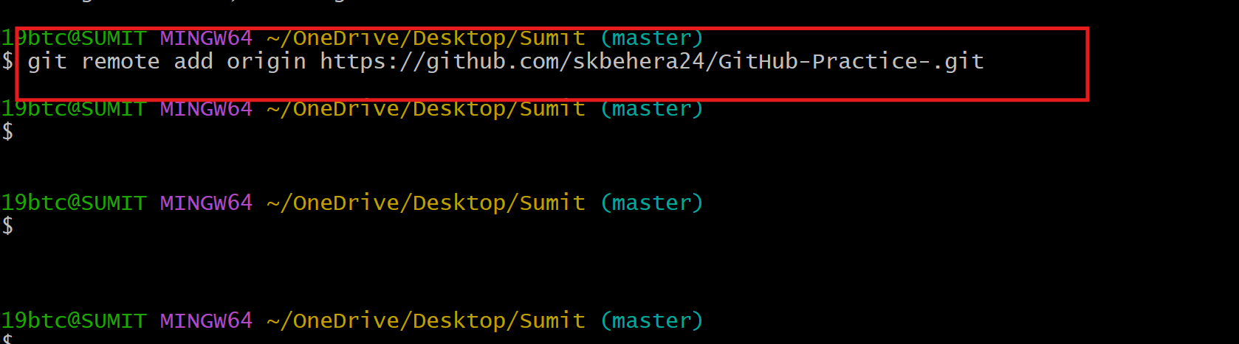
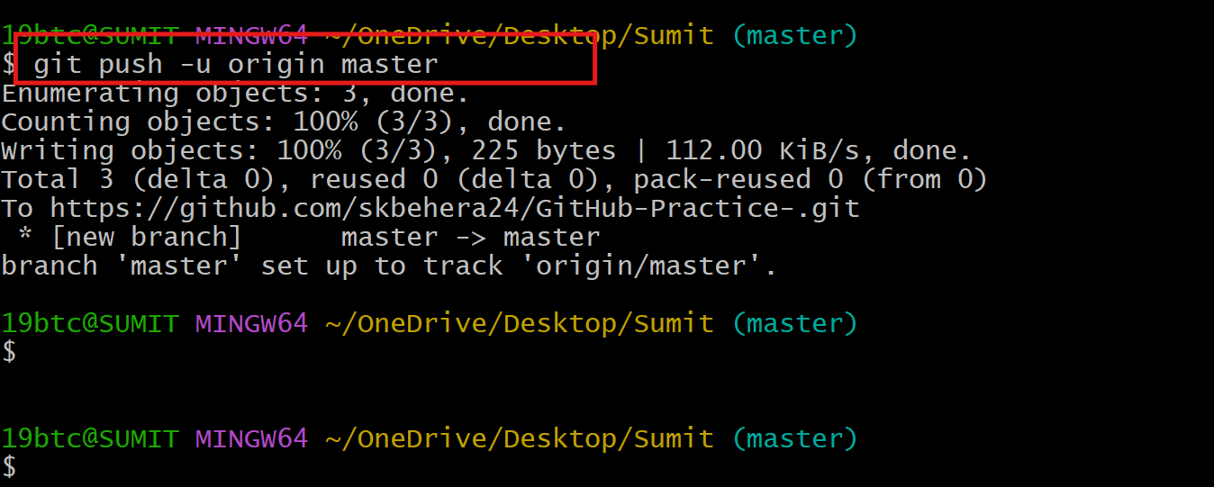
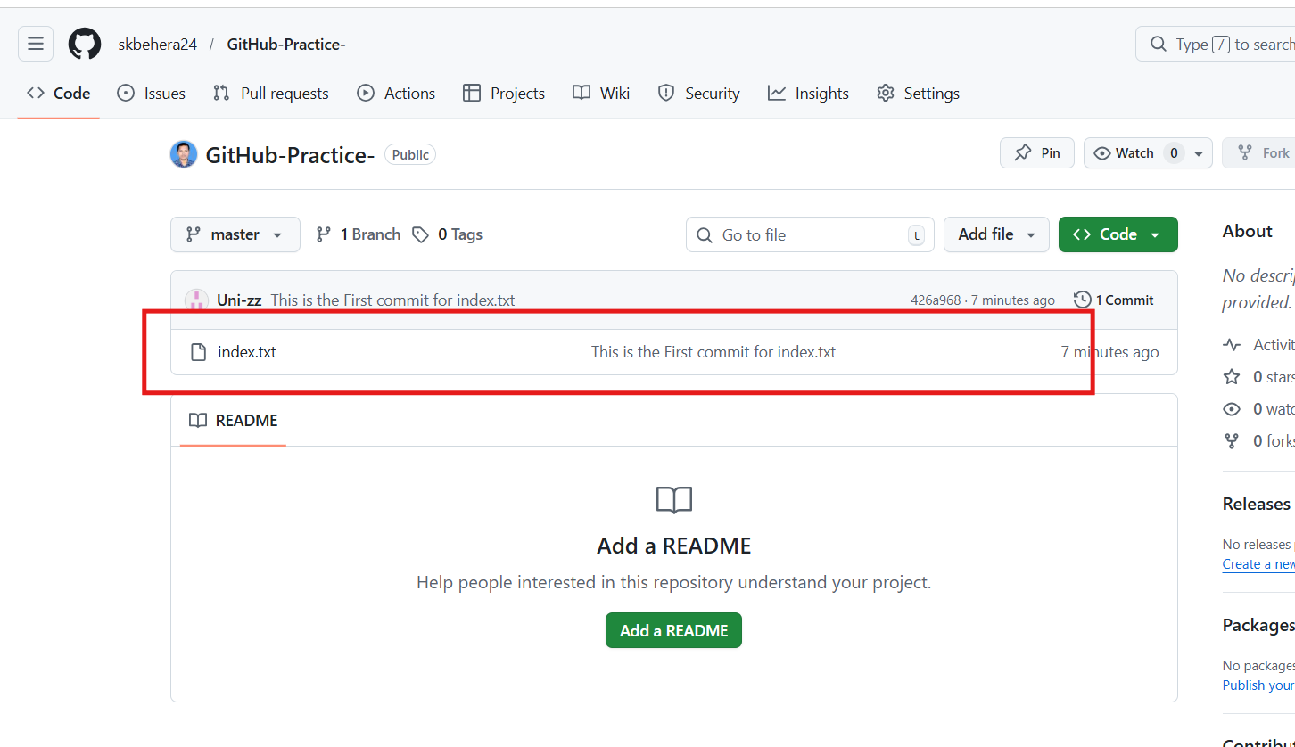
git push
========
push file local repo to central
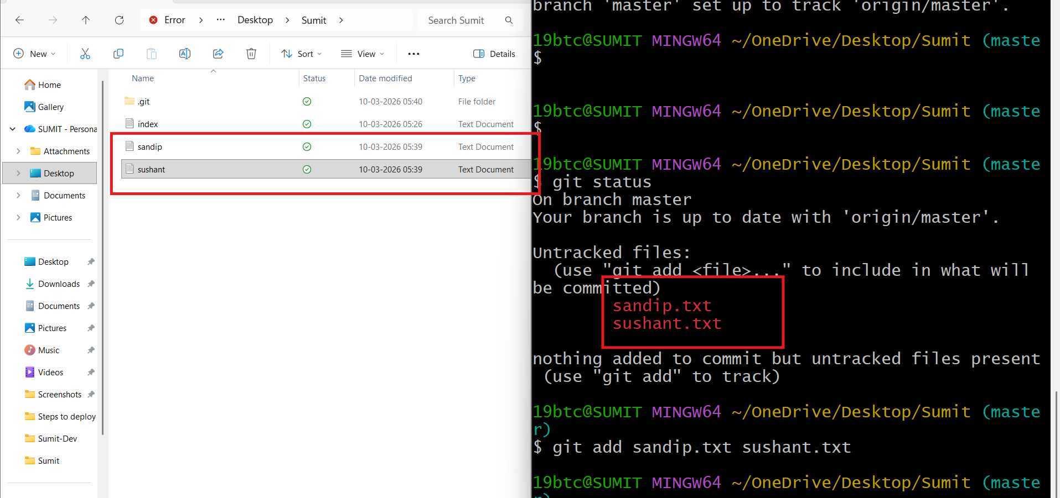
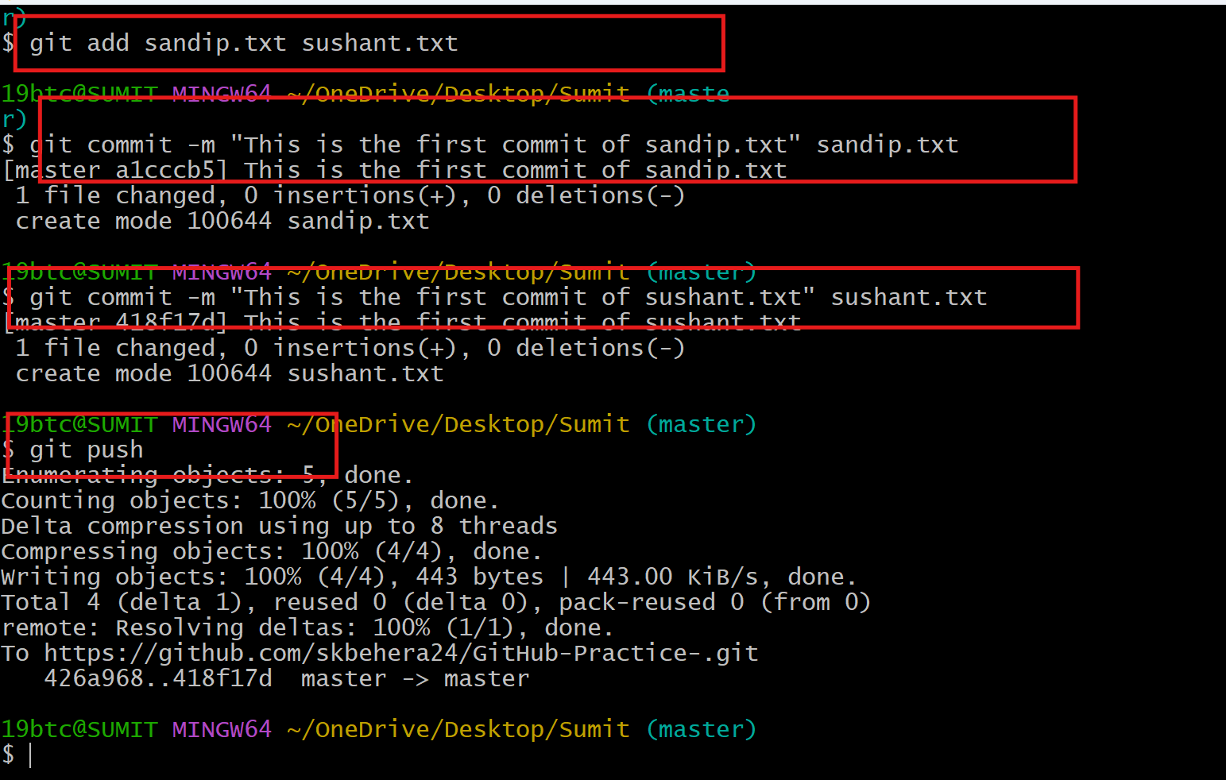
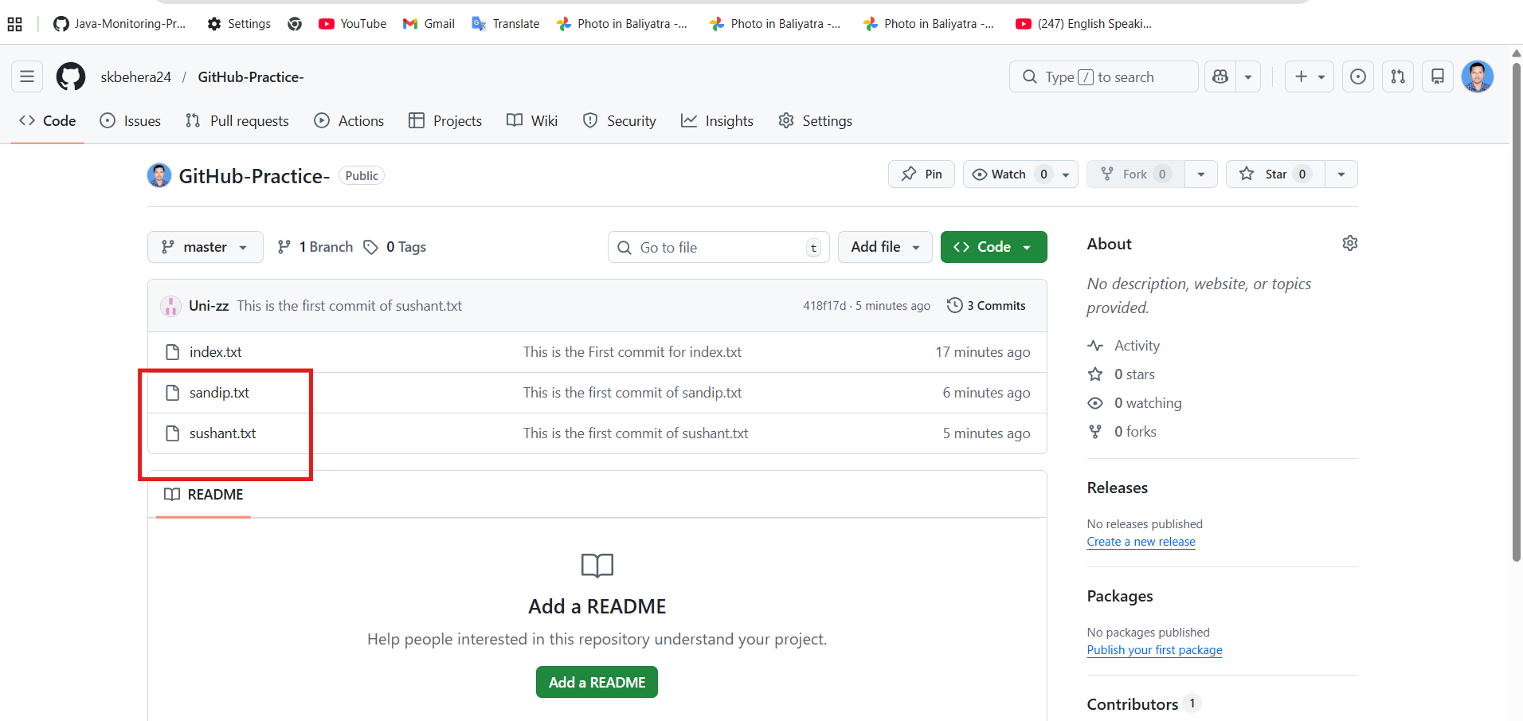

git add
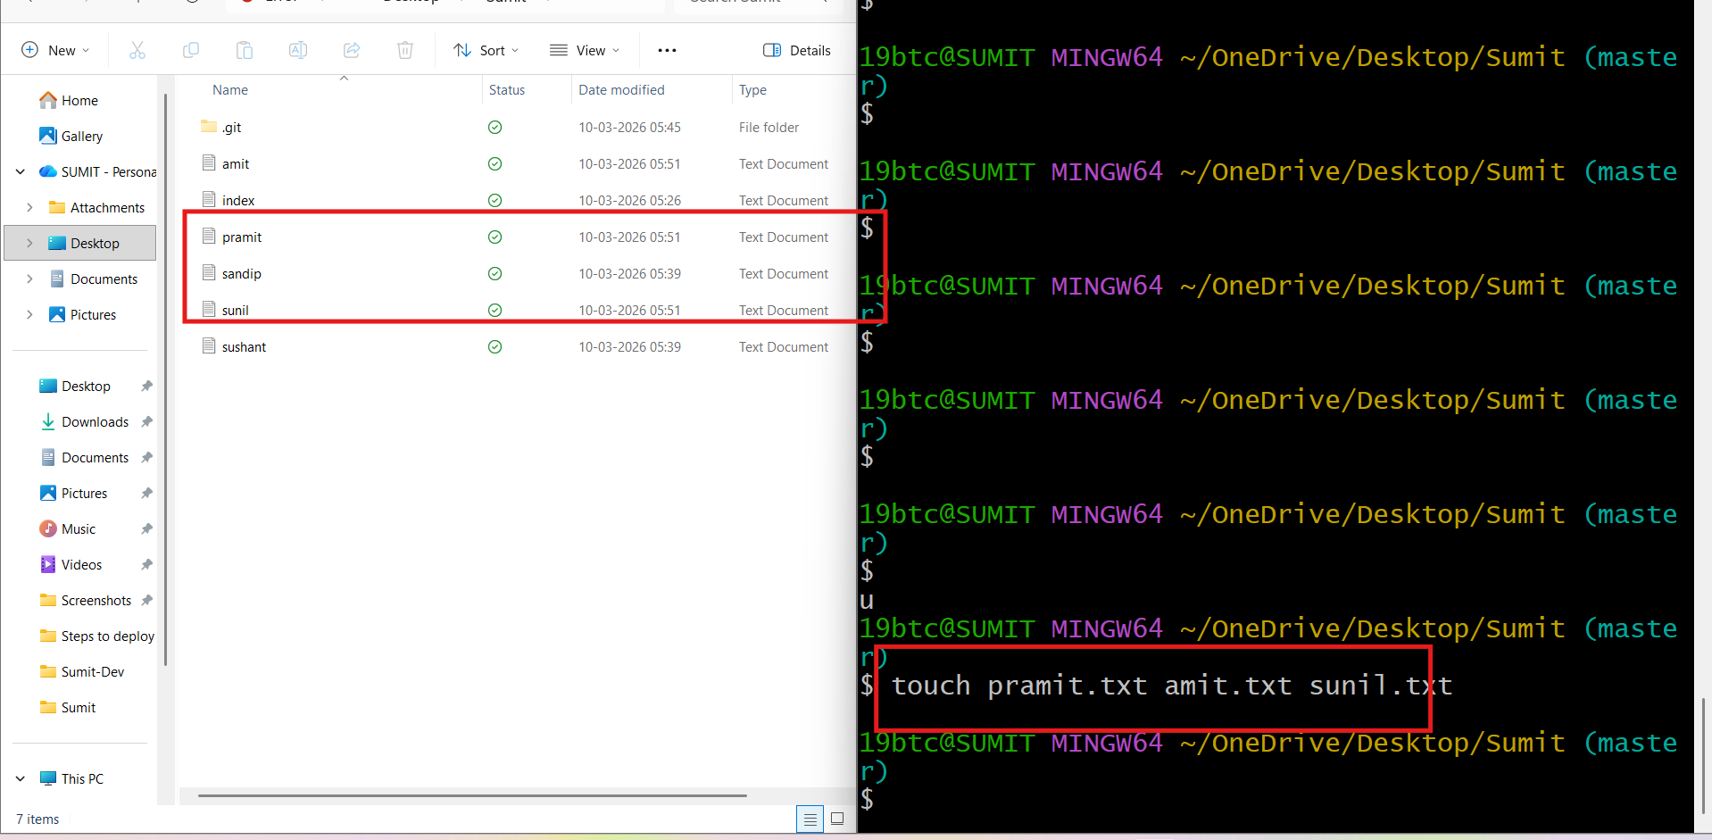

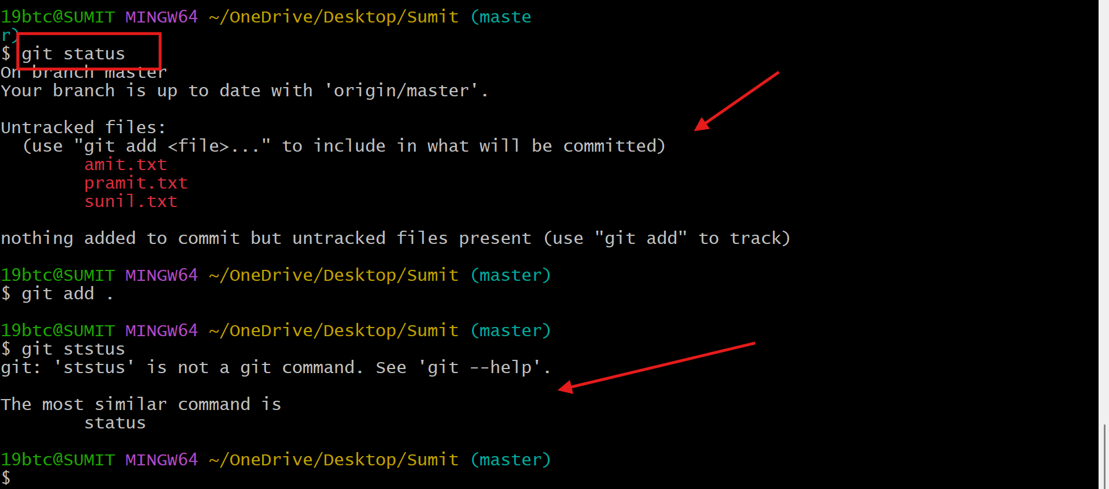

git log
=======
To see all commit history
By default it will display the newest commit to oldest commit

git rm <file-name>
===================
It will remove the file from both the working directory and staging area.
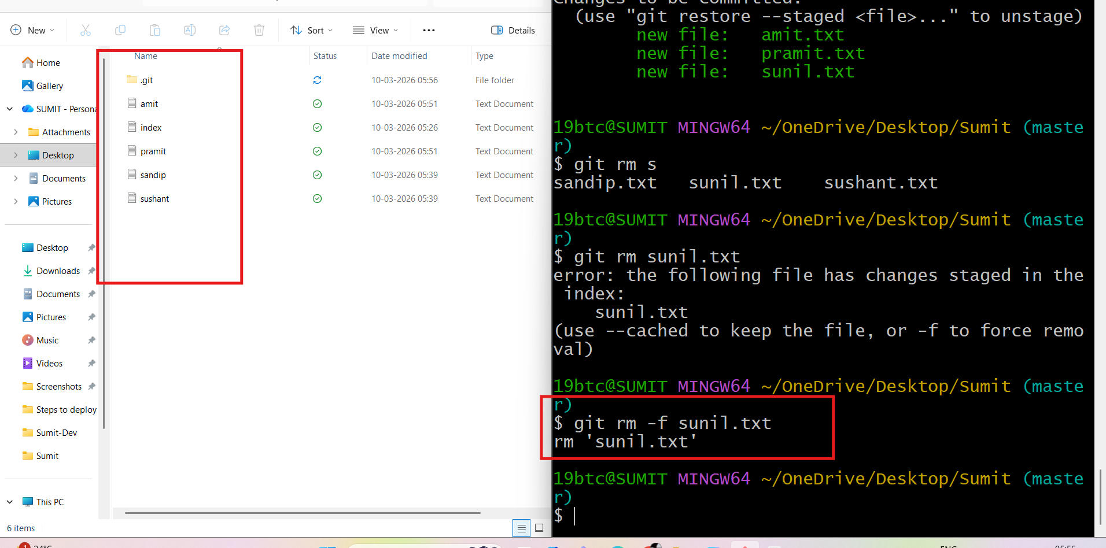
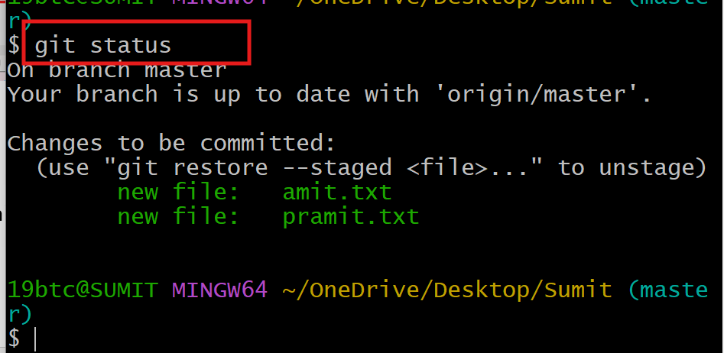

git rm --cached <file-name>
=======================
It will remove the file from staging area but it won't delete from
working directory.
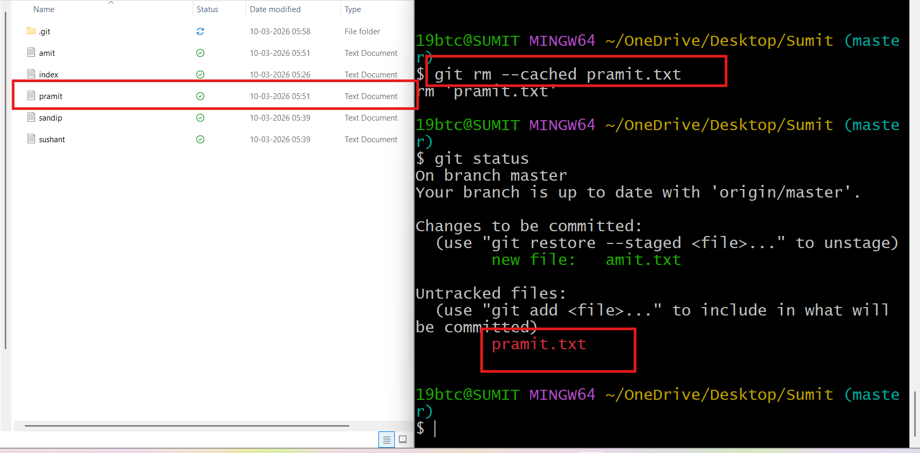

.git ignore file
============
A file used to tell git which files or directories to ignore.
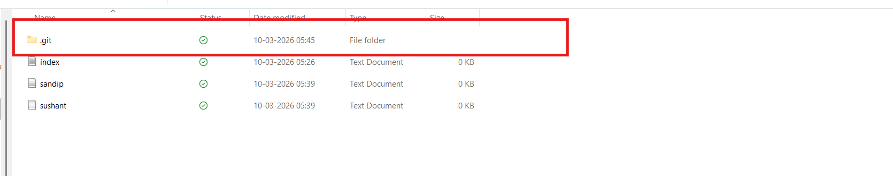
git log
=====
To see all commit history
By default it will display the newest commit to oldest commit
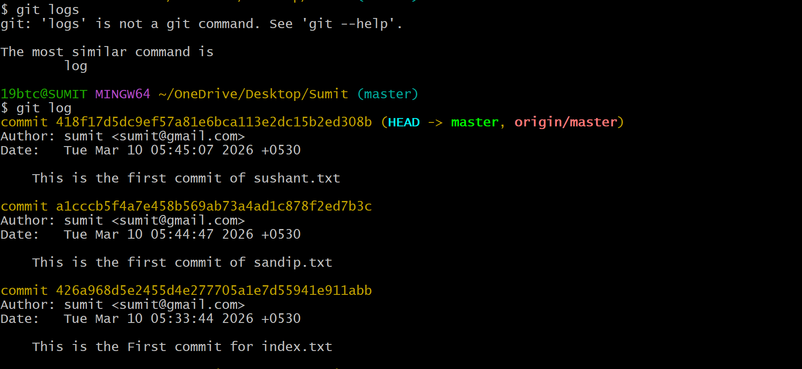

git log --oneline
=============
To see simplified view of the commit history
