Jenkins Instalation
Step -1
Create a EC2 Instance
i)Go to EC2 and Click on Lunch instance
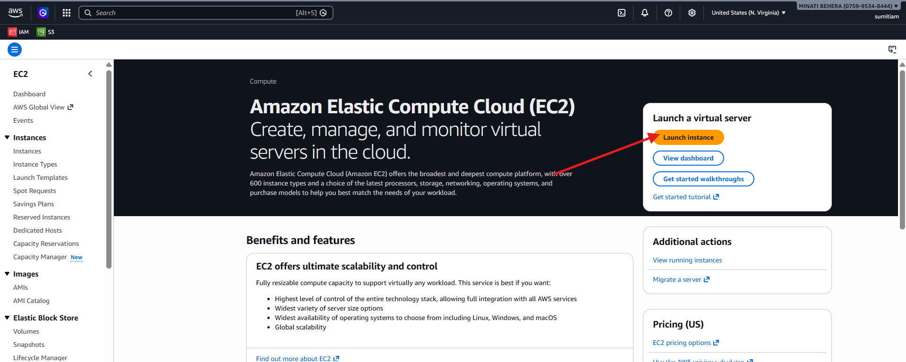
ii)Set the Name ,OS and Key Pair and Instance Type
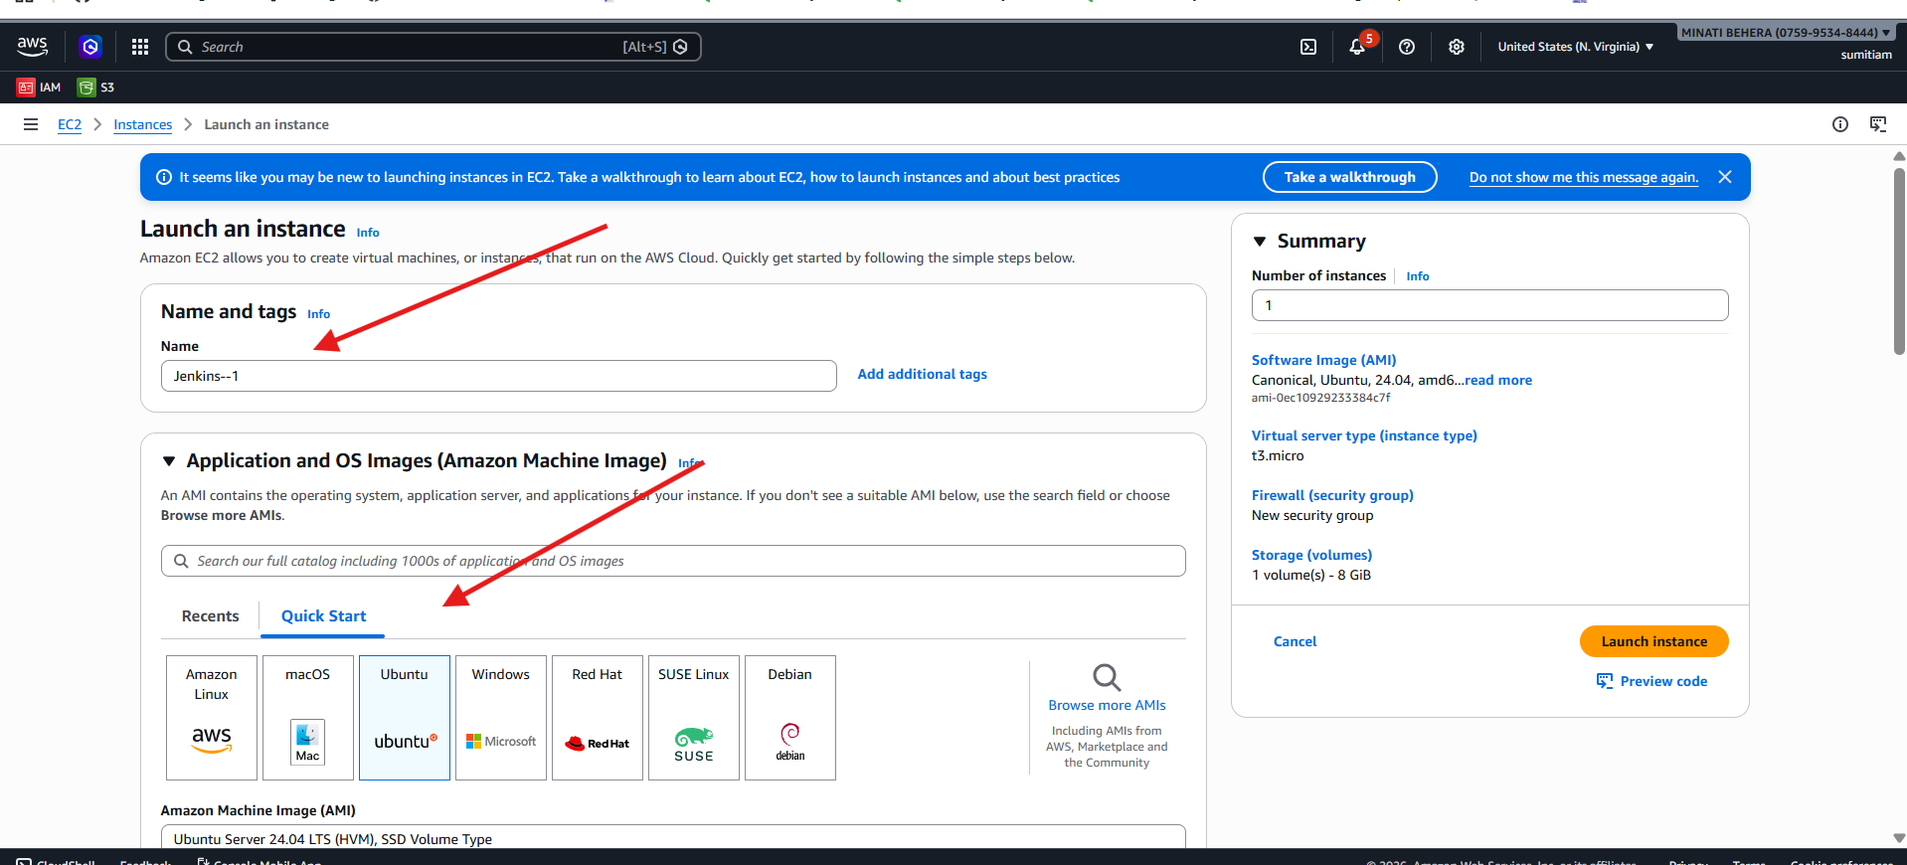

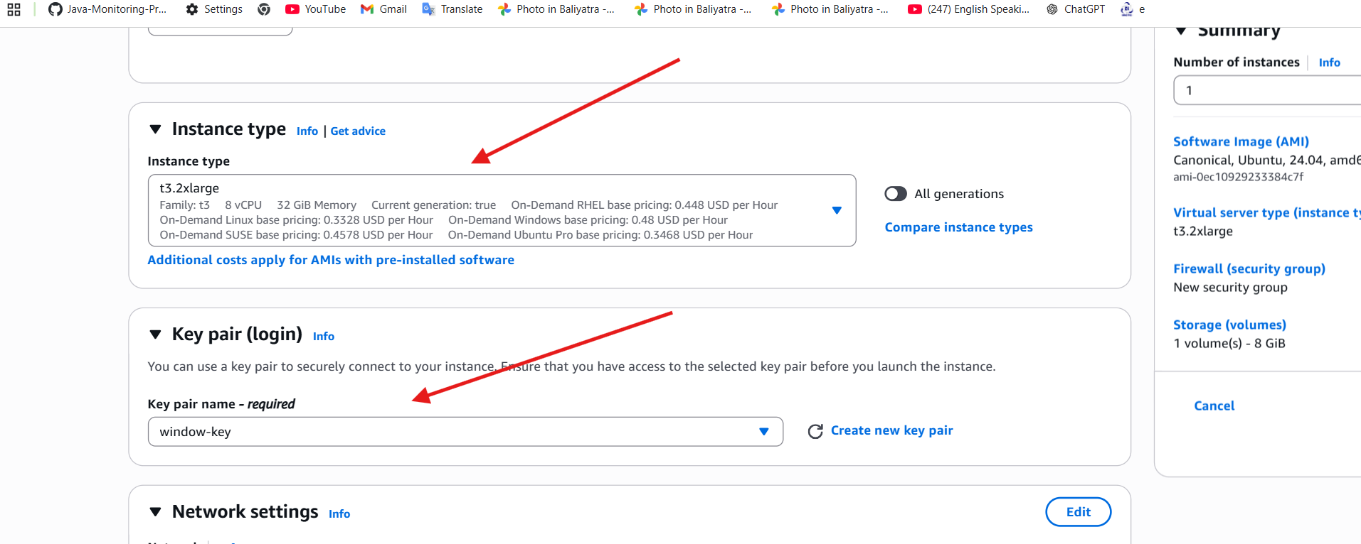
iii)Click onLunch instance

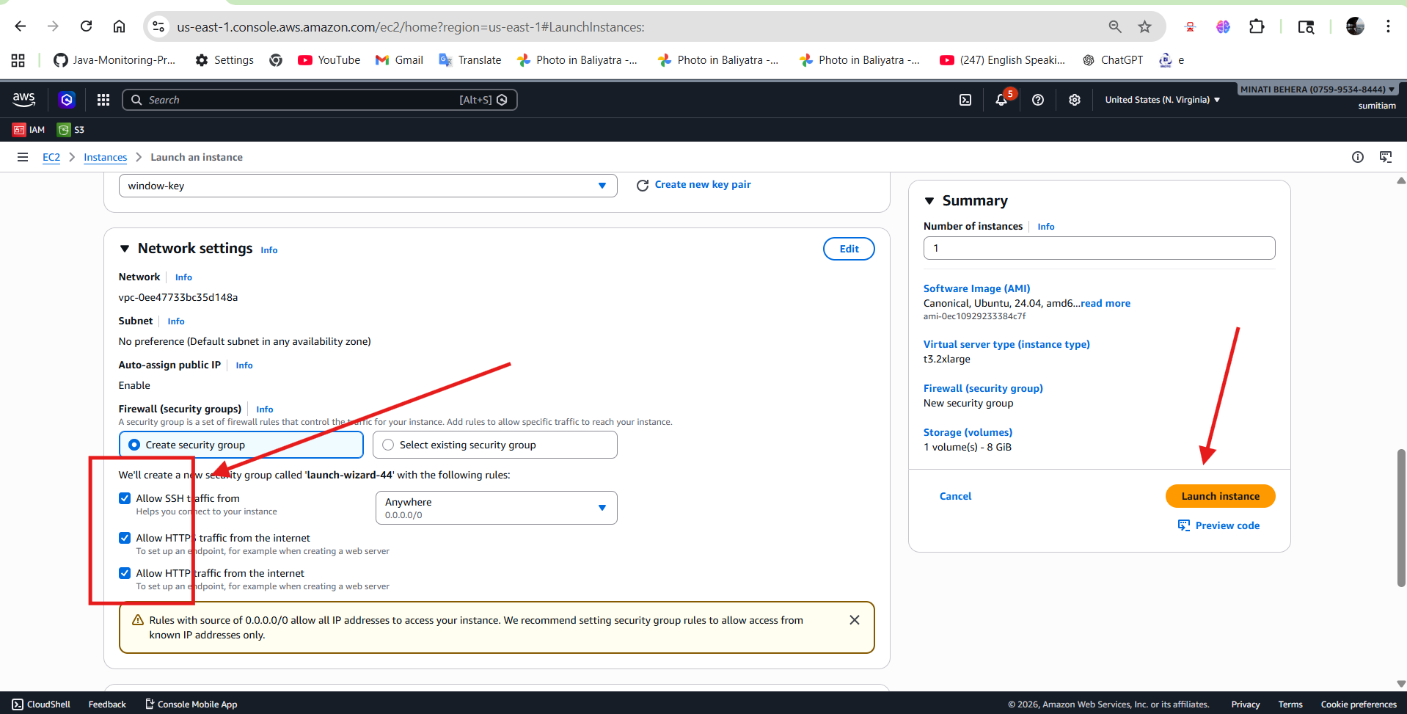
iv)Go to connect SSh client copy
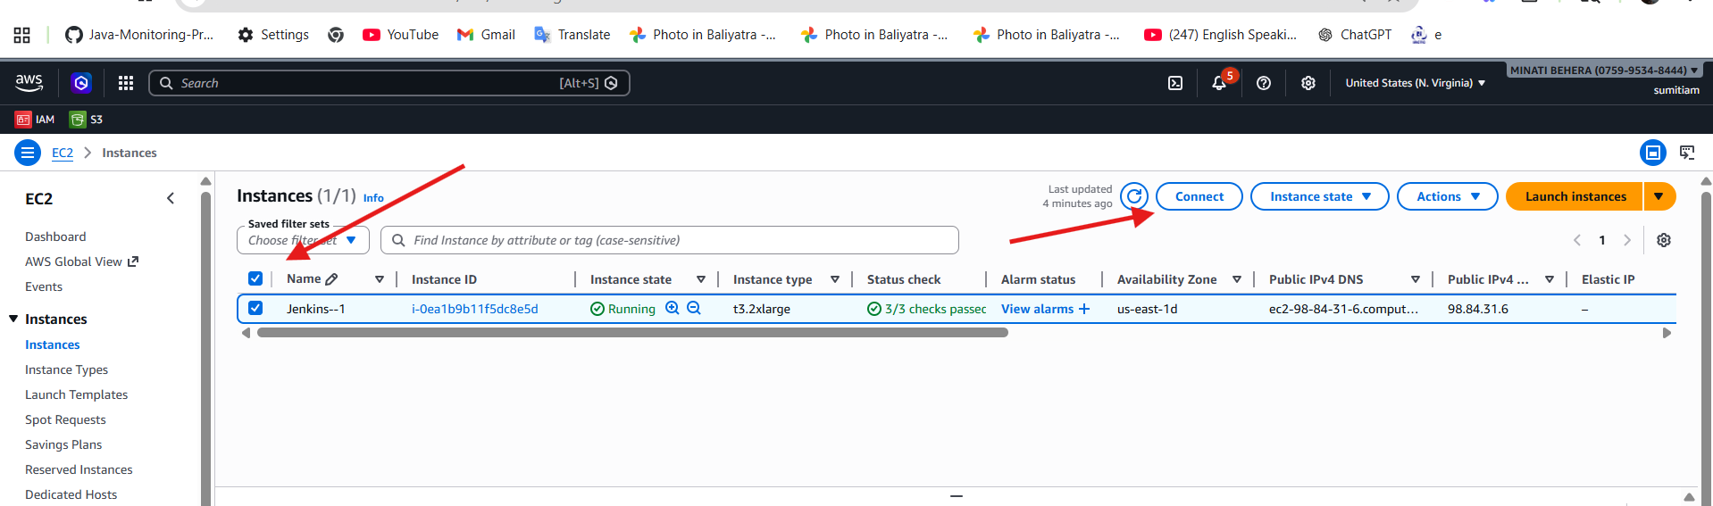
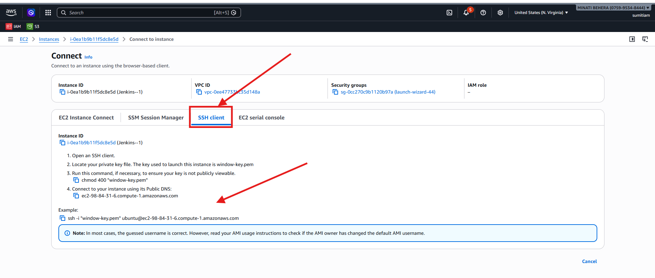
Step-2
Navigate to the folder where the .pem key file is located and open the Command Prompt there.
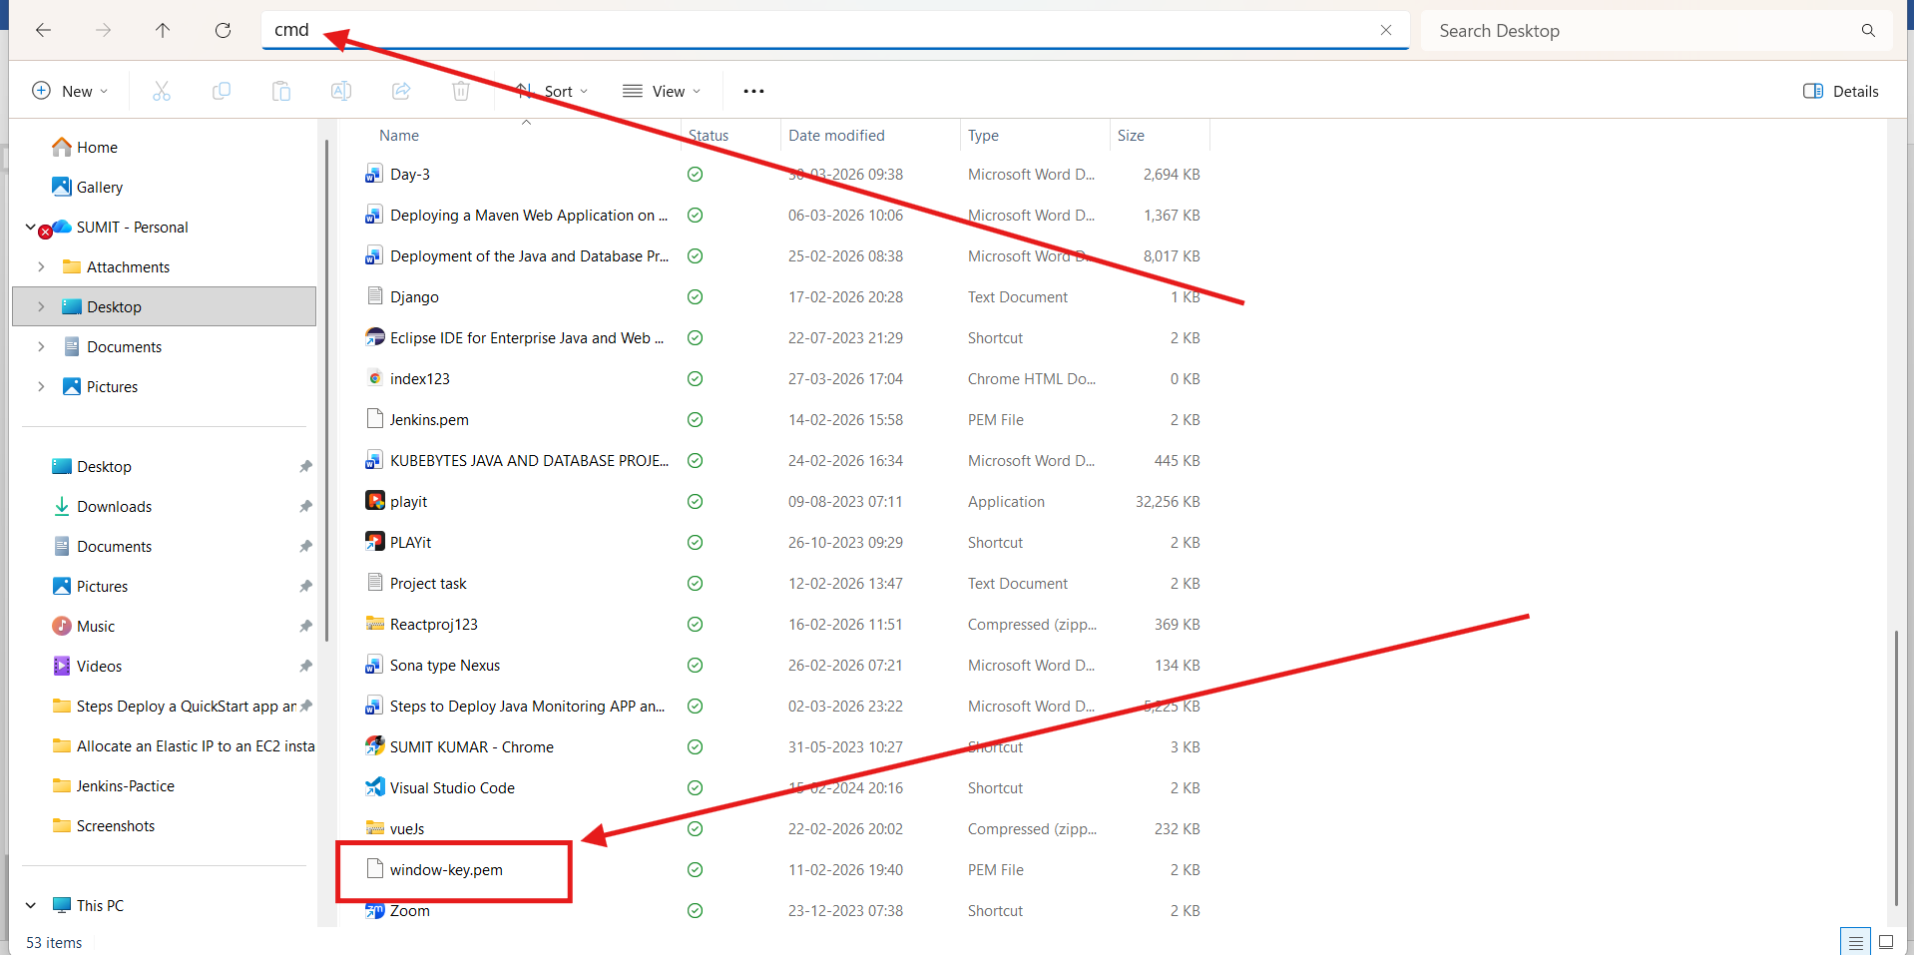

Step-3
connect to a remote server securely using Secure Shell protocol.
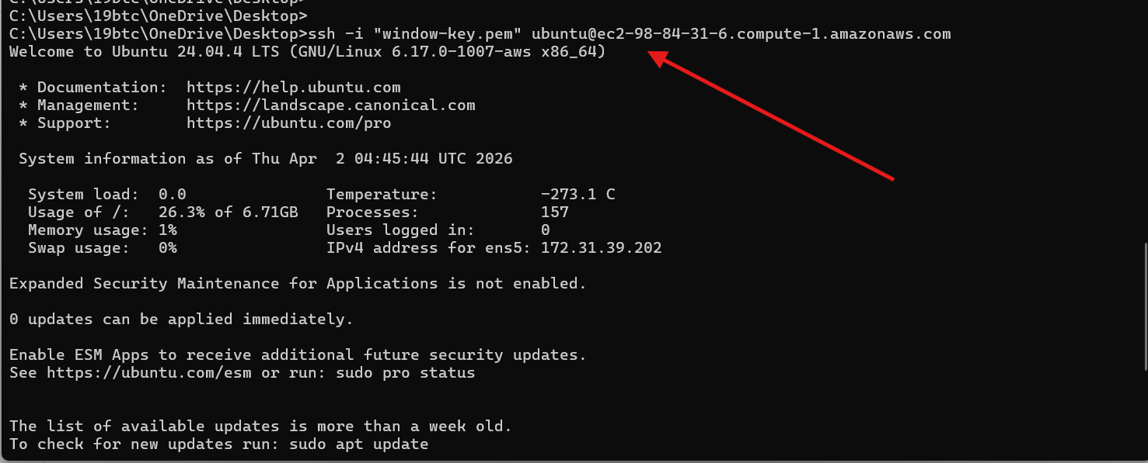
Step-4
Install Docker, run Jenkins in a container, store its data persistently, verify the setup, retrieve the admin password, and enable access through port 8080.
✅ Step I: Install and Configure Docker
👉 Why this is used:
- apt update → updates package list
- install docker.io → installs Docker
- start docker → starts Docker service
- enable docker → runs Docker automatically on system boot
- usermod -aG docker $USER → allows current user to run Docker without sudo
👉 Purpose: Prepare the system to run containers

sudo apt update && sudo apt install -y docker.io sudo systemctl start docker sudo systemctl enable docker sudo usermod -aG docker $USER
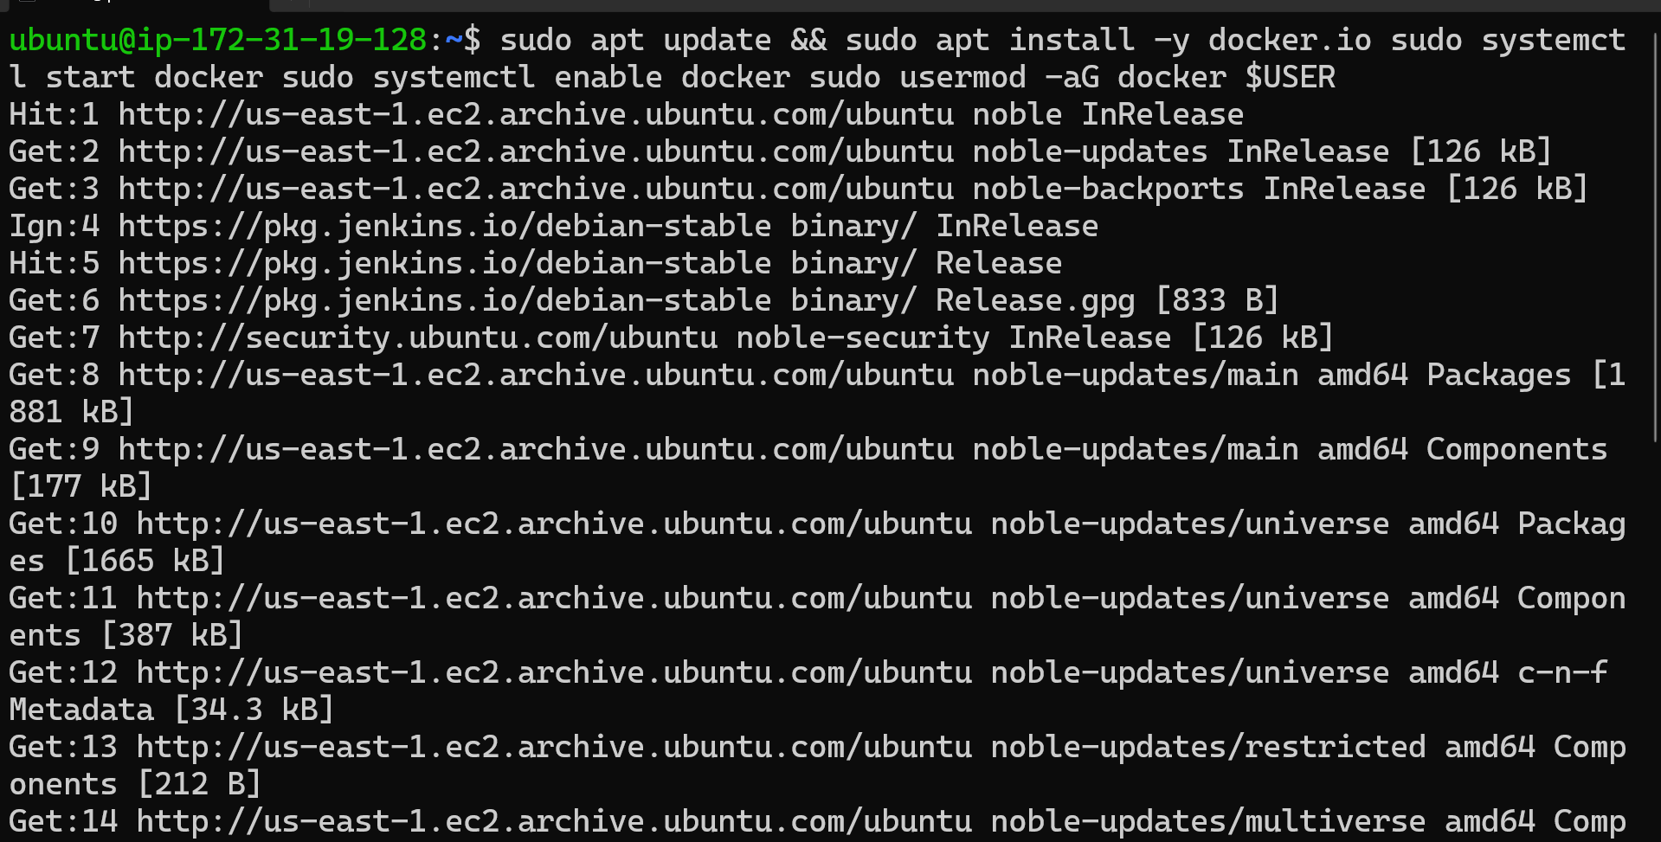
✅ Step II: Create Docker Volume
👉 Why this is used:
- Creates a persistent storage volume for Jenkins
👉 Purpose:
Even if the container stops or deletes, Jenkins data (jobs, configs) will not be lost
sudo docker volume create jenkins_data
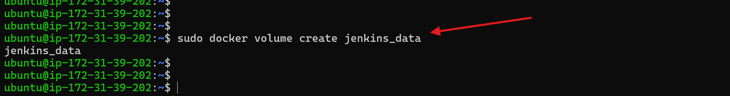
✅ Step III: Run Jenkins Container
👉 Why this is used:
- -d → runs container in background
- -p 8080:8080 → access Jenkins UI in browser
- -p 50000:50000 → for Jenkins agents
- -v → attach storage volume
- --name → give container a name
- --restart → auto-restart if it fails
👉 Purpose: Launch Jenkins application using Docker

sudo docker run -d \
-p 8080:8080 \
-p 50000:50000 \
-v jenkins_data:/var/jenkins_home \
--name my-jenkins \
--restart=on-failure \
jenkins/jenkins:lts
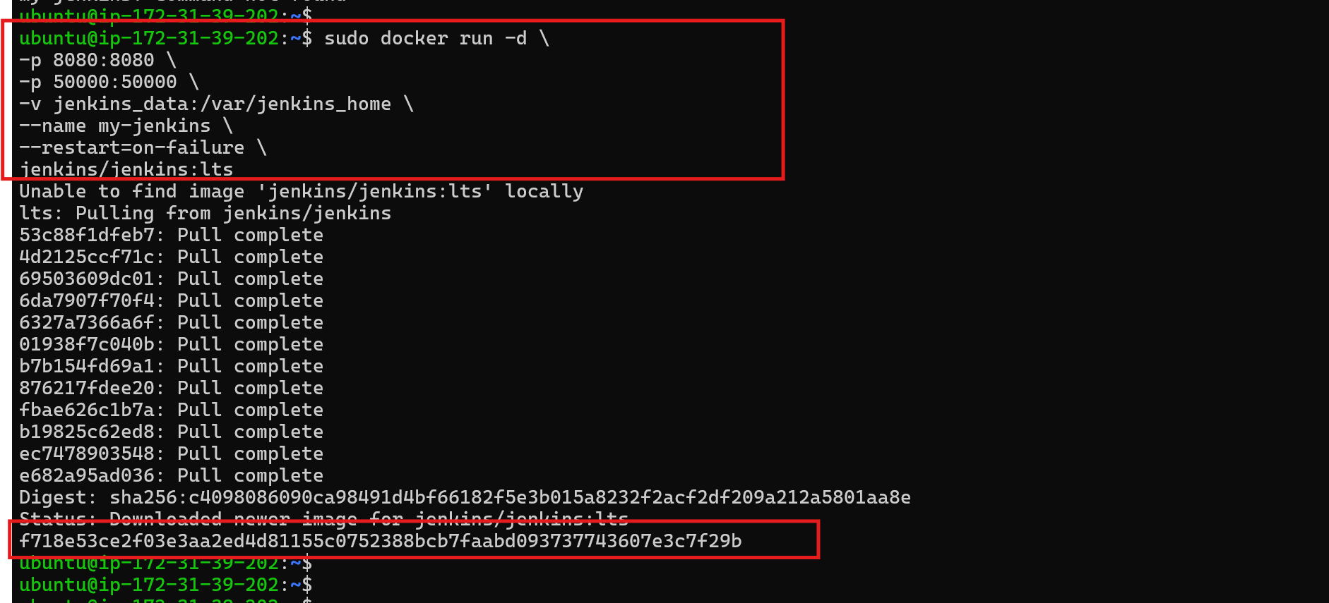

✅ Step IV: Verify & Access Container
👉 Why this is used:
- docker ps → check if container is running
- docker exec → go inside the container
👉 Purpose: Verify Jenkins is running and troubleshoot if needed

sudo docker ps
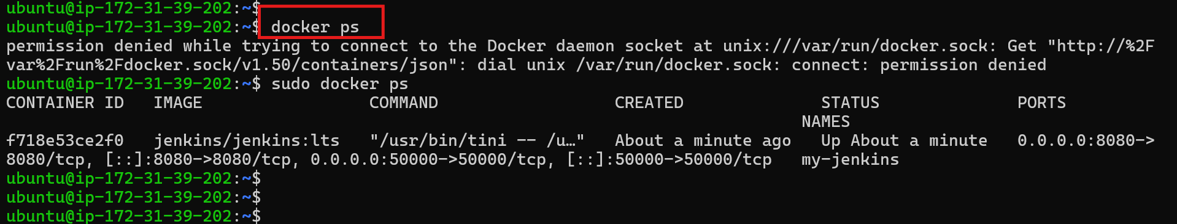

sudo docker exec -it my-jenkins bash
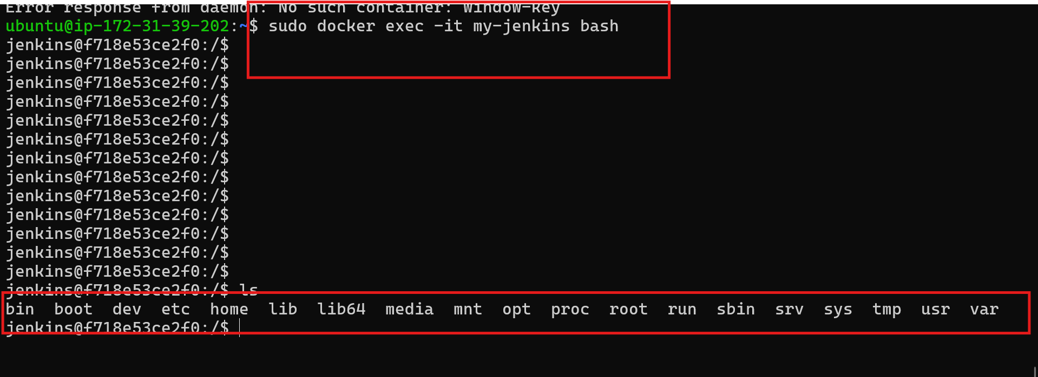
✅ Step V: Get Jenkins Admin Password
👉 Why this is used:
- Jenkins requires an initial password for first login
👉 Purpose: Unlock Jenkins setup page

sudo docker exec my-jenkins cat /var/jenkins_home/secrets/initialAdminPassword
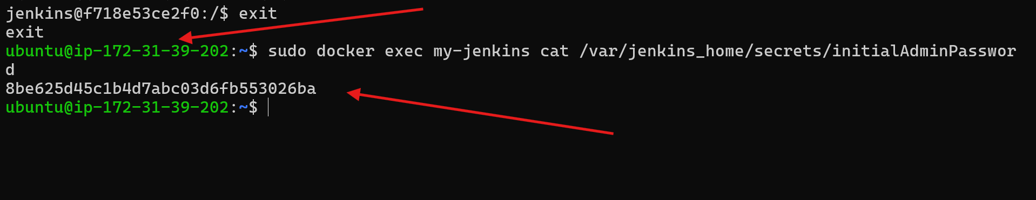

✅ Step VI: Enable Port 8080 in Security Group
👉 Why this is used:
- AWS blocks incoming traffic by default
- You must open port 8080 to access Jenkins in browser
👉 Purpose: Allow external access to Jenkins UI

✅ Step VII: Enable the port number 8080 in security group
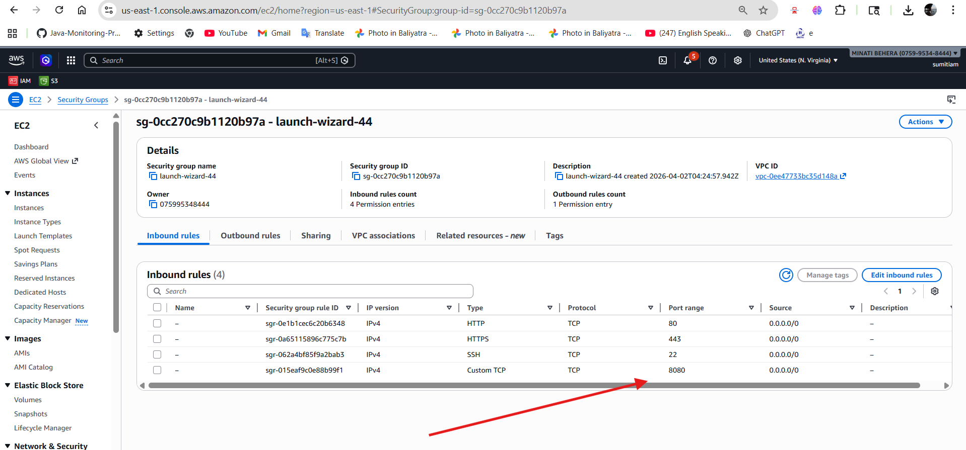

Step-4
👉 Access Jenkins using the public IP followed by the port number.
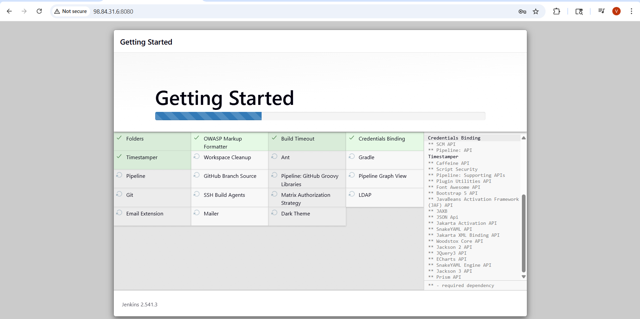

Step-5
Create First Admin User in jenkins
i)Set the username, password, full name, and email address.
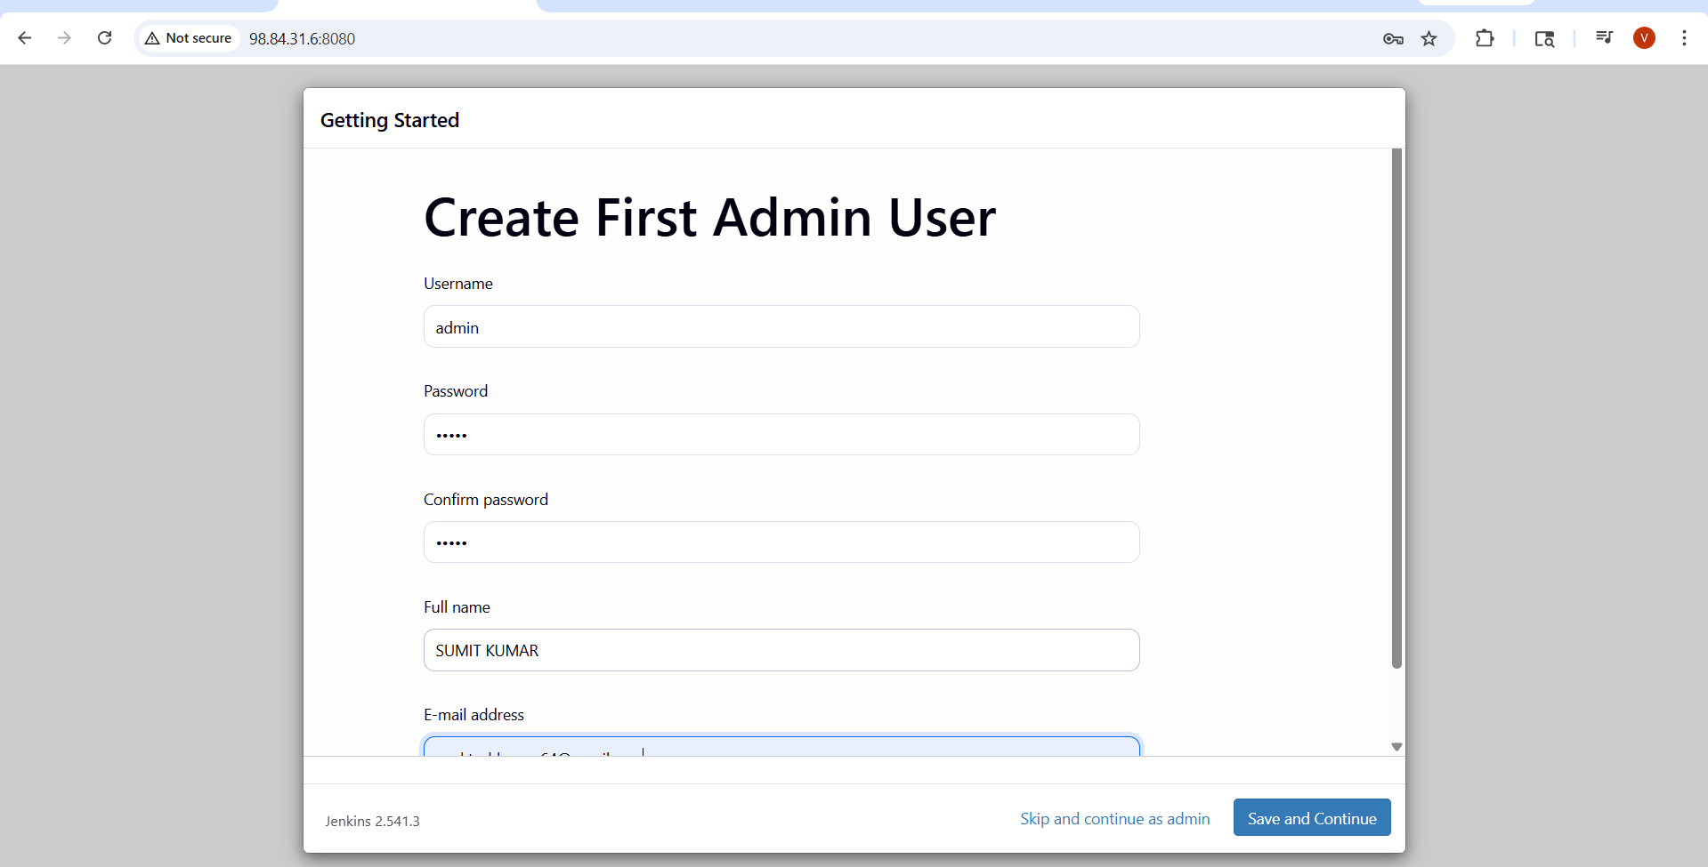
ii)click on start using jenkins
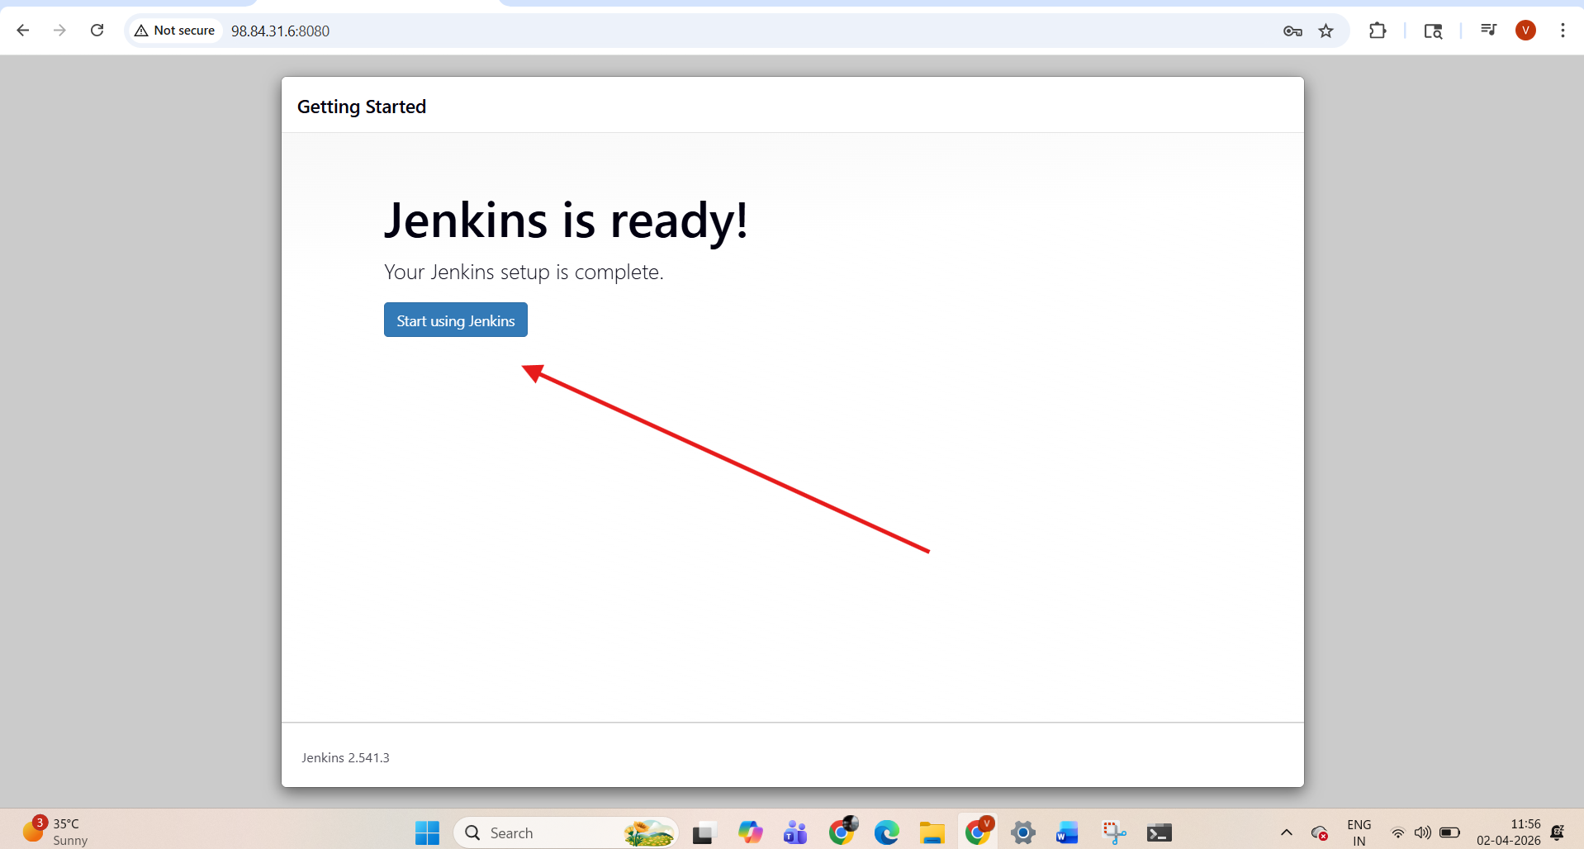

Note
The default jenkins location in docker container ?
-------------------------------------------------------------------
/var/jenkins_home/workspace
