Jenkins Automation and CI/CD Tasks Day-2
integration jenkins + github + maven
create job 6
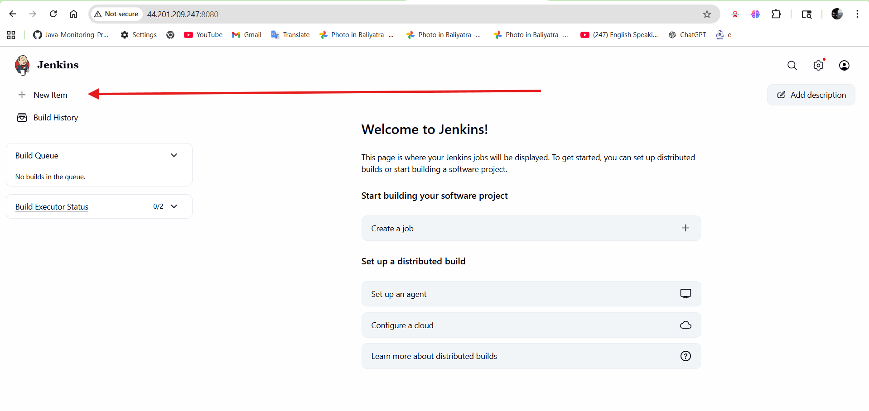
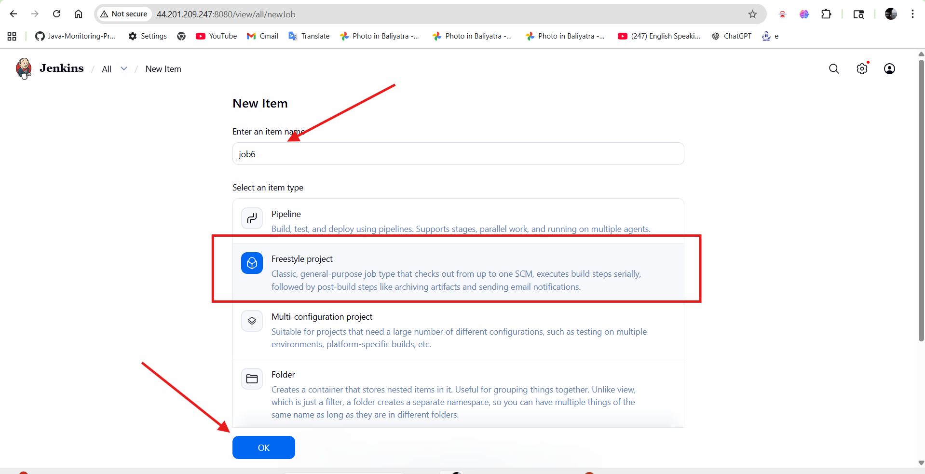
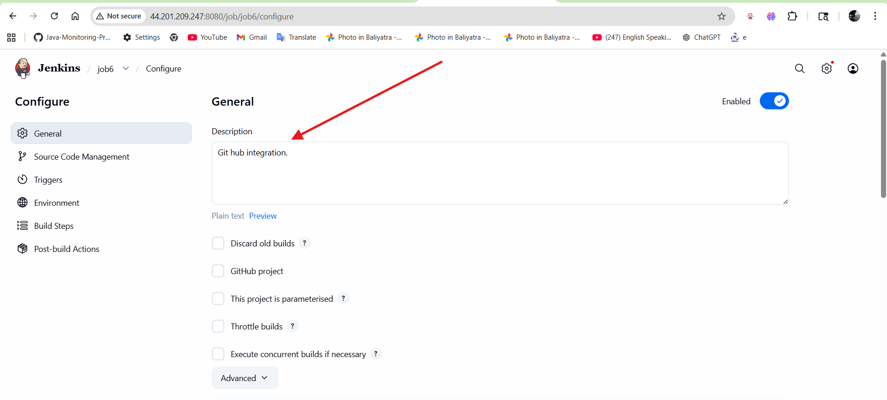
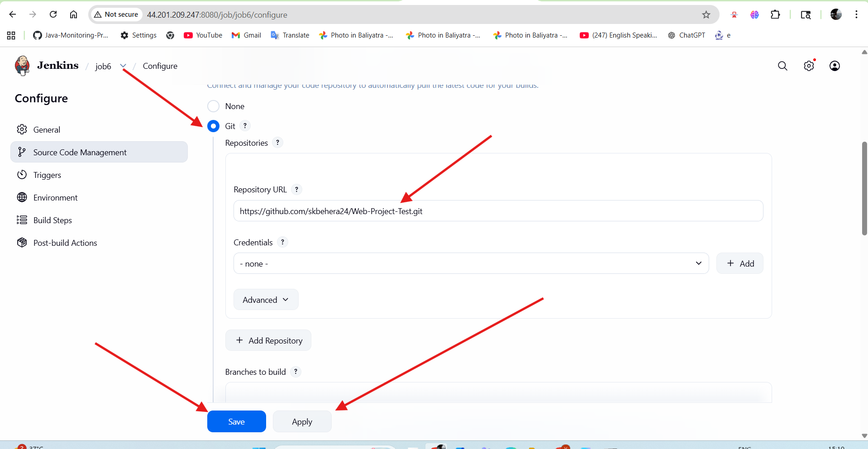
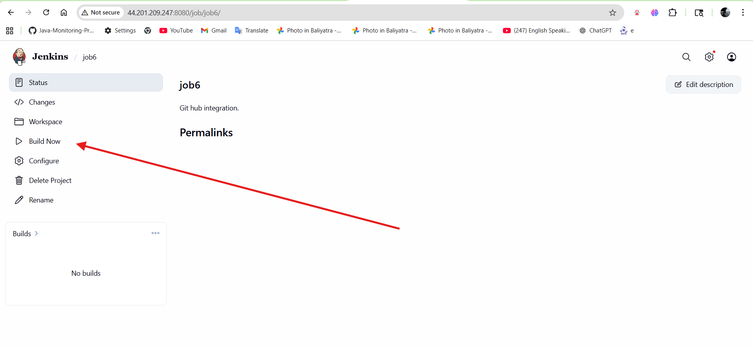
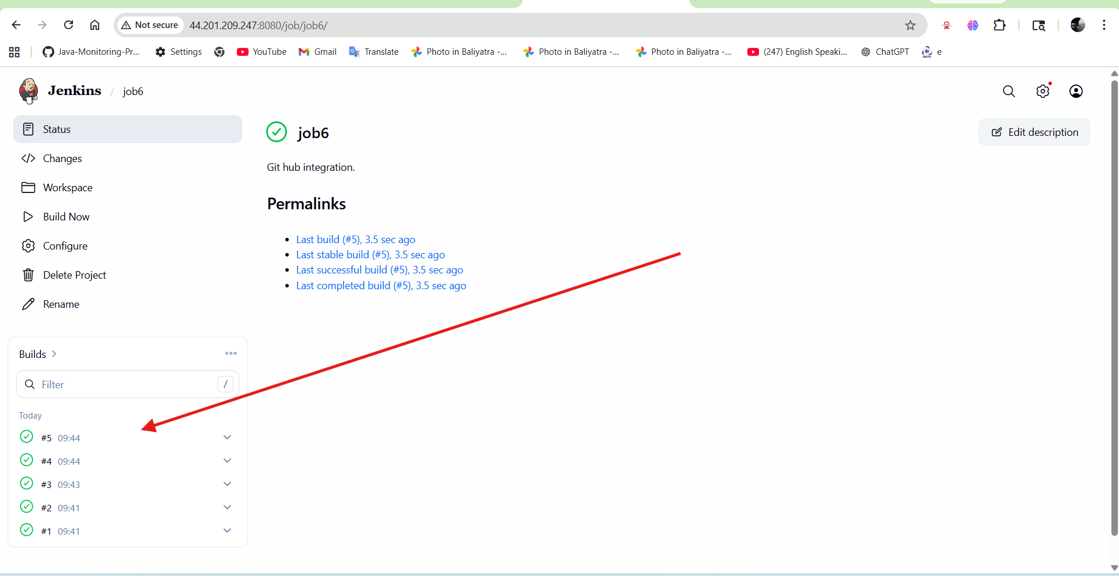
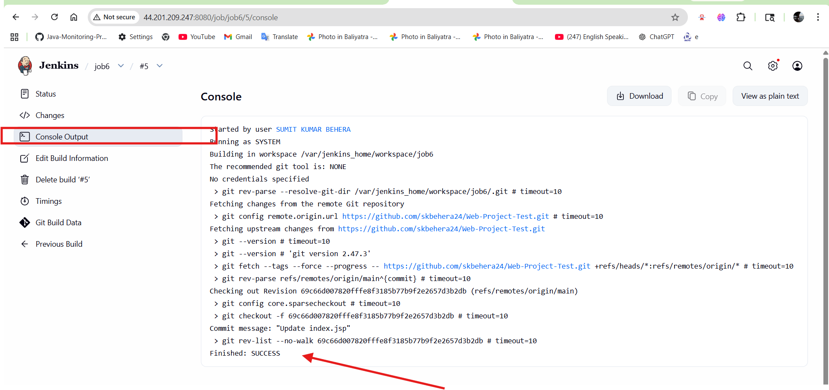
Login into cointainer
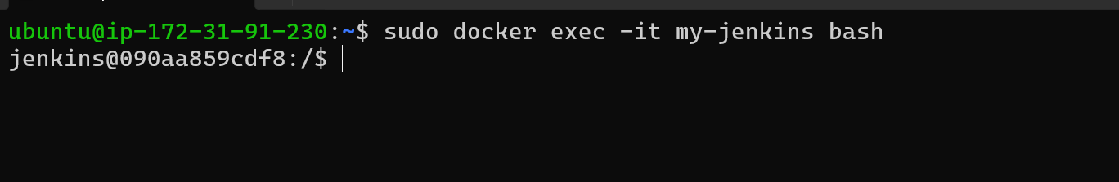
Job available in location ---- /var/jenkins_home/workspace
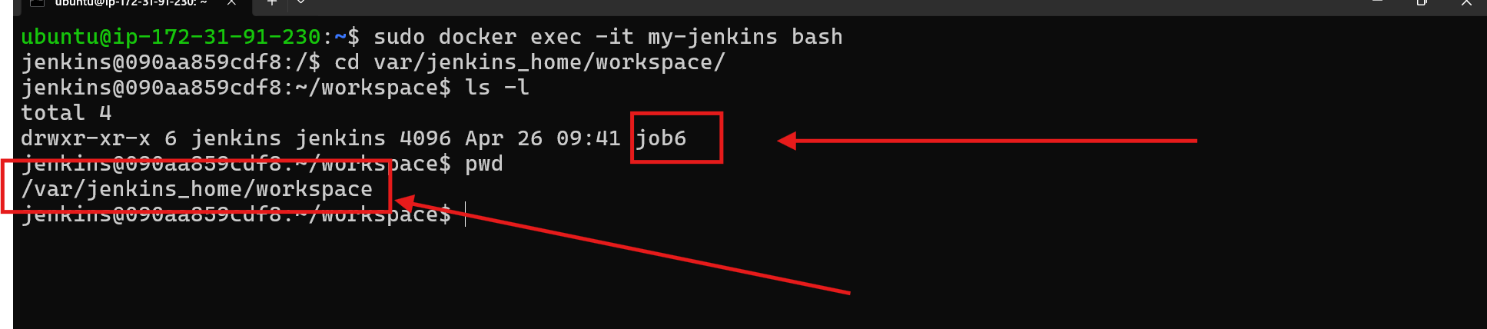

Inside job6 our code is copied
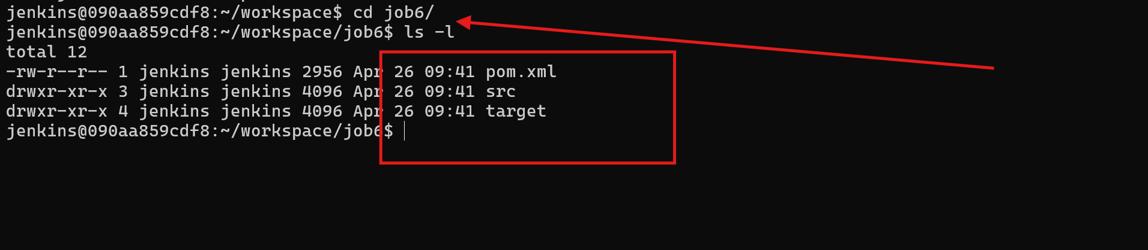

Add maven in tools maven installation
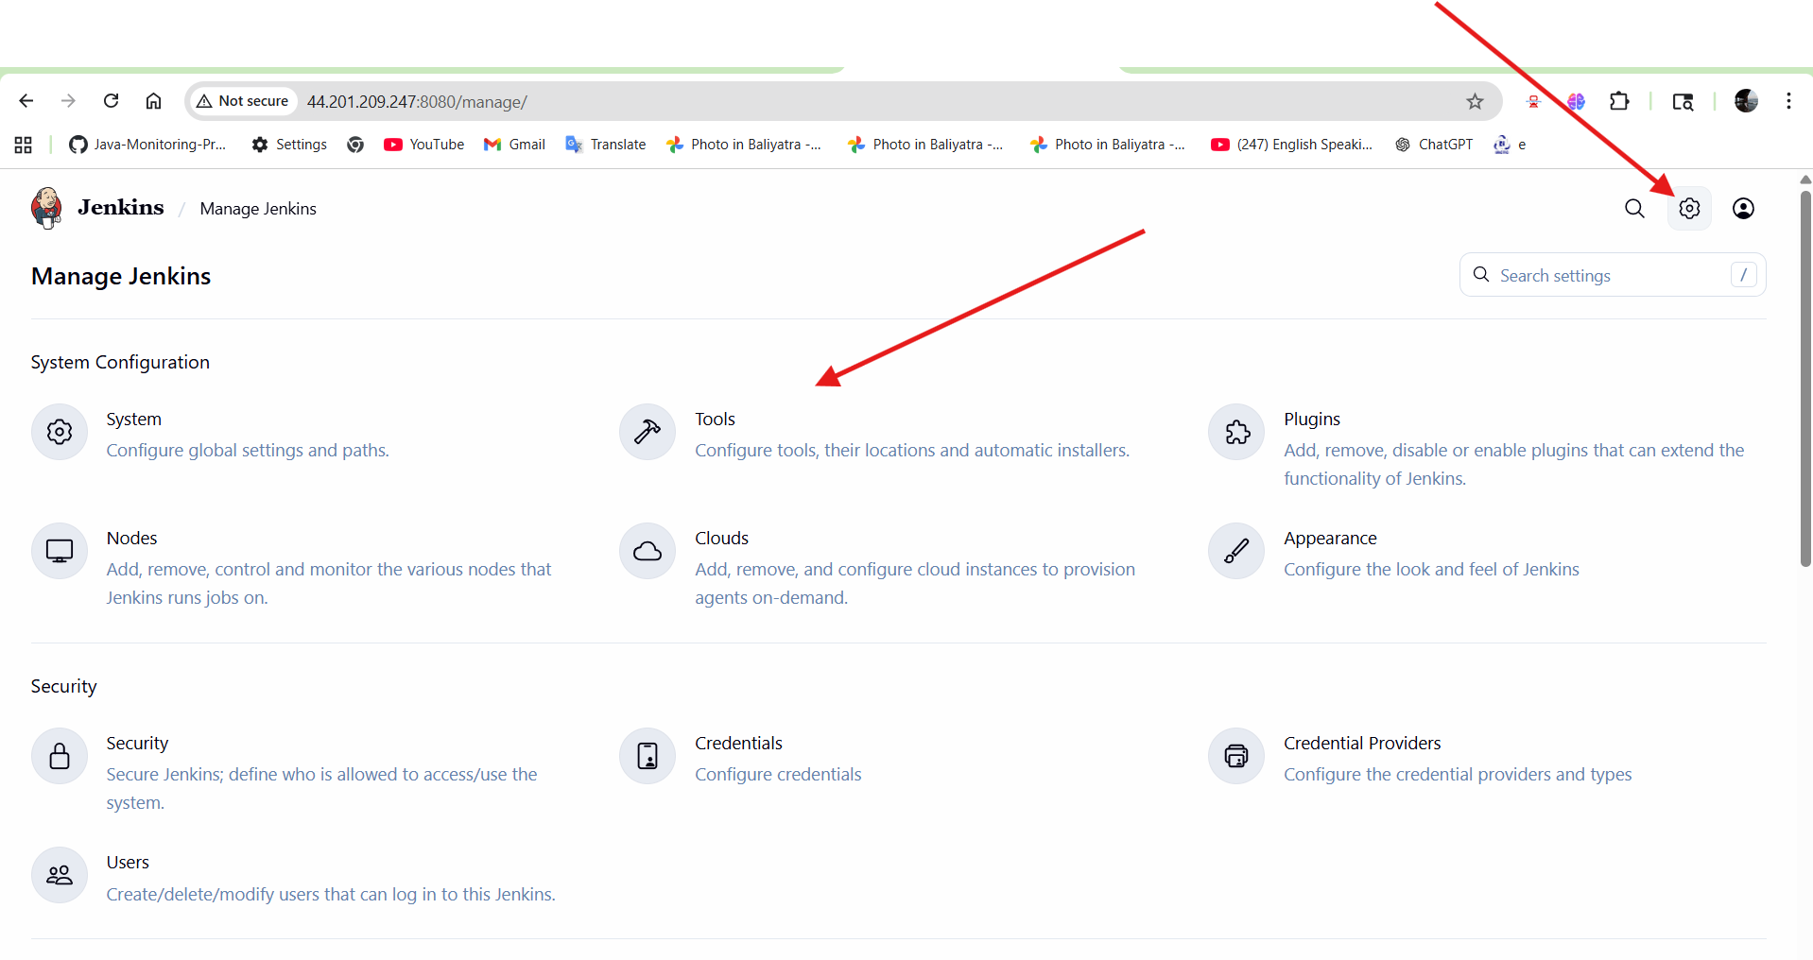
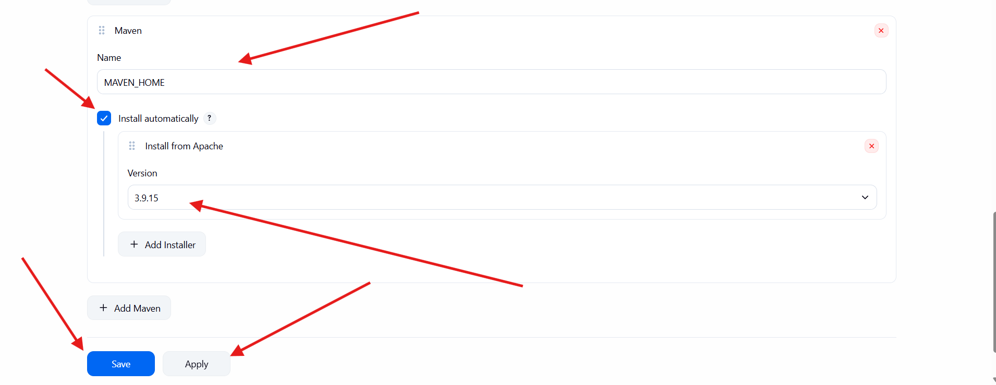

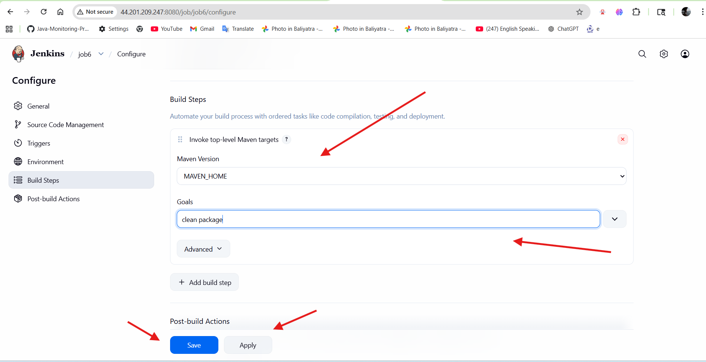
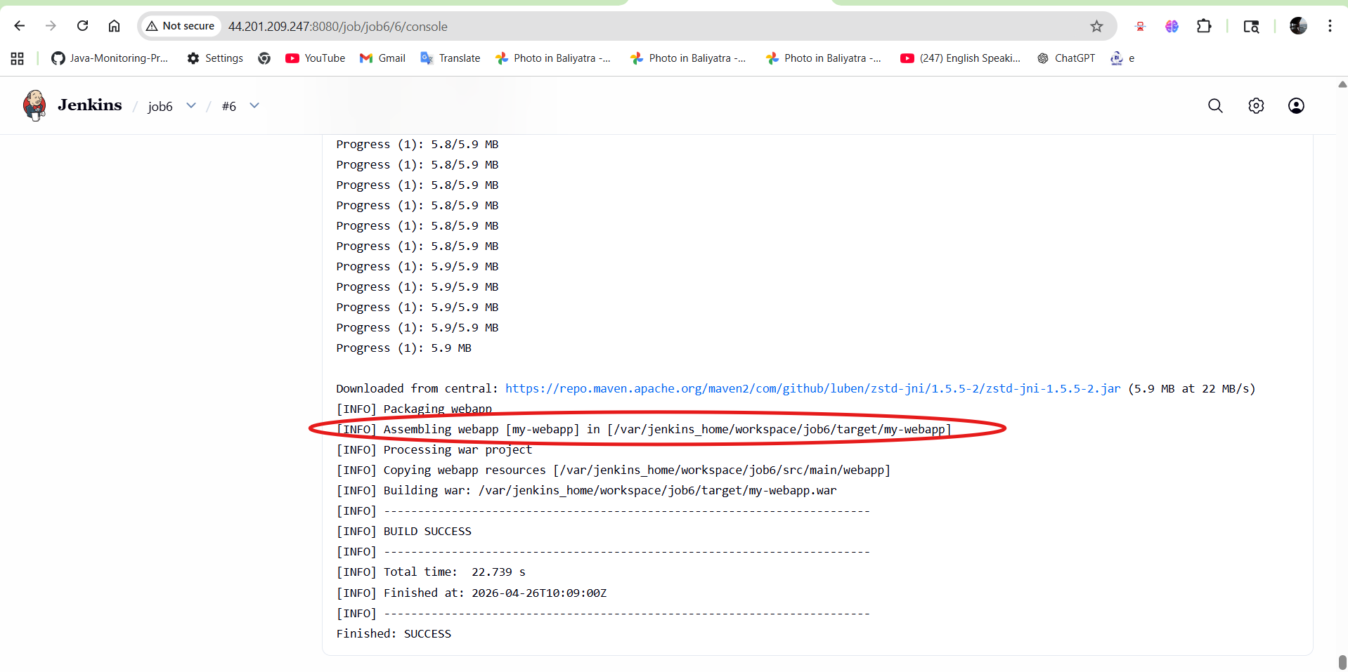

/var/jenkins_home/workspace/job6/target
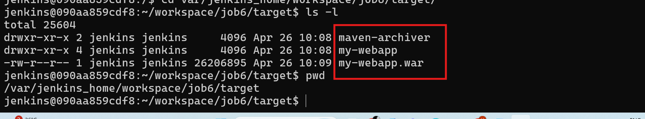

triggers
========
build periodically trigger
poll scm trigger
github webhooks trigger

build periodically trigger
===========================
If you want to build the job at a specific time or period only then
you need to go with build periodically trigger concept.
to configure time we will use CRON expression .

* * * * * ---> the job will build every minutes
H * * * * ---> the job will build every hour
H/2 * * * * ---> the job will build every 30 minutes

How it works:
-------------
Jenkins uses a CRON expression to decide when the job should start.
The CRON expression defines the minute, hour, day, month, and weekday
for the scheduled build.
When the configured time matches the CRON schedule:
1. Jenkins checks the job.
2. Jenkins starts the build automatically.
3. The job runs according to the configured pipeline or build steps.
Example:
--------
If the CRON expression is:
H 9 * * *
It means Jenkins will run the job once every day around 9 AM.
Benefits:
---------
- Automates regular builds
- Saves manual effort
- Useful for nightly builds
- Helps continuous integration process

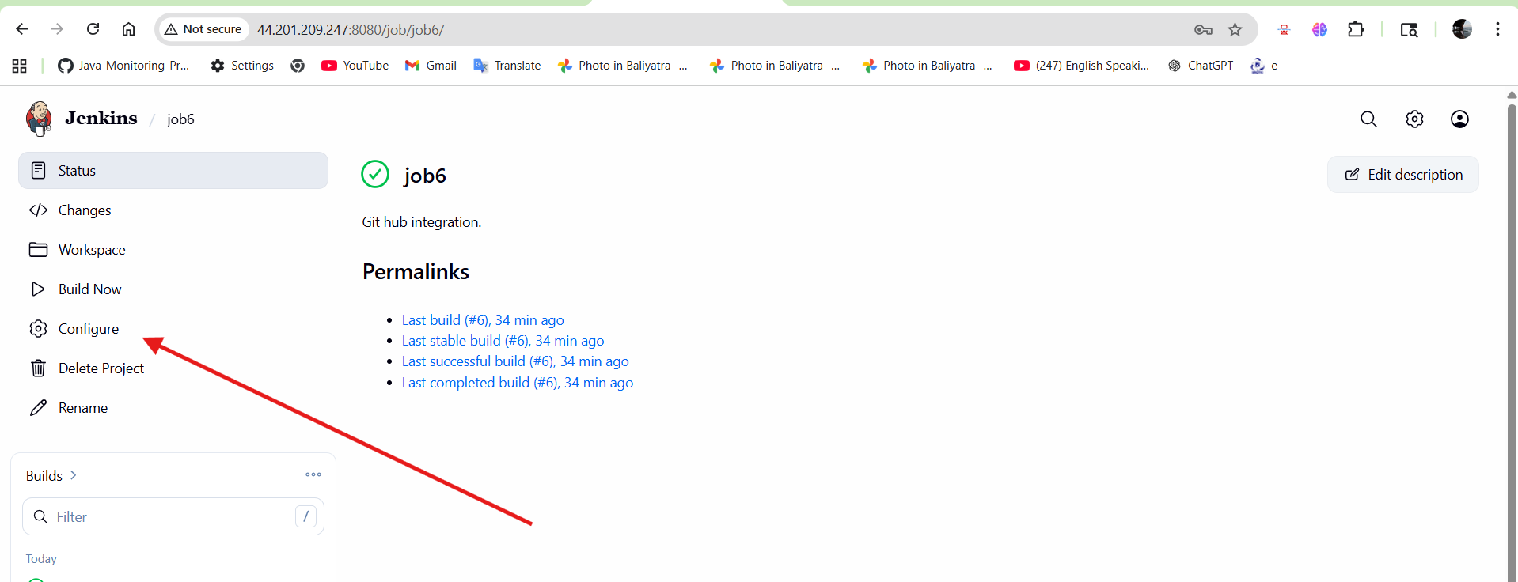

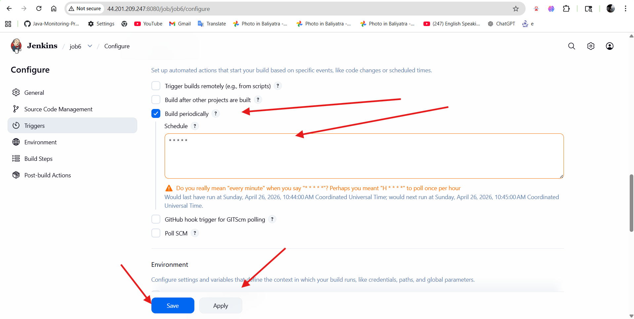
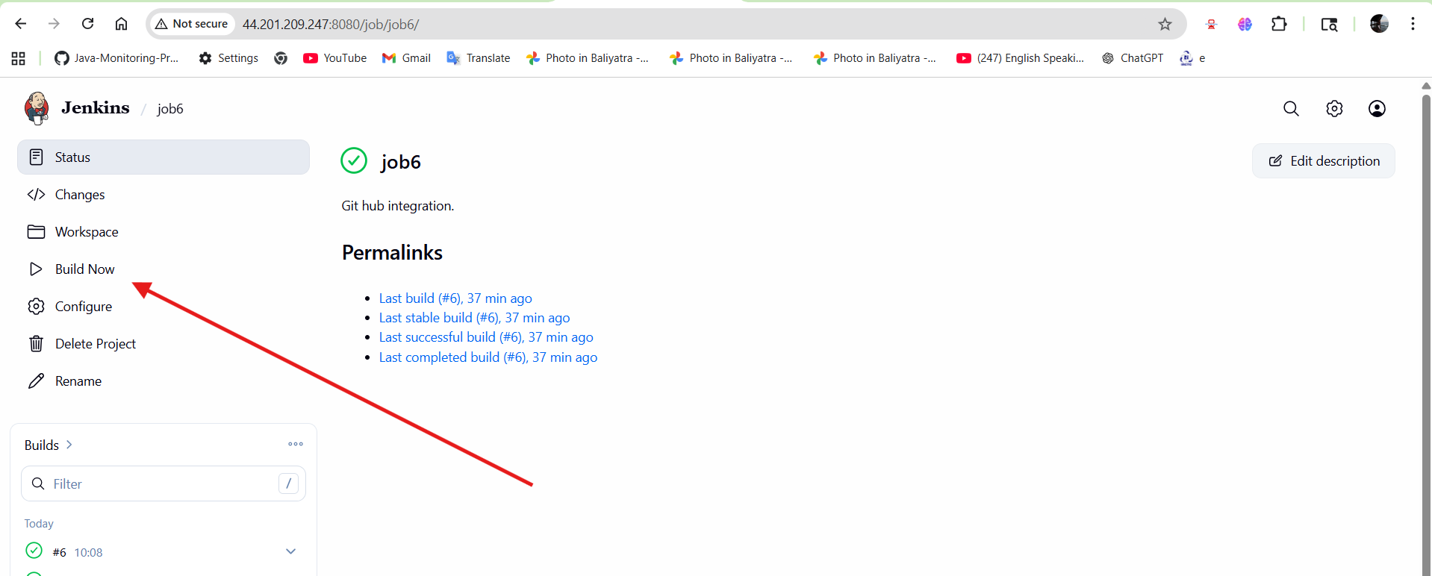
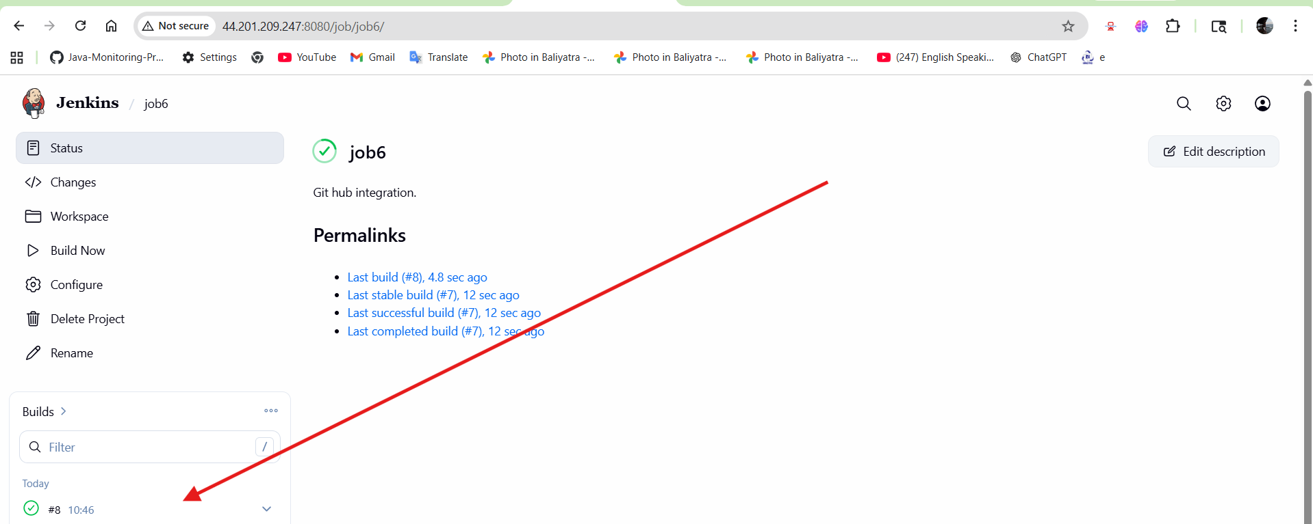
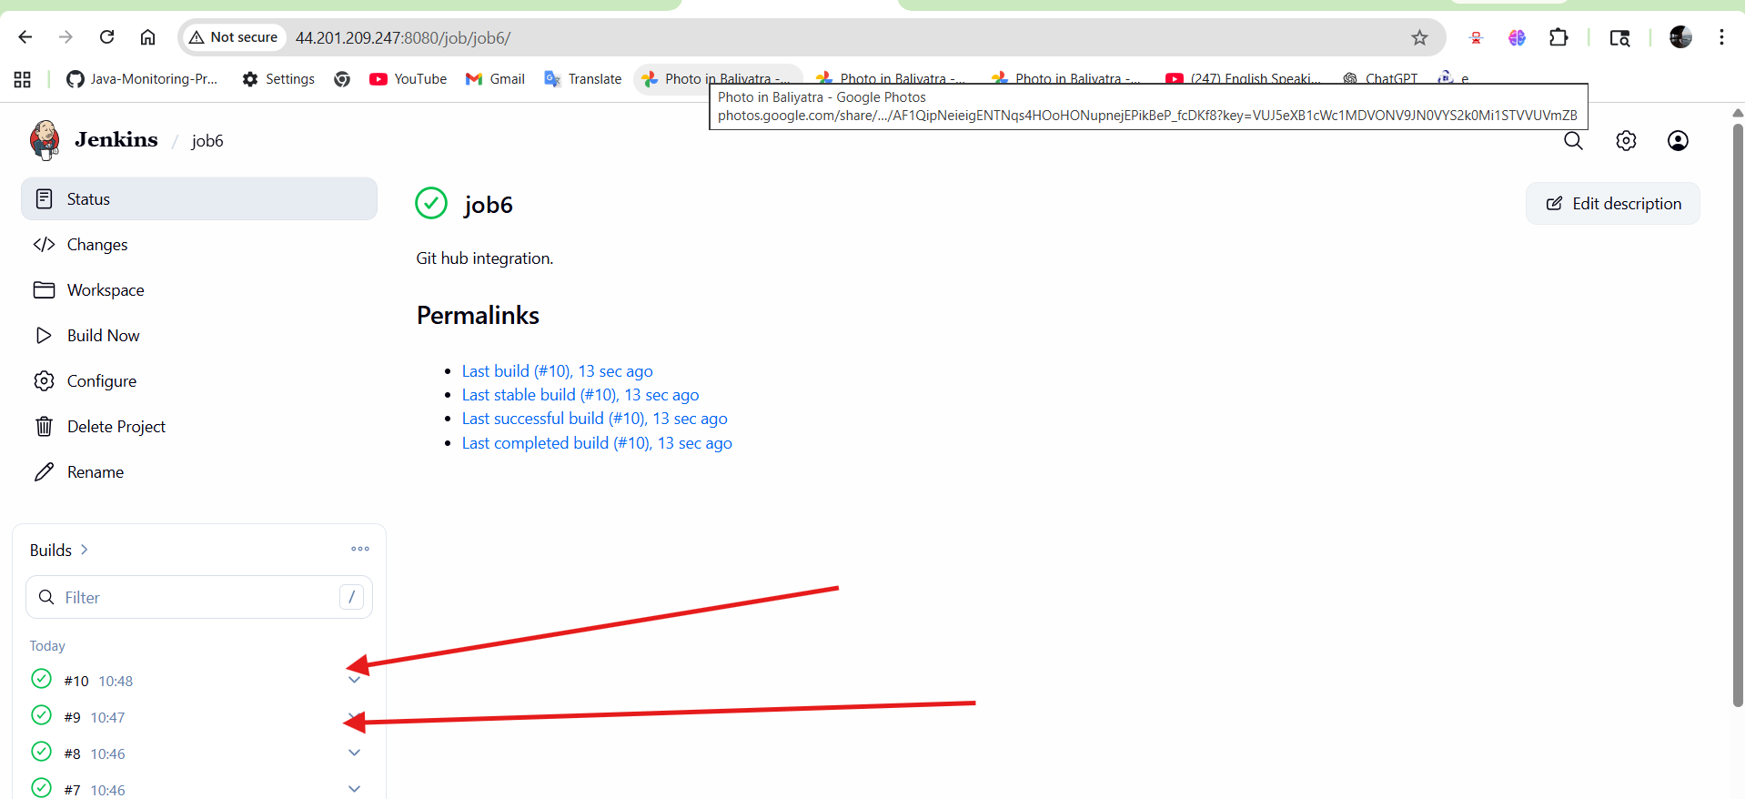

Disadvantages of Build Periodically Trigger
===========================================
1. Resource Consumption
-----------------------
If many jobs are scheduled at the same time, Jenkins server CPU and memory
usage can increase and slow down the system.
2. Unnecessary Builds
---------------------
The job may run even when no code changes are made, which can waste time
and system resources.
3. Queue Overload
-----------------
Too many scheduled jobs can create a long build queue and delay important jobs.
4. Maintenance Required
-----------------------
Incorrect CRON expressions can cause jobs to run at the wrong time, so
careful configuration is required.
5. Fixed Schedule Only
----------------------
It runs only based on time, not based on code changes or real events,
which makes it less flexible than webhook triggers.

Poll SCM Trigger
================

Poll SCM Trigger in Jenkins is used to automatically check the Source Code
Management (SCM) repository such as Git for any changes at regular intervals.

How it works:
-------------
Jenkins checks the repository based on a CRON schedule.
If Jenkins detects a new commit or code change, it automatically starts the build.

Process:
--------
1. Jenkins checks the repository.
2. It compares the latest code with the previous build.
3. If changes are found, the build starts automatically.
4. If no changes are found, the build does not run.

Example:
--------
CRON expression:

H/5 * * * *

This means Jenkins checks the repository every 5 minutes.

Benefits:
---------
- Builds only when code changes
- Saves server resources
- Reduces unnecessary builds
- Supports continuous integration

Difference from Build Periodically:
-----------------------------------
Build Periodically:
Runs at a fixed time whether code changes or not.

Poll SCM:
Runs only when Jenkins detects changes in the repository.

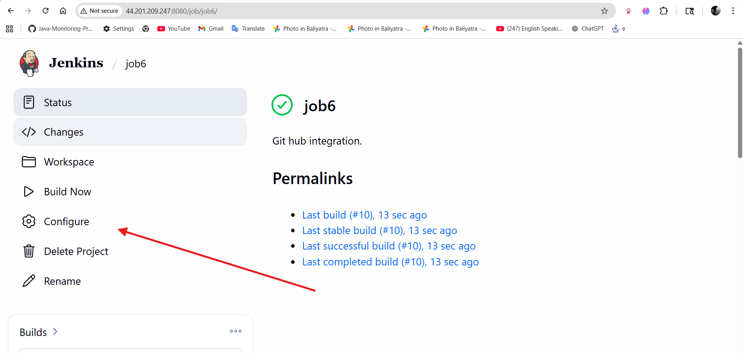
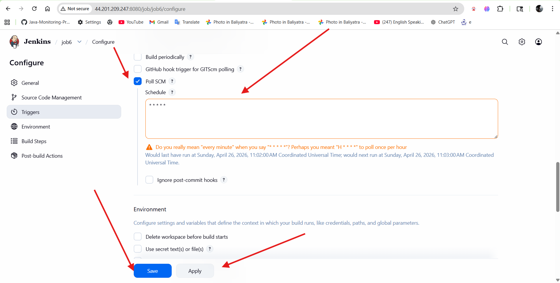
Change the code in git hub
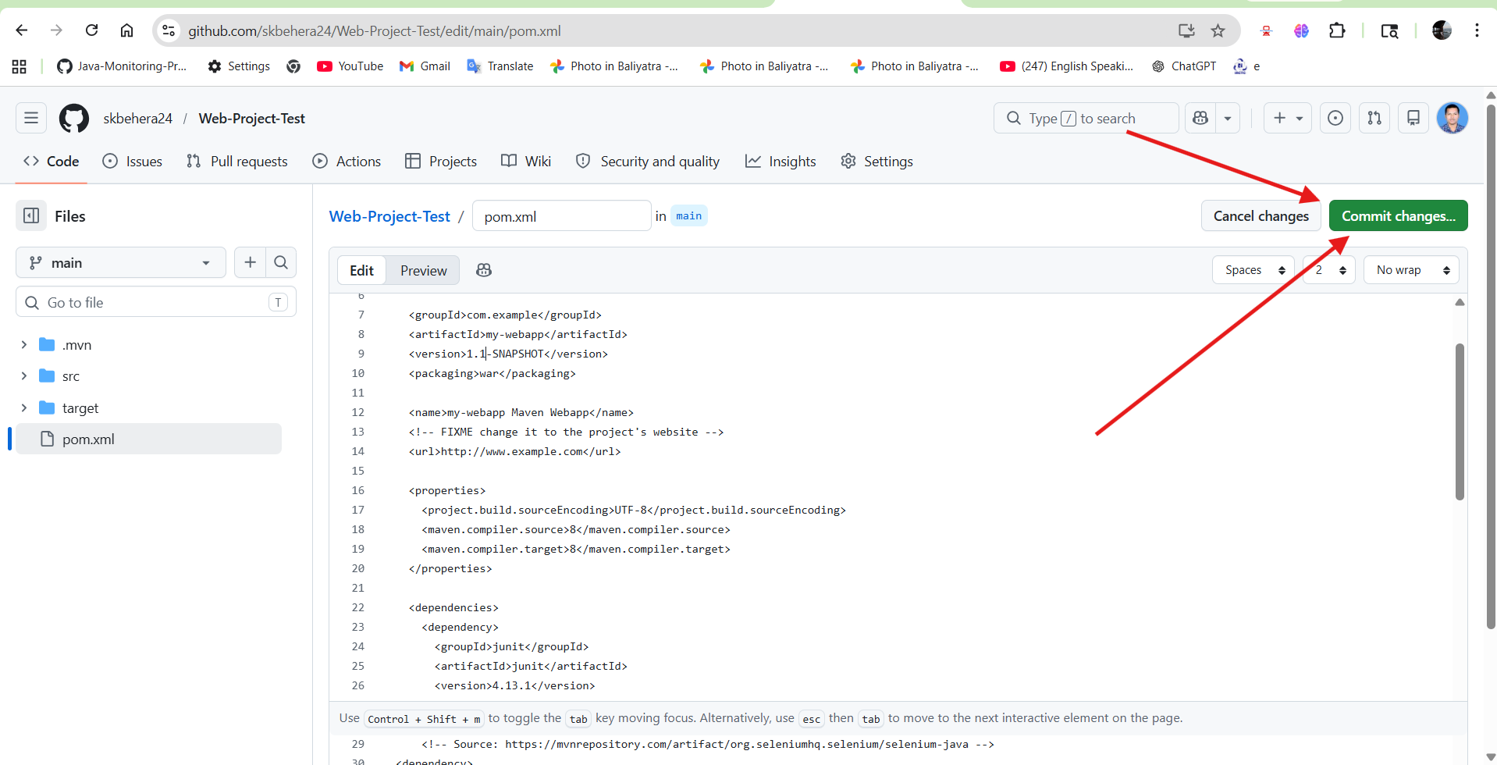

After changing the code in the central repository and committing the changes, a new build is created automatically.

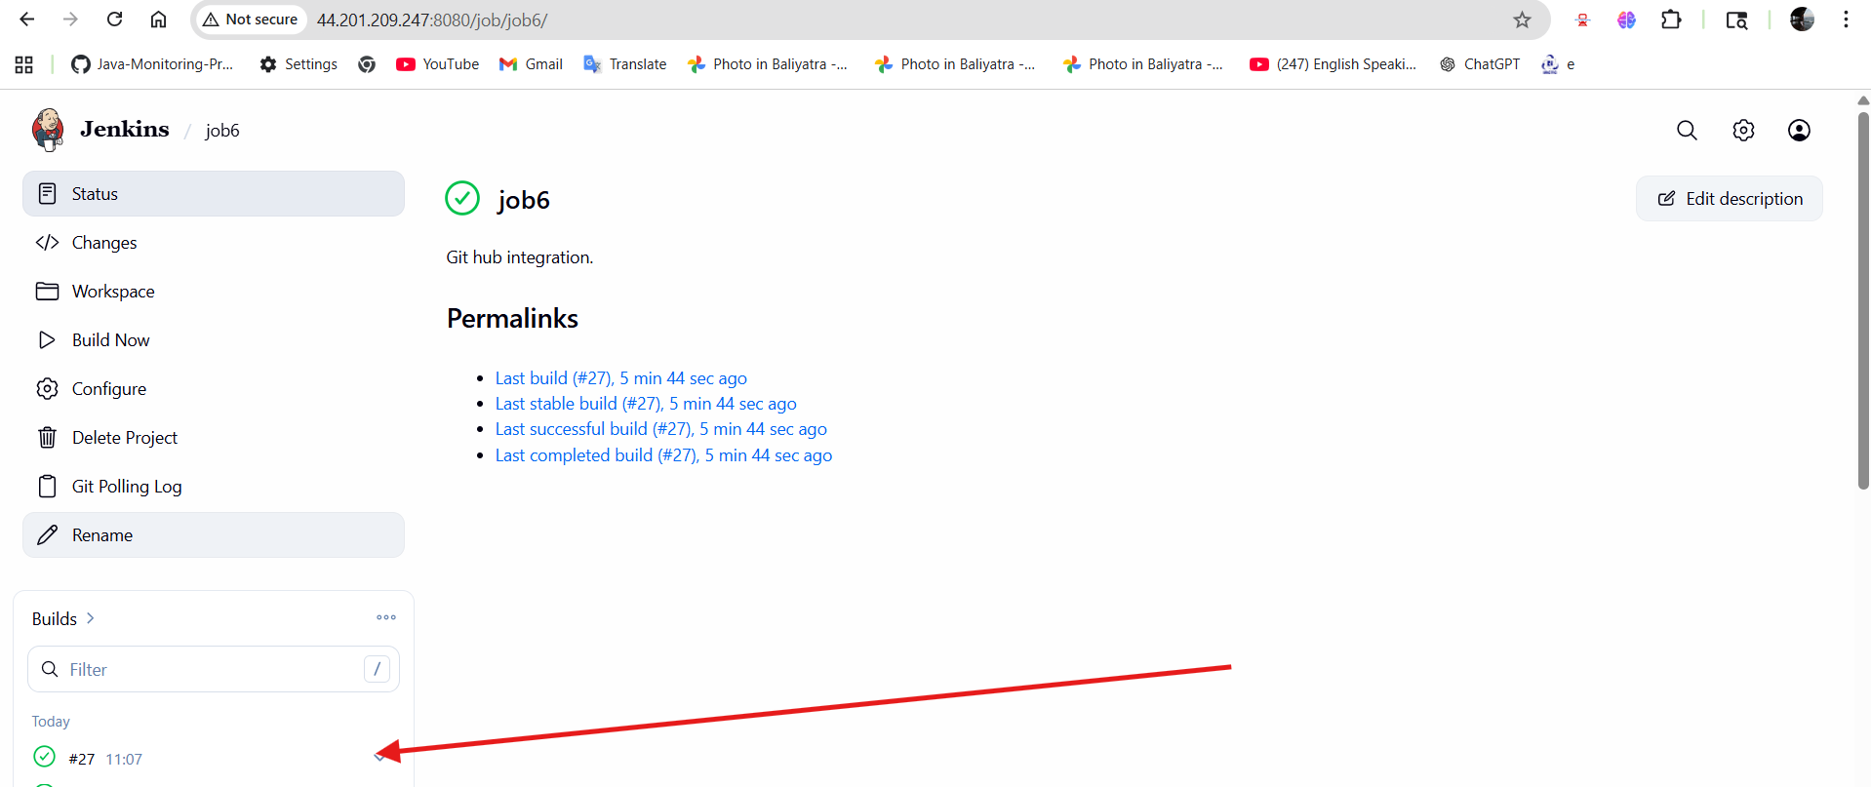

GitHub Webhook Trigger
======================

GitHub Webhook Trigger in Jenkins is used to automatically start a build
immediately when changes are pushed to a GitHub repository.

How it works:
-------------
Instead of Jenkins checking GitHub repeatedly, GitHub sends a notification
(webhook) to Jenkins whenever a new commit or pull request happens.

Process:
--------
1. Developer pushes code to GitHub.
2. GitHub sends a webhook request to Jenkins.
3. Jenkins receives the webhook event.
4. Jenkins starts the build automatically.
5. Build result can be sent back to GitHub.

Example Flow:
-------------
Developer → GitHub → Webhook → Jenkins → Build Started

Benefits:
---------
- Faster than Poll SCM
- No repeated repository checking
- Saves server resources
- Real-time build triggering
- Better for continuous integration

Required Configuration:
-----------------------
1. Enable "GitHub hook trigger for GITScm polling" in Jenkins job.
2. Add webhook in GitHub repository.
3. Webhook URL format:

http://JENKINS_URL/github-webhook/

Disadvantage:
-------------
If webhook is configured incorrectly or network fails,
the build may not trigger automatically.
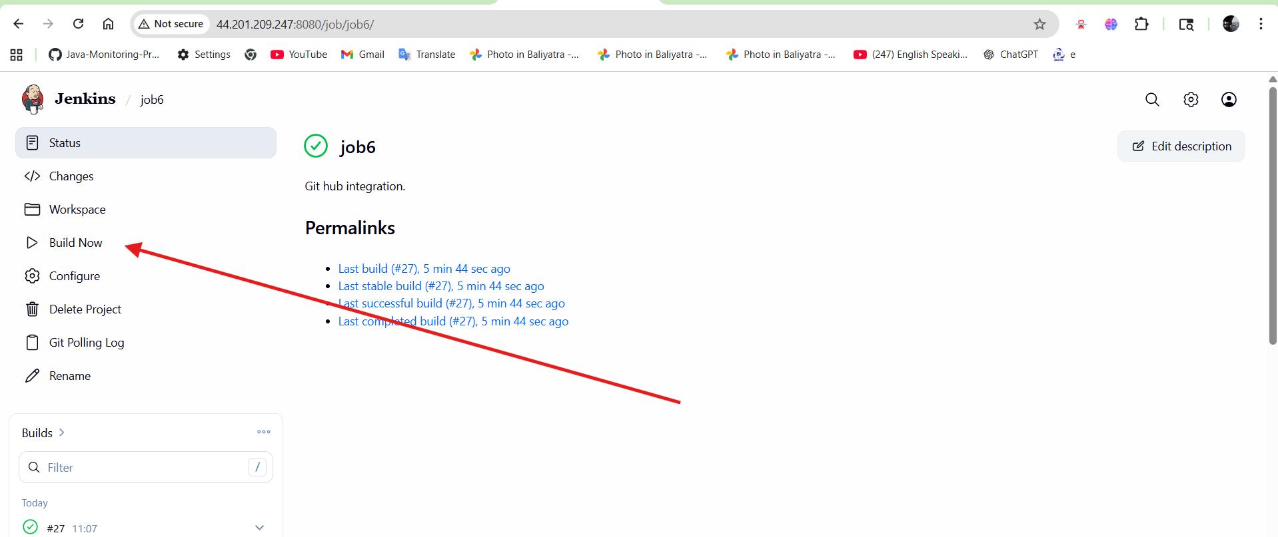
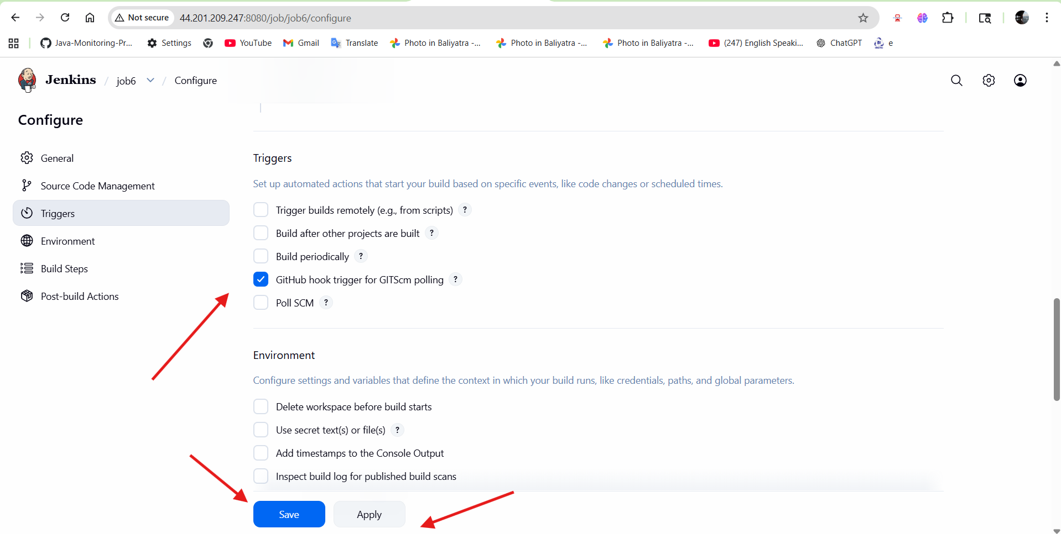
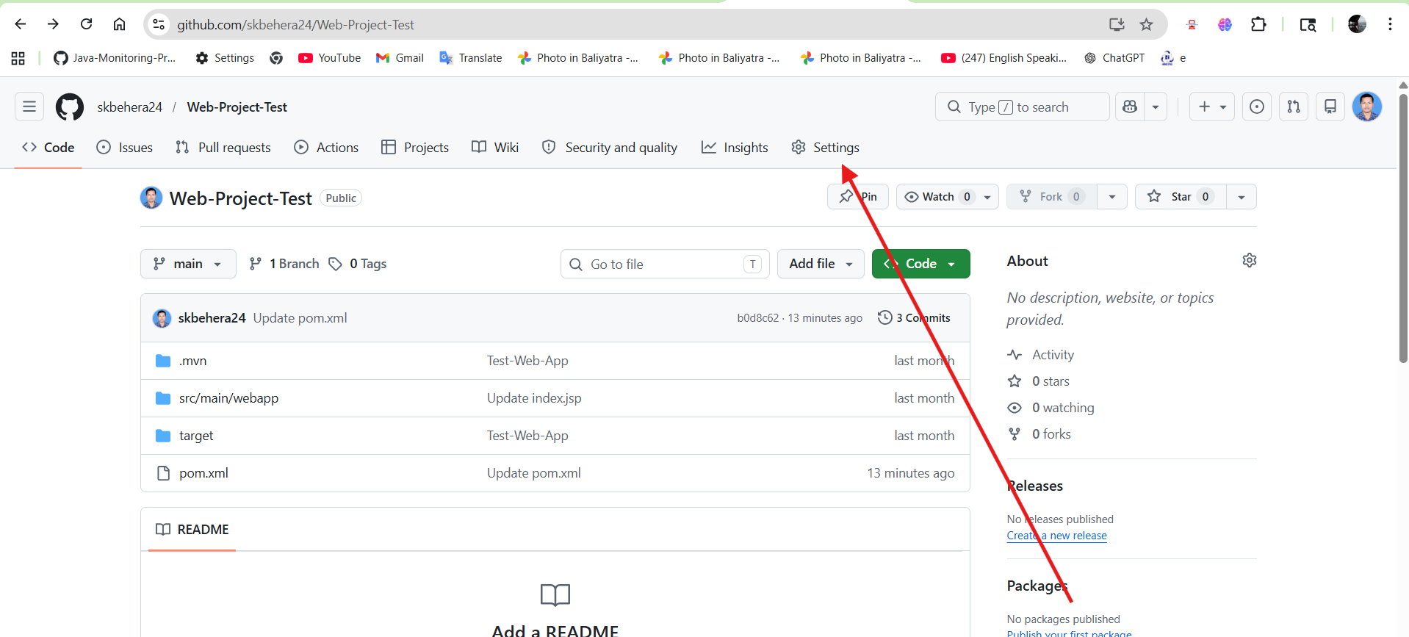
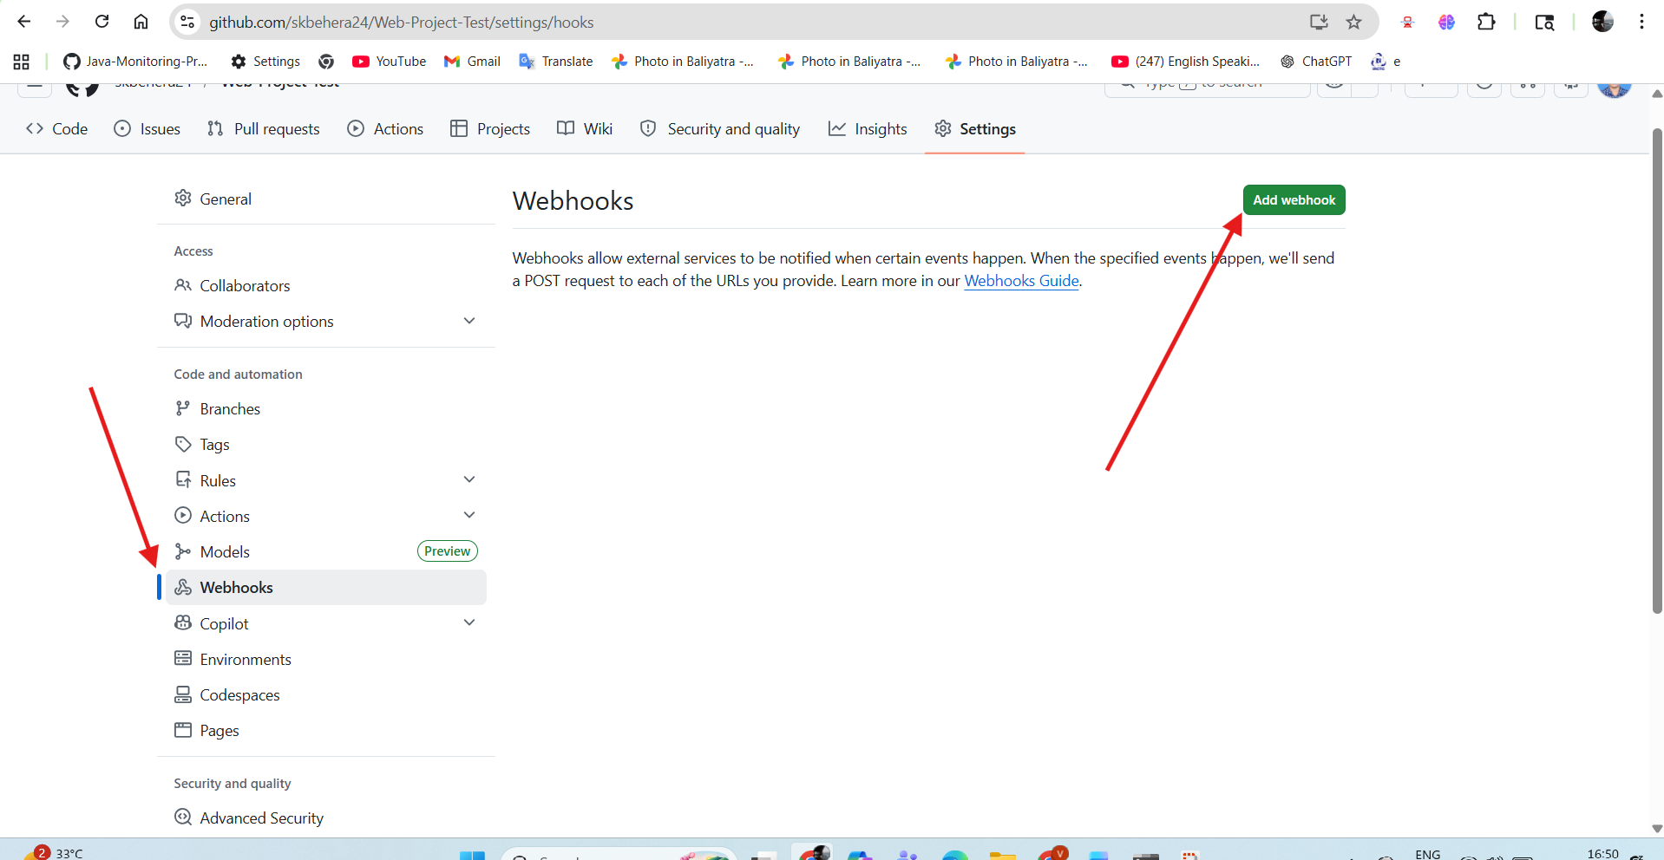

Payload URL *
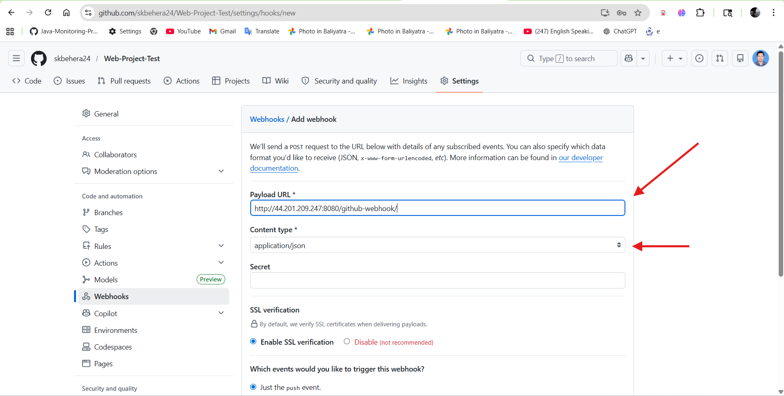
Click on ‘Add webhook’
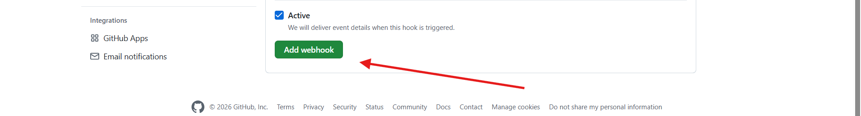

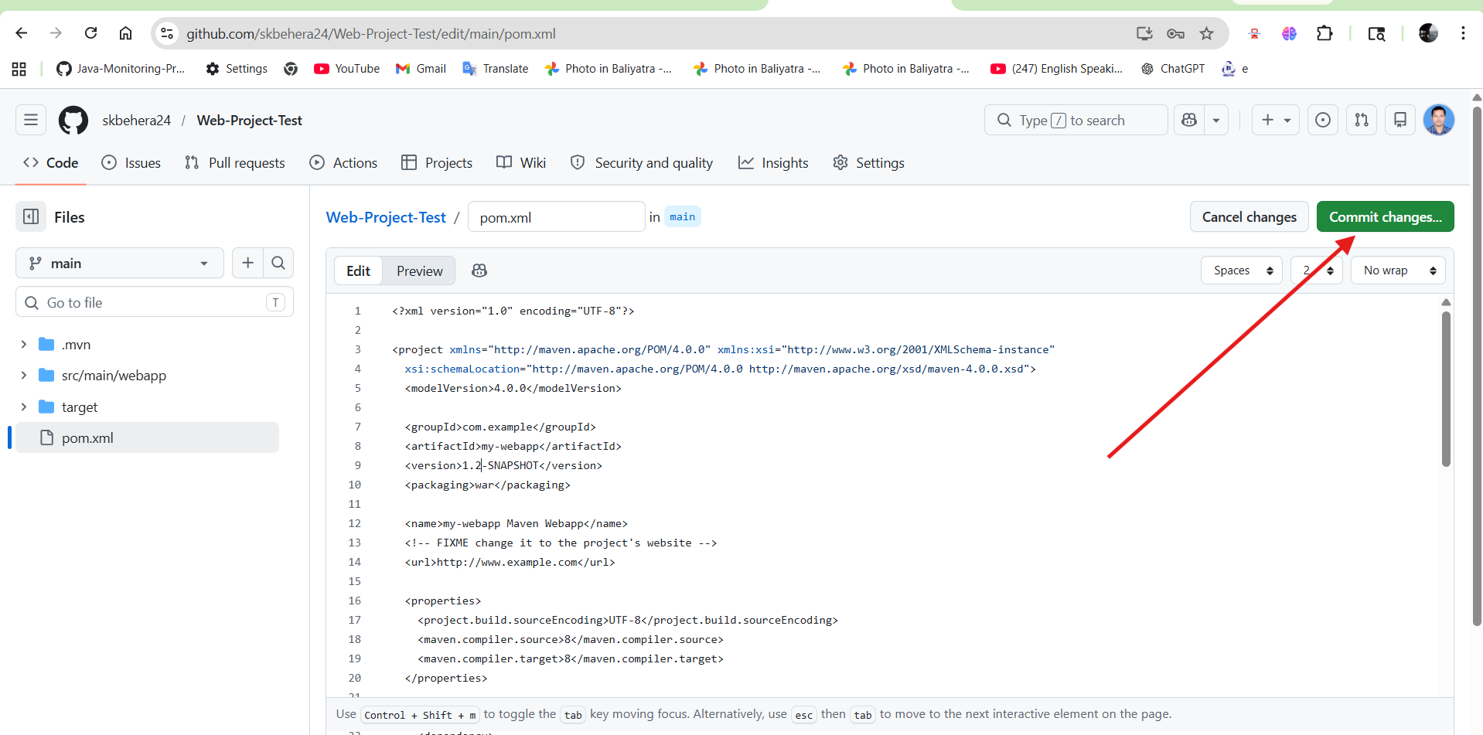

After changing the code in the central repository and committing the changes, a new build is created automatically.
