Assignment_1

**Q – 1 What is the function of summation junction of a neuron? What is threshold activation function?**

Ans – Summation, in physiology, the additive effect if serval electrical impulses on a neuron muscular junction, the junction between a nerve cell and muscle cell. Individually the stimuli cannot evoke a response, but collectively they can generate a response.

A threshold activation function results in an output signal only when in input signal exceeding a specific threshold value comes as an input.

Q – 2 **What is the step function? What is the difference of step function and threshold activation function.**

Ans – A step function like that used by the original perceptron. The output is a certain value, A1 if the input sum is above certain threshold and A0 if the input sum is below a certain threshold. The values used by the perceptron were A1 = 1 and A0 = 0

Step function is one of the simplest kind of activation function. In this we consider a threshold value and if the value if net input say y is greater then the threshold then the neuron is activated.

**Q – 3 Explain the McCulloch–Pitts model of neuron.**

**Ans –** The McCulloch – pitts neural, which was the earliest ANN model, has only two types of inputs -**Excitatory and inhibitory.** The excitatory input have weights of positive magnitude and the inhibitory weights have weights of negative magnitude. The input of the McCulloch-pitts neuron could be the either 0 or 1.

**Q – 4 Explain the ADALINE network model?**

Ans – Adaline which stands for Adaptive Linear Neuron, is a network having a single linear unit. It was developed by widrow and Hoff in 1960. Some important points about Adaline are follows –

* It uses bipolar activation function.
* Adaline neuron can be trained using Delta rule or Least Mean square (LMS) rule or widrow-hoof rule.
* The net input is compared with the target value to compute the error signal.
* On the basis of adaptive training algorithm weights are adjusted.

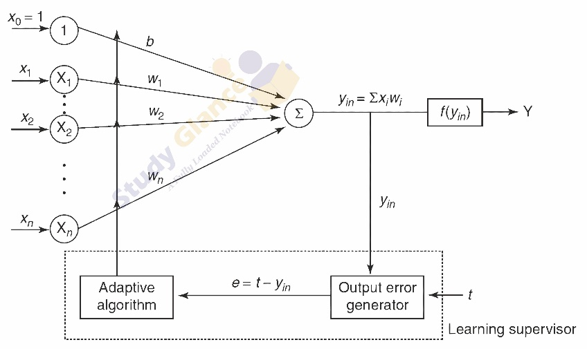

**Q – 5 What is the constraint of a simple perceptron? Why it may fail with a real-world data set?**

Ans – The most glaring limitation of the perceptron is the fact that it is only capable of solving classification problems that are linearly separable. The implies separation by a line two-dimensional space, a plane in three-dimensional space, and a hyperplane in p-dimensional space.

Perceptron network have several limitations, first the output value of a perceptron can take on only one of two value (0 or 1) due to first hard-limit transfer function. Second perceptron can only classify linearly separable sets of vectors.

**Q – 6 What is linear inseparable problem? What is the role of hidden layer?**

Ans – A linearly inseparable problem is a problem that, when represented as a pattern space, requires more then one straight cut to separate all of the patterns of one type in the space from all of the patterns of another type.

In neural network, a hidden layer is located between the input and output of the algorithm, in which the applies weights to the inputs and directs them through an activation function as the output. In short the hidden layers perform nonlinear transformation of the inputs entered into the network.

**Q – 7 Explain OXR problem in case of simple perceptron?**

**Ans –** The XOR problem is that we need to build a Neural network(a perceptron in our case) produce the truth table related to the XOR logical operator. This is a binary classification problem. Hence supervised learning is a better way to solve it, in this case we will be using perceptron’s.

**Q – 8 Design a multi-layer perceptron to implement A XOR B?**

**Ans –** To solve this problem, we add an extra layer to our vanilla perceptron, i.e., we create a multi layered perceptron(or MLP). We call this extra layer as the hidden layer. To build a perceptron, we first need to understand that the OXR gate can be written as a combination of AND gates, NOT gate and OR gates in the following way:-

a **XOr** b = (a **AND NOT** b)**OR**(b**AND NOT**a)

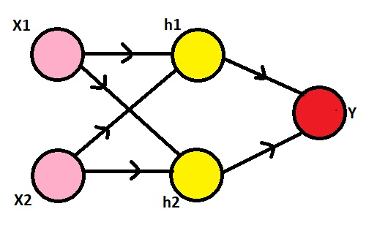

Here, we need to observe that our inputs are 0s and 1s. To make it a XOR gate, we will make the h1 node to perform the (x2 **AND NOT** x1) operation, the h2 node to perform (x1 **AND NOT** x2) operation and the y node to perform (h1 **OR** h2) operation. The NOT gate can be produced for an input a by writing (1-a), the AND gate can be produced for inputs a and b by writing (a.b) and the OR gate can be produced for inputs a and b by writing (a+b). Also, we'll use the sigmoid function as our activation function σ, i.e., σ(x) = 1/(1+e^(-x)) and the threshold for classification would be 0.5, i.e., any x with σ(x)>0.5 will be classified as 1 and others will be classified as 0.

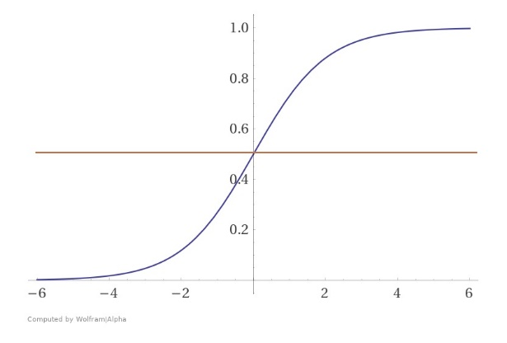

**Q – 9 Explain the single-layer feed forward architecture of ANN.**

**Ans –** The input layer is connected to the output layer nodes with weights. All the input nodes connected to each of the output nodes. The term feed-forward depicts that there is not feedback sent from the output layer to input layer. This forms a single layer feed-froward network.

**Q – 10 Explain the competitive network architecture of ANN.**

**Ans –** 1.2 Artificial Neural network Architecture. ANN is made of three layer namely input layer, output layer, and hidden layer. There must be a connection form the nodes in the input layer with the nodes in the hidden layer and layer and from each hidden layer node with the nodes of the output layer.

**Q – 11 Consider a multi-layer feed forward neural network. Enumerate and explain steps in the backpropagation algorithm used to train the network.**

**Ans** – Multilayer Feed-Forward neural network is an interconnection Artificial neural network with multiple layer that has neuron with weights associated with them and they compute the result using activation functions.

The backpropagation algorithm performs learning on a multilayer feed-forward neural network. It iteratively learns a set of weights for prediction of the class labels of tuples. A multilayer feed froward neural network consists of an input layer, one or more hidden layer and an output layer.

**Q – 12 What are the advantages and disadvantages of neural network.**

**Ans – Advantages –** ANNs have the ability to learn and model non-linear and complex relationships, which is really important because in real-life, many of the relationship inputs and outputs are non-linear as well as complex.

**Disadvantages –**

1. Black box
2. Duration of development.
3. Amount of data
4. Computationally expansive.

**Q – 13 Write a short notes of two followings.**

**Ans – Biological neuron –** The simplified models of biological neurons, as describe above, can be assembled to form the stereotypical neuron in deep learning models. The deep learning neurons receives inputs or activation from other neurons. The activation are rate coded representation of the spiking of biological neurons.

**ReLU function –** The rectified linear activation function or Relu for short is a piecewise linear functions that will output the input directly if it is positive, otherwise, it will output zero.