Pytho_Assingment_14

**Ques – 1 What does RGBA stand for?**

Ans – The RGB colour model is extended in this specification to include “alpha” to allow specification of the opacity of a colour.

**Ques – 2 From the Pillow module, how do you get the RGBA value of any image?**

Ans – import the image module from the pillow library. From PIL impot image.

Open any image and get the RGBBAG value. Img =opne(‘image.png’)rgba = img.convert(RGBA“)

**Ques – 3 What is the box tuple, and how does it works?**

Ans – The box.tuple submodule provides read-only access for the tuple user data type. It allows, for a single tuple: selective retrieval of the filed contents, retrieval of information about size, iteration over all the file, and conversion to lua table.

**Ques – 4 Use your image and load in notebook then, How can you find out the width and hight of an image object?**

Ans –

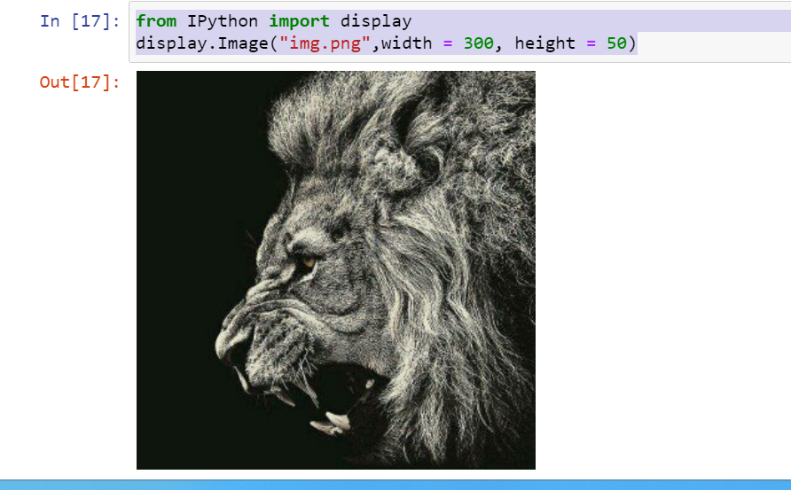

**Ques – 5 What method would you call to get image object for a 100*100 image, excluding the lower-left quarter of it?**

Ans – Open() method is used to open the image and then width and hight property of the image is used to get the height and width of the image.

**Ques – 6 After making changes to an image object, how could you SAVE it as an image file?**

Ans – imwrite() save the image file to the specified path.

**Ques – 7 What module contains pillow’s shape-drawing code?**

Ans – The **‘ImageDraw’** module provides simple 2D graphics support for image object. Generally, we use this module to create the new image, annotate or retouch existing image and to generate graphics on the fly for web use. The graphics commands support the drawing of shapes and annotation of text.

**Ques – 8 Image do not have drawing methods. What kind of object does? How do you get this kind of object?**

Ans -