



OCI Windows Instance Console Connection Creation

April 2025, Version 1.0

Sharath Kumar

EMEA Cloud Compute domain specialist

Copyright © 2024, Oracle and/or its affiliates Public

This document explains how to troubleshoot malfunctioning OCI Windows VM instances remotely.

Console connections allow administrators to directly diagnose and fix issues with VMs that aren't working as expected. This is particularly helpful when an imported or custom image fails to boot, or when a previously working VM stops responding.

Using console connections, administrators can access the VM's serial output to make necessary repairs or changes, resolving issues quickly without needing physical access to the machine.

Contents

**Introduction** 3

**Prerequisites** 3

**Accessing the OCI Console** 3

**Navigating to the Instance** 3

**Creating a Console Connection** 4

**Connecting via VNC Viewer** 4

**Connecting via Serial Console** 6

**Troubleshooting & Documentation** 7

Summary 7

**Introduction**

A Console Connection in Oracle Cloud Infrastructure (OCI) enables users to access their Windows/Linux instances when SSH is unavailable.

This guide provides a step-by-step process for setting up console connections using both VNC and Serial Console for Windows.

**Prerequisites**

Before you begin, ensure you have the following:

* An OCI account with appropriate permissions
* An existing Windows instance (Windows 2019 used for this demo)
* SSH Key Pair for authentication
* VNC Viewer (for graphical console access)

**Accessing the OCI Console**

1. Open the [OCI Console](https://cloud.oracle.com/).
2. Sign in using your OCI credentials

**Navigating to the Instance**

1. Click on the **Navigation Menu** (☰) in the top-left corner.
2. Go to **Compute → Instances**.

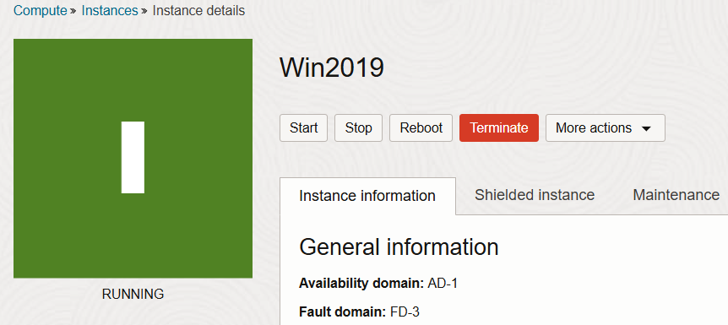

1. Click on the **Instance Name** to open its details page.

**Creating a Console Connection**

1. In the **Resources** section, select **Console Connections**.
2. Click **Create local connection**.
3. Choose one of the following options:
   * **Generate a new Key Pair** (Download the private key).
   * **Paste a Public Key** (If you already have one).
4. Click **Create Console Connection**.

**Connecting via VNC Viewer**

1. Click the three dots (⋮) menu next to the console connection.

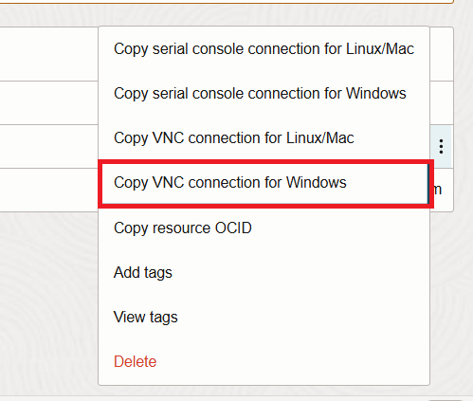

1. Select **Copy VNC Connection for Windows**.
2. Download [plink](https://the.earth.li/~sgtatham/putty/latest/w64/plink.exe).exe and place the file in c:\windows\system32
3. Open Windows Powershell as admin user and modify the SSH key path:

Start-Job { Echo N | plink.exe -i Your SSH key path -N -ssh -P 443 -l ocid1.instanceconsoleconnection.oc1.eu-frankfurt-1.antheljtldij5aic2thcxnk5jiuch2nyrlkkcxdmeq6y676abb337rny4txa -L 5905:ocid1.instance.oc1.eu-frankfurt-1.antheljtldij5aicckghi2kmuccrdyvha2nld2ahhdoavd5as4et5l55aiyq:5905 instance-console.eu-frankfurt-1.oci.oraclecloud.com }; sleep 5; plink.exe -i Your SSH key path -N -L 5900:localhost:5900 -P 5905 localhost -l ocid1.instance.oc1.eu-frankfurt-1.antheljtldij5aicckghi2kmuccrdyvha2nld2ahhdoavd5as4et5l55aiyq

Note : If you are using OCI generated SSH key and connecting from windows machine use [PuttyGen](https://the.earth.li/~sgtatham/putty/latest/w64/puttygen.exe) tool to convert the SSH key to windows format

1. Open **VNC Viewer** and enter:

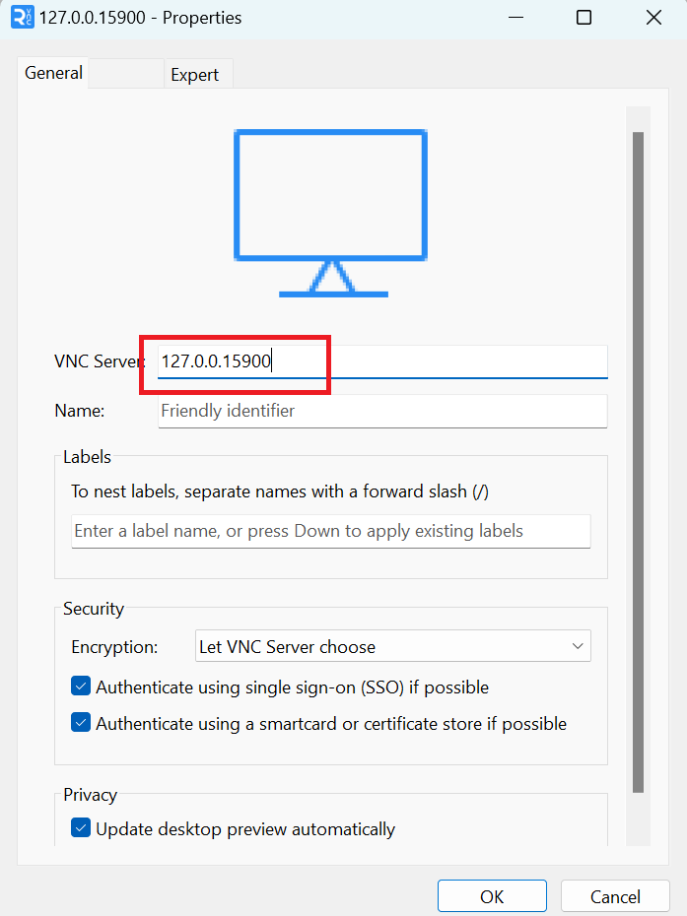

1. Click **Connect** to access the instance via VNC.

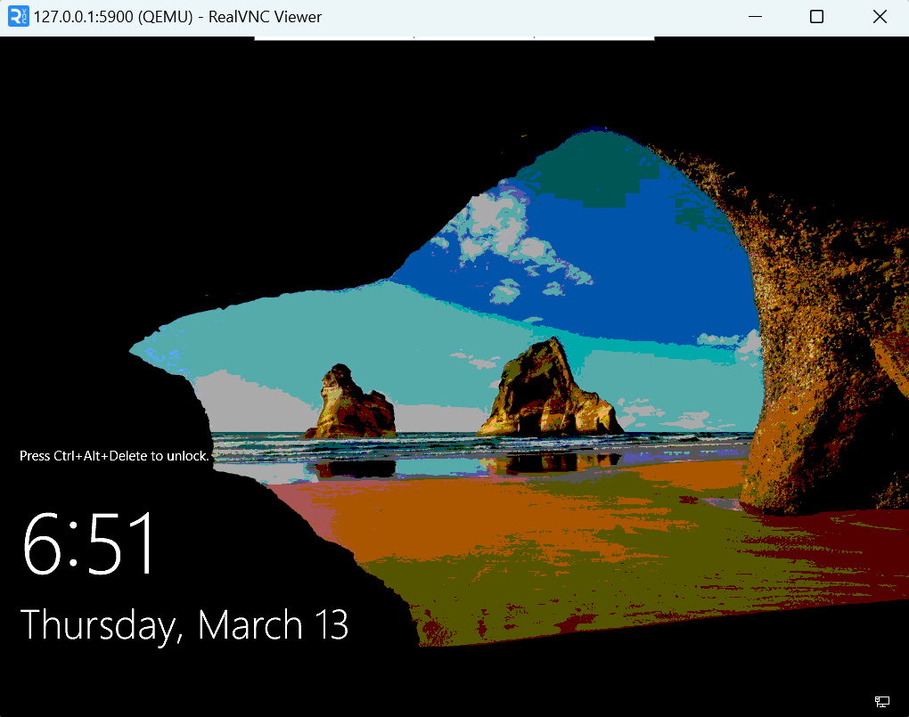

**Connecting via Serial Console**

If you don’t have VNC Viewer, you can connect using the Serial Console:

1. Click the three dots (⋮) menu again.

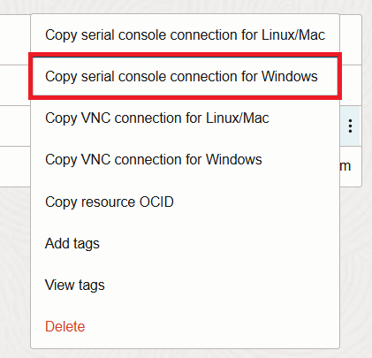

1. Select **Copy Serial Console for Windows**.
2. Open Windows Powershell or command prompt modify the SSH command and run:

Start-Job { Echo N | plink.exe -i Your SSH key path -N -ssh -P 443 -l ocid1.instanceconsoleconnection.oc1.eu-frankfurt-1.antheljtldij5aicvuztz4snc4pvmrsqywuvex5awqy26ujbtk6fxowmol6a -L 22000:ocid1.instance.oc1.eu-frankfurt-1.antheljtldij5aicckghi2kmuccrdyvha2nld2ahhdoavd5as4et5l55aiyq:22 instance-console.eu-frankfurt-1.oci.oraclecloud.com }; sleep 5; plink.exe -i Your SSH key path -P 22000 localhost -l ocid1.instance.oc1.eu-frankfurt-1.antheljtldij5aicckghi2kmuccrdyvha2nld2ahhdoavd5as4et5l55aiyq

1. You will now be connected to the server via the serial console.

**Troubleshooting & Documentation**

* Ensure the private key path is correct.
* If VNC does not connect, verify that the SSH tunnel is active.
* For additional details, refer to the [OCI Documentation](https://docs.oracle.com/en-us/iaas/Content/Compute/References/serialconsole.htm).

# Summary

By utilizing both serial console and VNC console connections, you can effectively troubleshoot and resolve issues with Oracle OCI instances.

The serial console provides a text-based interface for diagnosing and repairing issues, such as access problems or recovery from a lost key or password. Meanwhile, the VNC console offers a graphical interface, allowing you to interact with the instance's desktop environment, which can be particularly useful for troubleshooting complex issues. To ensure successful connections and management, carefully follow the provided steps for configuring and accessing both console types.

This process will enable you to monitor instance status, access logs, and perform recovery tasks efficiently.

**Connect with us**

Visit **oracle.com**. find your local office at: **oracle.com/contact**.

 blogs.oracle.com  facebook.com/oracle  twitter.com/oracle

Copyright © 2024, Oracle and/or its affiliates. All rights reserved. This document is provided for information purposes only, and the contents hereof are subject to change without notice. This document is not warranted to be error-free, nor subject to any other warranties or conditions, whether expressed orally or implied in law, including implied warranties and conditions of merchantability or fitness for a particular purpose. We specifically disclaim any liability with respect to this document, and no contractual obligations are formed either directly or indirectly by this document. This document may not be reproduced or transmitted in any form or by any means, electronic or mechanical, for any purpose, without our prior written permission.

This device has not been authorized as required by the rules of the Federal Communications Commission. This device is not, and may not be, offered for sale or lease, or sold or leased, until authorization is obtained.

Oracle and Java are registered trademarks of Oracle and/or its affiliates. Other names may be trademarks of their respective owners.

Intel and Intel Xeon are trademarks or registered trademarks of Intel Corporation. All SPARC trademarks are used under license and are trademarks or registered trademarks of SPARC International, Inc. AMD, Opteron, the AMD logo, and the AMD Opteron logo are trademarks or registered trademarks of Advanced Micro Devices. UNIX is a registered trademark of The Open Group. 0120

Disclaimer: If you are unsure whether your data sheet needs a disclaimer, read the revenue recognition policy. If you have further questions about your content and the disclaimer requirements, e-mail [REVREC_US@oracle.com.](mailto:REVREC_US@oracle.com)