**SDM Assignment 8 – Sai Kiran Batchu**

The given data is a Poisson model type.

***Visualizations:***

Histograms of all the dependent variables seem to be right skewed and they are count data so Poisson models will be correct to use.

Most of the numeric variables are highly correlated so I have chosen one of the correlated variables.

***Predictor Table***

|  |  |  |  |  |
| --- | --- | --- | --- | --- |
| **Predictor** | **Spend** | **Units** | **HHS** | **Rationale** |
| City/State/MSA | +/- | +/- | +/- | City or state or MSA type can have either positive or negative impact based on the demographics and economic conditions of that place |
| Segment | +/- | +/- | +/- | Mainstream, upscale, or value segments can have positive or negative effect based on the population living in the vicinity of the stores |
| Parking | + | + | + | More parking is always beneficial for all the dependent variables |
| Size | +/- | +/- | +/- | Usually, larger the size of the store the better it is for all the dependent variables but it depends on the product mix offered |
| Average Weekly  Baskets | + | + | + | Weekly baskets is usually beneficial for spend, units and HHS |
| Manufacturer | +/- | +/- | +/- | Spend, units and HHS depends on the manufacturer’s reputation and the product mix offered but the manufacturer |
| Category/  Sub Category | +/- | +/- | +/- | Bag snacks and cold cereals can have more sales than frozen pizza as they are usually consumed everyday |
| Product Size | +/- | +/- | +/- | Product size can either increase or lower all the dependent variables as they should be appealing to the consumer of the store |
| Visits | + | + | + | Visits are highly correlated with all the dependent variables |
| Price | +/- | +/- | +/- | A product priced affordably or at a high discount can sell more in sales, units, or number of households purchased |
| Base Price | +/- | +/- | +/- | A product priced affordably can sell more in sales, units, or number of households purchased |
| Feature/Display  TPR | + | + | + | All of these special techniques can increase the spend or units sold or households purchased. |

**Week_end_date, store_id, store_num, UPC, and description will have no impact as they are identifiers.**

***Models***

**Spend:** spend_nb = glm.nb(round(spend) ~ price_reduction + circular + special_display + size + price + segment + category + city + special_display*category + price_reduction*category + circular*category + special_display*segment + price_reduction*segment + circular*segment + description + price * description, data = df)

**Units:** units_nb = glm.nb(units ~ price_reduction + circular + special_display + size + price + segment + category + state + city + special_display*category + price_reduction*category + circular*category + special_display*segment + price_reduction*segment + circular*segment+ description + price * description, data = df)

**HHS:**hhs_nb = glm.nb(hhs ~ price_reduction + circular + special_display + size + price + segment + category + state + city + special_display*category + price_reduction*category + circular*category + special_display*segment + price_reduction*segment + circular*segment + description + price * description, data = df)

***Assumptions Testing***

There was dispersion for all the glm poisson models so I have chosen the negative binomial model for controlling the overdispersion.

|  |  |  |  |
| --- | --- | --- | --- |
| Assumption | Spend Model | Units Model | HHS Model |
| Durbin Watson for autocorrelation | 1.9899 | 1.9833 | 1.99 |

As all the models have dw test value close to 2 they have no autocorrelation

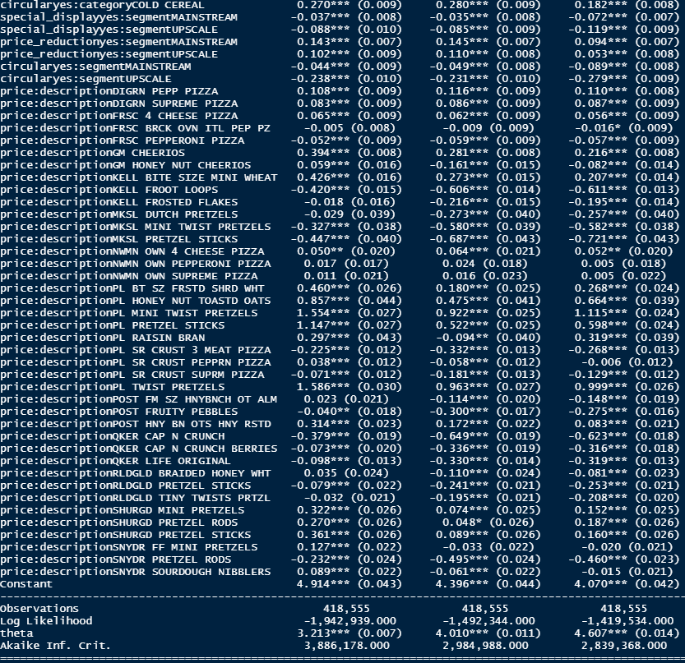

1. ***What are the effects of product display, being featured on in-store circular, and temporary price reduction on product sales (spend), unit sales, and number of household purchasers?***

***Spend***

**TPR:**

d(spend)/d(tpr): -0.187 – 0.055 * CategoryBagSnacks + 0.102 * CategoryColdCereal + 0.143 *segmentMainstream + 0.102* SegmentUpscale

spend depends on whether the customers purchased bagsnacks or cold cereal compared to frozen pizza and purchased from mainstream or upscale stores compared to value stores. If all those things are constant, then spend reduces by 18.7% when price of a product is slashed by 1$. This is probably because people think that there is something wrong with the product and it is being sold at a discount.

**Feature:**

d(spend)/d(feature): 0.298 + 0.016 * CategoryBagSnacks + 0.270 * CategoryColdCereal -0.044 *segmentMainstream -0.238* SegmentUpscale

spend depends on whether the customers purchased bagsnacks or cold cereal compared to frozen pizza and purchased from mainstream or upscale stores compared to value stores. If all those things are constant, then spend increases by 29.8% when the product is featured on an in-store flyer. This is probably because people get more aware of the product and they spend more on it.

**Dsiplay:**

d(spend)/d(display): 0.447 + 0.037 * CategoryBagSnacks + 0.070 * CategoryColdCereal -0.037 *segmentMainstream -0.088* SegmentUpscale

spend depends on whether the customers purchased bagsnacks or cold cereal compared to frozen pizza and purchased from mainstream or upscale stores compared to value stores. If all those things are constant, then spend increases by 44.7% when the product is placed on a special display.

***Units***

**TPR:**

d(units)/d(tpr): -0.199 – 0.032 * CategoryBagSnacks + 0.11 * CategoryColdCereal + 0.145 *segmentMainstream + 0.110* SegmentUpscale

spend depends on whether the customers purchased bagsnacks or cold cereal compared to frozen pizza and purchased from mainstream or upscale stores compared to value stores. If all those things are constant, then units sold reduces by 19.9% when price of a product is slashed by 1$.

**Feature:**

d(units)/d(feature): 0.293 + 0.049 * CategoryBagSnacks + 0.28 * CategoryColdCereal -0.049 *segmentMainstream -0.231* SegmentUpscale

spend depends on whether the customers purchased bagsnacks or cold cereal compared to frozen pizza and purchased from mainstream or upscale stores compared to value stores. If all those things are constant, then units sold increases by 29.3% when the product is featured on an in-store flyer.

**Dsiplay:**

d(units)/d(display): 0.446 + 0.037 * CategoryBagSnacks + 0.064 * CategoryColdCereal -0.035 *segmentMainstream -0.085* SegmentUpscale

spend depends on whether the customers purchased bagsnacks or cold cereal compared to frozen pizza and purchased from mainstream or upscale stores compared to value stores. If all those things are constant, then the units sold increase by 44.6% when the product is placed on a special display.

***HHS***

**TPR:**

d(units)/d(tpr): -0.142 – 0.036 * CategoryBagSnacks + 0.07 * CategoryColdCereal + 0.094 *segmentMainstream + 0.053* SegmentUpscale

spend depends on whether the customers purchased bagsnacks or cold cereal compared to frozen pizza and purchased from mainstream or upscale stores compared to value stores. If all those things are constant, then number of household purchases sold reduces by 14.2% when the price of a product is slashed by 1$.

**Feature:**

d(units)/d(feature): 0.321 + 0.067 * CategoryBagSnacks + 0.182 * CategoryColdCereal -0.089 *segmentMainstream -0.279* SegmentUpscale

spend depends on whether the customers purchased bagsnacks or cold cereal compared to frozen pizza and purchased from mainstream or upscale stores compared to value stores. If all those things are constant, then units sold increases by 32.1% when the product is featured on an in-store flyer.

**Dsiplay:**

d(units)/d(display): 0.482 + 0.037 * CategoryBagSnacks + 0.028 * CategoryColdCereal -0.072 *segmentMainstream -0.119* SegmentUpscale

spend depends on whether the customers purchased bagsnacks or cold cereal compared to frozen pizza and purchased from mainstream or upscale stores compared to value stores. If all those things are constant, then the units sold increase by 48.2% when the product is placed on a special display

1. ***How do the effects of display, feature, and TPR on SPEND vary by product categories (cold cereals, frozen pizza, bag snacks) and store segments (mainstream, upscale, value)? (3 points)***

***Spend***

**TPR:**

d(spend)/d(categoryBagSnacks): – 0.055 * tprYes = compared to TPR no and category frozen pizza the category of bagsnacks has 5.5% less spend

d(spend)/d(categoryColdCereal): + 0.102 * tprYes = compared to TPR no and category frozen pizza the category of coldcereal has 10.2% more spend

d(spend)/d(segmentMainstream): 0.143 *tpsYes = compared to TPR no and segment value the mainstream store has 14.3% more spend

d(spend)/d(SegmentUpscale): +0.102* TprYes = compared to TPR no and segment value the upscale store has 10.2% more spend

**Feature:**

d(spend)/d(CategoryBagSnacks): 0.016 * FeatureYes = compared to feature no and category frozen pizza the category of bagsnacks has 1.6% more spend

d(spend)/d(CategoryColdCereal): + 0.270 * featureYes = compared to feature no and category frozen pizza the category of coldcereal has 27% more spend

d(spend)/d(segmentMainstream): -0.044 * featureYes = compared to feature no and value store mainstream store has 4.4% less spend

d(spend)/d(SegmentUpscale): -0.238* featureYes = compared to feature no and value store upscale store has 23.8% less spend

**Dsiplay:**

d(spend)/d(CategoryBagSnacks): + 0.037 * DisplayYes = compared to display no and category frozen pizza the category of bagsnacks has 3.7% more spend

d(spend)/d(CategoryColdCereal): + 0.070 * DsiplayYes = compared to display no and category frozen pizza the category of coldcereal has 7% more spend

d(spend)/d(segmentMainstream): -0.037 *DisplayYes = compared to display no and value store mainstream store has 3.7% less spend

d(spend)/d(SegmentUpscale): -0.088* DisplayYes = compared to display no and value store upscale store has 8.8% less spend

1. ***What are the five most price elastic and five least price elastic products? Price elasticity is the change in units sold for change in product price. (3 points)***

Price elasticities are calculated using the following steps:

1. Filter the data for each product based on the product description
2. Calculate the mean price and mean qty for each product
3. Now regress the units variable with price for each product and find the beta coefficient of price.
4. Price elasticity = betaCoeff (mean_price/mean_qty) . this is calculated for each product.
5. Absolute value of the price elasticities is calculated.

From the attached excel sheet products with highest absolute elasticity are more elastic and products with least absolute elasticity are least price elastic.

**Highly elastic**: NWMN OWN SUPREME PIZZA, FRSC 4 CHEESE PIZZA, FRSC PEPPERONI PIZZA, FRSC BRCK OVN ITL PEP PZ, MKSL PRETZEL STICKS

**Least Elastic**: PL HONEY NUT TOASTD OATS, PL RAISIN BRAN, SHURGD MINI PRETZELS, SHURGD PRETZEL STICKS, PL BT SZ FRSTD SHRD WHT

1. ***As the retailer, which products would you lower the price to maximize (a) product sales and (b) unit sales, and why?***

The products with high elasticity positive elasticity value will increase the units sales and product sales. They are PL TWIST PRETZELS, PL MINI TWIST PRETZELS and PL HONEY NUT TOASTD OATS