**SQL SCHEMA, CODE and RESULTS**

**SCHEMA:**

create table Intl_debt

(country_name varchar(40),

country_code varchar(10),

indicator_name varchar(120),

indicator_code varchar(20),

year70 numeric(16,0),

year71 numeric(16,0),

year72 numeric(16,0),

year73 numeric(16,0),

year74 numeric(16,0),

year75 numeric(16,0),

year76 numeric(16,0),

year77 numeric(16,0),

year78 numeric(16,0),

year79 numeric(16,0),

year80 numeric(16,0),

year81 numeric(16,0),

year82 numeric(16,0),

year83 numeric(16,0),

year84 numeric(16,0),

year85 numeric(16,0),

year86 numeric(16,0),

year87 numeric(16,0),

year88 numeric(16,0),

year89 numeric(16,0),

year90 numeric(16,0),

year91 numeric(16,0),

year92 numeric(16,0),

year93 numeric(16,0),

year94 numeric(16,0),

year95 numeric(16,0),

year96 numeric(16,0),

year97 numeric(16,0),

year98 numeric(16,0),

year99 numeric(16,0),

year00 numeric(16,0),

year01 numeric(16,0),

year02 numeric(16,0),

year03 numeric(16,0),

year04 numeric(16,0),

year05 numeric(16,0),

year06 numeric(16,0),

year07 numeric(16,0),

year08 numeric(16,0),

year09 numeric(16,0),

year10 numeric(16,0),

year11 numeric(16,0),

year12 numeric(16,0),

year13 numeric(16,0),

year14 numeric(16,0),

year15 numeric(16,0),

year16 numeric(16,0),

primary key(country_name, country_code, indicator_code)

);

create table Intl_debt2

(country_name varchar(40),

country_code varchar(10),

indicator_name varchar(120),

indicator_code varchar(20),

year14 numeric(16,0),

year15 numeric(16,0),

year16 numeric(16,0),

primary key(country_name, country_code, indicator_code)

);

create table Country_summary

(country_code varchar(10),

country_name varchar(40),

region varchar(40),

income_group varchar(30),

wb_code varchar(5),

primary key(country_code)

);

1. Which country has the highest debt?

**ANS:** China(CHN) seems to have the highest external debt[1] i.e.$1430 Billion across

all[2] countries

**SQL Querry:**

SELECT * FROM Intl_debt2 WHERE year16 IN(

SELECT max(year16) FROM Intl_debt2 WHERE indicator_code = "DT.DOD.DECT.CD" AND country_code NOT IN

(SELECT distinct country_code FROM Intl_debt2 WHERE country_code = "LMY" OR country_code ="MIC" OR country_code ="UMC" OR country_code ="EAP" OR country_code ="LMC" OR country_code ="LAC" OR country_code ="ECA" OR country_code ="SSA" OR country_code ="LDC" OR country_code ="MNA")) LIMIT 1;

**RESULTS:**



1. Which country has the least debt?

**ANS:** Tonga(TON – Polynesian Island) seems to have the lowest external debt[1] i.e.$159.855 Million across

**SQL Querry:**

SELECT * FROM Intl_debt2 WHERE year16 IN(

SELECT min(year16) FROM Intl_debt2 WHERE indicator_code = "DT.DOD.DECT.CD" AND country_code NOT IN

(SELECT distinct country_code FROM Intl_debt2 WHERE country_code = "LMY" OR country_code ="MIC" OR country_code ="UMC" OR country_code ="EAP" OR country_code ="LMC" OR country_code ="LAC" OR country_code ="ECA" OR country_code ="SSA" OR country_code ="LDC" OR country_code ="MNA")) LIMIT 1;

**RESULTS:**



1. What category of debt is highest across different countries?

**ANS:** On an average long-term external debt seems to be highest across all countries. Within long-term debt, private non-guaranteed category contributes majorly towards the debt(**49.4%**). Official creditors(WB entities) contributing **20%**.

**SQL Querry 3.1:**

CREATE VIEW Max_debt_bycountry AS

SELECT country_code, max(year16) AS year16 FROM Intl_debt2 WHERE indicator_code<> "DT.DOD.DECT.CD" AND indicator_code<>"DT.DOD.PVLX.CD" GROUP BY country_code;

Select * from Max_debt_bycountry;

SELECT Intl_debt2.country_name, Intl_debt2.country_code, Intl_debt2.indicator_name, Intl_debt2.indicator_code, Intl_debt2.year16 FROM Intl_debt2 INNER JOIN Max_debt_bycountry ON Intl_debt2.year16 = Max_debt_bycountry.year16;

**SQL Results 3.1 Top few rows: (rest are exported to csv):**

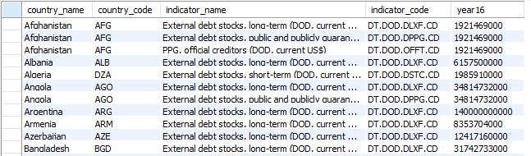

**SQL Querry 3.2:**

Drop view Tot_Debt_bycountry;

CREATE VIEW Tot_Debt_bycountry AS

SELECT country_name, country_code, indicator_name, indicator_code, year16 FROM Intl_debt6 WHERE indicator_code= "DT.DOD.DECT.CD" ORDER BY year16 DESC;

Create View LT_Percent AS

SELECT T1.country_name, T1.country_code, T1.indicator_name, T1.indicator_code, T1.year16, (T1.year16/T2.year16)*100 AS Percent_Of_Tot_Debt, T2.year16 AS Tot_Debt FROM Intl_debt2 AS T1, Tot_Debt_bycountry AS T2 WHERE (T1.indicator_code= "DT.DOD.OFFT.CD" OR T1.indicator_code="DT.DOD.PRVT.CD" OR T1.indicator_code="DT.DOD.DPNG.CD") AND T1.country_code = T2.country_code;

Select indicator_code, sum(year16) from LT_Percent GROUP BY indicator_code ORDER BY sum(year16) DESC;

**SQL Result 3.2:**

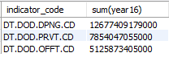

1. Does the income level has any effect on the debt level of the country?

**ANS:** The average debt of countries with Upper middle income level seems to be

highest(64%) among all the countries and Low income level seems to be the least

**SQL Querry 4.1:**

CREATE VIEW Income_Groups AS

SELECT Intl_debt2.country_name, Intl_debt2.country_code, Intl_debt2.indicator_name, Intl_debt2.indicator_code, Intl_debt2.year16, Country_summary.region, Country_summary.income_group, Country_summary.wb_code

FROM Intl_debt2

JOIN Country_summary ON Intl_debt2.country_code = Country_summary.country_code;

SELECT income_group, Avg(year16) FROM Income_Groups WHERE indicator_code = "DT.DOD.DECT.CD" GROUP BY income_group ORDER BY Avg(year16) DESC;

**Results 4.1:**

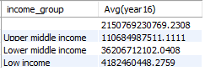

1. What are the top 10 or more countries with the highest debts from private non-guaranteed sources?

**RESULTS**:

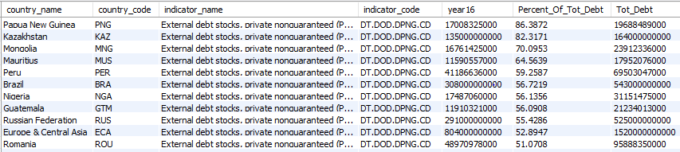

**Associated SQL Querry:**

Select * from LT_Percent WHERE indicator_code = "DT.DOD.DPNG.CD" ORDER BY Percent_Of_Tot_Debt DESC;

1. What are the top 10 or more countries with the highest debts from official creditors?

**RESULTS**:

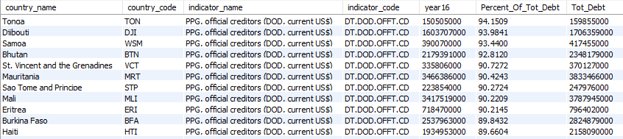

**Associated SQL Querry:**

Select * from LT_Percent WHERE indicator_code = "DT.DOD.OFFT.CD" ORDER BY Percent_Of_Tot_Debt DESC;