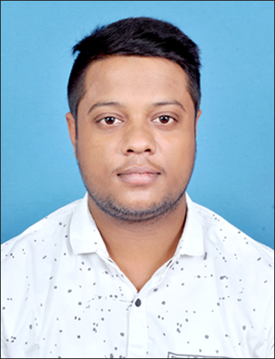
SHUBHAM KUMAR CHOUDHARY

Contact No: (M) +91 9088826921
Email: shubhamchoudhary0126@gmail.com

Aspiring to be a part of a reputed organization, working in a responsible position and performing consistently to the best of my skills and abilities in order to learn and grow along with the organization.

EDUCATION

- Pursuing B. Tech in Electronics and Communication Engineering (2015-2019) from M.C.K.V. Institute of Engineering, Liluah under Maulana Abul Kalam Azad University of Technology. Presently in 8th semester with a CGPA of 7.63.

CLASS | BOARD | INSTITUTE | YOP | MARKS/CGPA
B. Tech | MAKAUT | MCKV Institute of Engineering, Liluah | 2019 | 7.63
12th | BSEB | GMSS High School, Madhubani | 2014 | 68.6%
10th | BSEB | DNP High School Bharam, Madhubani | 2012 | 81.4%

INDUSTRIAL EXPERIENCES/TRAININGS

Internship and Summer Training in Operation and Maintenance Department under guidance of Sri Sunil Kumar, Sr. Manager/Tech/NOC, Eastern Region from 25.06.2018 to 24.07.2018 in RailTel Corporation of India Limited.

ACHIEVEMENTS AND AWARDS

- Winner of Essay competition at district level held by State Ministry of Education-Bihar.
- Got third prize in Mathematics Competition in Block.
- Certificate holder of NPTEL on Fiber Optics.

EXTRA-/CO-CURRICULAR ACTIVITIES

- Member of “IET (The Institution of Engineering and Technology)”.
- Member of “Rotaract Club of MCKVIE”.
- Participated in TELOS 2017 & 2018 of Online Annual Technical Festival of MYWBUT.
- Attended 2 days workshop on Electronics Circuit Design.
- Participant in Rota cricket & badminton at college level.

COMPUTER SKILLS

- Programming Languages: Basics of C
- Operating Systems: Windows.
- Softwares: MS Word, MS Excel, MS PowerPoint

PROJECT

- Currently ongoing final year project on “Metal Detector Circuit”.

SUBJECTS OF INTEREST

- Optical Communication
- Analog Communication

PERSONAL INTERESTS & HOBBIES

- To Write Hindi Poetry.

PERSONAL DOSSIER

- Father’s name : Mr. Shrawan Kumar Choudhary
- Mother’s name : Mrs. Kumkum Devi
- Permanent Address : Vill. + PO. : Kothiya,
Block: Jhanjharpur,
Dist.: Madhubani,
State: Bihar
Pin: 847404

- Address for correspondence : H C Banerjee Road,
Shanti Niketan Apartment
23, flat no.-12, Belurmath,
Howrah, West Bengal,
711202

- Date of Birth : 10th Aug 1996.
- Nationality : Indian.
- Gender : Male.
- Marital Status : Single.
- Languages Known : English, Hindi and Maithili.

REFERENCES

- Dr. SATADAL SAHA, Head of Department, Electronics &Communication Engineering Dept., MCKVIE. Contact No: (M) +919836149699 Email: satadalsaha@yahoo.com

- Mr. Rajarshi Sanyal, Assistant Professor, Electronics &Communication Engineering Dept., MCKVIE. Contact No: (M) +919830448726 Email: rajarshi.sanyal1972@gmail.com

DECLARATION

I hereby declare that the above information is true to the best of my knowledge.

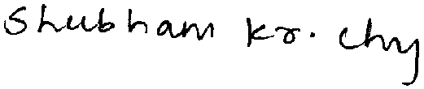
Place: Kolkata (SIGNATURE)
Date: 17/04/2019

