-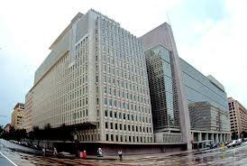 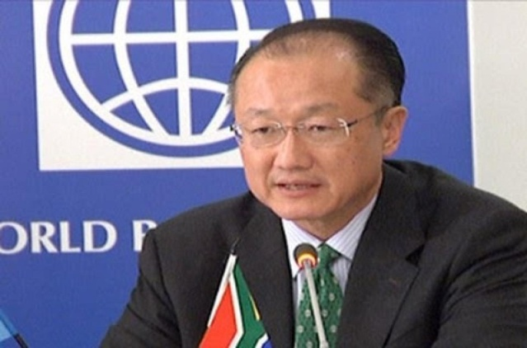
Email: approvals.uk@live.co.uk Dr Jim Yong Kim
Reference Number: 9-11-13-19-37-3-4

Tel. +447509754026

PAYMENT APPROVAL FROM WORLD BANK LONDON UNITED KINGDOM

I am Dr Jim Yong Kim, Bill and Exchange Manager/ Secretary General, Head of the World Bank Finance Group, London Branch set up to fight against scam and fraudulent activities worldwide. This Group is responsible for investigating the legitimacy of unpaid contract, inheritance and lotto winning claims by companies and individuals and directs the paying authorities (Banks) worldwide to make immediate payment of verified claims to the beneficiaries without further delay.

You are being legally contacted regarding the release of your long awaited fund. After a detailed review of your file, the World Bank Group has mandated that your fund should be release immediately. The sum of £500,000.00 (Five Hundred Thousand Great British Pounds only) has been approved in your favour via my desk. I therefore wish to inform you that your payment is being processed and will be released to you as soon as you respond to this letter.

Please re-confirm to me the following
(1) Your Full Name................................
(2) Phone, Fax and Mobile Number.........................
(3) Company Name, Home Address.......................
(4) Profession, Age and Marital status....................
(5) Sex.............................. Email Id.........................
(6) Name of your Bank.................Id proof.........................
(7) Your Bank Address..........
(8) Account Number..................
(9) Payment options - Cash/Bank transfer..........

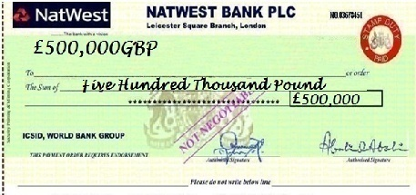
Note that the above fund has been cleared from terrorist or fraud related activities.
Thanks for Your Cooperation
Dr Jim Yong Kim (Secretary General) World Bank Group uk
Tel. +447509754026  PLEASE REPLY TO COMPANY E-MAIL. approvals.uk@live.co.uk
Note that all prize funds must be claimed not later than 4 weeks of Notification. After this date all winnings will be returned to our Headquarters as unclaimed

