**NIT WARANGAL** 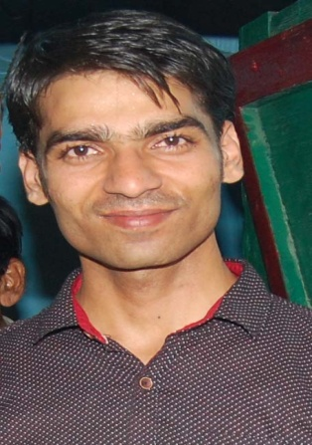

**Email:** [**satishchawala@outlook.com**](mailto:satishchawala@outlook.com) **Mobile: +91-9929418560**

**PERSONAL DETAILS:**

* **Name:** Satish Kumar
* **Father’s name:** Rambabu
* **Mother’s name:** Chandravati
* **Nationality:** Indian
* **Home Address:** Pala, Kumher

Bharatpur, Rajasthan, India -321201

**EDUCATION:**

* National Institute of Technology Warangal
* **Bachelor of Technology in Computer Science & Engineering (CSE)**
* Expected Graduation: 2017 Current CGPA (after VI semesters): 6.76/10

**RELEVANT COURSE UNDERTAKEN:**

* Data structures & Algorithms, Object Oriented Programming, Computer networking, Compiler Design.
* Data Warehousing & Data Mining, File structure, Database Management System, Assembly language, Discrete Mathematics, Software Metrics and Project Management.

**EDUCATION QUALIFICATION:**

|  |  |  |  |
| --- | --- | --- | --- |
| Degree/Examination | Passing year | University/Board | Percentage/CGPA |
| 1.Bachelor’s Degree | 2017 | NIT Warangal | 6.76/10 |
| 2.Higher Secondary (12th) | 2012 | RBSE | 86.20/100 |
| 3.Matriculation (10th) | 2010 | RBSE | 90.50/100 |

**PROJECTS/TRAINING UNDERTAKEN:**

* **Arp cache poisoning and preventing(computer network project)-May 2016**

Using Libpcap, Libnet, Sockets.

* **An online group chat website design May 2015**

Using PHP, MySQL ,HTML JavaScript, ajax , Bootstrap.

Link: <http://www.satishkumar.net46.net/>

* **In-house Minor Project- May 2014**: Website design for bookmarking URLs Using- PHP, MySQL, HTML, CSS.

**TECHNICAL SKILLS:**

* **Software Skills**: C/C++,JAVA, Python , PHP, JavaScript, SQL, HTML, CSS,

Data Structure & Algorithms Design.

* **Laboratory Techniques**: Data structure implementation, file structure implementation, Oracle Database and SQL query writing & executing, assembly language programming, Object- oriented programming and applets, Compiler design,

Game development(applet).

* **Other Technical Skills**: Basic knowledge about CodeIgniter framework,MVC pattern,xampp,wamp.

**ACADEMIC ACHIEVEMENTS:**

* Have been School topper for three consecutive years 2009-2012.

**EXTRA CURRICULAR ACTIVITIES:**



* Served the College Technical fest ‘Technozion-2013’ as a Volunteer.
* School Student Council as **Discipline Prefect** for the session 2010-2012.

**INTERESTS/HOBBIES:**

* + - * Reading novels
      * Interacting with people
      * Watching TV series