Result of H/P Convergence of Spectral Method on [0,1] for S-curve of order 9

1. Approximation of Polynomial (Order 9) by Dirichlet-Dirichlet Conditions on [0, 1]

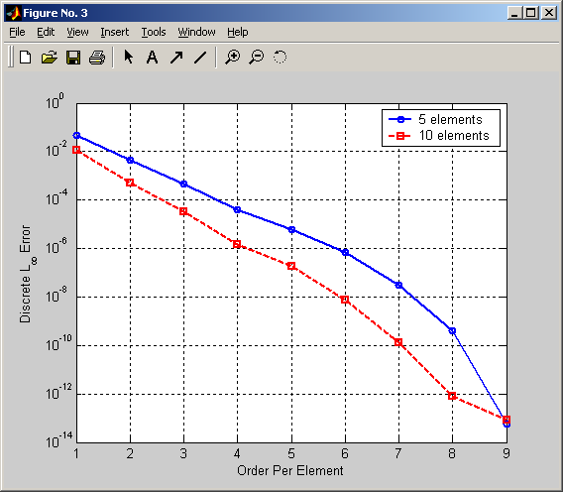
Figure 1 P-Convergence of DD Boundary Conditions

Error Table for Figure 1:
5 Elements | 10 Elements
5.5067e-014 | 7.9936e-014

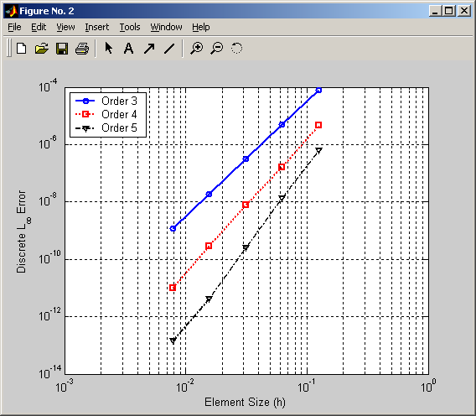
Figure 2 H-Convergence of DD Boundary Conditions

Result Table for Figure 2:

Order | Error | Slope
3 | 1.2076e-009 | 3.9887
4 | 9.6373e-012 | 4.7105
5 | 1.3822e-013 | 5.5248
2. Approximation of Polynomial (Order 9) by Dirichlet-Neumann Conditions on [0, 1]

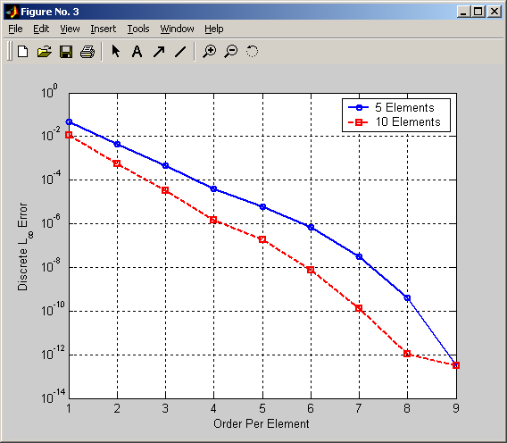
Figure 3 P-Convergence of DN Boundary Conditions

Error Table for Figure 3:
5 Elements | 10 Elements
3.0420e-013 | 3.1197e-013

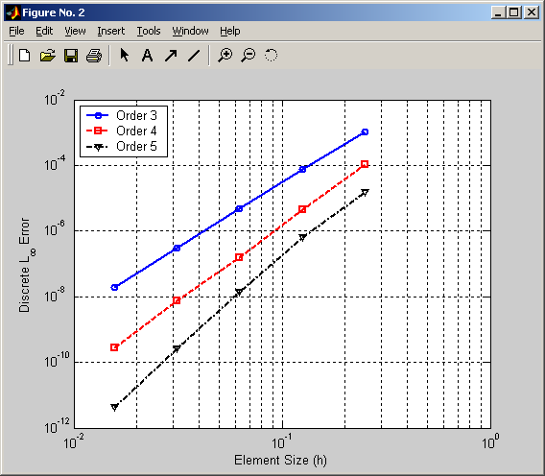
Figure 4 H-Convergence of DN Boundary Conditions
Result Table for Figure 4:

Order | Error | Slope
3 | 1.9291e-008 | 3.9442
4 | 2.8368e-010 | 4.6196
5 | 4.2255e-012 | 5.4323

