Result of Fourier Method for 1,2th order differential equations.

- du/dx = f
1 f = sin(x); u = - cos(x); error = 4.5797e-016
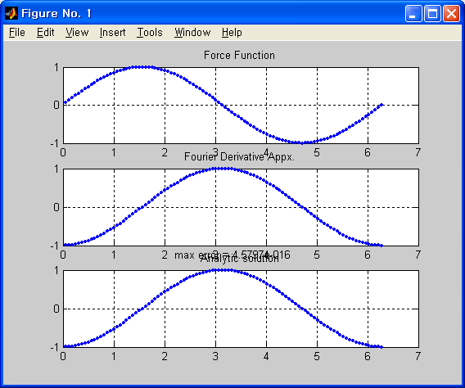

2 f = cos(x) .* exp(sin(x)); u = exp(sin(x)); error = 1.2661
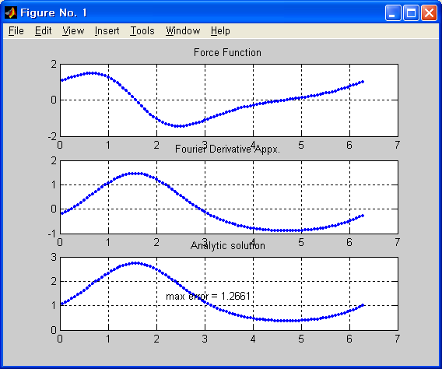
Non-Periodic Functions
3 f = 1./x .* exp(log(x)); u = exp(log(x)); error = 6.2832
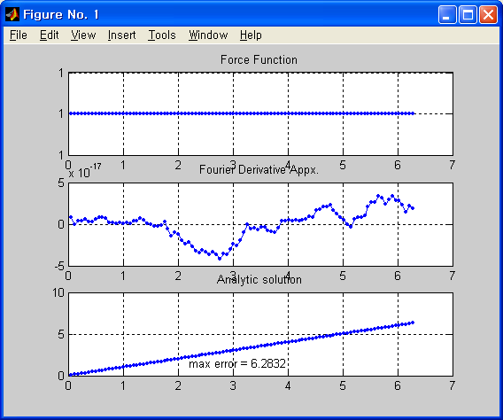

4 f = log(x) + 1; u = x .* log(x); error = 10.0595
