Result of Fourier Method for 1,2th order differential equations.

- d^2u/dx^2 = f
1 f = sin(x); u = - sin(x); error = 6.4325e-016
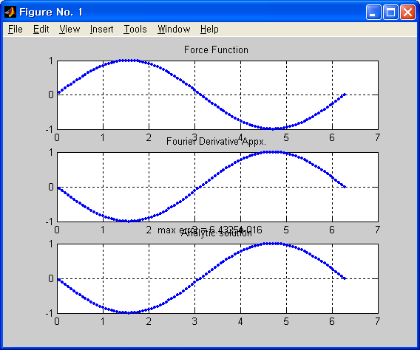

2 f = (1 - sin(x) - sin(x) .* sin(x)) .* exp(sin(x)); u = exp(sin(x)); error = 1.2661
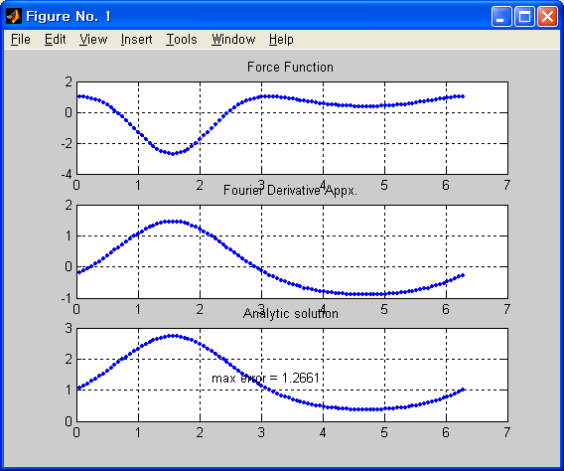
Non-Periodic Functions
3 f = 0; u = exp(log(x)); error = 6.2832
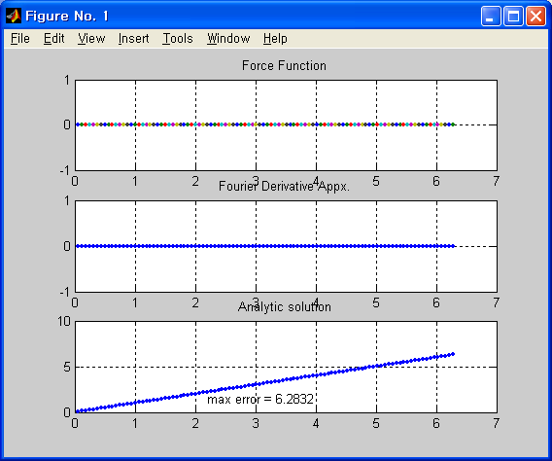

4 f = log(x) + 1; u = x .* log(x); error = 12.7094
