Hasan and Skyler

BNFO 420: Applications in Bioinformatics

Quiz 1: Lettuce Turnip the Beet

Please choose one of the following questions to answer, and upload all of your files to blackboard.

1. You have been tasked to create a database. After looking at a few of the files, and researching database theory, you realize that many of the columns are multivalued (and are not in 1NF). We have provided to you all one of these files: “I_LIKE_FROOT.txt”. Here is the first four lines of the file:

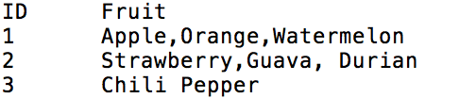

Please take notice of the “Fruit” column. Again, it is this column that contains non-atomic values. Please create a new file that is in the following format:

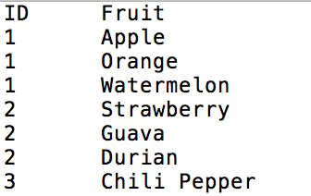

Please name the new file “firstnameLASTNAME_4NF_froot.txt” and its respective program “firstnameLASTNAME_1NF_parser.py”.

1. For this question instead of writing your own script we will have you comment a program that has already been written. Go through “random.py” and comment each line with what that line does. Please be thorough in your comments :).