ROI tool User Manual

Version 1.0

Author : Sylvain Kritter Date : 14 April 2017

_____________________________________________________________________________________

# Start

After launch a menu appears:

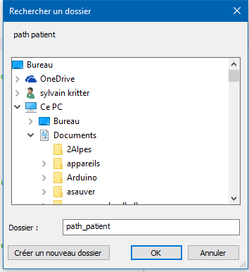

## Select the path to directory where patients Dicom databases are stored

## When done click on *OK*

## You can exit here

# Select patient data set

## To visualize this Help File

## Here you have the list of patients, with the list of ROI already drawn

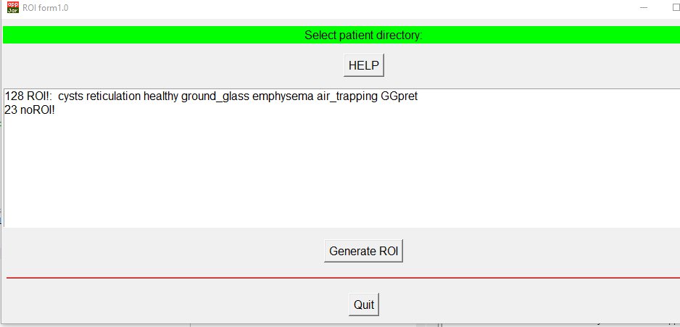

## You select one

You must select one at least and only one

## You click *Generate ROI* to launch the graphic tool

## To exit

# Graphic Tool

Two windows open after clicking on Generate ROI.

Then the previous database menu is not active, as long as the graphic windows are open, do not try to click on it, until they are active again.

## Drawing Window

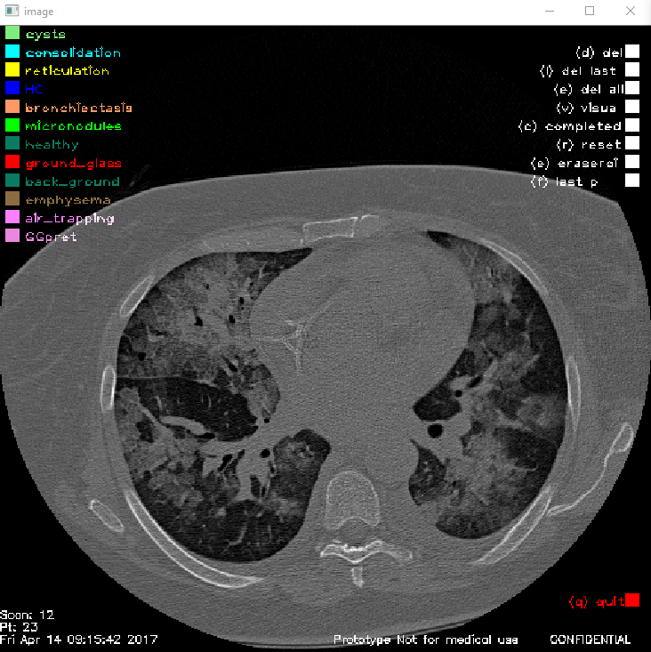

## Control window

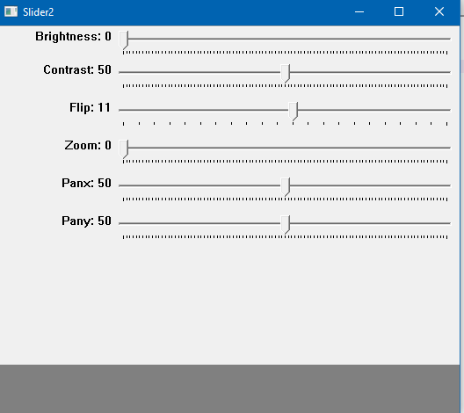

# Drawing Window

His is the window to draw and store ROI

It opens by default on the scan number in the middle of the full set.

Slice number appears on the bottom left, together with patient name

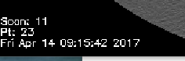

All commands are activated by clicking on menus (or using short cut on keyboard, when the mouse is on this window and the window activated, keys are mentioned between parenthesis on the menus)

## Quit this window

This is only possible with clicking on quit (bottom left), do not try to close it in another way!

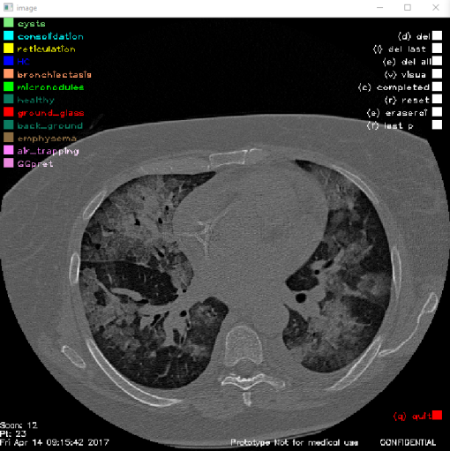

## Select pattern for drawing

You click on pattern to select

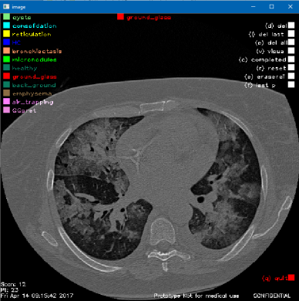

The name of selected patterns appears here

## Draw region of interest on the picture

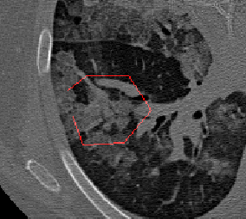

Click one time with the left button of the mouse where to define polygon summit. A straight line is drawn between summits.

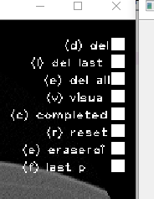

When a polygon is completed, click here to end it

Then you can draw another polygon, or change pattern and draw others polygons

## Drawing Commands

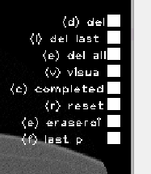

Delete last summit on the polygon currently in drawing

Delete the last drawn polygon entirely

Delete all polygons on this slice

ALL THESE ABOVE COMMANDS APPLY ONLY TO SELECTED PATTERN

Erase all polygons for all patterns

ERASE ALL APPLIES TO ALL PATTERNS, ALL POLYGONS in this slice

## Visualization and store commands

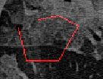

Visualization of area filling from polygon Applies to all polygons and patterns

Store the drawn polygons in ROI database on disk for this slice

Erase all ROI in the database for this scan number, for the selected pattern only

# Control Window

This windows opens and closes together with graphic window.

Do not try to close it another way.

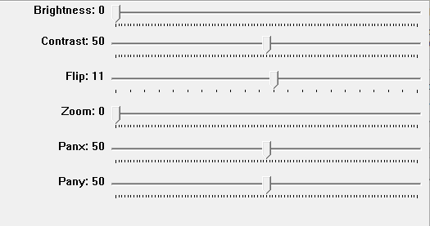

Adjust brightness

Adjust contrast

Select slice number to visualize

(you can navigate from one slice number to another, without losing the previous work in progress)

Zoom inside the window

In zoom mode, allows to move the visible area in x and y