PRACTICAL No: 01

Aim: To Install Node.js on the system and verify its successful installation using the Command Prompt/Terminal.
Steps
1. Open a web browser and go to the official Node.js website:
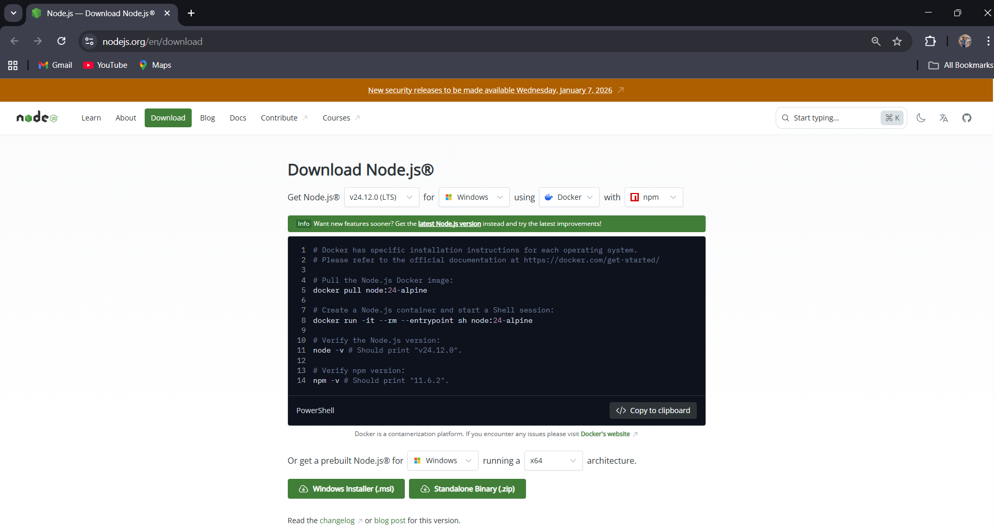
https://nodejs.org/en/download & on the homepage, download the LTS (Long-Term Support) version of Node.js suitable for your operating system.
2. Once the installer is downloaded, double-click on it to start the installation & Follow the installation wizard:
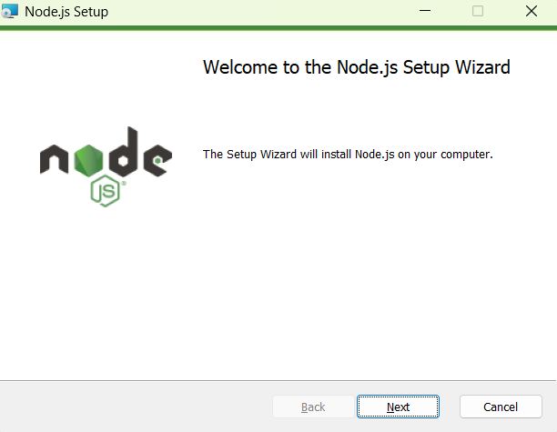

- Click Next

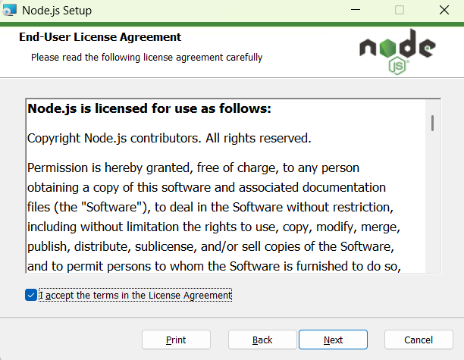

2. Accept the Terms of license and do Next
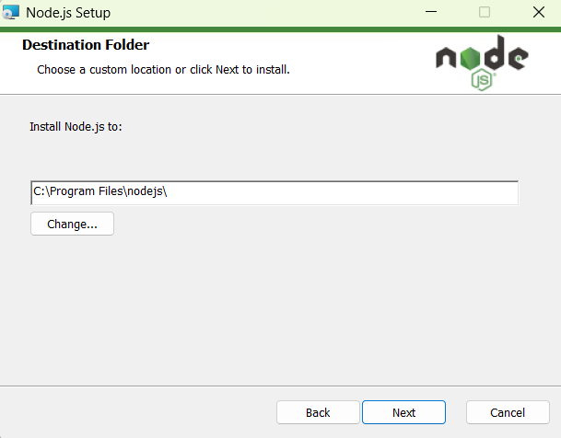

3. Select the destination folder

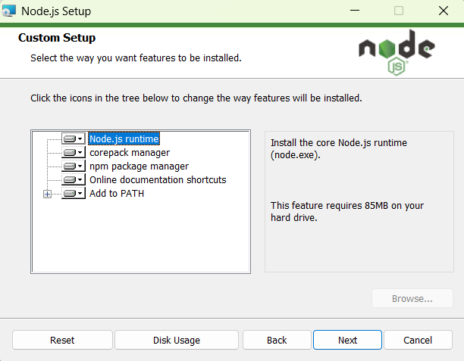

4. Select the custom setup and do Next
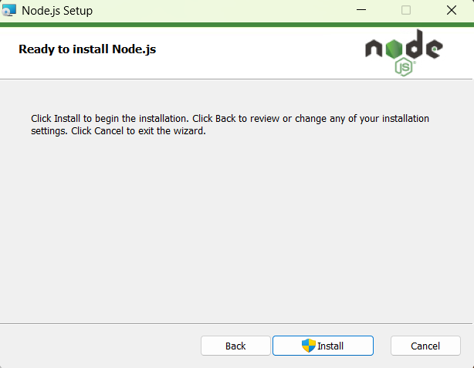

5. Now ready to download the Node.js

6. Wait until the installation is completed, then click Finish.
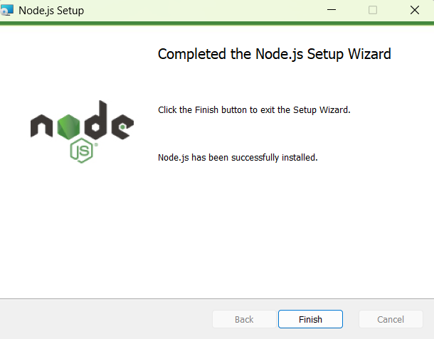
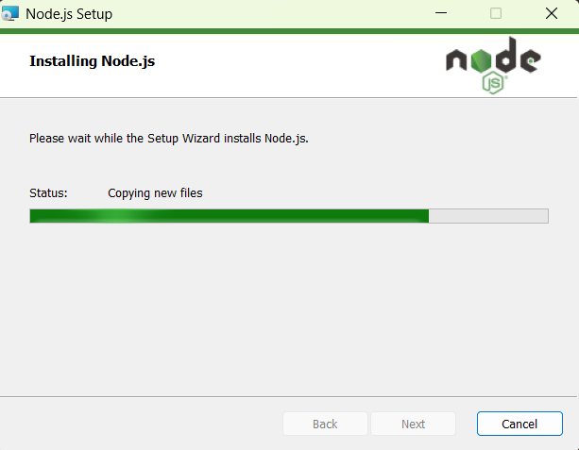
Prompt / Terminal to verify installation & Type the following commands to check the version :

- node -v → Displays Node.js version
- npm -v → Displays npm (Node Package Manager) version
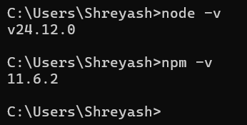

Aim: To execute basic Node.js console programs for arithmetic.
a) Addition of two numbers

console.log("Name: Shreyash Utekar 126");
let a = 10;
let b = 20;
let sum = a + b;
console.log("Addition =", sum);

Output :

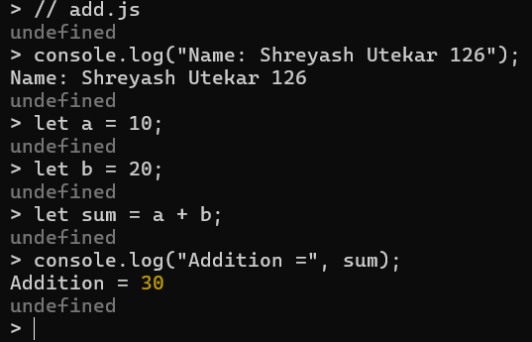

b) Simple Calculator

console.log("Name: Shreyash Utekar 126");
let a = 20;
let b = 5;
let choice = 3; // 1:Add 2:Sub 3:Mul 4:Div

switch (choice) {
case 1:
console.log("Addition =", a + b);
break;
case 2:
console.log("Subtraction =", a - b);
break;
case 3:
console.log("Multiplication =", a * b);
break;
case 4:
console.log("Division =", a / b);
break;
default:
console.log("Invalid choice");
}

Output :
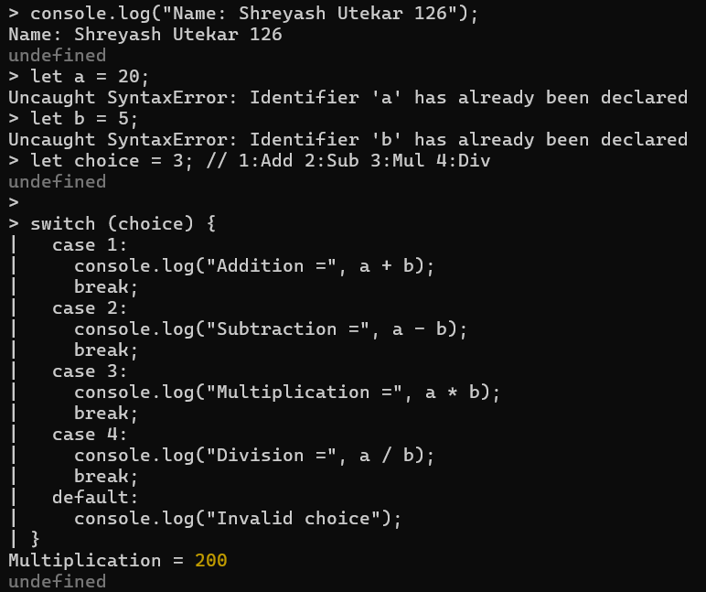
PRACTICAL No: 02
Aim: To implement iterative logic using Node.js loops.
a) implementation using do…while loop
let i = 1;
do {
console.log("Number:", i);
i++;
} while (i <= 5);

Output :
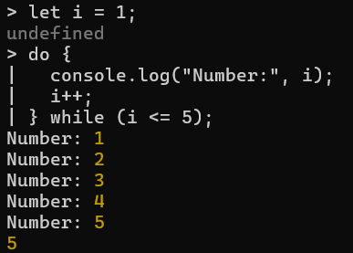

b) implementation using for loop
for (let i = 1; i <= 5; i++) {
console.log("Number:", i);
}

Output :
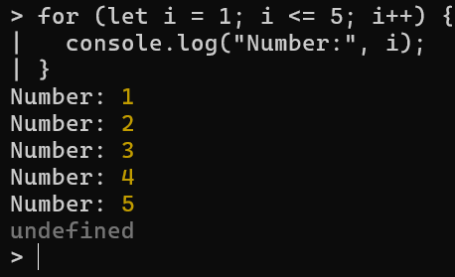

PRACTICAL No: 03
Aim: To demonstrate mathematical table generation and conditional logic.
a) Generating table of 2
console.log("Name: Shreyash Utekar 126");
let num = 2;

for (let i = 1; i <= 10; i++) {
console.log(`${num} x ${i} = ${num * i}`);
}

Output :
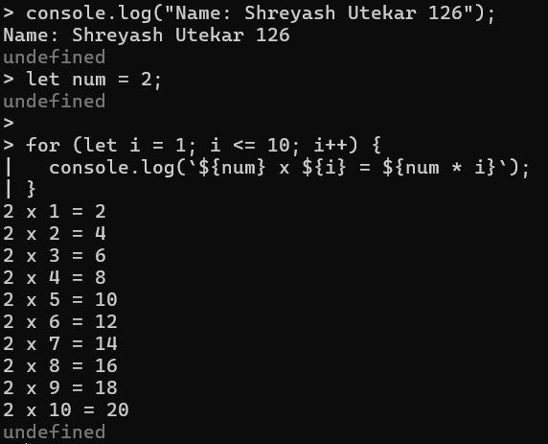

b) Generating table of 3
console.log("Name: Shreyash Utekar 126");
let num = 3;

for (let i = 1; i <= 10; i++) {
console.log(`${num} x ${i} = ${num * i}`);
}

Output :

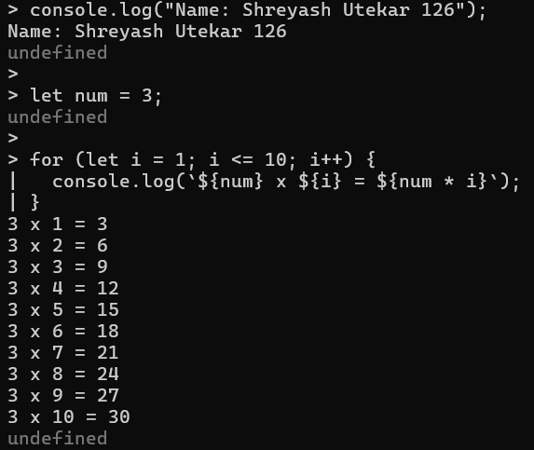

c) Greatest of three numbers using if…else if
console.log("Name: Shreyash Utekar 126");
let a = 15;
let b = 25;
let c = 10;

if (a > b && a > c) {
console.log("Greatest number is:", a);
} else if (b > a && b > c) {
console.log("Greatest number is:", b);
} else {
console.log("Greatest number is:", c);
}

Output :
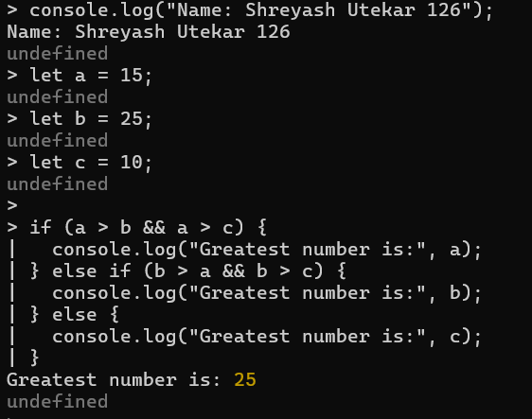

PRACTICAL No: 04
Aim: To demonstrate nested loop structures for pattern printing.
Create an application in NodeJS to print * patterns
starpattern.js
console.log("Name: Shreyash Utekar 126");

var n = 5;
var pattern = "";

for (var i = 1; i <= n; i++) {
for (var j = 1; j <= i; j++) {
pattern += "* ";
}
pattern += "\n";
}

console.log(pattern);

Output :

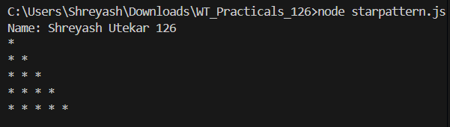

PRACTICAL No: 05

AIM: To implement number property checks and ranges.

a)Write a program to find if the number is odd or even
odd_even.js
console.log("Name: Shreyash Utekar 126");

function checkOddOrEven(num) {
if (num % 2 === 0) {
console.log(num + " is an Even Number");
} else {
console.log(num + " is an Odd Number");
}
}
const number = 27;
checkOddOrEven(number);

Output :
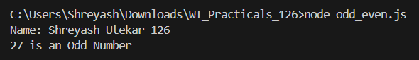

b) Write a program to print the Prime Numbers from 1 to 50
prime.js
console.log("Name: Shreyash Utekar 126");

function isPrime(num) {
if (num <= 1) return false;
for (let i = 2; i <= Math.sqrt(num); i++) {
if (num % i === 0) {
return false;
}
}
return true;
}

for (let i = 1; i <= 50; i++) {
if (isPrime(i)) {
console.log(i);
}
}
Output :
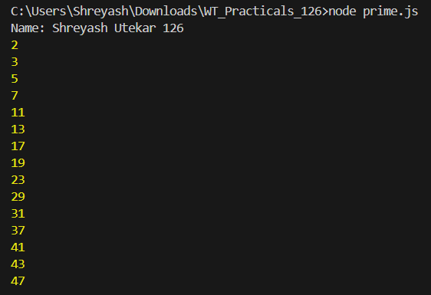

PRACTICAL No: 06
Aim: To study digit manipulation and mathematical constants.
a) Write a program to index the reverse of a four-digit number
reverse.js
console.log("Name: Shreyash Utekar 126");

function reverseNumber(num) {
if (num < 1000 || num > 9999) {
console.log("Please enter a valid four-digit number");
return;
}
const reverseNum = num.toString().split('').reverse().join('');
return parseInt(reverseNum);
}

const number = 7856;
const reversed = reverseNumber(number);

console.log("Original :", number);
console.log("Reversed :", reversed);

Output :
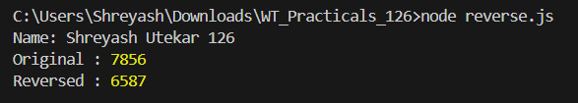

b) Write a program to check if the entered number is Armstrong or not
armstrong.js
console.log("Name: Shreyash Utekar 126");

function isArmstrong(num) {
const numStr = num.toString();
const numDigits = numStr.length;
let sum = 0;
let temp = num;

while (temp > 0) {
const digit = temp % 10;
sum += Math.pow(digit, numDigits);
temp = Math.floor(temp / 10);
}

if (sum === num) {
console.log(num + " is an Armstrong number!");
} else {
console.log(num + " is not an Armstrong number.");
}
}

const number = 153;
isArmstrong(number);

Output :
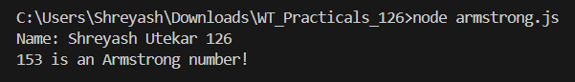

PRACTICAL No: 07
AIM: To implement series generation and unit conversion.

a)Write a program to print the Fibonacci series
fibonacci.js
console.log("Name: Shreyash Utekar 126");

const prompt = require('prompt-sync')();

function printFibonacci(n) {
let a = 0, b = 1, next;
console.log("Fibonacci Series up to " + n + " terms:");
for (let i = 1; i <= n; i++) {
console.log(a);
next = a + b;
a = b;
b = next;
}
}
const numTerms = parseInt(prompt("Enter the number of terms for Fibonacci series: "));
printFibonacci(numTerms);

Output :
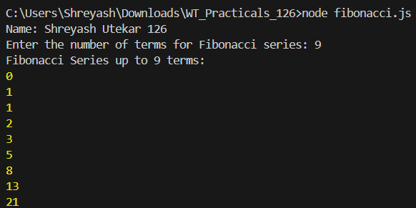

b) Write a program to convert the temperature entered by the user
temperature.js
console.log("Name: Shreyash Utekar 126");

const prompt = require('prompt-sync')();

function celsiusToFahrenheit(celsius) {
return (celsius * 9 / 5) + 32;
}

function fahrenheitToCelsius(fahrenheit) {
return (fahrenheit - 32) * 5 / 9;
}

console.log("Choose the conversion type:");
console.log("1. Celsius to Fahrenheit");
console.log("2. Fahrenheit to Celsius");

const choice = prompt("Enter 1 or 2 to choose conversion: ");

if (choice === "1") {
const celsius = parseFloat(prompt("Enter temperature in Celsius: "));
const fahrenheit = celsiusToFahrenheit(celsius);
console.log(`${celsius}°C is equal to ${fahrenheit.toFixed(2)}°F`);
} else if (choice === "2") {
const fahrenheit = parseFloat(prompt("Enter temperature in Fahrenheit: "));
const celsius = fahrenheitToCelsius(fahrenheit);
console.log(`${fahrenheit}°F is equal to ${celsius.toFixed(2)}°C`);
} else {
console.log("Invalid choice. Please enter 1 or 2.");
}

Output :

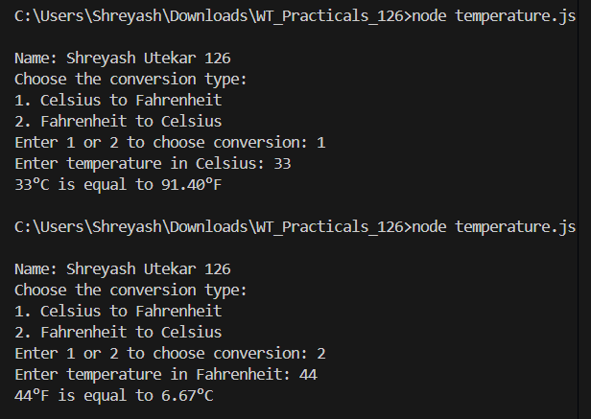

PRACTICAL No: 08
Aim: To demonstrate the use of Anonymous Functions in Node.js.
a)Write a program to demonstrate the factorial of a number using Anonymous Functions
factorial.js
console.log("Name: Shreyash Utekar 126");

const prompt = require("prompt-sync")();

let number = parseInt(prompt("Enter a non-negative integer: "));

if (isNaN(number) || number < 0) {
console.log("Please enter a valid non-negative integer.");
} else {
// Anonymous function to calculate factorial
const factorial = function(n) {
let fact = 1;
for (let i = 1; i <= n; i++) {
fact = fact * i;
}
return fact;
};

console.log("The factorial of " + number + " is: " + factorial(number));
}

Output :
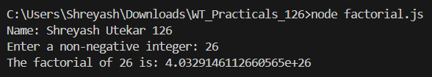

b)Write a program to demonstrate the Pattern using Anonymous Functions
pattern.js
console.log("Name: Shreyash Utekar 126");

// Anonymous function using arrow syntax
const generatePattern = (rows) => {
const patternLine = (i) =>
Array.from({ length: i }, (_, idx) => idx + 1).join(" ");

for (let i = 1; i <= rows; i++) {
console.log(patternLine(i));
}
};

const rows = 5;
generatePattern(rows);

Output :
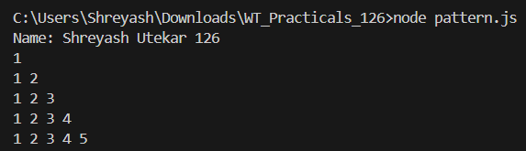

Practical No:-09
Aim: To study asynchronous behavior and Callback functions.
a)Write a program to demonstrate the arithmetic operations using Callback Functions
callback_arithmetic.js
console.log("Name: Shreyash Utekar 126");

function add(a, b, callback) {
const result = a + b;
callback(null, result);
}

function subtract(a, b, callback) {
const result = a - b;
callback(null, result);
}

function multiply(a, b, callback) {
const result = a * b;
callback(null, result);
}

function divide(a, b, callback) {
if (b === 0) {
callback("Error: Division by zero is not allowed", null);
} else {
const result = a / b;
callback(null, result);
}
}

function main() {
const a = 10, b = 5;
console.log("Performing Arithmetic Operations Using Callbacks:");

add(a, b, (err, result) => {
if (err) {
console.error(err);
} else {
console.log(`Addition: ${a} + ${b} = ${result}`);
}
});

subtract(a, b, (err, result) => {
if (err) {
console.error(err);
} else {
console.log(`Subtraction: ${a} - ${b} = ${result}`);
}
});

multiply(a, b, (err, result) => {
if (err) {
console.error(err);
} else {
console.log(`Multiplication: ${a} * ${b} = ${result}`);
}
});

divide(a, b, (err, result) => {
if (err) {
console.error(err);
} else {
console.log(`Division: ${a} / ${b} = ${result}`);
}
});
}
main();
Output :
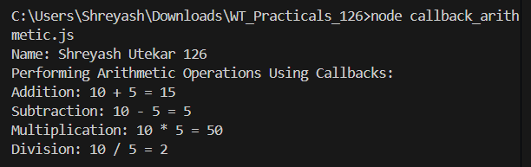

b) Write a program to demonstrate the setTimeout function
delay.js
console.log("Name: Shreyash Utekar 126");

const delayedTask = () => {
console.log("This message is displayed after a 3-second delay.");
};

console.log("Program started. Waiting for 3 seconds...");
console.log("You will see this message immediately after the program starts.");

// Call the function after 3 seconds (3000 milliseconds)
setTimeout(delayedTask, 3000);

Output :
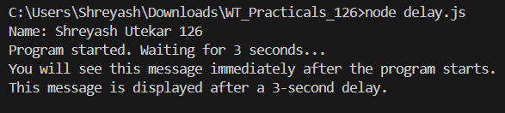

Practical No:-10
AIM: To implement modularity in Node.js using require and exports.
a) Using modules, perform the Arithmetic Operations
Arithmetic.js
console.log("Name: Shreyash Utekar 126");

function add(a, b) {
return a + b;
}

function subtract(a, b) {
return a - b;
}

function multiply(a, b) {
return a * b;
}

function divide(a, b) {
if (b === 0) {
return "Error: Division by zero";
}
return a / b;
}

// Export functions
module.exports = {
add,
subtract,
multiply,
divide
};

Index.js
const arithmetic = require('./Arithmetic');

const num1 = 10;
const num2 = 5;

console.log(`Addition of ${num1} and ${num2}: ${arithmetic.add(num1, num2)}`);
console.log(`Subtraction of ${num1} and ${num2}: ${arithmetic.subtract(num1, num2)}`);
console.log(`Multiplication of ${num1} and ${num2}: ${arithmetic.multiply(num1, num2)}`);
console.log(`Division of ${num1} by ${num2}: ${arithmetic.divide(num1, num2)}`);

Output :
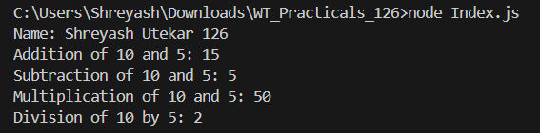

b) Using modules, index the Area of a Circle, Rectangle, Square
area.js
console.log("Name: Shreyash Utekar 126");

function circle(radius) {
if (radius < 0) return "Invalid radius";
return Math.PI * radius * radius;
}

function rectangle(length, width) {
if (length < 0 || width < 0) return "Invalid dimensions"; return length * width;
}
function square(side) {
if (side < 0) return "Invalid side length";
return side * side;
}

module.exports = {
circle,
rectangle,
square
};

Index1.js
const area = require('./area');

const radius = 5;
const length = 10;
const width = 6;
const side = 4;

console.log(`Area of Circle with radius ${radius}:`, area.circle(radius));
console.log(
`Area of Rectangle with length ${length} and width ${width}:`,
area.rectangle(length, width)
);
console.log(`Area of Square with side ${side}:`, area.square(side));

Output :
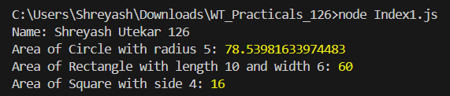

Practical No:-11
Aim: To implement user input processing and complex grading logic.
a) Write a program to take the marks of four subjects from user and check if the student has passed the examination or not, calculate percentage and grade
result.js
console.log("Name: Shreyash Utekar 126");

const prompt = require('prompt-sync')();

const subject1 = parseFloat(prompt("Enter marks for subject 1: "));
const subject2 = parseFloat(prompt("Enter marks for subject 2: "));
const subject3 = parseFloat(prompt("Enter marks for subject 3: "));
const subject4 = parseFloat(prompt("Enter marks for subject 4: "));

let passStatus;

// Pass / Fail condition
if (subject1 >= 40 && subject2 >= 40 && subject3 >= 40 && subject4 >= 40) {
passStatus = "Passed";
} else {
passStatus = "Failed";
}

const totalMarks = subject1 + subject2 + subject3 + subject4;
const percentage = (totalMarks / 400) * 100;

// Grade calculation
function calculateGrade(percentage) {
if (percentage >= 90) {
return "A+";
} else if (percentage >= 80) {
return "A";
} else if (percentage >= 70) {
return "B+";
} else if (percentage >= 60) {
return "B";
} else if (percentage >= 50) {
return "C+";
} else if (percentage >= 40) {
return "C";
} else {
return "F";
}
}

const grade = calculateGrade(percentage);

console.log(`Total Marks: ${totalMarks}/400`);
console.log(`Percentage: ${percentage.toFixed(2)}%`);
console.log(`Status: ${passStatus}`);
console.log(`Grade: ${grade}`);

Output :

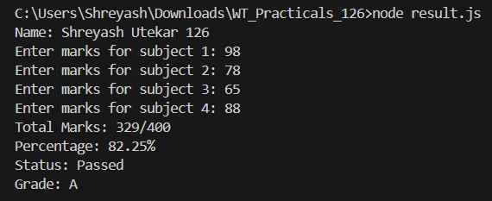

Practical No:-12
Aim: To manage event listeners within the EventEmitter class.
a) Write an application to demonstrate function (removeListner, listnerCount).
p9_listner.js
console.log("Name: Shreyash Utekar 126");

const events = require("events");
const eventEmitter = new events.EventEmitter();

function listener1() {
console.log("Event received by Listener 1");
}

function listener2() {
console.log("Event received by Listener 2");
}

// Adding listeners
eventEmitter.addListener("write", listener1);
eventEmitter.on("write", listener2);

// Emitting event
eventEmitter.emit("write");

// Listener count
console.log("Listener count:", eventEmitter.listenerCount("write"));

// Removing listener1
eventEmitter.removeListener("write", listener1);
console.log("Listener 1 is removed");

// Emitting event again
eventEmitter.emit("write");

// Listener count after removal
console.log("Listener count:", eventEmitter.listenerCount("write"));

console.log("Program Ended . . . .");

Output :
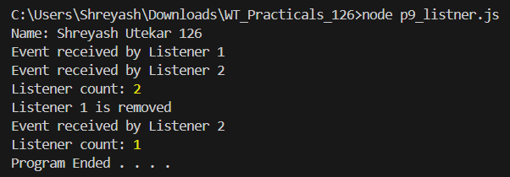
Practical No:-13
Aim: To implement advanced EventEmitter patterns.
a) Create an application in nodejs to create Return Event Emitter.
p10_listner.js
console.log("Name: Shreyash Utekar 126");

const EventEmitter = require('events').EventEmitter;

function LoopProcessor(num) {
const e = new EventEmitter();

setTimeout(function () {
for (let i = 1; i <= num; i++) {
e.emit('BeforeProcess', i);
console.log('Processing number: ' + i);
e.emit('AfterProcess', i);
}
}, 2000);

return e;
}

const lp = LoopProcessor(3);

lp.on('BeforeProcess', function (data) {
console.log('About to start the process for ' + data);
});

lp.on('AfterProcess', function (data) {
console.log('Completed processing ' + data);
});

Output :
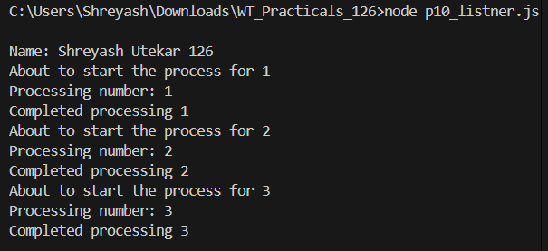

b) Create an application in node.js to create Extent Event Emitter.
p11_listner.js
console.log("Name: Shreyash Utekar 126");

const EventEmitter = require('events').EventEmitter;
const util = require('util');

function LoopProcessor(num) {
const me = this;

setTimeout(function () {
for (let i = 1; i <= num; i++) {
me.emit('BeforeProcess', i);
console.log('Processing number: ' + i);
me.emit('AfterProcess', i);
}
}, 2000);

return this;
}

// Inherit EventEmitter
util.inherits(LoopProcessor, EventEmitter);

const lp = new LoopProcessor(3);

lp.on('BeforeProcess', function (data) {
console.log('About to start the process for ' + data);
});

lp.on('AfterProcess', function (data) {
console.log('Completed processing ' + data);
});

Output :
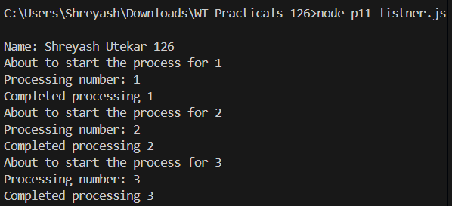

Practical No:-14
Aim: To apply event-driven programming to a business workflow.
a) Write a program to place the order for a pizza using Events
pizza_order.js
console.log("Name: Shreyash Utekar 126");

const EventEmitter = require('events');

class PizzaOrder extends EventEmitter {}

const pizzaShop = new PizzaOrder();

pizzaShop.on('orderPlaced', (customerName, pizzaType) => {
console.log(`Order placed by ${customerName} for a ${pizzaType} pizza.`);
setTimeout(() => {
pizzaShop.emit('preparing', customerName, pizzaType);
}, 2000);
});

pizzaShop.on('preparing', (customerName, pizzaType) => {
console.log(`Preparing the ${pizzaType} pizza for ${customerName}.`);
setTimeout(() => {
pizzaShop.emit('delivering', customerName, pizzaType);
}, 3000);
});

pizzaShop.on('delivering', (customerName, pizzaType) => {
console.log(`Delivering the ${pizzaType} pizza to ${customerName}.`);
setTimeout(() => {
pizzaShop.emit('delivered', customerName, pizzaType);
}, 2000);
});

pizzaShop.on('delivered', (customerName, pizzaType) => {
console.log(`The ${pizzaType} pizza has been delivered to ${customerName}. Enjoy your meal!`);
});

console.log("Welcome to Pizza Shop!");

setTimeout(() => {
pizzaShop.emit('orderPlaced', 'Shreyash Utekar', 'Margherita');
}, 1000);

Output :
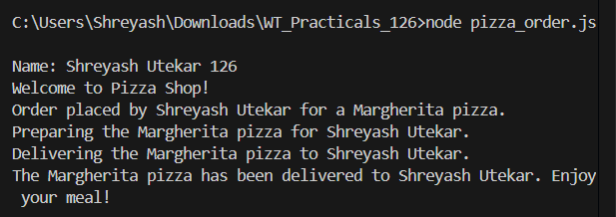

Practical No:-15
Aim: To apply event-driven programming to financial calculations.
a)Write a program to calculate the salary using Event
salary_calculator.js
console.log("Name: Shreyash Utekar 126");

const EventEmitter = require('events');

class SalaryCalculator extends EventEmitter {}

const salaryEmitter = new SalaryCalculator();

const TAX_RATE = 0.2;
const BONUS = 5000;
const DEDUCTIONS = 2000;

salaryEmitter.on('calculate', (baseSalary) => {
console.log(`Base Salary: $${baseSalary}`);
const tax = baseSalary * TAX_RATE;
salaryEmitter.emit('applyTax', baseSalary, tax);
});

salaryEmitter.on('applyTax', (baseSalary, tax) => {
console.log(`Tax Deducted: $${tax}`);
const afterTaxSalary = baseSalary - tax;
salaryEmitter.emit('applyBonus', afterTaxSalary);
});

salaryEmitter.on('applyBonus', (afterTaxSalary) => {
console.log(`Bonus Added: $${BONUS}`);
const afterBonusSalary = afterTaxSalary + BONUS;
salaryEmitter.emit('applyDeductions', afterBonusSalary);
});

salaryEmitter.on('applyDeductions', (afterBonusSalary) => {
console.log(`Other Deductions: $${DEDUCTIONS}`);
const finalSalary = afterBonusSalary - DEDUCTIONS;
salaryEmitter.emit('finalSalary', finalSalary);
});

salaryEmitter.on('finalSalary', (finalSalary) => {
console.log(`Final Salary: $${finalSalary}`);
});

const baseSalary = 50000;
console.log("Starting salary calculation...");
salaryEmitter.emit('calculate', baseSalary);

Output :
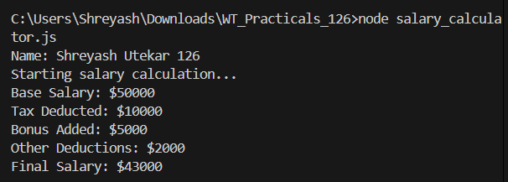

Practical No:-16
Aim: To handle complex data arrays and duplicate events.
a) Write a program to create Event Emitters to print the sum of odd and even numbers from an array
sum_even_odd.js
console.log("Name: Shreyash Utekar 126");

const EventEmitter = require('events');

class SumEmitter extends EventEmitter {
constructor(arr) {
super();
this.arr = arr;
}

sumEven() {
let evenSum = this.arr
.filter(num => num % 2 === 0)
.reduce((acc, curr) => acc + curr, 0);

this.emit('evenSum', evenSum);
}

sumOdd() {
let oddSum = this.arr
.filter(num => num % 2 !== 0)
.reduce((acc, curr) => acc + curr, 0);

this.emit('oddSum', oddSum);
}
}

const numbers = [1, 2, 3, 4, 5, 6, 7, 8, 9, 10];
const sumEmitter = new SumEmitter(numbers);

sumEmitter.on('evenSum', (sum) => {
console.log(`The sum of even numbers is: ${sum}`);
});

sumEmitter.on('oddSum', (sum) => {
console.log(`The sum of odd numbers is: ${sum}`);
});

sumEmitter.sumEven();
sumEmitter.sumOdd();

Output :
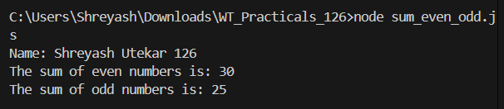

b) Write a program to demonstrate Events by the same name
same_event.js
console.log("Name: Shreyash Utekar 126");

const EventEmitter = require('events');
const eventEmitter = new EventEmitter();

eventEmitter.on('greet', (name) => {
console.log(`Hello, ${name}! Welcome to our Node.js event demo.`);
});

eventEmitter.on('greet', (name) => {
console.log(`${name}, hope you have a fantastic day!`);
});

eventEmitter.on('greet', (name) => {
console.log(`Goodbye, ${name}. See you next time!`);
});

console.log("Emitting the 'greet' event...");
eventEmitter.emit('greet', 'Shreyash');

Output :
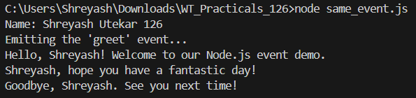

Practical No:- 17
Aim: To study and display local system file paths.
a) Write an Application to Display Details of the Current File Path
filepath.js
console.log("Name: Shreyash Utekar 126");

console.log("Current File Path:", __filename);
console.log("Current Directory Path:", __dirname);

Output :
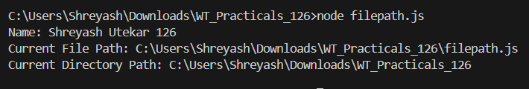

Practical No:-18
Aim: To implement basic file I/O operations using the fs module.
a) Write an Application to Read File
readFile.js

const fs = require("fs");
fs.readFile("shreyash.txt",'utf8',function(err,data){
console.log("Reading File");
console.log(data);
});

Output :
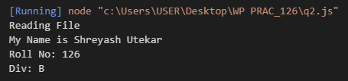

b)Write an Application to Write in File
writeFile.js
const fs = require("fs");
fs.writeFile("shreyash.txt",'Welcome to Sterling',function(err,data){
console.log("Writing File");
console.log(data);
});

Output :
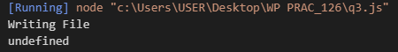

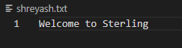

Practical No:- 19
AIM: To perform advanced file system tasks and modern syntax.
a) Write an Application to Add Data in File
appendFile.js
const fs = require("fs");
fs.appendFile("shreyash.txt",'\n Hello Everyone \n Do like, share & subscribe',function(err,data){
console.log("Append File");
});

Output :
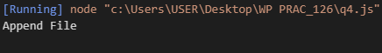

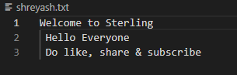

b) Write an Application to Delete a File
deleteFile.js
const fs = require("fs");
fs.unlink("shreyash.txt",function(err,data){
console.log("Deleting File");
console.log("File Deleted Succesfully!");
});

Output :
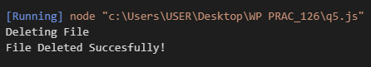

c) File Handling Programs Using Arrow Function
1) Read File (Arrow Function)
arrowRead.js
console.log("Name: Shreyash Utekar 126");

const fs = require('fs');

fs.readFile('data.txt', 'utf8', (err, data) => {
if (err) return console.error("Error reading file:", err);
console.log("File Content:");
console.log(data);
});

Output :
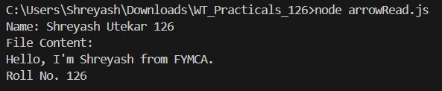

2) Write File (Arrow Function)
arrowWrite.js
console.log("Name: Shreyash Utekar 126");

const fs = require('fs');

fs.writeFile('data.txt', 'Arrow function write example', err => {
if (err) return console.error("Error writing file:", err);
console.log("File written using arrow function.");
});

Output :
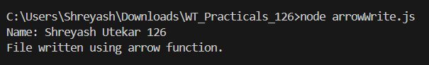
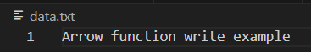
3) Append File (Arrow Function)
arrowAppend.js
console.log("Name: Shreyash Utekar 126");

const fs = require('fs');

fs.appendFile('data.txt', '\nAppended using arrow function', err => {
if (err) return console.error("Error appending file:", err);
console.log("File appended using arrow function.");
});

Output : 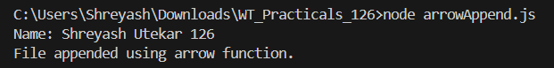
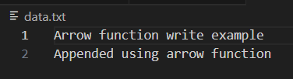

Practical No:-20
Aim: To create a web server and handle data streams.
a) To create a simple Node.js HTTP Server
server.js
console.log("Name: Shreyash Utekar 126");

const http = require('http');

const server = http.createServer((req, res) => {
console.log('Server Running');
res.setHeader('Content-Type', 'text/html');
res.write('<html>');
res.write('<h1>Hello from Node.js server</h1>');
res.write('<h1>I am Shreyash Utekar From FYMCA 126</h1>');
res.write('<h2>Welcome to this course</h2>');
res.write('</html>');
res.end();
});

server.listen(3000, () => {
console.log('Server is listening on port 3000');
});

Output :
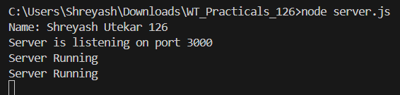

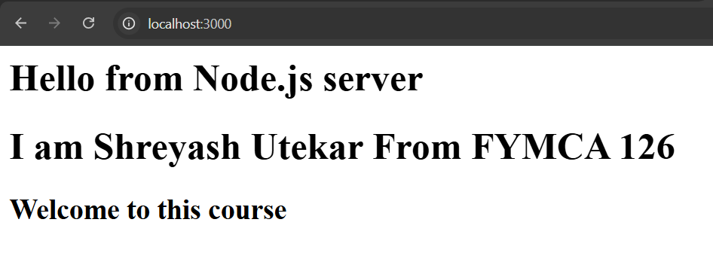

b) Demonstrate Piping in Node.js
1) pipingDemo.js
console.log("Name: Shreyash Utekar 126");

const fs = require("fs");

const readStream = fs.createReadStream("input.txt");
const writeStream = fs.createWriteStream("output.txt");

// Pipe read stream into write stream
readStream.pipe(writeStream);

writeStream.on('finish', () => {
console.log("Piping completed successfully");
});

readStream.on('error', (err) => {
console.error("Error reading input file:", err);
});

writeStream.on('error', (err) => {
console.error("Error writing output file:", err);
});

Output :
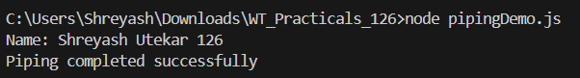

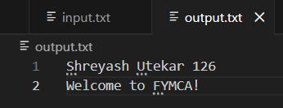

2) pipingDemo2.js
console.log("Name: Shreyash Utekar Roll No: 126");

const fs = require('fs');

const readableStream = fs.createReadStream('input.txt', 'utf8');

const writableStream = fs.createWriteStream('output.txt');

readableStream.pipe(writableStream);

writableStream.on('finish', () => {
console.log('File copy completed!');
});

readableStream.on('error', (err) => {
console.error('Error reading file:', err);
});

writableStream.on('error', (err) => {
console.error('Error writing file:', err);
});

Output :
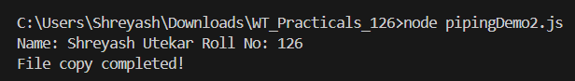

Practical No:-21
AIM: To implement server-side routing and business logic.
a) Write an application to create Home Page, Admin Page, and Student Page using HTTP
server
form.js
console.log("Name: Shreyash Utekar 126");

const http = require('http');

const server = http.createServer((req, res) => {
if (req.url === '/') {
res.writeHead(200, { 'Content-Type': 'text/html' });
res.write(`
<html>
<head>
<style>
ul li {
display: inline-block;
float: right;
height: 40px;
}
ul li a {
padding: 20px;
background: orange;
color: white;
text-decoration: none;
}
</style>
</head>
<body>
<h1>My First Website</h1>
<ul>
<li><a href="/admin">Contact Admin</a></li>
<li><a href="/student">Student</a></li>
<li><a href="/home">Home</a></li>
</ul>
<div style="padding:20px;">
<h2>Start Page</h2>
<p>This is my first webpage!</p>
<p>Hi everyone</p>
</div>
</body>
</html>
`);
res.end();
}
else if (req.url === '/home') {
res.writeHead(200, { 'Content-Type': 'text/html' });
res.write(`
<html>
<body style="background-color: lightyellow; padding: 40px;">
<h1>This is Home Page</h1>
<h2>Shreyash Utekar</h2>
<h3>This page is a brief insight to who I am.</h3>
<nav>
<a href="/">Start Page</a> |
<a href="/student">Student</a> |
<a href="/admin">Admin</a>
</nav>
</body>
</html>
`);
res.end();
}
else if (req.url === '/student') {
res.writeHead(200, { 'Content-Type': 'text/html' });
res.write(`
<html>
<body style="background-color:pink;">
<h1 align="center">Student Page Form</h1>
<form>
<fieldset>
<legend>Personal Information</legend>
Name:<br><input type="text"><br>
Email:<br><input type="email"><br>
Password:<br><input type="password"><br><br>

Gender:<br>
<input type="radio" name="g"> Male
<input type="radio" name="g"> Female<br><br>

Hobbies:<br>
<input type="checkbox"> Sports<br>
<input type="checkbox"> Music<br>
<input type="checkbox"> Reading<br><br>

City:<br>
<select>
<option>Mumbai</option>
<option>Pune</option>
<option>Ahilyanagar</option>
</select><br><br>

<input type="submit" value="Submit" onclick="alert('Thanks!')">
</fieldset>
</form>
</body>
</html>
`);
res.end();
}
else if (req.url === '/admin') {
res.writeHead(200, { 'Content-Type': 'text/html' });
res.write(`
<html>
<body style="background-color:#faf89a;">
<h1><u>Admin Login</u></h1>
<form>
Username:<br><input type="text"><br>
Password:<br><input type="password"><br><br>
<button onclick="alert('SUCCESS')">LOGIN NOW</button>
</form>
</body>
</html>
`);
res.end();
}

else {
res.writeHead(404, { 'Content-Type': 'text/plain' });
res.end("Invalid Request");
}
});
server.listen(9000, () => {
console.log("Node.js web server running at http://localhost:9000");
});
Output :
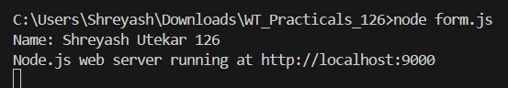
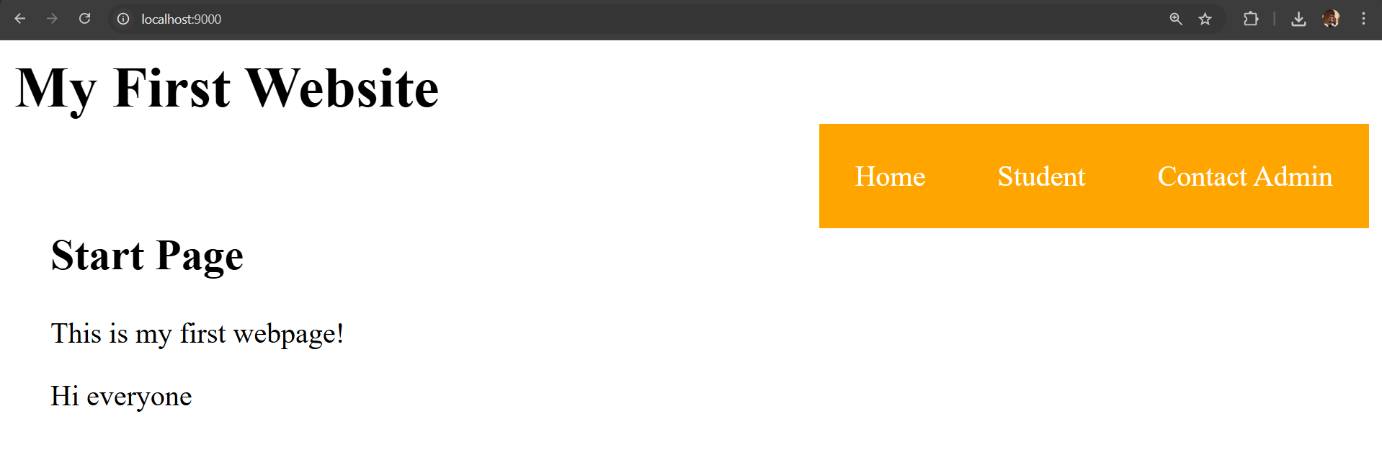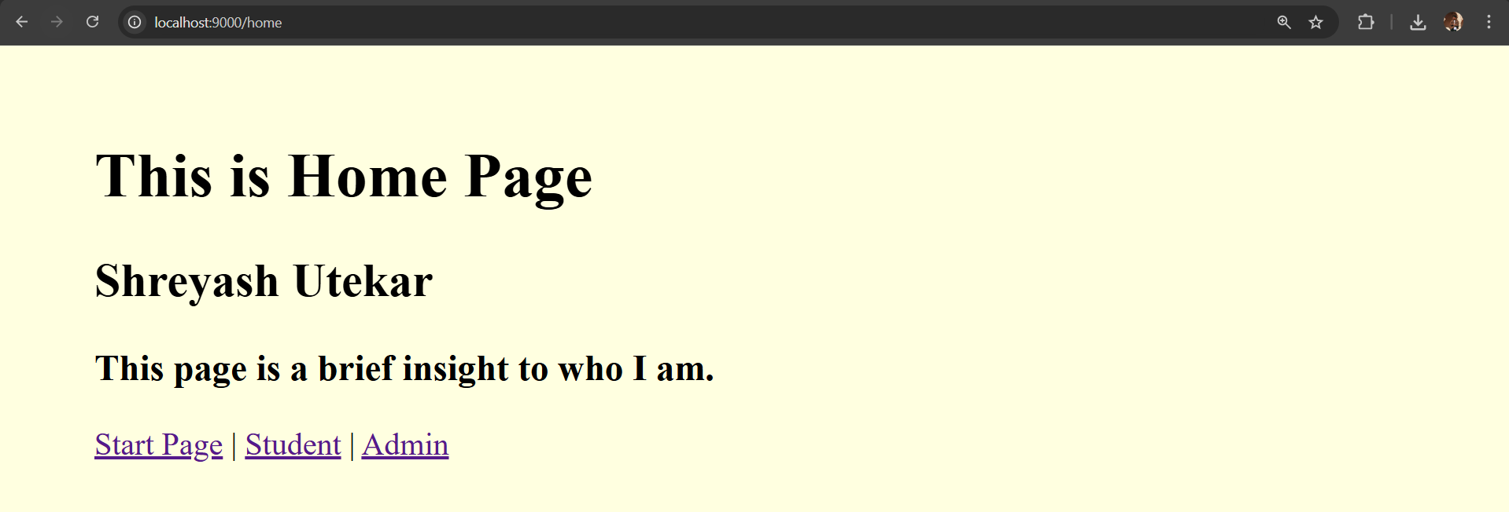
b) ERP Program
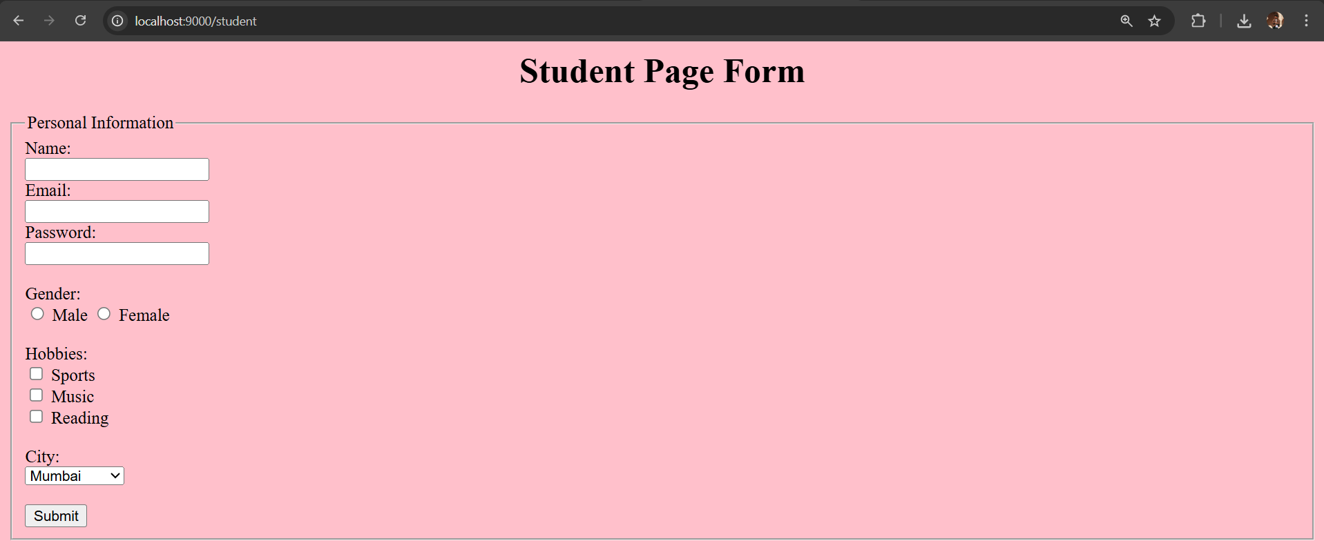
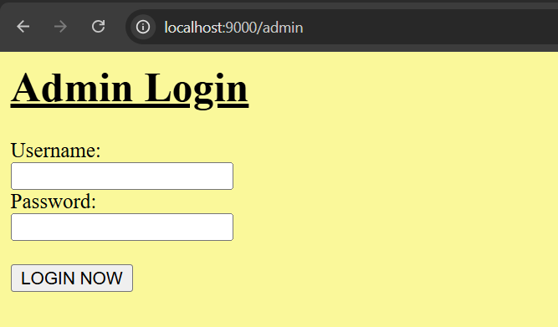

erp.js
console.log("Name: Shreyash Utekar 126");

var http = require('http');

var server = http.createServer(function (req, res) {

// DASHBOARD
if (req.url == '/') {
res.writeHead(200, { 'Content-Type': 'text/html' });
res.write('<html><head>');
res.write('<style>');
res.write('body{font-family:Arial;} ul li{display:inline-block; margin:10px;}');
res.write('a{padding:15px; background:teal; color:white; text-decoration:none;}');
res.write('</style>');
res.write('</head><body>');
res.write('<h1 align="center">ERP DASHBOARD</h1>');
res.write('<h3 align="center">Shreyash Utekar (Roll No: 126)</h3>');
res.write('<ul>');
res.write('<li><a href="/student">Student Module</a></li>');
res.write('<li><a href="/faculty">Faculty Module</a></li>');
res.write('<li><a href="/admin">Admin Module</a></li>');
res.write('</ul>');
res.write('</body></html>');
res.end();
}

// STUDENT MODULE
else if (req.url == '/student') {
res.writeHead(200, { 'Content-Type': 'text/html' });
res.write('<html><body bgcolor="lightpink">');
res.write('<h1>Student ERP Module</h1>');
res.write('<p>Name : Shreyash Utekar</p>');
res.write('<p>Roll No : 92</p>');
res.write('<p>Course : MCA</p>');
res.write('<p>Attendance : 85%</p>');
res.write('<a href="/">Back to Dashboard</a>');
res.write('</body></html>');
res.end();
}

// FACULTY MODULE
else if (req.url == '/faculty') {
res.writeHead(200, { 'Content-Type': 'text/html' });
res.write('<html><body bgcolor="lightyellow">');
res.write('<h1>Faculty ERP Module</h1>');
res.write('<p>Faculty Name : ____________</p>');
res.write('<p>Subject : Web Technology</p>');
res.write('<p>Department : MCA</p>');
res.write('<p>Lecture Hours : 4 hrs/day</p>');
res.write('<a href="/">Back to Dashboard</a>');
res.write('</body></html>');
res.end();
}

// ADMIN MODULE
else if (req.url == '/admin') {
res.writeHead(200, { 'Content-Type': 'text/html' });
res.write('<html><body bgcolor="lightblue">');
res.write('<h1>Admin ERP Module</h1>');
res.write('<form>');
res.write('Username:<br><input type="text"><br>');
res.write('Password:<br><input type="password"><br><br>');
res.write('<button onclick="alert(\'Login Successful\')">LOGIN</button>');
res.write('</form>');
res.write('<br><a href="/">Back to Dashboard</a>');
res.write('</body></html>');
res.end();
}

else {
res.end('Invalid Request');
}
});

server.listen(8000);
console.log('ERP Server running on port 8000');

Output :
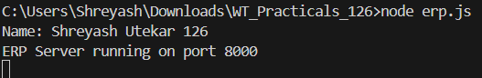

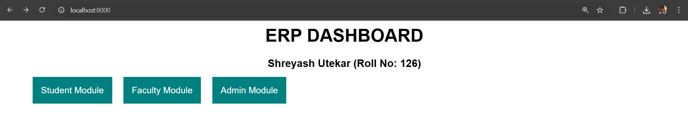

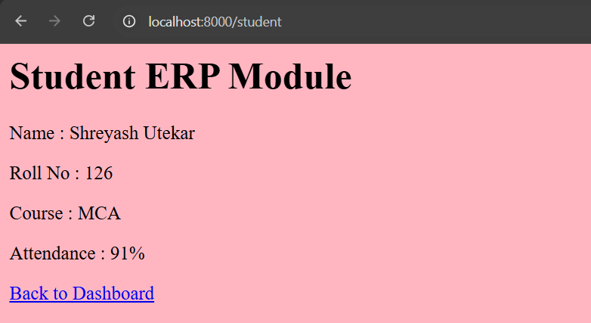

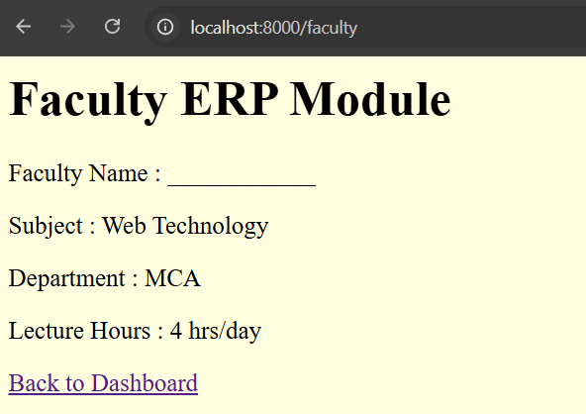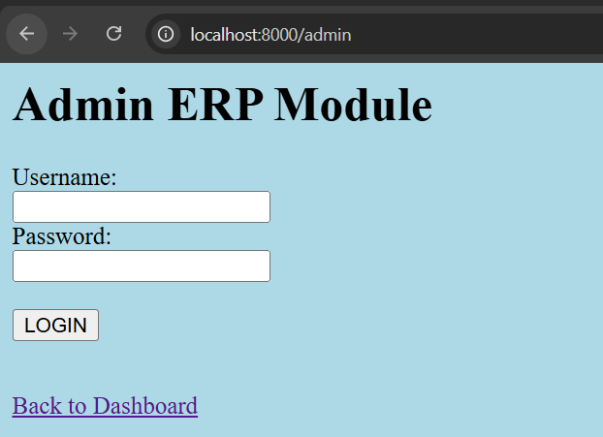

Practical No:-22
Aim: To introduce ReactJS basics and component structure.
Implement Functional Component (React Programs):
a) Hello World using ReactJS
1) Write a program to display Hello World using ReactJS
Heading.jsx
import logo from './logo.svg';
import './App.css';
function Heading() {
return (
<div className="App">
<header className="App-header">
<img src={logo} className="App-logo" alt="logo" />
<h1>Hello, World!</h1>
<h2>Name: Shreyash Utekar</h2>
<h3>Roll No: 126</h3>
</header>
</div>
);
}
export default Heading;

Output:-
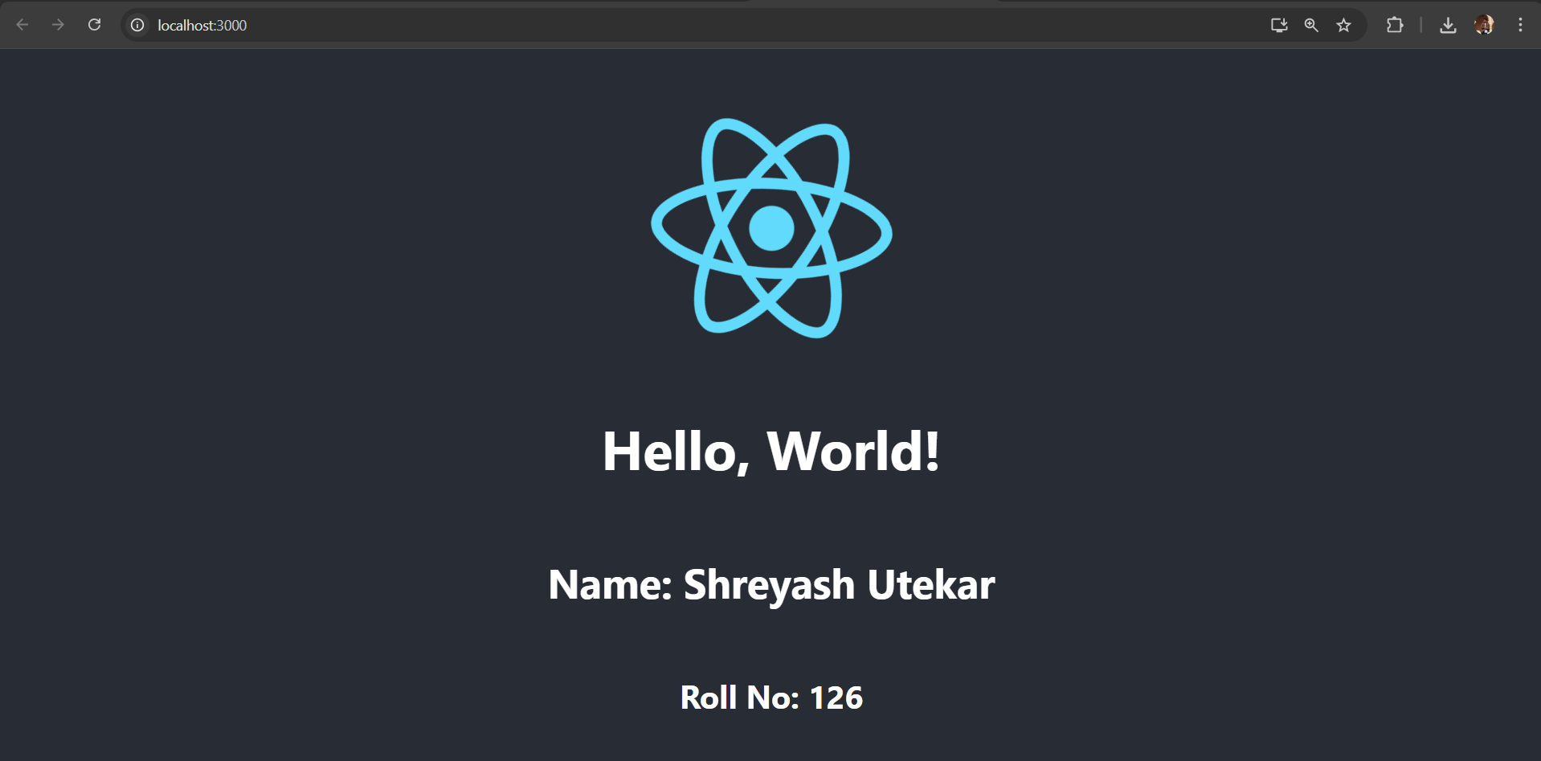
b) Implementing JSX in actions
1) Passing Childern in JSX
App.js
import React from "react";
const Welcome = (props) => {
return <div>{props.children}</div>;
};
const App = () => {
return (
<Welcome>
<h1>Hello, Hackers!!</h1>
<p>Welcome to my world.</p>
</Welcome>
);
};
export default App;

Output:
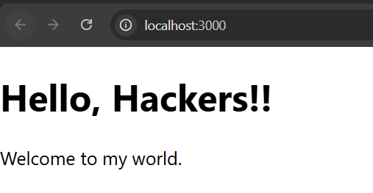

2) Using Attributes in JSX
App.js
import React from "react";
function App() {
const name = "Shreyash Utekar";

const greeting = <h1>Hello, {name}!</h1>;
const element = (
<img
src="/image.jpg"
alt="CJ Always Rock"
style={{
width: "300px",
height: "auto",
borderRadius: "8px",
}}
/>
);
return (
<div>
{greeting}
{element}
</div>
);
}
export default App;

Output :
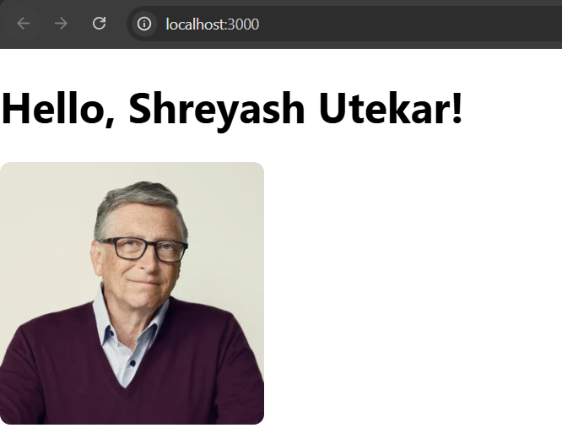

3) Embedding Expressions
import React from "react";
function App() {
const name = "Shreyash";
const greeting = <h1>Hello, {name}!</h1>;
return (
<div>
{greeting}
</div>
);
}
export default App;

Output :

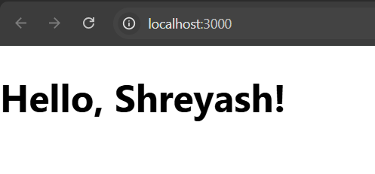

c) Create an application in ReactJS to Import and Export Files (Components)
App.js
import React from "react";
import FileUploader from "./components/fileUploader";
import FileDownloader from "./components/fileDownloader";
import "./App.css";
function App() {
return (
<div className="App">
<h2>ReactJS File Import & Export</h2>
<h3>Name: Shreyash Utekar</h3>
<h4>Roll No: 126</h4>

<FileUploader />
<hr />
<FileDownloader />
</div>
);
}
export default App;

fileUploader.js
import React, { useState } from "react";
const FileUploader = () => {
const [fileContent, setFileContent] = useState("");

const handleFileUpload = (e) => {
const file = e.target.files[0];
const reader = new FileReader();

reader.onload = (event) => {
setFileContent(event.target.result);
};

if (file) {
reader.readAsText(file);
}
};
return (
<div>
<h3>Upload a File</h3>
<input type="file" onChange={handleFileUpload} />

{fileContent && (
<div>
<h4>File Content:</h4>
<textarea
value={fileContent}
readOnly
rows="10"
cols="50"
/>
</div>
)}
</div>
);
};
export default FileUploader;

fileDownloader.js
import React from "react";
const FileDownloader = () => {
const handleDownload = () => {
const content = "This is some sample text for the file.\nName: Shreyash Utekar\nRoll No: 126";
const blob = new Blob([content], { type: "text/plain" });
const url = URL.createObjectURL(blob);
const link = document.createElement("a");
link.href = url;
link.download = "sample.txt";
link.click();

URL.revokeObjectURL(url);
};
return (
<div>
<h3>Download a File</h3>
<button onClick={handleDownload}>Download</button>
</div>
);
};
export default FileDownloader;
Output :
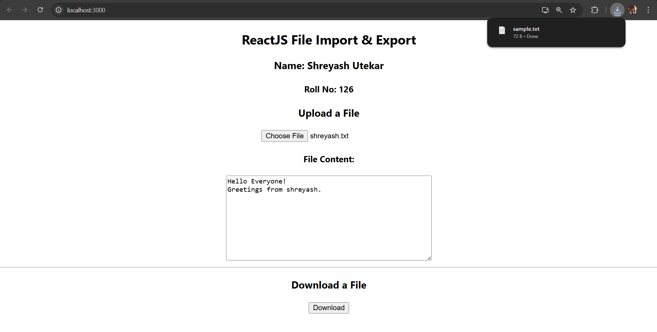

d) Implement React Routing
App.js
import React from "react";
import { BrowserRouter as Router, Routes, Route, Link } from "react-router-dom";
import Home from "./components/Home";
import About from "./components/About";
import Contact from "./components/Contact";
const App = () => {
return (
<Router>
<nav>
<ul>
<li><Link to="/">Home</Link></li>
<li><Link to="/about">About</Link></li>
<li><Link to="/contact">Contact</Link></li>
</ul>
</nav>

<Routes>
<Route path="/" element={<Home />} />
<Route path="/about" element={<About />} />
<Route path="/contact" element={<Contact />} />
</Routes>
</Router>
);
};
export default App;

components/Home.js
import React from "react";
const Home = () => {
return <h1>Welcome to the Home Page – Shreyash Utekar</h1>;
};
export default Home;
components/About.js
import React from "react";
const About = () => {
return <h1>About Us - Shreyash Utekar </h1>;
};
export default About;

components/Contact.js
import React from "react";
const Contact = () => {
return <h1>Contact Us - Shreyash Utekar </h1>;
};
export default Contact;

Output :

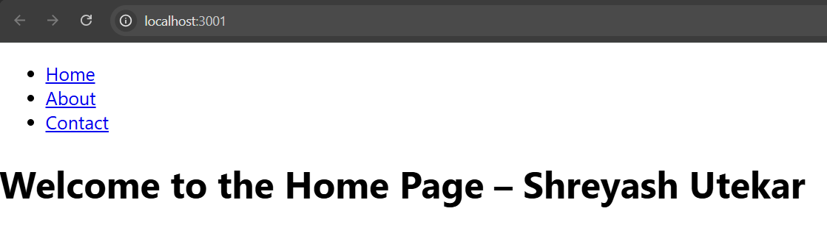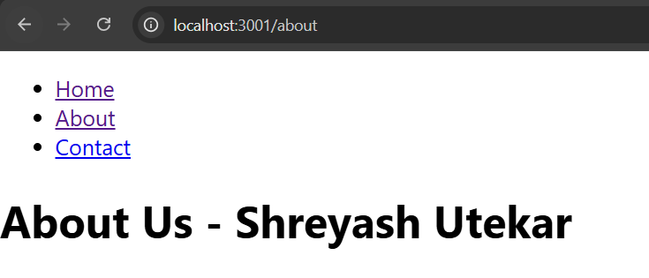
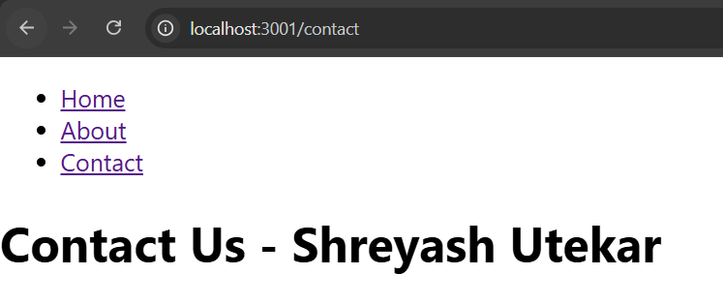

Practical No:- 23
Aim: To study React component lifecycles and state management.
a) Create an application in ReactJS to implement Component Life Cycle.
App.js
import React, { useState, useEffect } from "react";
import "./App.css";

const LifecycleComponent = () => {
const [count, setCount] = useState(0);
const [message, setMessage] = useState("Hello, World!");

useEffect(() => {
console.log("Component mounted!");

return () => {
console.log("Component will unmount!");
};
}, []);

useEffect(() => {
console.log(`Count updated to: ${count}`);
}, [count]);

const handleClick = () => {
setCount(count + 1);
};

const handleMessageChange = () => {
setMessage("Message has been changed!");
};

return (
<div>
<h1>React Component Lifecycle Example</h1>
<h3>Name: Shreyash Utekar</h3>
<h4>Roll No: 126</h4>

<p>Message: {message}</p>
<p>Count: {count}</p>

<button onClick={handleClick}>Increment Count</button>
<br /><br />
<button onClick={handleMessageChange}>Change Message</button>
</div>
);
};

function App() {
return (
<div className="App">
<h2>React Component Lifecycle Demo</h2>
<LifecycleComponent />
</div>
);
}
export default App;

App.css (Optional)
.App {
text-align: center;
font-family: Arial, sans-serif;
}

button {
padding: 8px 15px;
margin: 5px;
}

Output :
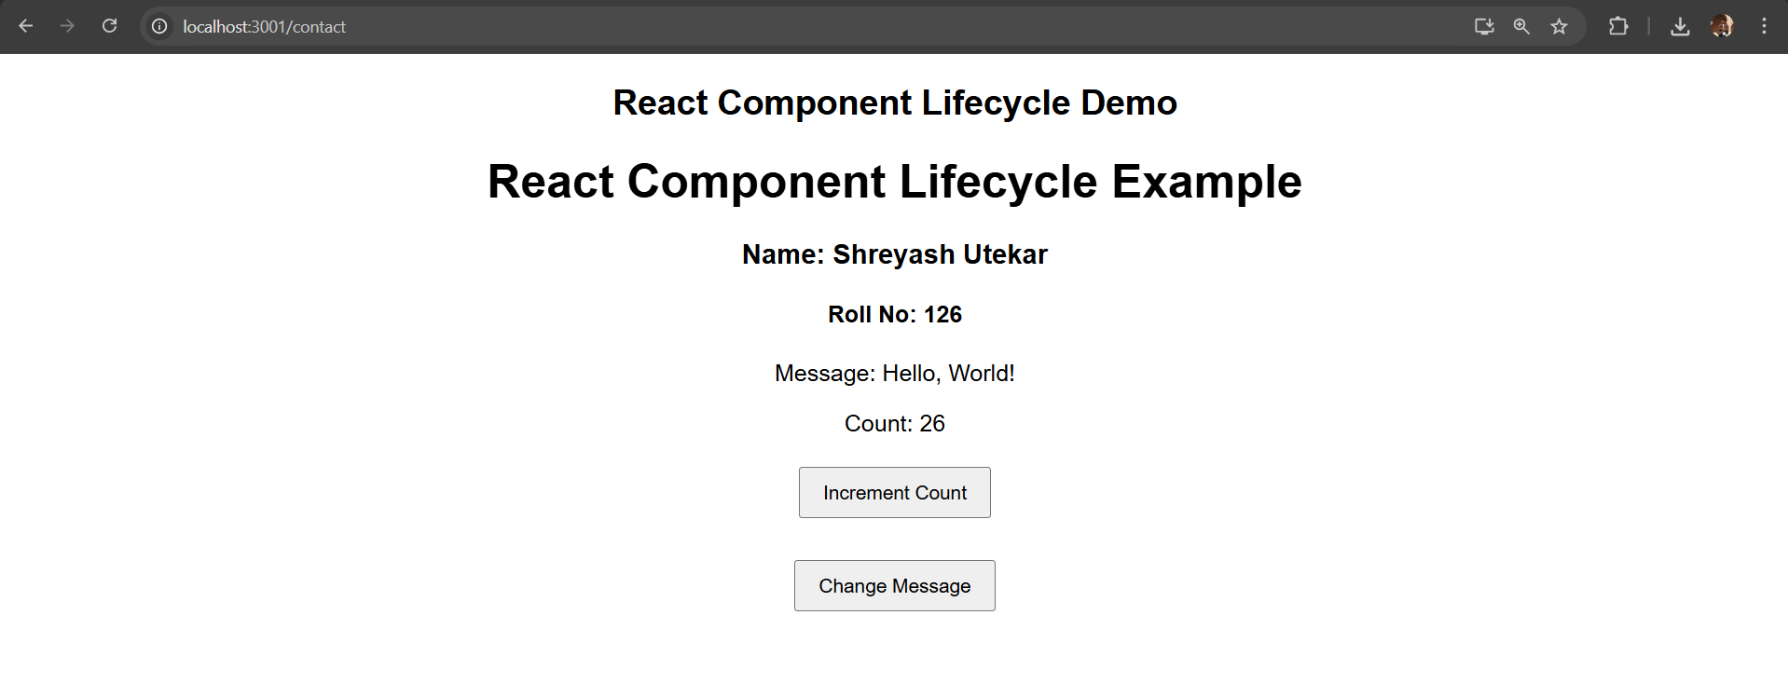
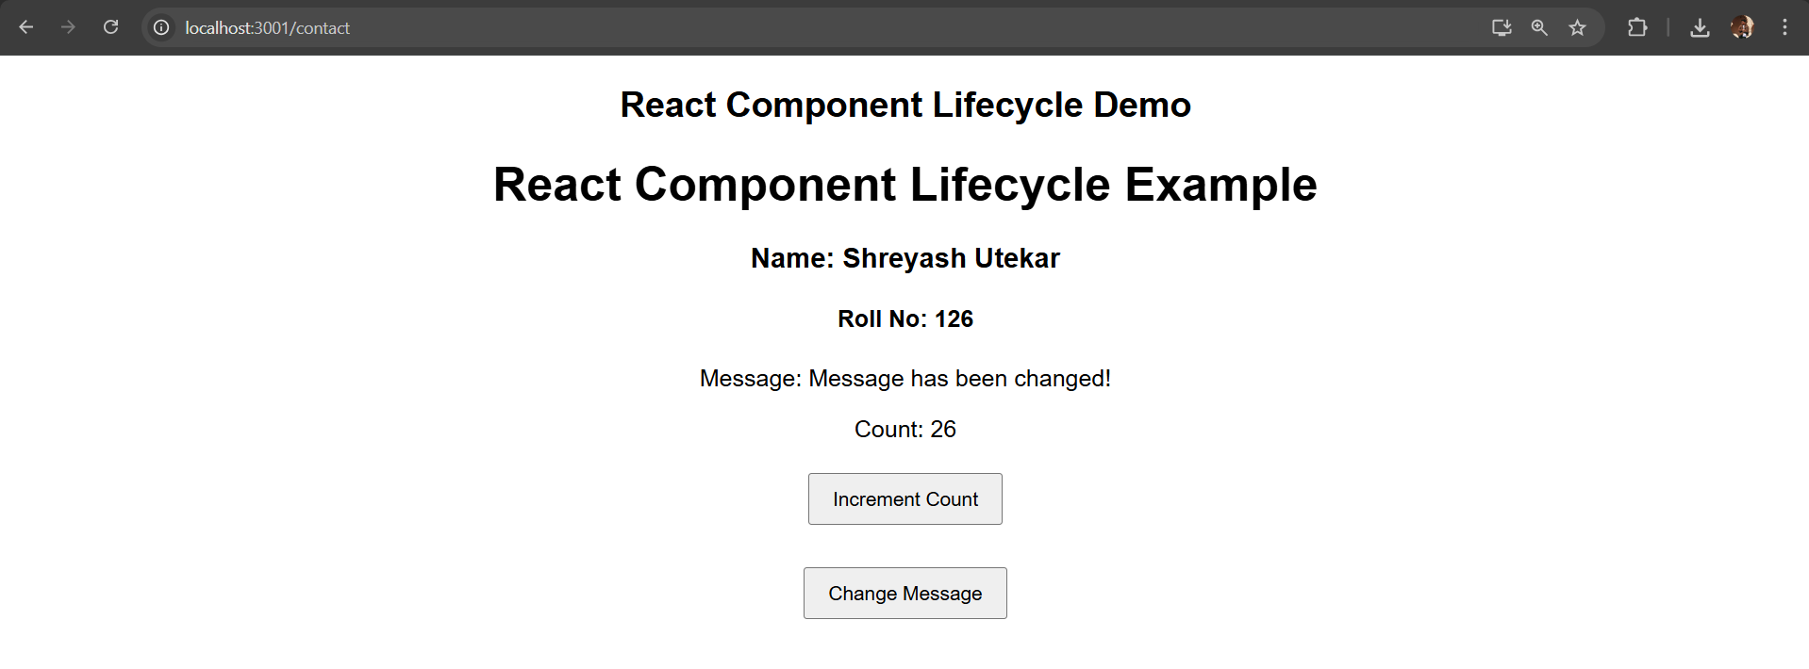

b) Increment/Decrement counter using state.
App.js
import React from "react";
import Counter from "./counter";

function App() {
return (
<div>
<Counter />
</div>
);
}
export default App;

counter.js
import React, { useState } from "react";

const Counter = () => {
const [count, setCount] = useState(0);

const increment = () => setCount(count + 1);
const decrement = () => setCount(count - 1);

return (
<div style={{ textAlign: "center", marginTop: "50px" }}>
<h1>Increment / Decrement Counter</h1>
<h2>{count}</h2>

<button onClick={increment} style={{ marginRight: "10px" }}>
Increment
</button>

<button onClick={decrement}>Decrement</button>

<p>Shreyash Utekar</p>
</div>
);
};
export default Counter;

Output :

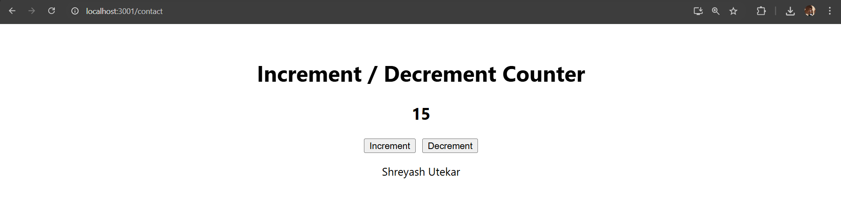

c) Implement Form Validation
App.js
import React from "react";
import BasicFormValidation from "./BasicFormValidation";

function App() {
return (
<div style={{ textAlign: "center", marginTop: "40px" }}>
<h2>Form Validation</h2>
<BasicFormValidation />
<p>Shreyash Milind Utekar</p>
</div>
);
}
export default App;
src/BasicFormValidation.js
import React, { useState } from "react";

function BasicFormValidation() {
const [formData, setFormData] = useState({
name: "",
email: ""
});

const [errors, setErrors] = useState({});

const handleChange = (e) => {
const { name, value } = e.target;
setFormData({
...formData,
[name]: value
});
};

const validate = () => {
const newErrors = {};

if (!formData.name) {
newErrors.name = "Name is required";
}
if (!formData.email) {
newErrors.email = "Email is required";
} else if (!/\S+@\S+\.\S+/.test(formData.email)) {
newErrors.email = "Email is invalid";
}

setErrors(newErrors);
return Object.keys(newErrors).length === 0;
};

const handleSubmit = (e) => {
e.preventDefault();
if (validate()) {
alert("Form submitted successfully!");
}
};

return (
<form onSubmit={handleSubmit}>
<div>
<label>Name:</label><br />
<input
type="text"
name="name"
value={formData.name}
onChange={handleChange}
/>
{errors.name && (
<p style={{ color: "red" }}>{errors.name}</p>
)}
</div>

<div>
<label>Email:</label><br />
<input
type="text"
name="email"
value={formData.email}
onChange={handleChange}
/>
{errors.email && (
<p style={{ color: "red" }}>{errors.email}</p>
)}
</div>
<button type="submit">Submit</button>
</form>
);
}
export default BasicFormValidation;

Output :

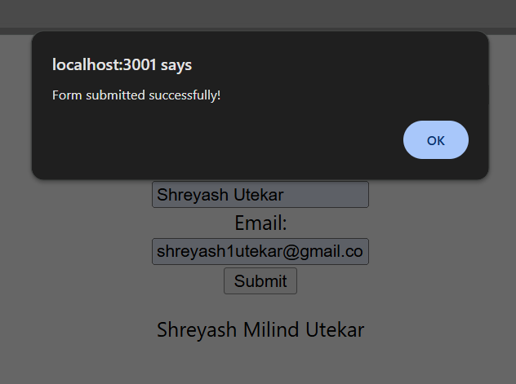

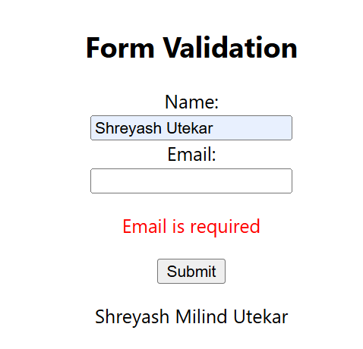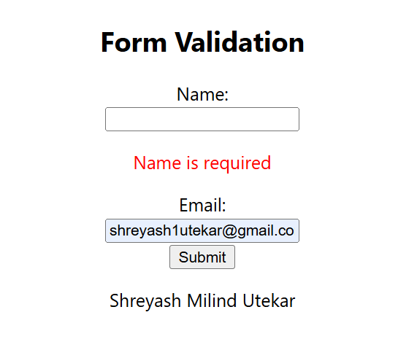

Practical No:-24
Aim: To handle user interaction via DOM events and Props.
a) Create an application to Display Your Name Using Prop
App.js
import React from "react";
import NameDisplay from "./NameDisplay";
function App() {
return (
<div>
<NameDisplay name="Shreyash Utekar" roll="126" />
</div>
);
}
export default App;

NameDisplay.js
import React from "react";
const NameDisplay = (props) => {
return (
<div style={{ textAlign: "center", marginTop: "50px" }}>
<h1>Hello, {props.name}!</h1>
<h2>Roll No: {props.roll}</h2>
</div>
);
};
export default NameDisplay;
Output :
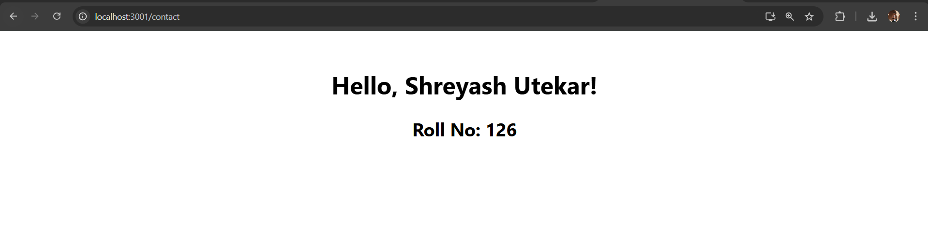

b) Write a Program that Tracks the Changes in an Input Field and Displays the Entered Text in Real-Time Using onChange DOM Event
App.js
import { useState } from "react";
function App() {
const [text, setText] = useState("");
const handleChange = (event) => {
setText(event.target.value);
};
return (
<div style={{ textAlign: "center", marginTop: "50px" }}>
<h2>Real-time Input Tracking</h2>
<input
type="text"
placeholder="Type something..."
onChange={handleChange}
style={{ padding: "10px", fontSize: "16px", width: "300px" }}
/>
<p>You typed: {text}</p>
</div>
);
}
export default App;

Output :
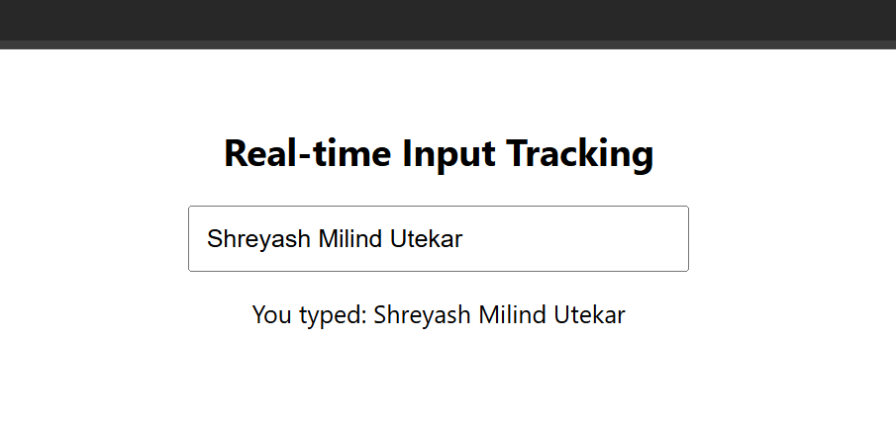

c) Write a Program to Count Words as They Are Typed Using onKeyUp Event
App.js
import React, { useState } from "react";

function App() {
const [keyPressed, setKeyPressed] = useState("");

const handleKeyUp = (event) => {
setKeyPressed(event.key);
};
return (
<div style={{ padding: "20px", textAlign: "center" }}>
<h1>React onKeyUp Event Demo</h1>
<p>Type something in the input box below and release a key to see the last key pressed.</p>
<div style={{ marginBottom: "20px" }}>
<input
type="text"
onKeyUp={handleKeyUp}
placeholder="Type something and release a key"
style={{
padding: "10px",
width: "300px",
border: "1px solid #ccc",
borderRadius: "5px",
fontSize: "16px",
}}
/>
</div>
<p style={{ fontSize: "20px", color: "#333" }}>
<strong>Last key pressed: </strong>
{keyPressed}
</p>
</div>
);
}

export default App;
Output :
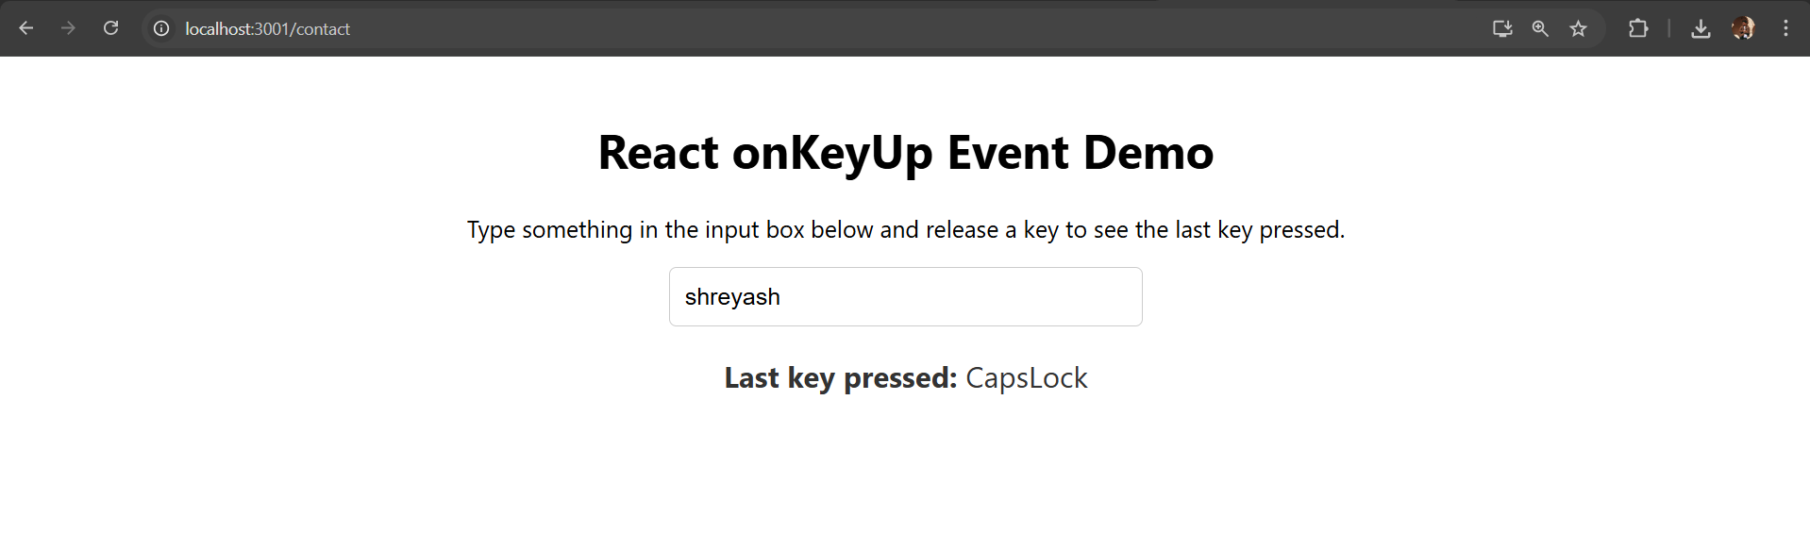
Practical No:-25
Aim: To perform database operations and create functional React apps.
a) Create an application to implement To-Do Task
App.js
import React from "react";
import ToDo from "./ToDo";

function App() {
return (
<div>
<ToDo />
</div>
);
}
export default App;

ToDo.js
import React, { useState } from "react";

const ToDo = () => {
const [tasks, setTasks] = useState([]);
const [task, setTask] = useState("");

const addTask = () => {
if (task.trim()) {
setTasks([...tasks, task]);
setTask("");
}
};

const removeTask = (index) => {
const updatedTasks = tasks.filter((_, i) => i !== index);
setTasks(updatedTasks);
};

return (
<div style={{ textAlign: "center", marginTop: "50px" }}>
<h1>To-Do List</h1>
<div>
<input
type="text"
value={task}
onChange={(e) => setTask(e.target.value)}
placeholder="Enter a task"
style={{ padding: "8px", width: "200px" }}
/>
<button
onClick={addTask}
style={{ padding: "8px 16px", marginLeft: "10px" }}
>
Add Task
</button>
</div>
<ul style={{ listStyle: "none", padding: "0", marginTop: "20px" }}>
{tasks.map((t, index) => (
<li
key={index}
style={{
margin: "10px 0",
display: "flex",
justifyContent: "center",
alignItems: "center",
}}
>
<span style={{ marginRight: "20px" }}>{t}</span>
<button
onClick={() => removeTask(index)}
style={{
backgroundColor: "red",
color: "white",
border: "none",
padding: "5px 10px",
cursor: "pointer",
}}
>
Remove
</button>
</li>
))}
</ul>
</div>
);
};
export default ToDo;

Output :
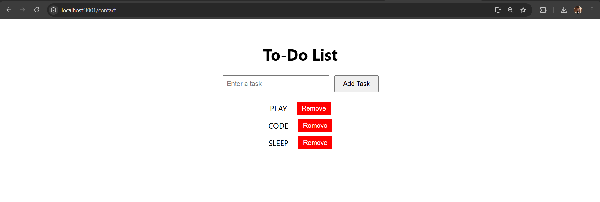
b) Database CRUD (Create Database, Table, Insert, Update, Delete, Add Column)
1) createDB.js
const mysql = require("mysql2");

const con = mysql.createConnection({
host: "localhost",
user: "root",
password: "shreyash"
});

con.connect((err) => {
if (err) throw err;
console.log("Connected to MySQL");

con.query("CREATE DATABASE IF NOT EXISTS students4", (err) => {
if (err) throw err;
console.log("Database created");

con.changeUser({ database: "students4" }, (err) => {
if (err) throw err;

const sql = `
CREATE TABLE IF NOT EXISTS student1 (
id INT AUTO_INCREMENT PRIMARY KEY,
name VARCHAR(255),
address VARCHAR(255),
course VARCHAR(50),
contact VARCHAR(15)
)
`;

con.query(sql, (err) => {
if (err) throw err;
console.log("Student table created");
con.end();
});
});
});
});

Output :
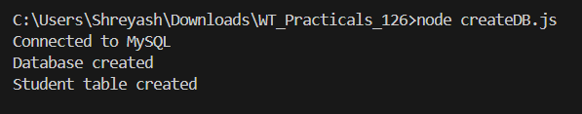

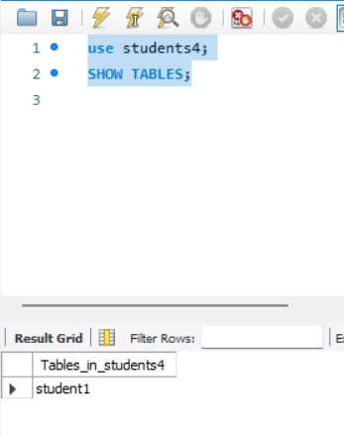

2)Create an application to insert rows into Student table in NodeJS
insertrows.js
const mysql = require('mysql2');
const con = mysql.createConnection({
host: "localhost",
user: "root",
password: "shreyash", // your password
database: "students4",
port: 3306
});
con.connect((err) => {
if (err) throw err;
console.log("Connected to Database");

const sql = "INSERT INTO student1 (name, address, course, contact) VALUES (?, ?, ?, ?)";

const values = ["Shreyash Milind Utekar", "Thane", "MCA", "126"];

con.query(sql, values, (err, result) => {
if (err) throw err;
console.log("Row inserted successfully!");
con.end();
});
});

Output :

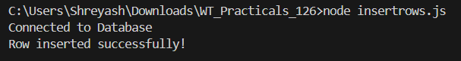

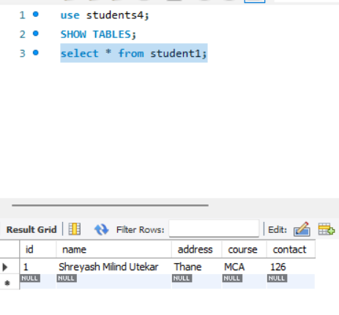

3) Create an application to update a row in Student table in NodeJS
update.js
const mysql = require('mysql2');
const con = mysql.createConnection({
host: "localhost",
user: "root",
password: "shreyash", // your password
database: "students4",
port: 3306
});
con.connect((err) => {
if (err) throw err;
console.log("Connected to Database");

const sql = "UPDATE student1 SET course = ? WHERE id = ?";
const values = ["Web Technology", 1]; // you can change id or course name here

con.query(sql, values, (err, result) => {
if (err) throw err;
if (result.affectedRows > 0) {
console.log("Record updated successfully");
} else {
console.log("No record found with the given ID");
}
con.end();
});
});

Output :
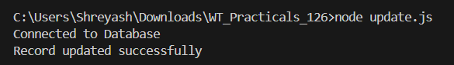
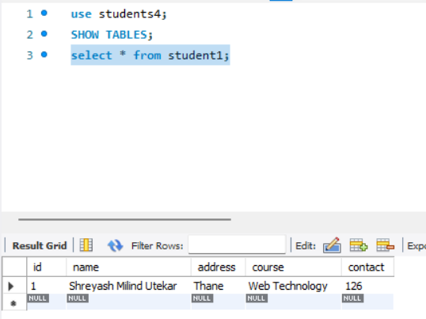

4) Create an application to delete rows in Student table in NodeJS
delete.js
const mysql = require("mysql2");
const con = mysql.createConnection({
host: "localhost",
user: "root",
password: "shreyash", // your password
database: "students4",
port: 3306
});
con.connect(function(err) {
if (err) throw err;
console.log("Connected to Database");

const sql = "DELETE FROM student1 WHERE id = ?";
const values = [2]; // you can change id as needed

con.query(sql, values, function(err, result) {
if (err) throw err;

if (result.affectedRows > 0) {
console.log("Record deleted successfully");
} else {
console.log("No record found with the given ID");
}
con.end();
});
});

Output :
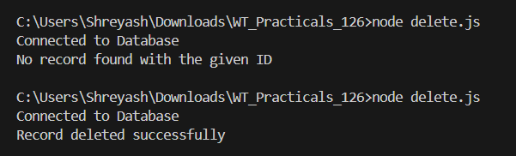
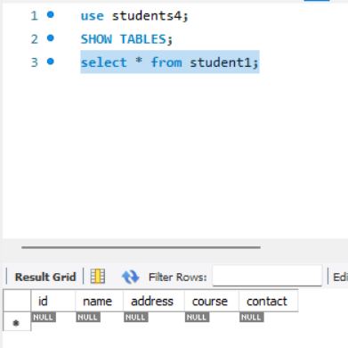
5) Create an application to add a column in Student table in NodeJS
addColumn.js
const mysql = require("mysql2");

const con = mysql.createConnection({
host: "localhost",
user: "root",
password: "shreyash", // your password
database: "students4",
port: 3306
});

con.connect(function(err) {
if (err) throw err;
console.log("Connected to Database");

con.query(sql, function(err, result) {
if (err) throw err;
console.log("Column 'email' added successfully");

con.end();
});
});

Output :
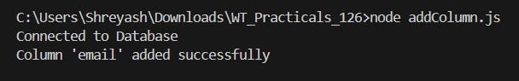

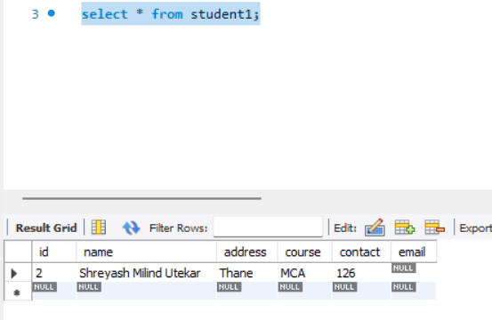

c) Implement React Hooks programs
Program 1: useState - Counter (array style)
App.js
import React, { useState } from "react";
const App = () => {
const array = useState(0);
const counter = array[0];
const setCounter = array[1];

function increaseCounter() {
setCounter(counter + 1);
}
return (
<div style={{ textAlign: "center", marginTop: "50px" }}>
<h3>Name: Shreyash Utekar</h3>
<h1>Counter: {counter}</h1>
<button onClick={increaseCounter}>Increase</button>
</div>
);
};
export default App;

Output :
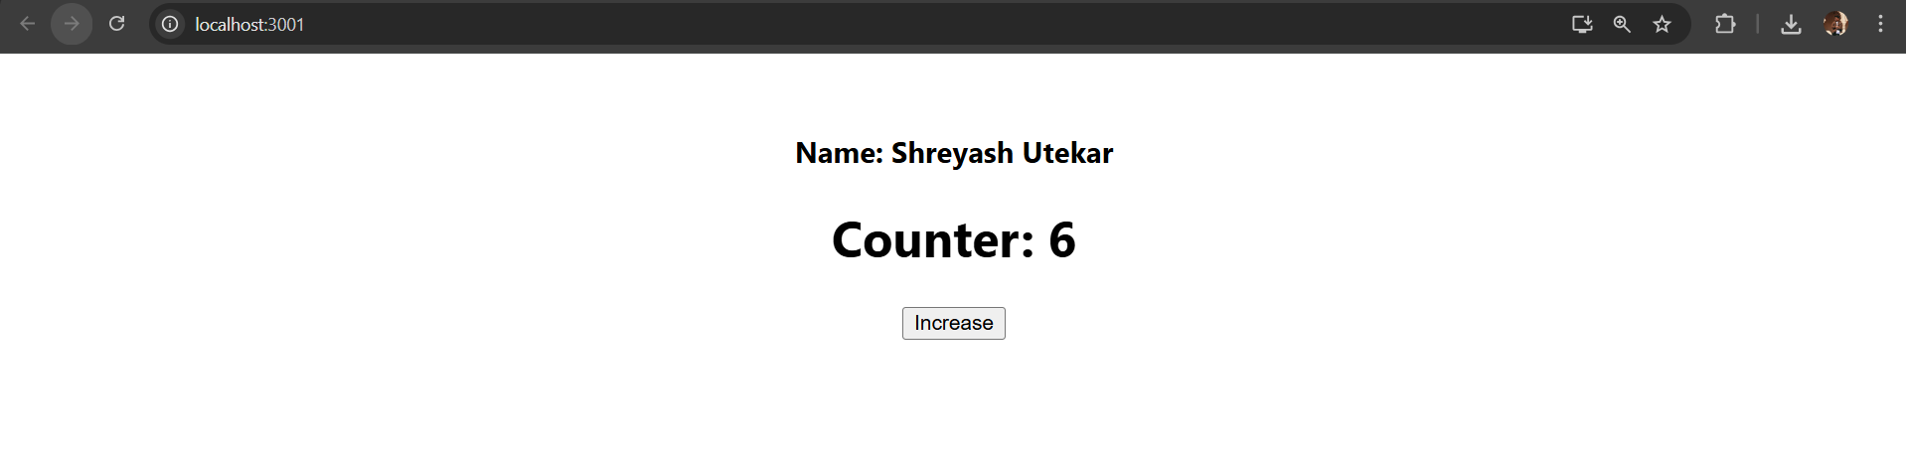

Program 2: useState - Counter (destructuring)
App.js
import React, { useState } from "react";
const App = () => {
const [counter, setCounter] = useState(0);

function increaseCounter() {
setCounter(counter + 1);
}

return (
<div style={{ textAlign: "center", marginTop: "50px" }}>
<h3>Name: Shreyash Utekar | Roll No: 126</h3>
<h1>Counter: {counter}</h1>
<button onClick={increaseCounter}>Increase</button>
</div>
);
};
export default App;

Output :
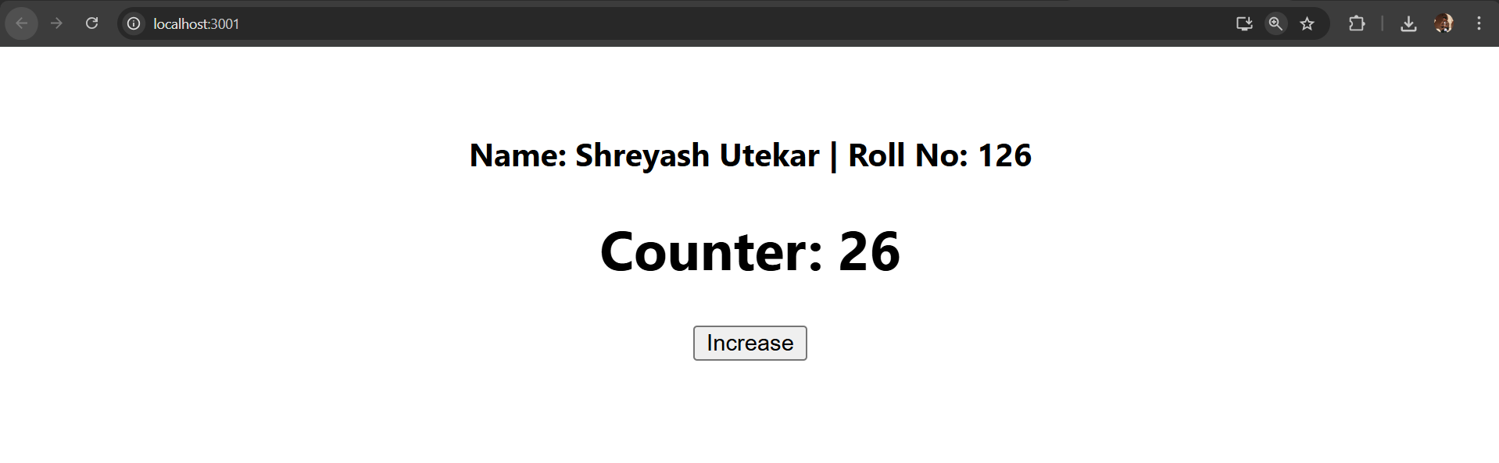

Program 3: useState – Name + Counter
App.js
import React, { useState } from "react";

const App = () => {
const [counter, setCounter] = useState(0);
const [name, setName] = useState("");

function increaseCounter() {
setCounter(counter + 1);
}

return (
<div style={{ textAlign: "center", marginTop: "50px" }}>
<h3>Enter your name:</h3>
<input
type="text"
placeholder="Type your name here"
onChange={(e) => setName(e.target.value)}
style={{ padding: "5px", fontSize: "16px" }}
/>
<h1>
{name || "Your Name"} has clicked {counter} times!!
</h1>
<button onClick={increaseCounter} style={{ padding: "10px 20px", fontSize: "16px" }}>
Increase
</button>
</div>
);
};

export default App;

Output :

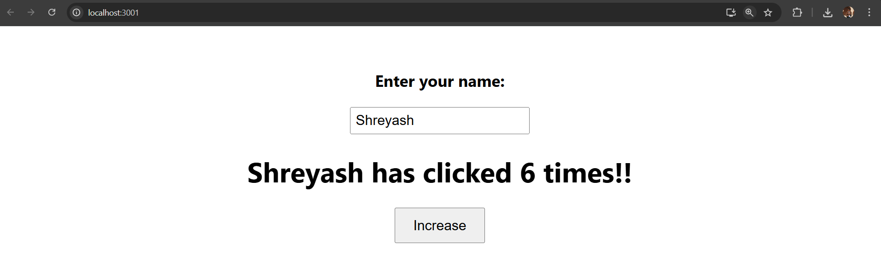

Program 4: useEffect – Document Title (runs every render)
App.js
import React, { useState, useEffect } from "react";

const App = () => {
const [count, setCount] = useState(0);

useEffect(() => {
document.title = `${count} new messages`;
});

return (
<div style={{ textAlign: "center", marginTop: "50px" }}>
<h3>Heyiii This is Shreyash, {count} new Messages!</h3>
<button
onClick={() => setCount(count + 1)}
style={{ padding: "10px 20px", fontSize: "16px", marginTop: "10px" }}
>
Increase
</button>
</div>
);
};

export default App;

Output :
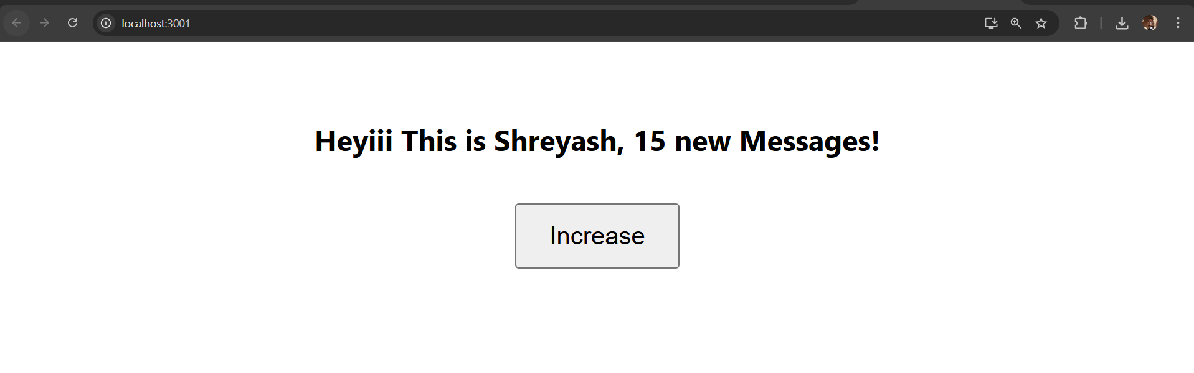

Program 5: useEffect – Document Title (dependency array)
App.js
import React, { useState, useEffect } from "react";

const App = () => {
const [count, setCount] = useState(0);

// useEffect with empty dependency array runs only once after first render
useEffect(() => {
document.title = `${count} new messages`;
}, []); // Runs only once

return (
<div style={{ textAlign: "center", marginTop: "50px" }}>
<h3>{count} new Messages from Shreyash!</h3>
<button
onClick={() => setCount(count + 1)}
style={{ padding: "10px 20px", fontSize: "16px", marginTop: "10px" }}
>
Increase
</button>
</div>
);
};
export default App;

Output :
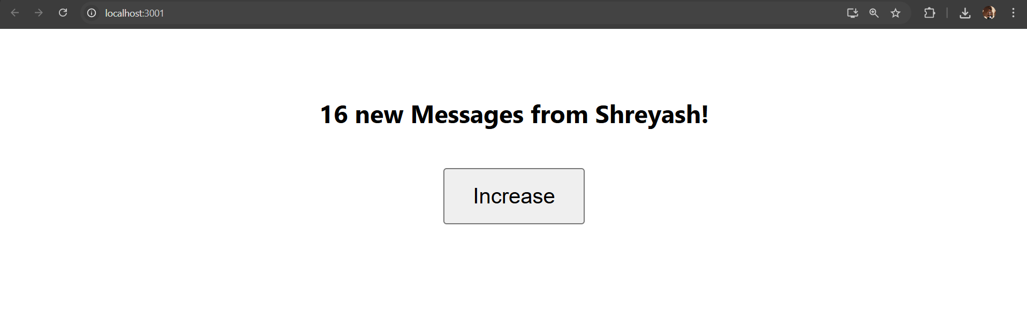

Program 6: useEffect – Timer with Cleanup
App.js
import React, { useState, useEffect } from "react";

const App = () => {
const [time, setTime] = useState(0);

useEffect(() => {
// Use functional update to avoid stale closure
const timer = setInterval(() => {
setTime(prevTime => prevTime + 1);
}, 1000);

// Cleanup function to clear interval on unmount
return () => {
clearInterval(timer);
};
}, []); // Empty dependency array ensures timer is set once

return (
<div style={{ textAlign: "center", marginTop: "50px" }}>
<h1>Shreyash 126</h1>
<h3>{time} seconds elapsed</h3>
</div>
);
};
export default App;

Output :
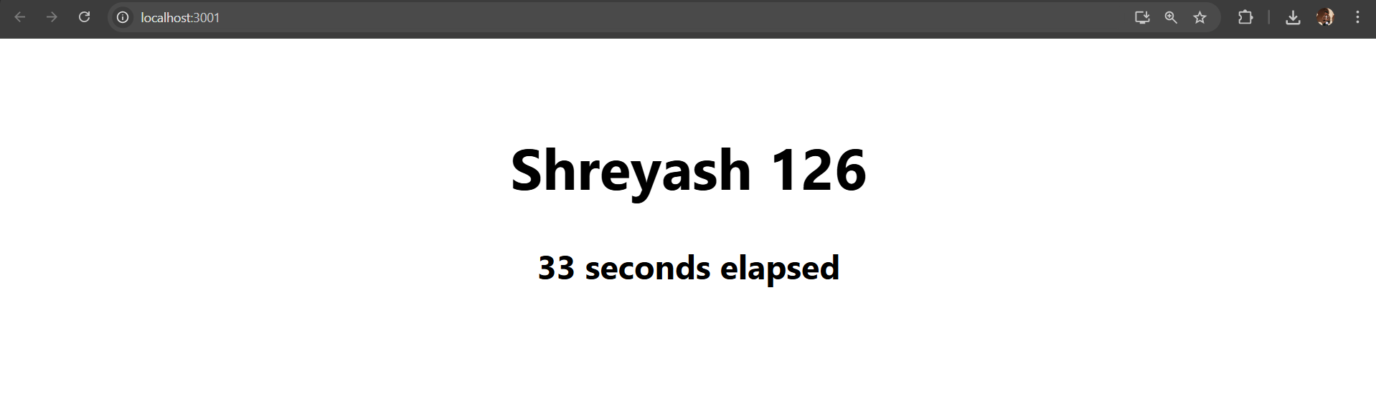

Program 7: Implement useContext Hook
App.js
import React, { createContext } from "react";
import MainComponent from "./components/MainComponent";

export const LoginContext = createContext();

const App = () => {
return (
<LoginContext.Provider value={true}>
<div>
<h2>useContext Demo</h2>
<MainComponent />
</div>
</LoginContext.Provider>
);
};
export default App;

components/MainComponent.js
import React from "react";
import SinglePost from "./SinglePost";

const MainComponent = () => {
return <SinglePost />;
};
export default MainComponent;

components/SinglePost.js
import React, { useContext } from "react";
import { LoginContext } from "../App";

const SinglePost = () => {
const login = useContext(LoginContext);

return (
<div>
<h3>Single Post</h3>
<p>Login Status: {login ? "Logged In" : "Logged Out"}</p>
<p>Name: Shreyash Utekar (Roll No: 126)</p>
</div>
);
};
export default SinglePost;

Output :
