**RESUME**

**\*\*\*\*\*\*\*\*\*\*\*\*\*\*\*\*\***

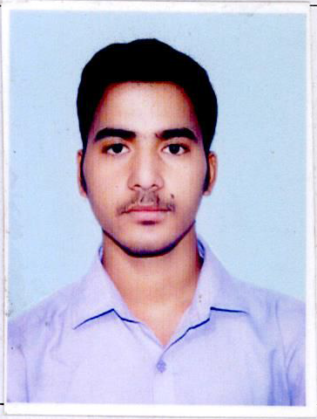

**Mr. Sunil Kumar Padhi**

**Contact No: +918327736634 / +917787901904**

**E-Mail: [sunilpadhi1998@outlook.com](mailto:sunilpadhi1998@outlook.com)**

**Career Objective** – Seeking an opportunity to be a part of dynamic and an esteem organization which provides a high quality of work life through challenging opportunities, career growth and professional development.

**Personality traits:**

* Ability to make people understand and convince them.
* Ability to produce best results under pressure Situations.
* Ability to work with Team as well as Individual

**EDUCATIONAL QUALIFICATIONS:-**

(+3) B.Sc. (Zoology Hons.): Passed in 2018 with 69.17 % (**First Class with Distinction Hons**.) From Berhampur University.

(+2) **CHSE**: Passed in 2015 with 52.67% (**Second Class**) from Council of Higher secondary education Board.

(10th) **H.S.C**: Passed in 2013 with 64.33 % (**First Class**) from Odisha secondary Education Board.

**COMPUTER SKILLS: -**

Advance Knowledge on computer basics, MS – Word, MS-Excel Power Point, Windows – 10, Internet with having basics knowledge on Computer Programming – SPSS

**Professional and Supervisor Experiences**

1. Currently Working At **TATA CAPITAL FINANCIAL SERVICES LIMITED**, as an Operations Executive from December 2018 to Present Date

Conneqt Business Solutions Limited (Formerly **TATA** Business Support Services Limited)

**Client**: **TATA** Capital Financial Services Ltd.

**Position** / **Role**: Branch Operations Executive

**Department**: Personal Loan, TW Loan, Used Car Loan and CD Loan, BL Loan

**Key Achievements:**

* Learnt Entire process in a very short Time Period.
* Trained Process to newly Joined Ops Executives.
* Became a Responsible Team Member working Under Pressure and late nights in month end.
* Maintained TAT in Repayments for Every month.
* Maintains the repayment dispatch and files dispatches to HUB on TAT Basis and clear RTB Cases with in EOD.
* Resolves audit Queries and Mailing the confirmations on the same by immediate basis.
* Writing of Contract/Loan No. On NACH/Mandate.
* Maker entry in Finnone for Disbursement TW Loan, Personal Loan , CD Loan and Auto Loan.
* Lead application of Business loan and Auto Loan
* Checks Properly KYCs and All relevant documents of Respective PSD Files and raise query to sale if any found.
* Handing Customer services and cash counter, resolving Walk-in customer’s queries on various loan .
* CDM Deposit authorization, Cash and cheque punching

1. Worked as Supervisor in the Project "Socially Smart City Implementation and Research (SSIR)" of United Nations Population Funds (**UNFPA**) for 3 Months

Achievements

* Achieved the Course work within Timeline with providing quality data to clients
* Supervising to Interviewer during Project Work.
* Analyzing the data with SPSS 2.0 Software and clean the unnecessary data from collected data.

1. Worked as Supervisor Under the “**TARINA Project**” of **CARE INDIA SUSTAINABLE DEVELOPMENT** , BBSR for 3 months

**Role: Supervisor**

* Controlling a team of 11 members for collecting data from various households to achieve the project work within time
* Solving the queries related to data collection
* Worked for Application development for data collections
* Project was held at Kalahandi & Kandhamal Districts 72 Gram panchayats

1. Worked as Data Collector Under the “**Youth Bol Project**” of **CENTRE FOR CATALYZING CHANGE (C3) taken by SADAN,BBSR** for 2 months
2. **Controlling Data Collection, Cleaning Data and Guiding to Interviewer about data collection, Mailing, some knowledge on Developing Data collection software and manage it.**

**SRENGTHS: -**

Communicating skill, friendly Nature, Sincere & Dedicated, Laborious and Punctuate

**EXTRA CURRICULAR ACTIVITIES: -**

Playing Cricket, Listening Music, Reading Books, Drawing Art, studying Zoological Book etc.

**PERSONAL DETAILS: -**

|  |  |
| --- | --- |
| **Name:** | **Sunil Kumar Padhi** |
| **Father Name :** | Prasant Kumar Padhi |
| **Date of Birth:** | 01 January 1998 |
| **Sex:** | Male |
| **Marital status:** | Unmarried |
| **Aadhar Card No.:**  **PAN Card No.:** | 621753035624  EWXPP1534D |
| **Religion :** | Hinduism |
| **Nationality :** | Indian |
| **Linguistic Capabilities:** | English , Hindi & Odia |

***DECLARATION***

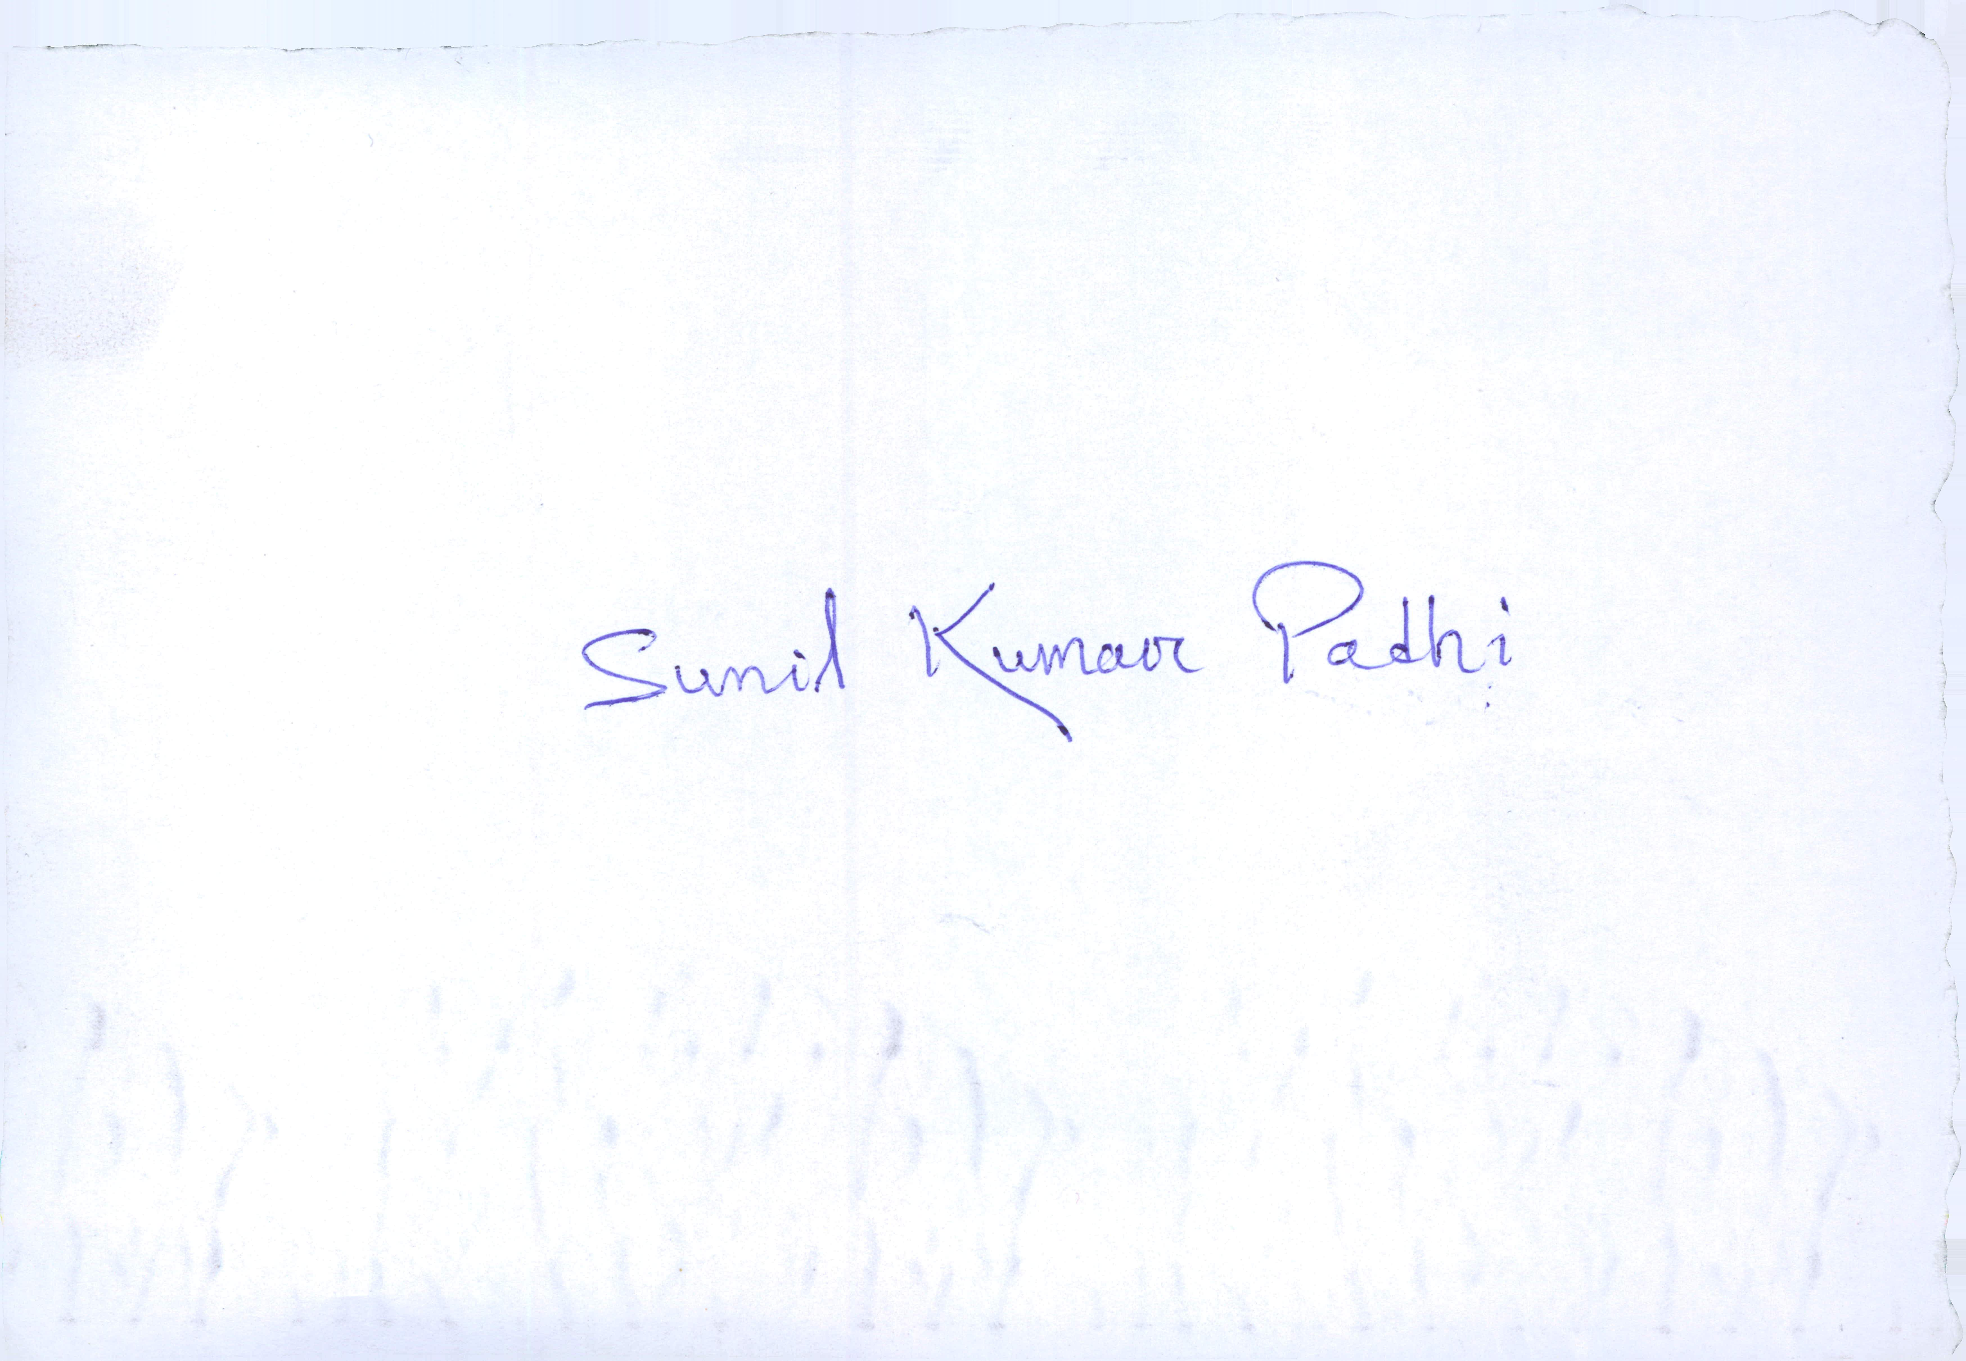I do here by declared that all the facts stated above are true correct and complete to the best of my knowledge and Belief.

**Place: Bhubaneswar (Odisha)**

**Date:** **Sunil Kumar Padhi**