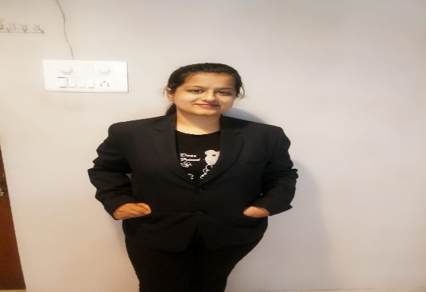

NAINCY SIHANI

**Phone:**

8602205990

**E-mail:** nainceesihani@gmail.com

**Address: B-5, sector 2, avanti vihar, raipur (c.g)**

# Skill Highlights

* Presentation skill
* Project management
* Problem solver
* Creative design
* Innovative
* Service-focused

# Language

English & Hindi

**STRENGTHs**

Work ethics

Focused

Flexibility to environment

Willing to learn

**HOBBIES**

Table tennis, Travelling , painting, content writing

**OBJECTIVE**:

To get a job where I can satisfy the organization objective and use my skills to its best and financially stabilize myself.

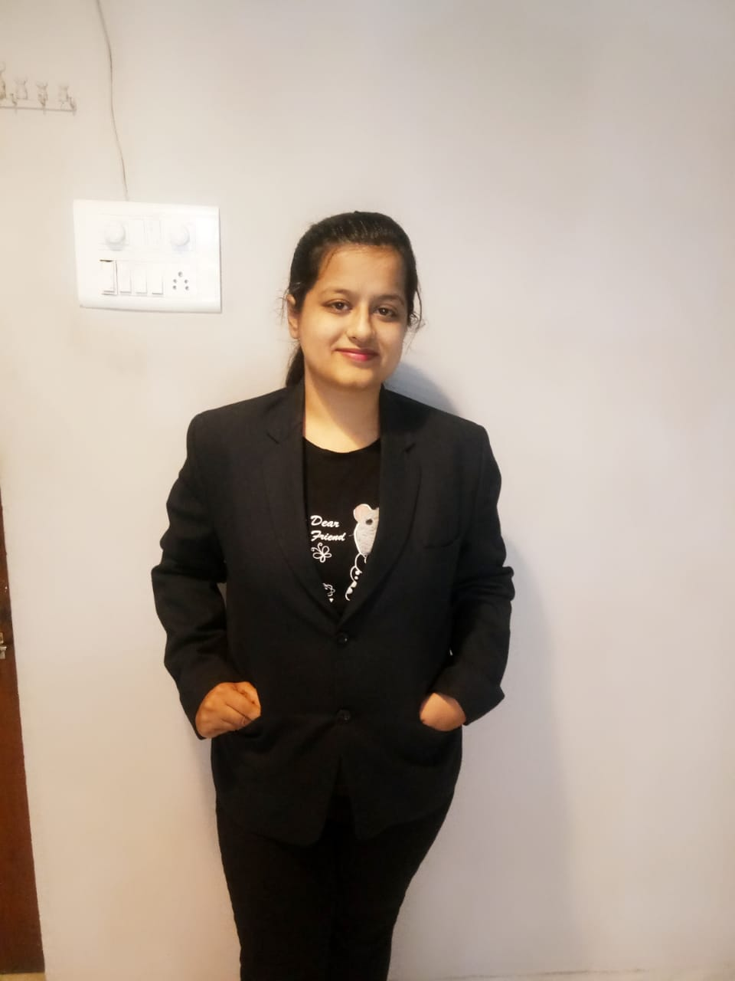

# ***EDUCATION***

|  |  |  |
| --- | --- | --- |
| Course | Board/University | Percentage |
| Class 10th | CBSE | 78% |
| Class 12th | CBSE | 76% |
| CS foundation | ICSI | 71.5% |
| B.Com | Pt. Ravishankar university | 60.33% |
| MBA | Chhattisgarh swami Vivekananda technical university | 78.8% |

# ***PROJECTS***

* Research project on "Impact of E-banking on customer satisfaction"
* Research project on " perception of investors investing in life insurance"
* Major Research project on – “Study of investment patterns of citizens of Raipur”

# ***CERTIFICATIONS***

Tally ERP 9.0

Sales workshop

Decoding equity market seminar

Career literacy awareness programme (CAREER VISION)

***EXPERIENCE***

Currently working at CashPo, A fintech organization operated by Intellimint Technologies Pvt. Ltd and Orrish finance Pvt. Ltd.(NBFC) as a Finance/ approcal executive. The KRA includes:

* Validation of Cibil document and verification of consumer data.
* Preparation of MIS reports, EMI repayment schedules and ensuring disbursal process.
* Conducting the procedure of loan disbursement in Software.
* Evaluation of customer loan eligibility.
* Connecting with customers and resolving queries.

**Internship** at The leading solutions [INDIAFIRST Life insurance (mahajeevan plan)]

4 years of experience in teaching profession in personal classes