

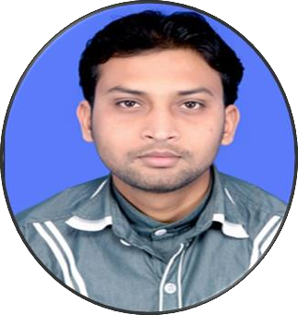

**ALEKH KUMAR PRUSTY**

**E-mail:** [alekhprusty5@gmail.com](mailto:alekhprusty5@gmail.com)

**Cell No:** +91 8763707520

(**Sr. Officer-Finance & Accounts with 9 years’ Experience**)

# SYNOPSIS:

* Object is to utilize my skills and abilities in achieving the organizational goals.
* Ability to adopt and adapt in any kind of work environment, especially in pressure.
* Good analytical and problem solving skills.
* Hardworking and ability to learn new technologies.
* A person with never die spirit attitude.

# PROFESSIONAL EXPERIENCE:

* Worked as an **Accounts Executive** in **OSTPL** (Orissa Software Technology Private Limited) at Rourkela for a period of 4 years.
* Worked as a **Sr. Accounts Executive** in **TPL** (Tata Projects Limited) at Jada for a period of 2 years.
* Working as a **Sr. Officer (Finance & Accounts)** **TEMPL** (Thriveni Earthmovers Private Limited) for a period of 3.1 years.

# ACADEMIC CREDENTIALS:

**ACADEMIC QUALIFICATION:**

* Completed B.COM (Graduation) From North Odisha University.

# SOFTWARE PROFICIENCY:

* SAP-FICO
* Tally ERP 9
* Tally 9.0
* MS Office

# AREAS OF EXPERIENCE:

**1. Accounts, Taxation & Audit**

|  |  |  |
| --- | --- | --- |
| **Account And Finance** | **Taxation** | **Other(procedural Aspect)** |
| Debtor and Creditor analysis | Income Tax Return Filling | HRA and Payroll audit |
| Statutory applicability and Compliance | GST | Stock Audit |
| Balance Sheet Finalization | Sub-Contracting | Balance sheet Audit |
| Capital Expenditure | TDS, | PF Audit |
| Books of Accounts | TCS,Advance tax, | Preparation of MIS |

# PERSONAL DETAILS:

* Father’s Name : Late.Managobinda Prusty
* Mother’s Name : Mrs. Sushama Prusty
* Present Address : Bhubaneswar, Odisha
* Permanent Address: Joda, Keonjhar, Odisha, India
* Date of Birth : 14/06/1991
* Sex : Male
* Marital Status : Married
* Languages Known : Odia, Hindi, English

# DECLARATION:

I hereby declared that the above mentioned information is correct up to my knowledge & I bear the responsibility for correctness of above mentioned particulars.

Yours truly

Date: 05.05.2020

Place: Bhubaneswar, Odisha Alekh Kumar Prusty