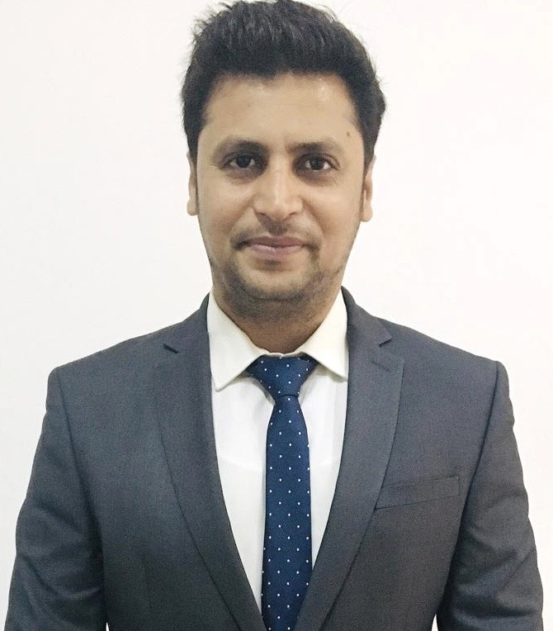

**CONTACT**

**Mobile:**  +91 9999870071

**Email:** aseesh.munish@rediffmail.com

**AREAS OF EXPERTISE**

* Retail/E-com Sales & Marketing
* Field Operations
* Revenue Generation
* Call Center Monitoring
* Brand Management
* Client Acquisition
* Vendor Management
* Group Level Marketing
* City Expansion
* Marketing Strategy Formulation
* Advertising/ Brand Promotion
* Marketing Campaigns
* Product Positioning & Branding
* ATL/ BTL Activity Monitoring
* Competitive Analysis
* Business Development/PR
* Client Relationship Management
* Stakeholder Management
* Team Handling

**ACADEMIC CREDENTIALS**

**PGDM (Marketing & International Business); 2011**

Greater NOIDA Institute of Management, Greater Noida, AICTE University

**BBA; 2009**

Sikkim Manipal University, New Delhi

**ADDITIONAL QUALIFICATIONS**

* Diploma in French Language from Bharti Vidya Bhavan, New Delhi
* Diploma in Multimedia from Arena Multimedia

**IT SKILLS**

Windows XP, Vista, Windows, Symbian OS, IOS and Microsoft office

**EXTRAMURAL ENGAGEMENTS**

* Served as a player in:
  + District under 16 Cricket
  + Junior National Cricket
* Actively participated in Inter College “Techno Quiz” Competition.

**PERSONAL DOSSIER**

**Date of Birth:** 22nd December 1983

**Current Address:** H25, Kalkaji, New Delhi, India

**Languages Known:** English, Hindi and French

**License No.:** 13178/09 (Valid till: 05/08/2022)

**ASEESH MUNISH**



***Managerial assignments in Retail/E-comm/Sales & Marketing/Business Development/ Branding/ Stakeholder Management***

**PROFILE**

Professional with **12 years** of experience in Retail/E-comm Sales & Marketing, Field, Business Development and Brand Management. Currently working with **Firstcry.com as Regional Manager- Marketing (North India).** Possess instinctive aptitude for Sales, branding, Advertising & campaign management development. Exposure in setting up new initiatives on Marketing, Client Relations & Acquisition, Event Management and creating strategic marketing plans including budgets, developing product campaigns, conducting market research studies, reviewing marketing plans & organizing various events. Expertise at maintaining high level of personal drive in achieving results with proven ability in managing successful programs with high satisfaction ratings within financial targets.

**KEY RESULT AREAS**

**Retail/Healthcare Marketing:**

* Checking all regional store/hospitals to increase brand revenue and market along with checking redemption across North India
* Tie-ups and revenue generation across North India
* Managing premium brands performance
* Adding new brands to the display in stores
* Tie ups with medical stores and pharmacy and OTC business expansion
* Administering the store opening operations along with raising the footfall from online/offline
* Investigating and resolving customer complaints along with setting- up store displays
* Reviewing merchandize movement and inspecting merchandize for quality and quantity

**Marketing Communications:**

* Determining marketing objectives and preparing annual budgets
* Planning marketing activities in conjunction with company’s growth plan and working out strategies to execute the plan
* Conceptualizing and orchestrating marketing campaigns that effectively reinforce and build brand images
* Developing marketing reports to be presented at the meeting of top management
* Developing systems and procedures to ensure that the leads generated are optimally utilized
* Conceptualizing and orchestrating marketing campaigns that effectively reinforce and build brand images
* Directing event coordination, community outreach, branding and channel marketing

**Business Development:**

* Developing existing business and forecasting prospective targets as well as executing them in a given time frame thus enhancing clientele.
* Identifying & networking with prospective clients generating business from existing accounts and achieving profitability
* Ensuring maximum brand visibility and capture optimum market shares.
* Interacting with the doctors/customers to gather their feedback regarding the product satisfaction.
* Leading, nurturing and monitoring the performance of team to ensure efficiency in process operations & meeting individual/ group targets.

**Stakeholder Management/ Team Management:**

* Leading, nurturing & monitoring the performance of the regional team to ensure efficiency in process operations & meeting of individual & group targets.
* Motivating, mentoring and leading talented professionals.
* Innovative and results-driven senior manager focused on achieving exceptional results in highly competitive environments that demand continuous improvement.

**CAREER CONTOUR**

**Mar 2017 Till Date with Firstcry.com as Regional Manager- Marketing (North India)**

*Online/Offline Store for Kids & Mothercare Products & More.*

**Accountabilities**

* Managing 60 retail stores and 3200 hospitals channel across the region
* Retail store, e-comm marketing increasing footfall
* On board medical stores to increase revenue and market healthcare brands
* Discounts, offers, sale price monitoring
* Brand Promotions, stores display, floor operation handling
* Administering distribution channel in Northern states of India with 150 team members in 106 cities
* Raising Online and Offline Redemptions for Firstcry.com
* Performing the tie ups with Vendors, hospitals and checking distribution part in hospitals
* Identifying opportunities to increase productivity by coordinating with the field team
* Performing recruitment and induction of Account Managers and City Managers
* Evaluating market trends and gathering competitive information
* Devising travel plan for Account Managers every month for visit
* Handling major brands including firstcry.com portal, New city activation and developing stores and hospitals channels

**Aug 2015 – Feb 2017 with GETIT Infoservices Pvt. Ltd. (askme grocery), Delhi/ NCR as Marketing Manager**

*Getit is a defunct directional media company in India. Its services included E-wallet, E-commerce, FMCG grocery, Local search, yellow pages, white pages directories, classified media, tele-information services.*

**Accountabilities**

* Handled Delhi/NCR hubs and Supermarket operations consisting of 50 members and devised strategic partnership
* Closed vendor tie – ups along with mentoring and training up sales staff
* SKU’s and online delivery monitoring
* MRP, discount, offers tracking and updates
* Modern trades, supermarkets tie ups and SKU’s update.
* Ensured current service offerings are continuously upgraded with innovative solutions that are market oriented
* Maintained relations with vendors, supermarkets identified and resolved their issues efficiently and timely
* Boosting FMCG retail channel through sales staff
* Ensure accurate Sales forecast to achieve optimum inventory levels and stock availability

**Jul 2012 - Aug 2015 with Wings Brand Activation (I) Pvt. Ltd., Delhi/NCR as BDM &Client Servicing**

*The Wings Group of Companies has pioneered the very concepts of event management and experiential marketing as an industry.*

**Accountabilities**

* Proactively worked on Project of “QuickBooks Online” As a Team leader and handled a team of 6 members
* Developed business and new client relationships.
* Followed up with the existing clients
* Sales and IT Team Handling

**Jul 2011 – May 2012 with Zenith Computers Ltd., Delhi/NCR as Business Executive**

*A computer manufacturer in India.*

**Accountabilities**

* Set sales targets and defined strategy to achieve these targets.
* Maintain business development database and developed business.
* New client accusation and relationships

**May 2006 – Apr 2008 with Sound of Music, New Delhi as BDM & Client Servicing Profile**

*A event management company & audio consultant.*

**Accountabilities**

* Managed customer database with profile information, order data and contacts
* Handled customer services, resolved client issues and extinguished escalated complaints
* Coordinate with all the department during events and client satisfaction.

**INTERNSHIP**

**Company:** ITC, Ranchi (Snacks and Food Division mainly based on Bingo Chips)

**Duration:** Jun 2010 – Aug 2010

**Project:** Empirical Study of Selling and Distribution – BINGO Chips

**Details:** Project was based on primary and secondary data. Conducted the market survey of Bingo chips and its demand & supply to the retailers and wholesalers.