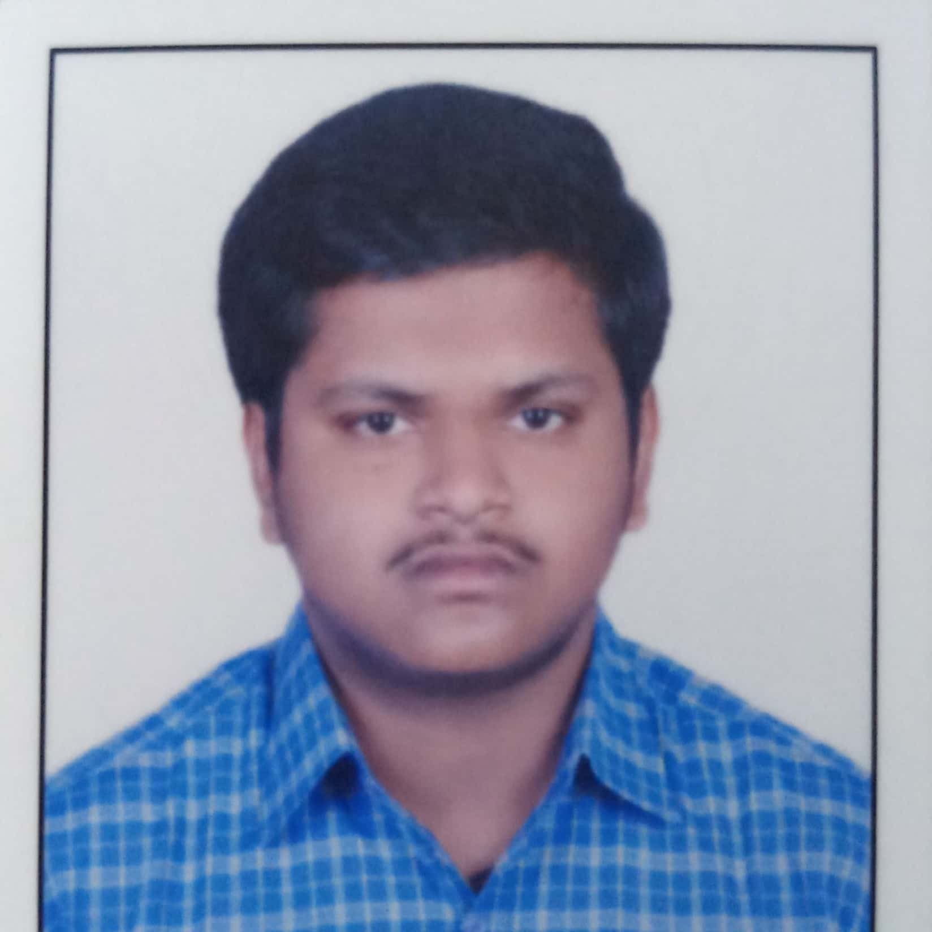N.V.Srikar

B/504 Nalco Nagar, Angul Odisha 759145, Angul, India D.O.B : 13-11-1999

Marital Status : Single

Email : [srikarnv99@gmail.com](mailto:srikarnv99@gmail.com) Mobile: 8456834295

# OBJECTIVE

Join a dynamic and progressive organization offering ample opportunities of diversified exposure where I can apply and enhance my professional skills.

EDUCATION

|  |  |  |  |
| --- | --- | --- | --- |
| Degree/Course | institute | Year of Passing | Percentage / Grade |
| 10th | Delhi Public School, Nalco Nagar, Angul | 2015 | 8 |
| 12th | Delhi Public School, Nalco Nagar, Angul | 2017 | 82 |
| B.com(H) | D.A.V. School Of Business Management, Bhubaneswar | Pursuing | 78 |

# INTERESTS

Doing Accountancy Sums Playing chess

Playing Badminton

# SKILLS

Good in accounting

Computer skills- Microsoft Word, excel, power point, access

# HOBBIES

Solving Accounting Sums Playing Chess

Doing Presentations Playing Badminton

# ACHIEVEMENTS

15th Rank in ACCA Scholarship Test at DSBM

1st Position in 11th class at Dps Nalco Nagar-81.77%

1st Position in Commerce Talent Search Examination @Dps Participated in state level Chess tournaments

Participated in international karate tournaments

# DECELERATION

I hereby declare that all above-mentioned information is in accordance with fact or truth up to my knowledge and I bear the responsibilities for the correctness of the above mentioned particulars.

Date: 25-02-2020

Place: Nalco Nagar

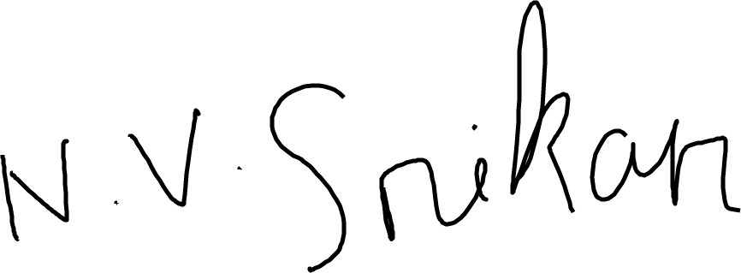

(N.V.Srikar)