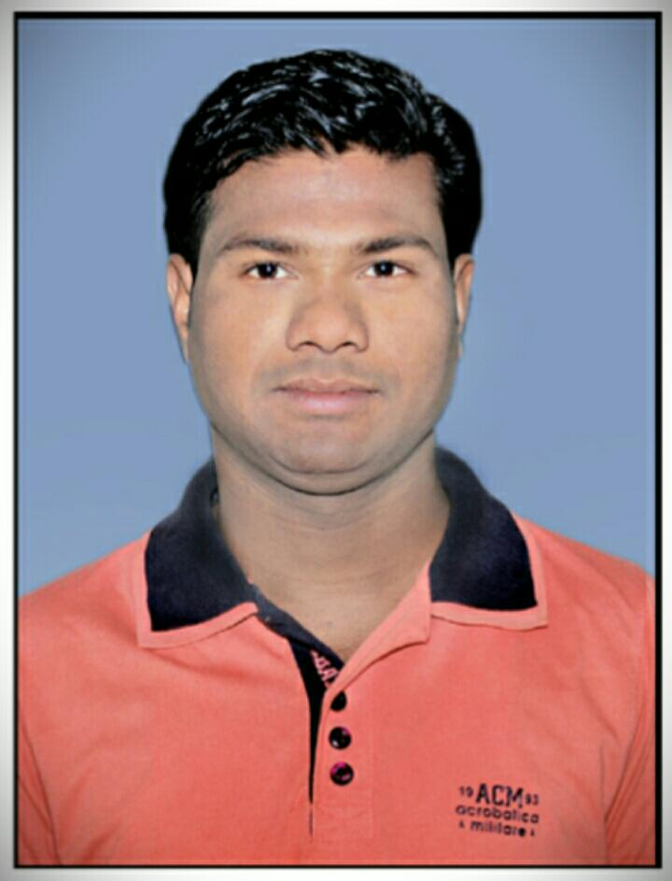**RESUME**

**MANABODH MALLIK**

Mob.- 7978064269, 9777266342

Email-[mallikdgr@gmail.com](mailto:mallikdgr@gmail.com)

At – Rahila Po - Binika

Ps – Binika

Dist - Subarnapur (Odisha)–767019

**CARRER OBJECTIVE**

To be associated with a progressive organization that givens me scope to update my knowledge and skills in accordance with the latest trends and to be a part of team that dynamically works towards the growth of the organization and gains satisfaction thereof.

**ACADEMIC QUALIFICATION**

* M. A (Sociology) from IGNOU in the year 2015 (60%).
* Graduation from Sambalpur University in the year 2008 (43%).
* +2 from Dunguripali College, Dunguripali in the year 2004 (40%).
* Matriculation from B.S.E., Orissa in the year 2002 (53%).

**PROFESSIONAL QUALIFICATION**

* DCA from ITCT Computer Education Center Balangir in 2007.
* PGDCA from SJIT Computer Education Center Balangir in 2012.

**IT EXPOSER**

* Window 98, Window 2000, Window Xp, Window 7 etc.
* MS Office, Page Maker 7.0, Photo Shop 9.0, C++, Tally, Internet etc.

**WORK EXPERIENCE**

|  |  |  |  |  |
| --- | --- | --- | --- | --- |
| **Name and Address of the Employer** | **Designation** | **Period** | **Experience in year and month** | **Brief description of duties** |
| **SELF EMPLOYED** | **SELF EMPLOYED** |  |  | **Sales executive in a Organic company commission basic** |
| **L & T Financial Services, Sonepur** | **FLO** | 11.10.2018 25.05.2020 | 01 Years 07 Month | To create Group & collect documents facilitated loan and collection in time. |
| M.I. Division, Sonepur  Pani Panchayat Cell | DEO | 16.06.2014 to 31.03.2018 | 03 Years 09 Month | 1. Arrange the documents & goods for meeting & training. 2. Coordination with PPDT staff in Data collection in reporting 3. DLST/PPDT/PP wise Data Analysis &Updating in various aspects. 4. Documentation |
| Shriram Life Insurance, Balangir. | Sales Officer | 16.06.2012 to 31.05.2014 | 01 years 11 months | Open policy account and collection. |
| HRMS, Sambalpur | Supervisor cum  Data Entry Operator | 01.10.2008  To  31.01.2010 | 01 Years 03 Months | Online data entry work of Govt. Employees service book details. |
| BKP, Pvt. Office | Computer Operator | 01.07.2007 to  08.07.2008 | 01 Years | All type of computer work & dealing to customer |

**LANGUAGES KNOWN**

* English, Hindi, Oriya

**STRENGTH**

* Believe in Hard work
* Self-confidence
* Co-operative

**PERSONAL PROFILE**

Name : **MANABODH MALLIK**

Father’s Name : Late Ram Mallik

Date of Birth : 16th June 1987

Gender : Male

Nationality : Indian

Religion : Hindu

Marital Status : Married

Category : SC

**HOBBIES**

* Read News Paper
* Listening Music
* Playing Cricket
* Making Friends
* Cooking

**DECLARATION**

I hear by declared that the above information is correct and complete to the best of my knowledge and belief and nothing has been concealed. If any time I am found to have given false assignment is liable for termination without notice or compensation.

**Date: 04.09.2021**

**Place : Sonepur** **Manabodh Mallik**