Subrata Kumar Das (MBA Finance)

Mob: - +91-7788002244 (M)

+91-7008246151 (M)

Address: - H-No-135 Upper Street

At- Kumar Beg Palli

Po/Ps- Chatrapur

Dist- Ganjam, Odisha-761020.

Email: - [subratakumar2427@gmail.com](mailto:subratakumar2427@gmail.com)

[subratakumar2244@gmail.com](mailto:subratakumar2244@gmail.com)

Dear Sir,

I came to know that some posts are lying vacant in your organization for which I offer my candidature for the same. The detailed bio-data is attached herewith for your kind perusal.

Preferable Area of Operation- Anywhere in Orissa/ India. Expecting an early and favorable reply.

(Enclosed: Resume)

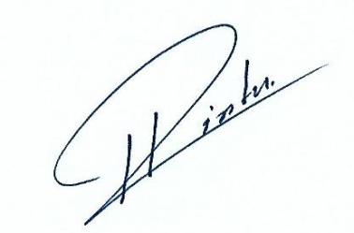

Thanking You. Yours Sincerely

Subrata Kumar Das

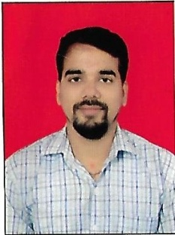**RESUME**

**SUBRATA KUMAR DAS**

**ADDRESS**: S/o- Simanchal Dash

H-No-135 Upper Street

At- Kumar Beg Palli

Po/Ps- Chatrapur

Dist- Ganjam, Odisha-761020

Phone: - +91-7788002244 (M)

+91-7008246151 (M)

Email: - [subratakumar2427@gmail.com](mailto:subratakumar2427@gmail.com)

[subratakumar2244@gmail.com](mailto:subratakumar2244@gmail.com)

**Career Objective**

To work in challenging, innovative, creative, ambitious, adaptive and healthy environment at par my level with a team of intellectuals that will enhance my professional skills and benefit the organization.

## Educational Qualification:-

|  |  |  |
| --- | --- | --- |
| **Year** | **Degree/ Certificate** | **Institute/ School, City** |
| 2003 | HSE | Onslow Institution, Chatrapur,Ganjam |
| 2005 | CHSE | G K V Mahavidyala Subalaya, Ganjam |
| 2007 | ITI (NTC) Electrician | Rajiv Memorial I.T.C |
| 2012 | B.Com (Honours) | Berhampur University |
| 2014 | MBA (Finance) | Punjab Technical University, Berhampur |

**Professional Experience: Total 11 Years 9 Months**

# Current Employer

# Organization: Odisha Rural Development & Marketing Society (ORMAS) Ganjam Dist.

## Duration : 1st November 2009 to till date

**Designation : Manager, Shakti Gaon Project (Legal & Administration)**

**Job responsibility:**

* Looking after all the aspect of the Project both Legal & Administration
* This project meant for the empowering the Woman Self Help Group Anti Poverty Income Generation Scheme through which the Corporate tie-up made with IOCL. This scheme can Capacity building on financial literacy, book keeping, customer relation & marketing made through the Woman Self Help Group & made the Woman Empowerment.
* Check & Verify all the reports like Daily Report (Production & Dispatch), Weekly report, Indents etc.

**Administration Jobs at Office:-**

* Check and Maintenance of employee’s personal record, attendance & leave register.
* Time Office Management.
* Generation of HR related MIS reports as required from time to time.
* General administration work at Office.
* Personnel Administration and Management.
* Liason with local people, Politicians, and Government administration department for smooth function of this activity.
* Supervision of Hygiene and living condition of the laborers in the site hutments.
* Monitoring smooth functioning of transportation.
* Finalization of Raising Contract, Delivery Contract etc.

## Area of operation:-

Covering all the blocks of Ganjam District.

Languages Known:

|  |  |  |
| --- | --- | --- |
| ENGLISH | : | Proficient (Read, Write, Speak) |
| HINDI | : | Expert (Read, Write, Speak) |
| ORIYA | : | Expert (Read, Write, Speak) |

**Computer Skills:-** : Dos, MS Office, Internet

* Operating Systems : Windows 98, Windows XP, Vista, Windows7/10

# Extra-Curricular Activities

* Organized various Cultural Programs.
* Coordinator for inter College Competitions.

**Area of Expertise**

* Livelihoods & Marketing
* Natural resource management
* Rural Enterprises
* Project Management
* Community mobilization
* Digital marketing

# Hobbies:

* Reading Books
* Listening to Music.
* Surfing Internet
* Playing Cricket

# Personal details:

Date of birth : 25th May 1988

Father’s Name : Simanchal Dash

Marital Status : Unmarried

Religion : Hinduism

Cast : Brahmin

Aim of life : Actively working for the good cause as repayment to the society

What I received from it.

Permanent address : S/o. Simanchal Dash at H-No-135 Upper Street, Kumar Beg Palli

Po/Ps- Chatrapur, Dist- Ganjam, Odisha-761020

**DECLARATION**

I do hereby declare that above statement given by me is true to the best of my knowledge and Belief.

**Date: 30.08.2021**

**Place: Chatrapur (Subrata Kumar Das)**