RESUME

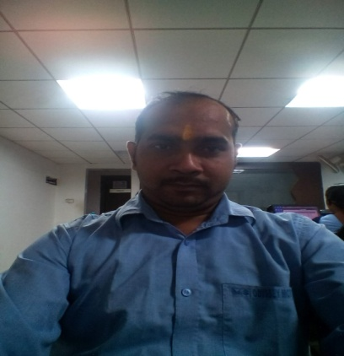

|  |  |
| --- | --- |
| **Name: Sunderdeep Prasad**  **Location: sambalpur**  **Phone: 91-9937851725**  **Email:** [**prasadsunderdeep@rediffmail.com**](mailto:prasadsunderdeep@rediffmail.com)  **Present Address  At/Po-remed, N.H.- 6  Near R.M.C colony, . Dist-Sambalpur (Orissa)  Pin No - 768 006  Mobile: 9937851725** |  |
| **Date of Birth:17 Jun 1981 Gender : Male Nationality : Indian  Language: English,Hindi,Oriya,Bhojpuri** |

|  |  |
| --- | --- |
| **Two years work experience in Accounts Manager in JALAN AUTOMOBILES PVT LTD 7 yrs (Deals in Sales & service of Ashok Lylend comm.Vehicle).**  **Current Salary :-25000/-(p.m)**  **Location :- Sambalpur.**  **Preveious job Detail :-** | |
| **Work Experience** | **: 7 years** |
| **Skills** | **: ware house asst(2 lakh sq ft).** |
| **Industry** | **: Storage (P.B Anode/Plant Extantation machine)** |
| **Function** | **: Purchase/ Logistics/ Supply Chain** |
| **Roles** | **: Logistics operation** |
| **Current Employer** | **: Total shipping & logistics pvt ltd.** |
| **Salary** | **: 19000/- Per Month** |
|  |  |
|  |  |

|  |  |
| --- | --- |
| **EDUCATIONAL QUALIFICATION :-  1. MATRICULATION :-2nd Division (K.S DALIMIA HIGH**  **SCHOOL,SAMBALPUR, DIST- SAMBALPUR).**  **2. +2 SCIENCE :- 2nd Division (N.A.C BURLA COLLAGE.,**  **BURLA, DIST-SAMBALPUR)**  **3. +3 COMMERCE :-2nd Division, GANGADHAR MEHER**  **COLLEGE(SAMBALPUR UNIVERSITY, sambalpur)   Tata Nager Service Station. :- 3 Years as role of ACCONTANT(Part Time).   VSC CONSTRCTION LTD. deals in ROAD CONTRACT and ACCOUNTS IN in TALLY-9.1(Part Time) .**  **Warehouse asst in total shipping & logistics pvt ltd.   Other related experience:-**  **Having knowledge of computer in windows MS-EXCEL & MS-WORD and Accounting Package like TALLY-ERP Also already have worked as Accountant in Tatanagar Service Station Sambalpur as an Audit/Accountant for more than 2 year(PART TIME).**  **DECLARATION** : I hereby declare that all the statements furnished above are true and best my knowledge  **PLACE** : Sambalpur  **Sunder deep Prasad.** | **trans** |
| **trans** | |