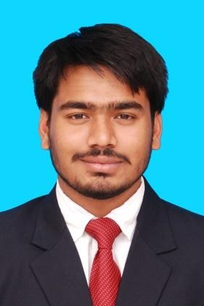

**Curriculum Vitae**

|  |  |  |  |  |  |  |
| --- | --- | --- | --- | --- | --- | --- |
| Student’s Name | : | **Sumit Jana** | | | |  |
| Email ID | : | [sumitjana15@gmail.com](mailto:sumitjana15@gmail.com) | Cell No | : | 9999830164 |
| PGPM Domain(s) | : | Marketing |  | | |
| UG Degree | : | B.Com ( Hons) | | | |

|  |  |  |  |  |  |
| --- | --- | --- | --- | --- | --- |
| **Career Objective** | | | | | |
| Play a leading and constructive role in an organization which values and being responsible with opportunities for growth and learning. | | | | | |
| **Experience** | | | | | |
| **Company** | | | | **Designation** | **Experience** |
| Indiabulls Housing Finance Limited | | | | Management Trainee | 1 Year 8 months |
| **Job Description** | | | * Sourcing prospect leads for Home loans and Mortgage loans through building relations with DSA (Direct Selling Agents). * Along with Sourcing leads also worked on selling insurance (Motor, Life, Health and Investment) and Mutual funds. * Worked with collection department in recovering EMI from loan repayment defaulters. | | |
| **Projects and Assignments** | | | | | |
| **Summer Internship**  **(February to May 2016)** | **:** | SPORTS365 | | | |
| **Project Title** | **:** | Building Networks And Relations With Schools And School Uniform Vendors Of Delhi-NCR And Increase The Market Share of Sports365 | | | |
| **Roles and**  **Responsibilities** | **:** | Sports365 is the official channel partner of Nike school shoes Pan India. From 2017 Sports365 is targeting School uniform vendors of Delhi•NCR. I had to prepare a database of all school uniform vendors region wise (north, west,east,etc) and call them and pitch the product. If interested showed them samples and describe the pricing. On agreement I would take orders  and advance from them. I had to follow up after two days on call. | | | |

|  |  |  |  |
| --- | --- | --- | --- |
| **Academic Profile** | | | |
| **Course & Specialization** | **College/Institute & Board/University** | **Year of Passing** | **Percentage Marks/CGPA** |
| PGPM | Completed PGPM in ICFAI Business School, Bangalore | 2018 | 6.15 CGPA |
| Graduation Degree: B.Com ( Hons ) | Motilal Nehru College, Delhi University | 2016 | 56% |
| XII Std | G.D. Salwan Public School, New Delhi (CBSE) | 2013 | 78.85% |
| X Std | G.D. Salwan Public School, New Delhi (CBSE) | 2011 | 6.2 CGPA |

|  |
| --- |
| ***Extra and Co-curricular Achievements*** |
| * Won first prize in Inter college Volleyball tournament organized by Delhi University. * Represented IBS Business School for marketing vertical in Mount Carmel Institution of Management. * Organizing committee of national level management fest at IBS Business School and also national level sports fest at IBS Business School |

|  |  |  |
| --- | --- | --- |
| **Personal Profile** | | |
| Gender | : | Male |
| State | : | New Delhi |
| Date of Birth | : | 25-03-1995 |
| Languages Known | : | English, Hindi & Bengali |

Signature