CURRICULAM VITAE

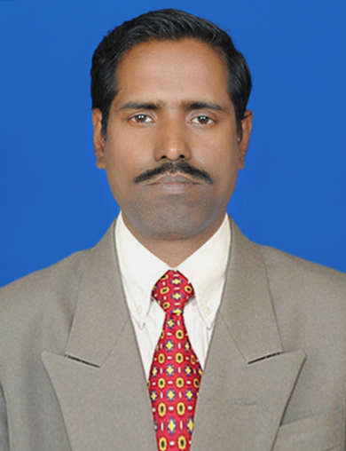

DILLIP SARANGI
Raiguru Basudeipur
Po-Balkati, Dist-Khurda
ORISSA-752100
Ph-0674-2464712, 9338222583 (M)

E-Mail-dillip666@gmail.com
dillip144@yahoo.co.in

Objective: - To play an active role there where will be scope to implement thoughts and ideas, also want to be proudly associate with an esteemed organization, where my knowledge and experience would be value and my professional growth would be encouraged where my sincerity coupled with hard work lead to mutual success. Also a result oriented community development practitioner experienced in providing administrative and accounting support to complete projects. I am knowledgeable in: disseminating project information to project stakeholders, monitoring the progress of projects, developing and maintaining project deliverables and gathering and inputting data into databases. More so, I have been involved with HIV/Aids initiatives, community mobilization, monitoring and evaluation, field research, capacity building as well as planning and implementing community based projects. I am looking for a position in a challenging environment that strives for organizational and personal development.
.
PROFESSIONAL SKILLS-
- Knowledge in all accounting function like Book keeping, Preparation of Periodical trial balance P/C A/C, Balance sheet, Bank reconciliation, Cash flow & fund flow statements, Preparation of Projected P/L Accounts, B/S, Budget preparation, financial Statement Analysis.etc
- Knowledge in Maintenance Bin card, price ledger, stock registers etc and Compliance with other purchase and store formalities
- Computation and filing of IT & ROC Return and compliance of with statutory law and knowledge in FCRA
- Performed accounting & book keeping administration through statements and collected documentations evidences’ for year-close reviews and answered to auditors' investigation
- Knowledge in monitoring and evaluation of projects.
- Proficiency in computer applications and ability to use software such as Tally Erp9,GST
- Excellent team working skills, good organizational and social skills.
- Possess good communication skills both spoken and written
- Strong skills in liaising & co-coordinating with State & District Level Government Officials including NRHM, ICDS, NGOs / CBOs, etc
Educational Qualification: -

Bachelor of Commerce (pass) from Utkal University, Odisha in 1992
M.B.A (fin) from SikkimManipal University (DDE) with 64% in 2014

WORK EXPERIENCE

- Worked at Sri Ramakrishna Mission Ashram , M.Rampur kalahandi (state level NGO running Residential schools) from December 1995 to February 2000 As an Accountant
Duties and Resposibilities
performed in all accounting function like Book keeping, Preparation of Periodical trial balance P/C A/C, Balance sheet, Bank reconciliation, Cash flow & fund flow statements, Preparation of Projected P/L Accounts, B/S, Budget preparation, financial Statement Analysis.etcWorked with M/s Y.Pani & Co Chartered accountant as audit executive from march 2000 to August 2003
- From September 2003 to April 2007-(Audit Executive.)- D.M. Associate chartered Accountants Bhubaneswer. Orissa.
Duties and Resposibilities
Conducted , statutory Audit, internal Audit, stock Audit etc of different government, non government organizations, NGOs, schools, PSUs etc on behalf of the Firms

- Worked with M/s Trellis infrastructure private limited, Bhubaneswar as an Accountant from May 2007 to November 2010
Duties and Responsibilities
Provided all accounting function like Book keeping, Preparation of Periodical trial balance P/C A/C, Balance sheet, Bank reconciliation, Cash flow & fund flow statements, Preparation of Projected P/L Accounts, B/S, Budget preparation, financial Statement Analysis.etc. Maintenance Bin card, price ledger, stock registers etc and Compliance with other purchase and store formalities
- worked with the Creative B. School, an authorized LC of Sikkim Manipal University at Sambalpur as Accounts Cum Administrative in charge from December-2010 to December, 2014
- Duties and Resposibilities -:
Providing all administrative and accounting support to the institution, also provided marketing support functions like student enrolment, logistic handling, collection etc
- Worked with Hope foundation an NGO conducting TI project on HIV/ AIDS as M&E cum Accountant from January 2015 to March,2020
Duties and Resposibilities -:Support banking operation in relation to project, data management and monitoring and Evaluation function for the organization .Provide administrative support as needed for efficient office operation .Provide support in alignment of finance and program me performance Participating in the design of M&E strategies and activities .Participating in field investigation and verification exercises. Overseeing implementation and monitor progress of the project.etc

Computer Skill
MS –Word Working Knowledge
MS Excel Working Knowledge
Tally 9.2 Working Knowledge
Internate Browsing Working Knowledge
Personal Details
Father’s Name Sri Debendra Nath Sarangi
Date of Birth 19th March 1970
Sex Male/Married
Linguistic skill Oriya, English, Hindi

Date: -30.06.20 Dillip Sarangi
Place: -BBSR Signature

References-
1- Manmohan Mishra
Lepra Society,Puri
Phone-8093469764

2- Dr. Sisir Kumar Behera
Phone-9237011024

