SITAKANTA MISHRA

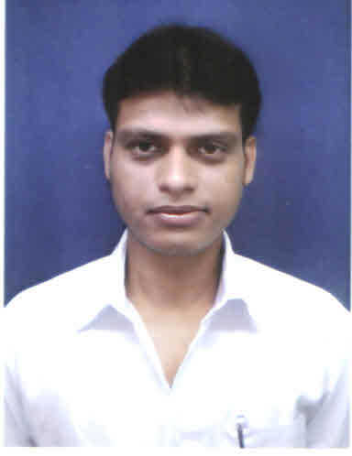
Mail Id – mishrasitakanta123@gmail.com
Mobile : +91-9437637929

OBJECTIVE:
Seeking a challenging and responsible position within a dynamic organization that offers learning opportunities and I can leverage my achievements and skills to contribute to the advancement of the organization.
EDUCATION:
- Passed Matriculation from Saraswati vidya Mandir Bargarh in 2004.
- Passed +2 Science from Panchayat college Bargarh in 2007.
- Passed B.B.A from Utkal University,BBSR in 2010.
WORK EXPERIENCE:
- Company Name : EVEREADY INDUSTRIES INDIA LTD
- Designation : Sale Officer
- Location : Bhadrak
- Duration : From Oct-2018 to Jan-2020
- Company Name : ITC Ltd
- Designation : Area Executive
- Location : Keonjhar
- Duration : From June-2016 to July-2018
- Company Name : GSK LTD.
- Designation : RURAL SALES REPRESENTIVE
- Location : PURI
- Duration : From Aug-2013 to Feb-2016
- Company Name : P&G LTD
- Designation : Distributor Sales Executive
- Location : ANUGUL
- Duration : From Apr-2012 to July 2013
JOB PROFILE:
- Managing and Motivating staff
- Ordering and managing stock
- Making sure sales target are hit.
- Making most prefer supply of the trade.
- Forecasting future sales.
- Budgeting for the store.
AT THE MARKET PLACE:
- Distribution Extension.
- Supervising the Distribution and Visibility.
- Dealing with any customer queries or complaints.
- Training staff
- Responding to customer demand.
- Market research
KEY SKILLS
- Good initiator can communicate effectively to motivate others and quick learner.

COMPUTER SKILL:
- MS office

FIELDS OF INTEREST:
- Marketing
- Sales

STRENGTH:
- Can make team and motivate people
- Leadership
- Hardworking

HOBBIES:
- Making friends
- Listening Music
- Travelling

PERSONAL PROFILE:
- Name : Mr. SITAKANTA MISHRA
- Father’s Name : Mr.Sashibhusan Mishra
- Permanent Address : At- Kansa kantapada,Po-Alanahata
- Dist : Jagatsinghpur
- Date of birth : 1st Feb 1989
- Sex : Male
- Marital Status : Married
- Religion : Hindu
- Nationality : Indian
- Languages Known : English, Hindi & Oriya

DECLARATION:
I do hereby declare that, all statement made in the application are true, complete and correct to the best of my knowledge and belief.

Place :
Date : SIGNATURE

