CURRICULUM VITAE

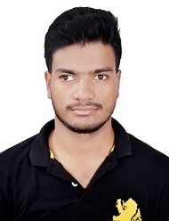

NAME : SUSANTA BEHERA
Phone Number: +91-9692767846
E-mail Id : susantamunu@rediffmail.com

CAREER OBJECTIVE

To work in an atmosphere that would enable me to use my knowledge, skill & contribute my dedicated effort as a team member to add value to the organization & learning the finer aspects of my subjects in return.

EDUCATIONAL QUALIFICATION:

I have passed M.A. in Analytical & Applied Economics from Utkal University, Vani Vihar, Bhubaneswar, Odisha.

Degree/Certificate | Degree | Discipline | Institute | Board/University | Year Of  Passing | Percentage of marks
Post-Graduation | M.A. | Analytical & Applied Economics | Utkal University, Vani Vihar, Bhubaneswar | Utkal University, Odisha | 2019 | 75.15%
Graduation | B.A. | Economics | N.C. Autonomous College, Jajpur | Utkal University, Odisha | 2016 | 62.22%
Intermediate | I.A. | Eco, Pol.Sc.,LOG, IT | N.C. Junior College, Jajpur | CHSE, Odisha | 2013 | 62.33%
10th | Matriculation | ALL | S.G.J. High School, Atalapur | BSE,Odisha | 2011 | 53.67%

ADITIONAL QUALIFICATION

Qualified UGC-National Eligibility Test in Economics for Assistant Professor
Exam held on 3rd December, 2019

SKILLS OBTAINED:

PGDCA

HOBBIES
Plantation
Playing Badminton

STRENGTH
Honest, Self-motivated, Hard working, Good Listener.

WEAKNESS
Trust more on people and I'm a good follower.

FAMILY DETAILS

Details | Name | Occupation
Father | Mr. Kalandi Behera | Self Employed
Mother | Mrs. Laxmi Behera | House Wife

PERSONAL DETAILS:

Date Of Birth : !0th January 1996
Gender : Male
Religion : Hindu
Nationality : Indian
Language Known :Odia,Hindi,English

ADDRESS

AT- Atalapur, P.O.- Samantarapur, VIA- Kabirpur
DIST-Jajpur, Odisha, PIN-755009

DECLARATION:
I certify that the statements made above are true, complete and correct to the best of my knowledge.

Date: 02-07-2020
Place: Bhubaneswar
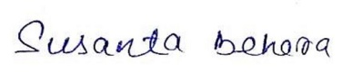
Susanta Behera

