CURRICULUM VITAE
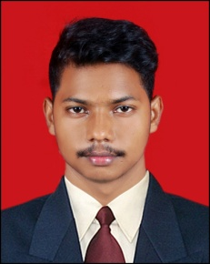

Bisworanjan pradhan

c/o-prof.(Dr) N.C.MISHRA

S/o-Laxmidhara pradhan
Plotno-1830/2652
Mahatab road
Oldtown,Bbsr
Dist-Khordha , Pin-751002
Contact No -9853517335 Mail-pradhanrinku489@gmail.com

CAREER OBJECTIVE:
Interest in working hard as an active member in the area of administration and marketing .Where I reinforce my knowledge and skill of communication for the betterment of my organization.

STRENGTH & RESPONSIBILITY:
- Enthusiastic, Energetic adaptable patience.
- Willing to smart working.
- Effective communication skill
- Good time management.

ACADEMIC QUALIFICATION:
- Passed +3 Science from Ekamra Degree college , Sundarpada, in the year 2016
- Passed +2 Science from Ekamra Degree college , Sundarpada, in the year 2012
- Passed HSC from Kaplilprasad high school,Sundarpada,in the 2010.

EXPERIENCE:
- 3 Year experience in Idea Cellular Ltd. Bhubaneswar as sales executive.
- 13 month experience in indibull dhani personal loan department as sales executive.

PERSONAL PROFILE:

Name : Bisworanjan pradhan
Father’s Name : Laxmidhara pradhan

Present Address : c/o-prof.(Dr) N.C.MISHRA

S/o-Laxmidhara pradhan
Plotno-1830/2652
Mahatab road
Oldtown,Bbsr
Dist-Khordha , Pin-751002
Contact No -9853517335

Date of Birth : 9th jun 1995
Gender : Male
Marital Status : Unmarried
Nationality : Indian
Religion : Hindu
Category : General
Languages Known : Odia, Hindi, English,

DECLARATION:
I do hereby declare that the above statements are true to the best of my knowledge and belief.

Date :
Place : Signature of the candidate

