CURRICULUM VITA
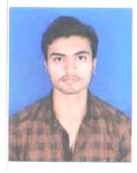
VISHAL SINGH

Address For Communication

Balaji kaivlaya Park Kumhari Raipur(C.G.)

Date of Birth: 8th October 1996
E-mail: vishalkumarsinghr@gmail.com
Mobile: +91-9140357157

JOB OBJECTIVE
Always wanted to be a part of an organization/Department where my skill Sets can be used positively

EDUCATIONAL QUALIFICATION

Degree | Board/University | Year | DIVISION
B.A. | MGKVP VARANASI | 2017 | 53%
12TH | U.P. BOARD | 2014 | 75%
10th | U.P. BOARD | 2012 | 70%

Personal profile:

Fathers Name: Shri.Vijay singh
Nationality: Indian
Marital Status: Single
Interest Includes: Reading books, Listening to music & Making friend.
Languages Known: Hindi, English.

WORK EXPERIENCE
1.Computer Operator 1Years Sai Jyoti Hospital Bhilai. (C.G.)
2. Area Sales Consultant 3 Years City Wheels Ashok Leyland Mohaba Bazaar Raipur (C.G)
3. Assistant Manager in present Indiamart Intermesh Limited Indravati Colony Raipur (C.G)

ACHIEVEMENTS
1.Diploma in Office Automation & Publishing.
2.Tally ERP.9 GST

DECLARATION
I hereby declare all above mentioned information is true and authentic .
Date: - .
Place: RAIPUR Signature

