Name- Sanjit Pattanayak 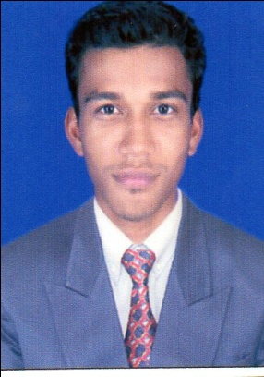
Date of birth-18th July 1990
Email id-sanjit.runa@gmail.com
PROFESSIONAL EXPERIENCE:
Specializations-Marketing/Finance
Mob : 7008609967

- Still working with TATA MOTORS FINANCE OPERATION TEAM(Branch operational activities . Cash collection ,Banking ,RO, File disburse , Customer handling , Booking and also all admin work)

- 1 Year working experience in TATA MOTERS LTD. As RURAL BUSINESS COORDINATOR .(Working and operating dealer team in rural area for develop the rural market )
- 3 year sales experience in VOLVO AND EICHER COMMERCIAL
VEHICLE LTD IN COCO (company own company Operated)

Objectives:
- To studycustomerpreferences for new Scheme.
- To know what attracts the customer for choosing a particular features.
- To study the key factors of the preferences of the customers.
PROJECT UNDERTAKEN:
Project title:
- To study the brand image of Ori-Plast,Balasore.
EDUCATION
Qualification | College/University | Year of completion | Division
BBA-Marketing | F.M (auto) college Bls. | 2011 | 1st
C.H.S.E-Arts | BahanagaCollege,Bls | 2008 | 3rd
H.S.C | Pratapada High School | 2006 | 3rd
OTHER PROFESSIONAL QUALIFICATION:
- Diploma in computer application.

AREAS OF INTEREST: | ELECTIVES
- Marketing management  - Business development  - Sales and distribution management  - Customer relationship management  - Training and development  - Performance appraisal  - Recruitment  - Client services | - Supply chain management  - Productivity management  - Strategic management  - Industrial analysis and development  - General management  - Operation research  - Industrial relation and labor law  - Management information system

ACHEIVEMENT AND AWARDS:
- Best comedian in F.M College in the yaer of 2010 &2011.
- Awarded best Volunteer in 2011 in F.M College (BBA Dept.).
STRENGTHS:
- Self confident
- Work under pressure
- Honesty and positive attitude towards work.
- A very good learner.
HOBBIES:
- Writing Stories.
- Mimicri.
- Acting in Comedy role.
PERSONAL DETAIL:
- Father name : SudhirPattanayak
- Mother name : BasantiPattanayak.
- Language known : English, Hindi, Oriya
- Permanent address : At/po-Padagan,Khantapada,Balasore, Odisha, 756043
DECLARATION:

I hereby declare that above mentioned information’s are true and correct to best of my knowledge
Date-04.09.2020
Place-BALASORE SanjitPattanayak.

