Curriculum Vitae
Basic Information
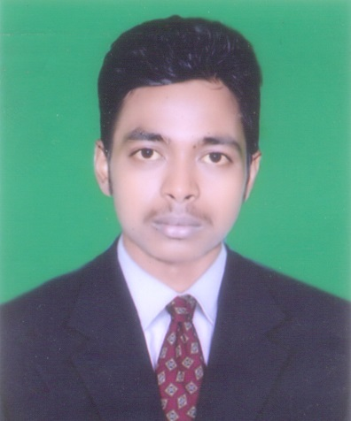
MANORANJAN POTHAL
C/O:- NIRANJAN POTHAL
AT/PO:- KORKORA
VIA:- ARNAPAL
PS:- BHADRAK RURAL
DIST:- BHADRAK- 756116
PH.NO:- 9439662838
E-MAIL:- pothal.mail@gmail.com

Language knowledge
English : Read, write & speak
Hindi : Read, write & speak
Oriya : Read, write & speak

Career Objective
To pursue a dynamic career in a professionally managed organization where I can achieve a tough position by utilizing my skills and abilities.
Education
Exam Passed | Name of the College / University | Total Mark | Mark Secured | Percentage (%) | Year of Passing
HSC | Satabhauni Ucha Bidya Pitha, Bhadrak | 600 | 454 | 75 | 2010
+2 | Bhadrak Junior College, Bhadrak | 600 | 360 | 60 | 2012
+3 | Bhadrak Autonomous College, Bhadrak | 1800 | 984 | 55 | 2015
Computer Knowledge
- PGDCA
- Tally 7.2
- Tally 9.0

- Office
  - Word,Excel,PowerPoint
Professional Qualification
I am Hard Working sincerity & Punctual
Adaptable in nature.
Dedicated towards my work & honest.
Personal Information
Candidate name : Manoranjan Pothal
Father’s name : Niranjan Pothal
Mother’s name : Yotsnarani Pothal
Date of Birth : 15th June 1995
Sex : Male
Marital Status : Unmaried
Nationality : Indian
Mobile : 9439662838
E-Mail : pothal.mail@gmail.com

Permanent address : At/Po- Korkora
: Via- Arnapal
: Dist -Bhadrak
: Pin -756116
Declaration
I do here by declare that the above information furnished by me is true to the best of my knowledge and belief.

Date:………...

Place:………. Manoranjan Pothal

