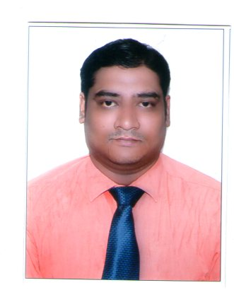
CURRICULAM VITAE

SATYA SWARUP BHATTA
C/o: Biswajit Mitra
Plot No-1279,Sriram Nagar,
Lane No 12,Old Town,
Bhubaneswar -2, Khurda, Odisha.
Mob. No. 7008867603,9776632349
Email: - satyas.bhatta@gmail.com

CAREER OBJECTIVE

Seeking for an opportunity to work as a Regional Business Manager in your esteemed organization to give the maximum effort in the form of knowledge and skills in my area of operation, accomplish it effectively and efficiently which strives my career towards corporate excellence.

ACADEMIC QUALIFICATION /
- Passed B.com from Utkal University, Orissa in the year 2003.
- Passed +2 Commerce from CHSE, Orissa in the year 2000.
- Passed Matriculation from BSE, Orissa in the year 1998.

EXPERIENCE- 13 YEARS IN PHARMACEUTICAL INDUSTRIES

- Working as REGIONAL BUSINESS MANAGER with NOVO MEDISCIENCES PVT. LTD. (Critical Care ) Since 17th Jan 2020 to till date
- Worked as a Area Business Manager with Abbott Healeathcare pvt. Ltd(PAIN MANAGEMENT) at Bhubaneswar HQ from14th May 2014 to 6th Jan 2020 at Bhubaneswar HQ.
- Worked as a Area Sales Manager with Osteva(ORTHO&GYNAC) ,Division of Macleods Pharmaceuticals since 18th Dec 2010 to 10th May 2014 at Bhubaneswar HQ
- Worked with Meyer Organics Pvt. Ltd. From 1st August 2006 to 14th Dec 2010 as a Medical Representative at Bhubaneswar HQ & dealing with ortho, gynac products.

AREA OF COVERAGE

- AREA OF COVERAGE IN MACLEODS

- Bhubaneswar, Angul, Sambalpur,Bargarh, Jharsuguda, Bolangir, Berhampur

- AREA OF COVERAGE IN ABBOTT (Covering Total Odisha State)

- Bhubaneswar, Cuttack, Balasore, Sambalpur,Berhampur

- AREA OF COVERAGE IN NOVO MEDISCIENCES PVT. Ltd. (ODISHA, CHHATISGARH)

- Bhubaneswar, Cuttack, Rourkela, Raipur (Chhatisgarh)⁰

PERSONAL SKILLS
- Confident in work
- Teamwork
- Hardworking & Positive Attitude

ACHIVMENTS
- In Abbott healthcare pvt ltd achieved 103% ,105%,108%,98% of my yearly target as ABM in 2014,2015,2016,2017 respectively.
- In the first year of launching of division Achieved 2.39lakh PMPM, which was No1 in all India in Macleods Pharmaceuticals ltd as a Area Manager
- Qualified for Foreign Trip for my achievements in the year 2011-12 in macleods Pharmaceuticals ltd
- Got achievement award for achieving 3.23lakh PRPM in 2012-13 in macleods Pharmaceuticals Ltd.
- As a Medical Representative achieved MD Dinner Award 4 times form 2006 to 2010 in Meyer Organics Pvt Ltd

PERSONAL DETAIL

Name : SATYA SWARUP BHATTA

Fathers name : Late Mr. Bibhuti Bhusan Bhatta

Permanent Address : At/Po: Rainrusinghpur,
Dist: - Dhenkanal, Orissa.
Pin: - 759026

Date of Birth : 14th May, 1983
Sex : Male.
Nationality : Indian.
Religion : Hindu.
Marital Status : Married.
Strength : Hardworking, Honest, Confident
Language : Oriya, English, & Hindi
Present CTC : 6.00 L p.a
DECLERATION

I do hereby declared that all the statements furnished in this curriculum vitae are true and best of my knowledge.

Place : Bhubaneswar

Date : 20/08/2020 Satya Swarup Bhatta

