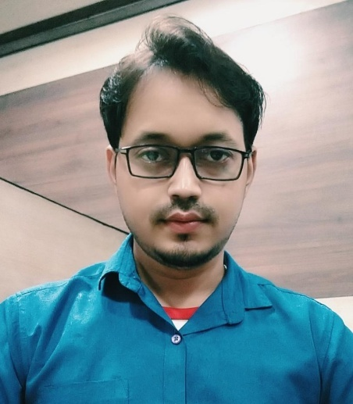
Phone:
+7978261355

E-Mail:
dev4u9040@gmail.com

Linkedin:
https://www.linkedin.com/in/dev-ranjan-pattnaik-93b478185/

Skill Highlights
- Strong decision maker
- Complex problem solver
- Creative design
- Innovative
- Service-focused

Languages
HINDI
ENGLISH
ORIYA

Computer Skills
- MS Office (Word, Excel, Outlook, Powerpoint)
Excel-v lookup , Pivot
- Tally ERP 9
- SAP MM MODULE
- Adobe Photoshop

Experience
11/2019 to 11/2020

COMMERCIAL OFFICER-SHYAM METALLIC AND ENERGY LTD.
- Preparing and Issuing Invoices.
- Coordination with transporters for any query and resolving the same.
- Analysis the quality of Raw material. (Coal, iron ore fines, dolochar etc..)
- Resolve GRN related query.
- mining return of Raw material .

03/2016 to 11/2019

SENIOR ACCOUNTANT- SHREE CHATURBHUJ ASSOCIATES
- Return filing , GST return(GSTR1 , GSTR- 3B)
- maintain inventory
- Analysis and reconciliation of Banking transactions, debtors and creditors and monitoring the same.
- TDS Payment.
- To co-ordinate with Sales, Operations and collection team.
- Maintaining cash book and petty cash book.
- Maintain i3ms portal for mines return.

Education
2017-2019
MBA in Finance & HR in the year 2019 from BPUT.

DEVA RANJAN PATTNAIK
Commercial Officer specializing Raw material procurement in Steel sector. Experienced with all transporters related query and resolving the same. Well-versed in MIS , Checking inward Invoices payment including GST ,Quality analysis of Raw material. Strong background GST return and Mining Return.

