Curriculum Vitae

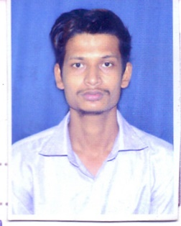
AJU CHANDRA PRADHAN
Mobile: 7735325018
Date Of Birth : 20/06/1998
Email ID: ajupradhan21@gmail.com
Address:
At:411, Shreya palace, Patrapada
PO: Dumduma Housing Board Colony
PS: khandgiri
DIST: khorda
PIN: 751019

PURPOSE STATEMENT
- A professional challenging career, which will provide opportunity for continuous growth
Learning with a dynamic organization which values individual contribution.
- To work with full dedication and gaining professional’s skills, competence and excellence this will develop my personality and enrich my experience.

SCHOLASTIC

- C.B.S.E. [X] Kendriya vidhyalaya no 2 ishapore (percentage of mark 52%)
- C.B.S.E. [XII] Airforce school barrackpore (percentage of marks54%)
- B.com NIIS group of institution (CGPA:6.65)

PROFESSIONAL SKILL
- Management and leadership quality.
- Familiar with all types of computer programs.
- Windows, Word & PowerPoint
- Analytical thinking, planning

JOB EXPERIENCE

Working as Telemarketing executive in Smart International Research Technology 2year (Sales Process )

EXTRA CURRICULAR ACTIVITIES
- Actively participated in various programs like acting, ppt and paper presentation & seminars, in school and college level.
- Playing outdoor games like cricket, badminton, football, khokho, volleyball

POSITIVE VIRTUES
- Highly trustworthy, discreet, hardworking and ethical
- Self-discipline, self-motivating

STRENGTHS
- Accuracy and attention to details.
- Problem analysis, use of judgment and ability to solve problems efficiency.
- Decision making, critical thinking, organizing and planning.
- Tolerant and flexible to different situations.
- Customer service orientation.
- Adaptability and ability to work under pressure.
- Positive thinking.

CIVIL STATISTICS
Father’s name: Mr. Munna Chandra Pradhan
Mother’s name: Mrs. Laxmi lata Pradhan
Permanent Address At: shope no 26, line bazar, ishapore, PO: Nawabganj, PS: Noapara
DIST: North 24 Parganas, PIN: 743144

DECLARATION
The details mentioned above are true to the best of my knowledge for which I can provide authentic documents.

[AJU CHANDRA PRADHAN]

