Alok Barik

RESUME

ADD: Samleswari colony, Modipada, Sambalpur
Mob.: 9348209012
Email ID: alokbarik086@gmail.com

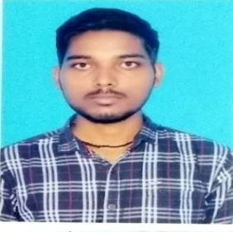CAREER OBJECTIVE

To seek a dynamic and challenging career an organization strives for excellence with my knowledge and team effort while making positive contribution to promote the individual opportunity and professional growth.

ACADMIC / EDUCATIONAL QUALIFICATION

SI.No. | Qualification | Stream | Institute | Board/ University | Year of  Passed | CGPA/Percentage
1. | B.com(Honors) | Accounting | G.M.University, Sambalpur | G.M.University, | 2020 | 6.7
2. | Higher Secondary Education | Commerce | G.M. Junior College, Sambalpur | CHSE | 2017 | 69.3
3. | Grade ‘X’ |  | Budharaja High school,Sambalpur | BSE | 2015 | 73

COMPUTER SKILLS

- Basic Computer Course
- Ms Word, Excel and Power point
- Book keeping
- Accounting

WEAKNESS

- Focus too much on details
- Lack of experience

STRENGTH FACTOR
- Good strength of working with team, Strong ability to work creative & determination.
- Flexible as per job requirement

PERSONAL PROFILE
Father Name : Nabhaghana Barik
Date of Birth : 05/03/2000
Marital status : Unmarried
Gender : Male
Religion : Hindu
Nationality : Indian

DECLLERATION
I do hereby declare that the statements made in this document are true to the best of my knowledge and belief.
Place: Modipada, Sambalpur

Date: (Alok Barik)

