RESUME
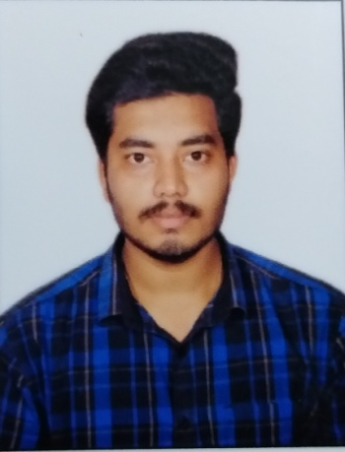
ANSHUMAN MAHARANA
S/o – Simanchala Maharana
At / Po – Gajapatinagar, Berhampur
Dist – Ganjam, Odisha
PIN – 760003
Mobile No. – 7077625986 / 7008425986
E-mail – kinganshuman05@gmail.com

Objectives:-
To continuosly enhance my knowledge, skills and experience by getting involved in challenges work environment and utilized them for personal and organizational growth to the best my educational qualification.

Examinations | Board / University | Name of the School/College | Percentage | Year of Passing
Graduction (BA in Economics) | Sambalpur University | Govt. Autonomous Junior College, Bhawanipatna | 46.5 | 2017
+2 ARTS | CHSE, Odisha | Govt. Autonomous Junior College, Bhawanipatna | 35.16 | 2015
10th | BSE, Odisha | Town High School, Bhawanipatna | 41.5 | 2012

Proffessiona Qualification:-

- PGDCA (Post Graducate Diploma In Computer Application) Utkal university, AIT Computer Education, Bhawanipatna, Kalahandi in the year 2013.

- Time Management
Skills

- Proposal Writing
- Data Entry
- Report Writing
- Back Office Operations
- Project Planning
Computer Proficiency

- Excel 2007
- Word 2007
- Power Point 2007
Languages

- Hindi
- English
- Odia
Experiences

- 1 Year experience in AIRTEL Merchant Executive
- 1.3 Year experience in Data Entry Operator at Tahshil Office
- 1 Year Experience In Loan Sector (Lead Generate) at Royal Finserv.

Personal Details

Father’s Name: Mr.Simanchala Maharana Marital Status: Unmarried
Birthday: June, 20, 1997 Nationality: Indian
Gender: Male
Declaration

I, Anshuman Maharana, hereby declare that the information contained herein is true and correct to the best of my knowledge and belief.

____________________________
Anshuma Maharana Berhampur, Odisha

